A. SPECIFIC AIMS
Fecal Incontinence (FI) affects 8-15 % of the US population, predominantly women and elderly, and 45% of nursing home residents. It significantly impairs quality of life and poses a major health care burden. FI is characterized by significant neuromuscular dysfunction of the pelvic floor that includes bilateral lumbo-anorectal and sacro-anorectal neuropathy and sensori-motor dysfunction. This multifactorial etiology suggests that maladaptive neuroplastic changes in the neural innervation of lower gastrointestinal tract could play a significant role in the pathogenesis of FI. A critical barrier to progress in the treatment of FI is the lack of understanding of how treatments affect the core pathophysiological mechanisms of FI, and the absence of mechanistically based non-invasive therapies. Our goal is to address the problem of FI by developing therapies that modulate peripheral and central neuronal perturbations and thereby improve visceromotor control and sensori-motor dysfunctions, and to understand the neurobiologic basis of these treatments. Our central hypothesis is that a novel non-invasive treatment consisting of repetitive translumbar magnetic stimulation (rTLMS) and repetitive transsacral magnetic stimulation (rTSMS) will significantly improve FI by enhancing peripheral and central neural excitability and will provide a multidimensional therapeutic benefit- enhance anal muscle strength, improve stool perception and improve rectal capacity. Our approach is based on our preliminary studies which suggest that repetitive translumbar magnetic stimulation (rTLMS) and transsacral magnetic stimulation (rTSMS) improve anorectal pain and neuropathy and induce central neuroplastic changes. Our objectives are to 1) address the significant gap in our knowledge regarding the peripheral and central neuroenteric axis and how perturbations in the afferent and efferent neural signaling can affect FI; 2) develop a new treatment for FI with repetitive magnetic stimulation and determine the feasibility, safety and optimal frequency setting of rTLMS and rTSMS; 3) determine the mechanistic basis for this neuromodulation therapy; 4) identify if the locus for improvement lies in the afferent or efferent signaling or both.

Our expected outcome include development of new treatment approaches for FI which are mechanistically based, effective, safe, low cost, less invasive, low risk and less dependent on patient compliance.
The impact of our project include a new non-invasive treatment modality for FI, a scientific basis for the development of this treatment and improved understanding of the peripheral and central neuroenteric axis in FI.

Aim 1: Test the hypothesis that neuromodulation therapy with combined repetitive translumbar magnetic stimulation (rTLMS) and transsacral magnetic stimulation (rTSMS) improves symptoms in FI patients. We will evaluate the efficacy, safety and optimal frequency setting of rTLMS and rTSMS for FI by investigating whether 6 sessions of weekly therapy with 1 Hz or 5Hz or 15 Hz magnetic stimulations of the lumbar and sacral regions provides therapeutic response in FI patients. We will randomize 48 patients with FI and assess symptoms and anorectal function. The primary outcome measure will be the reduction in number of episodes of FI. The secondary outcome measures will be i) bowel symptoms/severity (FISI, FICA), ii) quality-of-life (FI-QOL), iii) psychosocial function, iv) anal sphincter pressures, v) rectal sensation, vi) rectal compliance. A safety assessment will monitor adverse effects.

Aim 2: Test the hypothesis that repetitive translumbar magnetic stimulation (rTLMS) and transsacral magnetic stimulation (rTSMS) will improve FI symptoms and anorectal function through modulation of ascending and descending signaling pathways in the neuroenteric axis. We will investigate the mechanistic basis for rTLMS/rTSMS therapy by examining the neuroenteric axis. We will examine rectal and anal motor evoked potentials (MEPs) in 48 FI patients with transcranial, translumbar and transsacral magnetic stimulations (descending signaling), before and after 6 sessions of therapy with 1 Hz or 5 Hz or 15 Hz magnetic stimulations. Also, we will examine the cortical evoked potentials (CEP) after anal and rectal stimulation (ascending signaling). We will determine whether rTLMS and rTSMS therapy shortens latency and increases amplitude and area under curve (AUC) of anal and rectal MEPs and ano-cortical and recto-cortical CEPs when compared to baseline. We will identify if the locus for improvement lies in the afferent signaling, efferent signaling or both and whether the neuroplastic changes are central or peripheral. The primary outcome measure for efferent signaling will be the latency of lumbo-anal and sacro-anal MEP responses and for afferent signaling will be the latency of ano-cortical CEP. Secondary outcome measures include anal and rectal electrical sensory thresholds, lumbo-rectal and sacro-rectal MEPs and recto-cortical CEPs and correlations of FI episodes and bowel symptoms with changes in latency and MEP measurements.
RESEARCH STRATEGY

B. SIGNIFICANCE:
Fecal incontinence (FI), affects 8-15% of the ambulatory US population [1,2], predominantly women and elderly and 45% of nursing home residents [3,4]. It adversely affects quality of life and psychosocial function and poses a major health care burden [5]. A significant problem has been lack of effective therapies for FI. A critical barrier to progress in the treatment of FI is the lack of understanding of how treatments affect the core pathophysiological mechanisms of FI, and the absence of mechanistically based non-invasive therapies. Our goal is to address the problem of FI by developing therapies that modulate peripheral and central neuronal perturbations and thereby improve visceromotor control and sensori-motor dysfunctions, and to understand the neurobiologic basis of these treatments. Our central hypothesis is that a novel non-invasive treatment with combined translumbar magnetic stimulation (rTLMS) and transsacral magnetic stimulation (rTSMS) will significantly improve FI by enhancing peripheral and central neural excitability and will provide a multidimensional therapeutic benefit- enhance anal muscle strength, improve stool awareness and improve rectal capacity. Our hypothesis is based on the understanding that FI is characterized by significant neuromuscular dysfunction of the pelvic floor that includes bilateral lumbo-anorectal and sacro-anorectal neuropathy and sensori-motor dysfunction. Eighty percent of FI patients demonstrate more than one abnormality that involves the sphincters, puborectalis, pudendal nerves, or rectal sensation or capacity [6–8]. This multifactorial etiology suggests that maladaptive neuroplastic changes in the neural innervation of the lower GI tract or a progressive neuropathy could play a significant role in the pathogenesis of FI [7,9]. This approach stems from our preliminary studies which suggest that repetitive translumbar magnetic stimulation (rTLMS) and transsacral magnetic stimulation (rTSMS) improves neuropathy and anorectal pain in patients with levator ani syndrome [10], and induces central neuroplastic changes that are frequency-dependent [11,12]. Our objectives are to 1) address the significant gap in our knowledge regarding the peripheral and central neuroenteric axis and how perturbations in the afferent and efferent neural signaling can affect FI; 2) develop a new treatment for FI with repetitive magnetic stimulation and determine the feasibility, safety and optimal frequency setting of rTLMS and rTSMS; 3) determine the mechanistic basis for this neuromodulation therapy; 4) identify if the locus for improvement lies in the afferent or efferent signaling or both.
The proposed project will improve scientific knowledge, technical capability, and/or clinical practice as they relate to FI by addressing the significant gap in our knowledge regarding the peripheral and central neuroenteric axis in patients with FI, and how perturbations in the afferent and efferent neural signaling can affect FI. This lack of understanding may explain why anal sphincter pressures or rectal sensation remain unchanged after SNS therapy but patients report symptomatic improvement [13–17]. Current treatment for FI is unsatisfactory and at best 25-40% of patients achieve continence [14,18–22], and the vast majority continue to suffer. Moreover, previous studies have not systematically examined anorectal sensori-motor function, rectal capacity and bidirectional brain and gut axis simultaneously in FI, especially after therapeutic interventions. Most have focused on symptomatic improvement for defining the end point of their clinical trial without objective appraisal of outcomes. Our proposal will objectively evaluate the scientific basis of this therapy and correlate this with bowel symptoms and physiological changes.
When the aims of this project are achieved the concepts, methods, technologies, treatments, services, or preventative interventions related to treatment of FI will be changed as a result of 1) development of a new non-invasive therapy for FI that modulates peripheral and central neuronal perturbations to improve visceromotor control and sensori-motor dysfunctions; 2) demonstration that treatment with translumbar magnetic stimulation (rTLMS) and transsacral magnetic stimulation (rTSMS) will significantly improve FI by enhancing peripheral and central neural excitability; 3) a new understanding of the peripheral and central neuroenteric axis in FI, and how these neurobiologic mechanisms regulate bowel function in FI.

INNOVATION:
This application challenges and seeks to shift current research and clinical practice paradigms in FI by proposing a new treatment that is non-invasive, low cost, low risk and has a multidimensional therapeutic effect. Unlike other commonly used therapies for FI such as antidiarrheals [18], surgical sphincter repair [23] or sphincter bulking agents (NASHA dx) [24] that are designed to correct only one of the myriad pathophysiologic mechanisms that cause FI, our unique approach of repetitive magnetic stimulation targets the peripheral spinal tracts, non-invasively, and through neuronal modulation could lead to peripheral and central neuroplastic changes. We seek to shift current treatment paradigms in FI by altering the key underlying pathophysiological changes in nerve and muscle function, rectal sensation, rectal compliance and pelvic floor- brain function.
This application builds upon the core concept of improved brain-gut signaling and neural stimulation and on the metrics we have developed to comprehensively examine the pathophysiology of pelvic floor problems such as dyssynergic defecation [25,26] and irritable bowel syndrome [27,28] and monitor therapeutic changes [10,12]. Sacral nerve electrical stimulation (SNS) is approved for treatment of FI, but requires a two stage neurostimulator implantation under anesthesia in the operating room [29], is expensive and invasive, and has serious complication rate of ~15%, [14,30]. Furthermore, its mechanism of action is unknown, outcome unpredictable, lacks sham controlled trials, and only 25% achieve continence [13–16,30,31]. The advantages of our approach over SNS are that magnetic stimulation is non-invasive, less expensive, has no serious complication rate and is based on sham-controlled studies which show that repetitive transcranial magnetic stimulation (rTMS) is effective in major depression [32,33], refractory auditory hallucinations (AH) [34], tinnitus [35] and visceral pain [36]. We demonstrated that it is effective in post-stroke dysphagia [37], and this effect is achieved by modifiying the underlying neuropathobiology [37–39].
The unique aspect of our study is magnetic stimulation of the peripheral spinal roots, a concept that has not been tested in patients with FI. Magnetic stimulation is non-invasive, safe, and less costly than SNS. Our project will provide important new mechanistic insights regarding the mode of action of rTLMS and rTSMS, and the results could have immediate clinical implications. Furthermore it expands on our long-term strategy of gaining insights into the neurobiologic mechanisms of pelvic floor disorders [7,8,26,27,40]. Upon successful completion of our aims, we will be prepared to perform a subsequent multicenter study of active versus sham controlled rTLMS and rTSMS, and examine the predictors of response including genotype and phenotype.
A potential new application for our intervention with rTLMS and rTSMS could be the treatment of other pelvic floor disorders such as urinary incontinence, interstitial cystitis and pelvic pain. Our ground-breaking work in defining the optimal frequency setting for magnetic stimulations will be a significant advantage when planning studies for these disorders because, the same pelvic nerves are maladaptive in these other disorders [41–44]. Also, our approach of investigating the efficacy and safety along with anorectal physiology, QOL, brain-gut neurophysiology and newly refined patient reported outcome instruments, will break new ground and lay the foundation for the development of rigorous clinical trials in FI. Our unique ability to perform the following experiments is demonstrated by our preliminary data above, unique medical and collaborative research expertise, highly qualified personnel, established and dedicated neurophysiology and rTMS labs.

APPROACH:
Overall strategy- Our goal is to address the problem of FI by developing therapies that modulate peripheral and central neuronal perturbations and thereby improve visceromotor control and sensori-motor dysfunctions, and to understand the neurobiologic basis of these treatments. Our objectives are to 1) address the significant gap in our knowledge regarding the peripheral and central neuroenteric axis and how perturbations in the afferent and efferent neural signaling can affect FI; 2) develop a new treatment for FI with repetitive magnetic stimulation and determine the feasibility, safety and optimal frequency setting of rTLMS and rTSMS; 3) determine the mechanistic basis for this neuromodulation therapy; 4) identify if the locus for mechanistic improvement lies in the afferent or efferent signaling pathways or both.

Aim 1: Test the hypothesis that neuromodulation therapy with combined repetitive translumbar magnetic stimulation (rTLMS) and transsacral magnetic stimulation (rTSMS) improves symptoms in FI.
Table 1 | Incontinence n= 48 | Controls n=20 | p
TL-rMEP (msec) | 3.9 (3.5-4.2) | 2.8(2.6-3.1) | 0.001
TS-rMEP (msec) | 4.4(4-4.8) | 2.7(2.3-3.1) | 0.0001
TL-aMEP (msec) | 5.7 (3-6.4) | 3.1(2.5-3.6) | 0.0001
TS-aMEP (msec) | 4.9(2.6-8.5) | 2.9(2.5-3.4) | 0.0001
Rationale: Current FI treatments are inadequate because they do not remedy the core multifactorial pathophysio-logical dysfunctions: sphincter weakness, neuronal perturbations, rectal capacity and anal/rectal sensory dysfunction. Our approach is supported by preliminary studies that demonstrated: 1) FI patients have significant lumbo-rectal (TL-rMEP), sacro-rectal (TS-rMEP), lumbo-anal (TL-aMEP) and sacro-anal (TS-aMEP) neuropathy as evidenced by prolonged MEP at all four sites when compared to healthy controls [8] (Table1.).
We expect to show that magnetic stimulation of lumbosacral spinal tracts will improve neuropathy in patients with FI and this will lead to improvement in symptoms of FI. 2) Repetitive lumbar and sacral magnetic stimulation significantly improved mean pain score (0-3), from 2.7 to 0.9, and peripheral nerve conduction as measured by MEP (Fig 1) in 3 subjects with refractory levator ani syndrome [10]. This shows that lumbo- sacral magnetic stimulation can improve neuropathy and anorectal symptoms, and provides a basis for our approach of performing peripheral repetitive magnetic stimulation in FI. 3) Different frequencies of peripheral or central magnetic stimulation have differential effects on effector organs [11,12]. We found that 15 Hz but not 5Hz or sham rTLMS enhanced anal EMG amplitude. Also, 1 Hz but not 10 Hz or sham rTLMS improved rectal and anal sensation and pain [45]. Hence, the optimal frequency for peripheral magnetic stimulation is unclear [45]. By testing 3 different frequencies, we expect to gain new knowledge on optimal frequency of rTLMS/rTSMS and develop an effective treatment modality.
Proposed Experiment 1. Test the efficacy, safety and optimal frequency setting of rTLMS and rTSMS. DESIGN: We will investigate whether a randomized dose (frequency) response study of 6 sessions of weekly therapy with 1 Hz, 5 Hz or 15 Hz lumbar and sacral magnetic stimulation will improve FI, as assessed by:
1.A. The number of incontinence episodes/week—primary outcome measure
1.B. (i) Bowel symptoms (stool frequency, consistency, urgency), and severity (FISI, FICA,SGA), (ii) FI Quality of life (FI-QOL), (iii) Psychological function (Rome III psychosocial symptom questionnaire), IV) Anal resting, squeeze and sustained squeeze pressure, (v) Rectal sensation (changes in thresholds for first sensation, desire to defecate, urgency to defecate), (vi) Rectal compliance - secondary outcome measures

Study Subjects and Recruitment: We will recruit subjects from 2 academic centers, Augusta, USA and Manchester, UK, where 5 new patients with FI are seen each week per center. We will perform 180 rTMS therapy sessions in year 1 (30 patients) and 108 in year 2 (18 patients), and with 4 half-day therapy sessions/week these studies can be accomplished. We will facilitate recruitment by advertising in the hospital newsletter, place posters, and email colleagues. Forty eight adult, out-patients, 21-80 years old with FI, defined as at least 1 episode of solid or liquid stool leakage per week will be recruited for this eight-week study. All patients will provide a detailed history and undergo physical examination, structural (colonoscopy) and biochemical evaluation, anorectal manometry, anal ultrasound (Appendix 1) , and balloon expulsion test [46]. Once eligible for screening, they will sign a consent form and maintain a 2-week prospective stool diary (Appendix 2). If the diary confirms FI and the inclusion criteria are met, they will be enrolled into the study
Fig 2
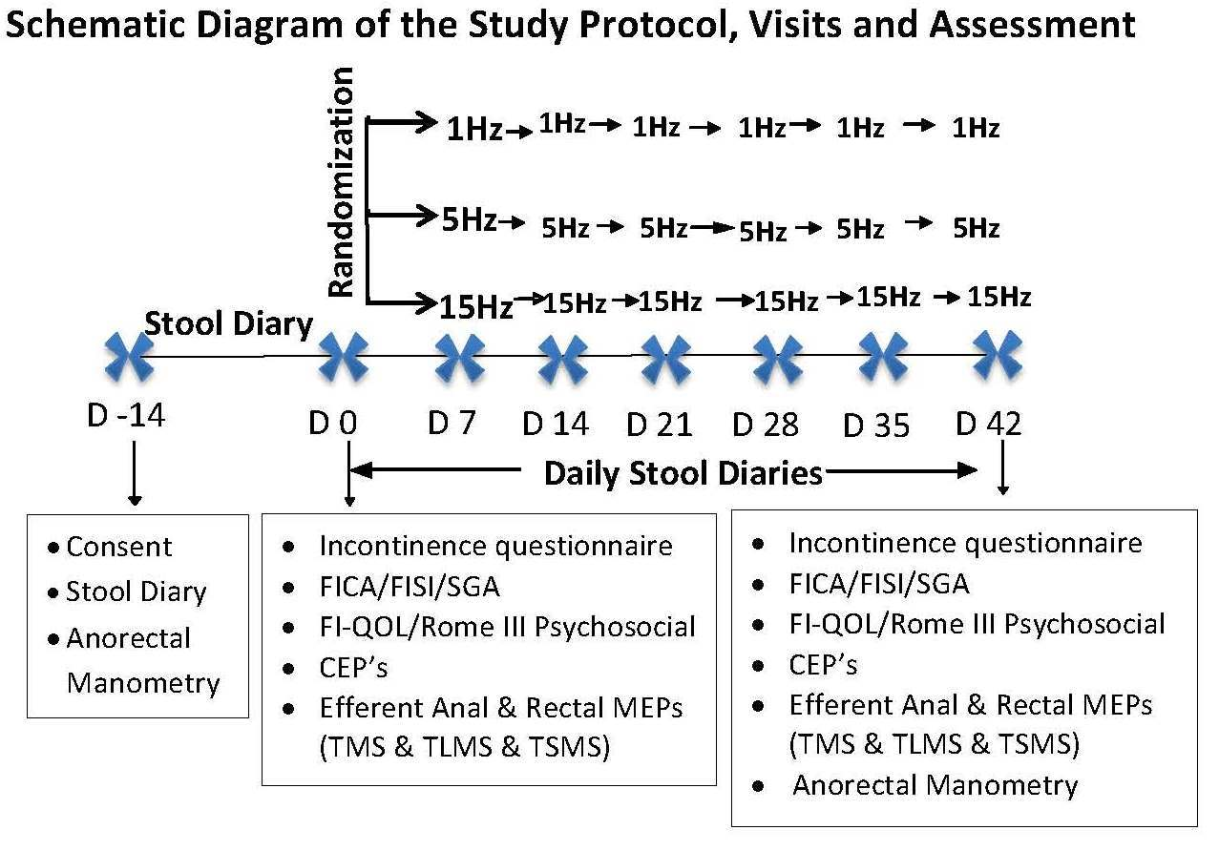
Inclusion criteria: a) Recurrent episodes of FI for 6 months; b) No mucosal disease (colonoscopy + biopsy); and c) On a 2-week stool diary patients reported at least one episode of solid or liquid FI/week.
Exclusion Criteria: Patients with 1) severe diarrhea (>6 liquid stools/day, Bristol scale >6); 2) on opioids, tricyclics (except on stable doses > 3months); 3) active depression; 4) comorbid illnesses, severe cardiac disease, chronic renal failure or previous gastrointestinal surgery except cholecystectomy and appendectomy; 5) neurologic diseases (e.g. head injury, epilepsy, multiple sclerosis, strokes, spinal cord injury); 6) impaired cognizance (mini mental score of < 15/25) and/or legally blind; 7) metal implants, pacemakers; 8) previous pelvic surgery, bladder repair, radical hysterectomy; 9) ulcerative and Crohn’s colitis; 10) rectal prolapse, anal fissure, anal surgery or inflamed hemorrhoids; 11) pregnant women 12) nursing mothers.
Study Protocol (See Flow Chart, Fig. 2): Enrolled patients will be asked to fill out incontinence, FISI [47], FICA [48], FI-QOL [49] questionnaires and a global assessment scale (SGA) and the Rome III Psychological Alarm Questionnaire [50] at baseline and after treatment (Appendices 3-8). Next, patients will undergo CEP, TMS, TLMS and TSMS studies (Appendices 9-11) as described below (see under AIM 2), and these tests will be repeated after the 6th session to assess brain-pelvic floor function. Next, patients will be randomized to one of 3 treatment groups, 1 Hz, 5Hz or 15 Hz frequency of rTLMS and rTSMS. The order of lumbar or sacral stimulations and the right or left side will be randomized. Six sessions of treatment will be given at weekly intervals (Appendix 12). Daily stool diaries will be kept (Appendix 1).
Randomization procedures: We will use the permuted blocks method to ensure balance among the 3 treatments, and at each center while making it highly improbable to predict the next treatment assignment. Serially numbered sealed envelopes containing the assignment will be used.
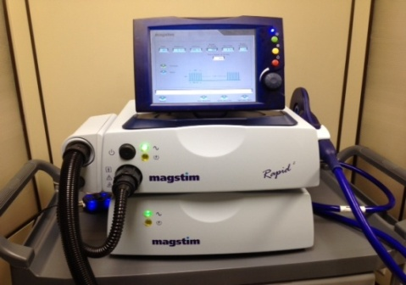
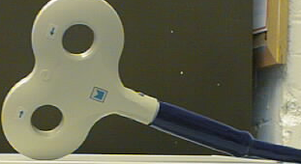
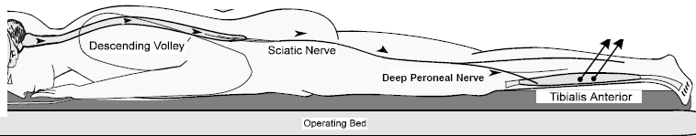
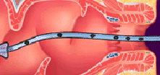
Magnetic Stimulator
Probe

Fig 4
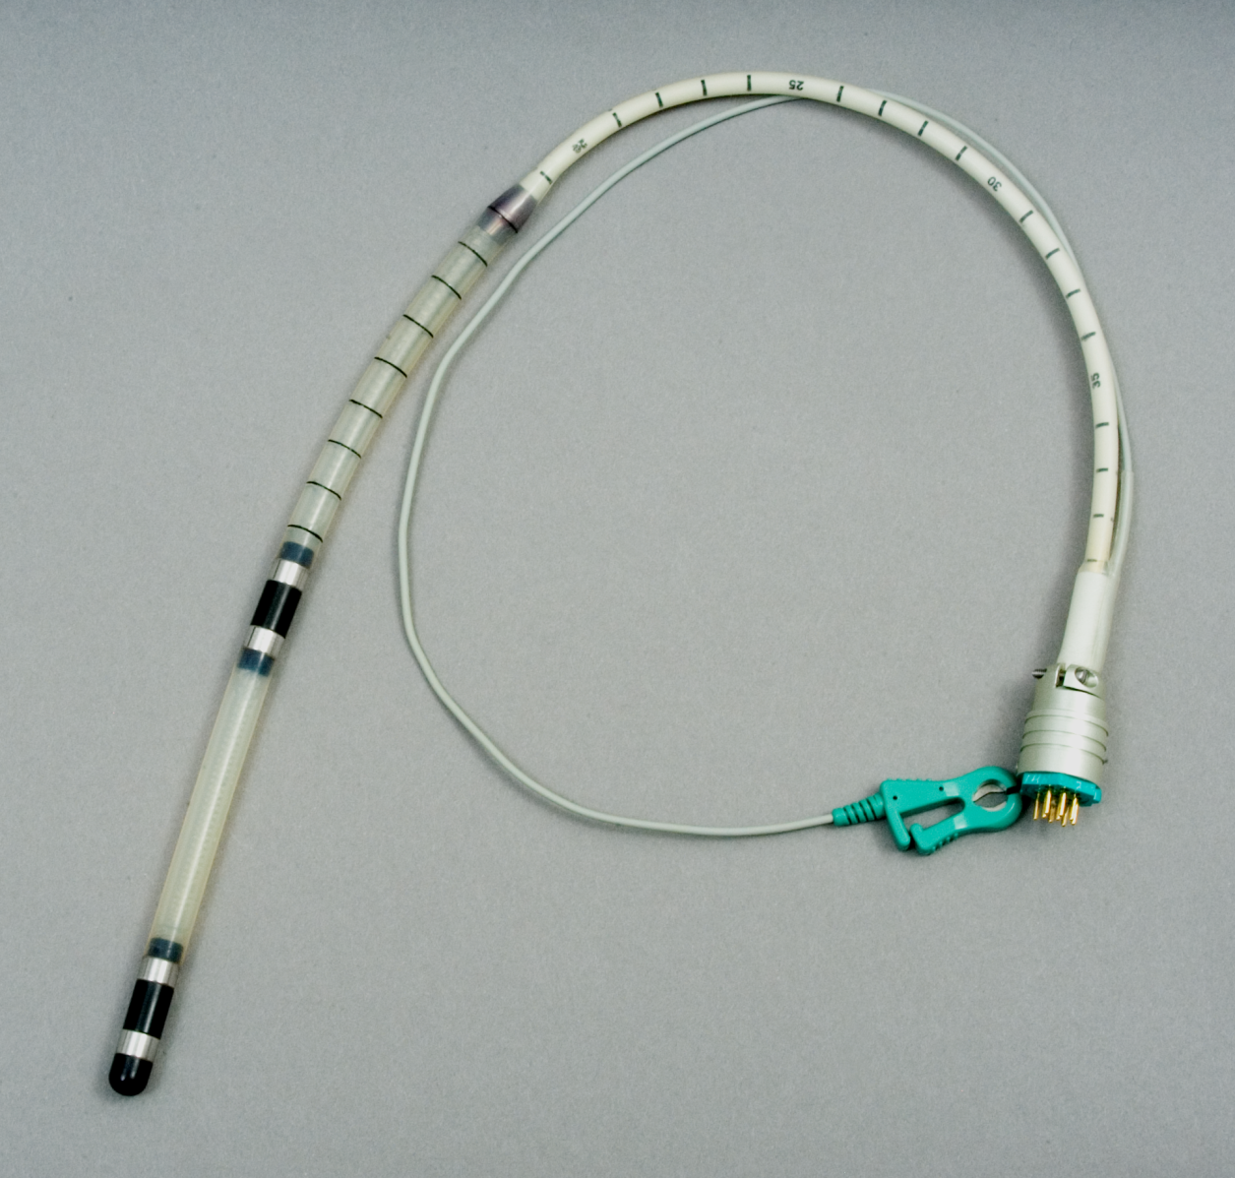
rTLMS and rTSMS therapy: With subject lying prone, a probe (Fig 3) with 2 pairs of bipolar steel ring electrodes, each 2 cm apart, is placed in the rectum. The proximal pair will record rectal MEP and the distal pair located at 1 cm from anus will record anal MEP. At each site a mapping procedure is performed with single stimulus coil (Magstim 200; MAGSTIM, Whitland, UK) to assess the motor threshold, defined as the minimum level of magnetic stimulation intensity required to achieve an anal and rectal MEP response of 10 microvolts and an anterior tibialis MEP of 20 microvolts with 50% of trials. Bilateral lumbar stimulations (rTLMS) are administered at L2/L3 disc space, 3-4 cm lateral to the midline on each side, and sacral stimulations (rTSMS) at S2/S3 level. The intensity for rTLMS/rTSMS is set at either 50% above this threshold or capped at 70% of stimulation output to comply with safety guidelines whichever is lesser. Next a 70 mm air film self-cooling coil ( MAGSTIM Rapid²) is positioned randomly over one of the 4 sites (right or left lumbar/ right or left sacral), held in place by a coil fixator and 300 stimulations are delivered (Fig 4). After a 5 min rest the cycle is repeated (Total =600/site). The coil is moved to the opposite side and after a rest period of 10 min, the stimulations will be repeated until all 4 sites have been stimulated (Total per session=2400). Patient will be monitored for any adverse events. The operator performing rTLMS will not be involved with data analysis.
Fig 3

Measures and Outcomes: The (blinded) results obtained for the symptomatic, physiologic, and QOL measures, before and after treatment, and the differences between the 3 treatment frequencies will be compared.

1. The primary outcome measure will be the change in weekly episodes of FI. A responder will be defined as an individual who shows at least 50% reduction in FI episodes when compared to baseline 2. Secondary outcome measures include: i) Bowel symptoms and severity: Stool frequency, consistency (Bristol Stool scale, 1-7), and urgency will be assessed from stool diaries, and global assessment of bowel satisfaction (Likert scale), and by validated FISI and FICA scales [47,48]. ii) FI- QOL: Assessed by changes in 8 domains [49]. iii) Psychological function: Assessed by Rome III questionnaire [50]. iv).Anal Sphincter function: Anal resting, squeeze and sustained sphincter pressures [51]. v). Rectal sensation: This will be assessed from sensory thresholds for first, desire and urge to defecate [51]. vi) Rectal compliance: assessed by dv/dp [51].
SD | Precision
0.10 | 0.053
0.15 | 0.080
0.20 | 0.107
0.25 | 0.133
0.30 | 0.160
Safety assessment will be performed by reviewing the daily symptom/stool diary and by direct inquiry at weekly visits for known or unknown events. If FI worsens or adverse events occur, patient will be withdrawn from study and a safety analysis will be performed by DSMB to determine its relationship to treatment.
Table 2

Power And Sample Size Calculations - To estimate the percent change (from baseline) in the number of episodes of FI a 95% confidence interval will be calculated for each group (1 Hz, 5 Hz, and 15 Hz). Table 2 shows the values of the precision (that can be attained with the 95% C.I.) for various SD for a sample size of 16 (PASS 2008, NCSS, LLC, Utah, US). Since the % change will be estimated for each group, a sample size of 16 will be needed for each treatment group, for a total of 48 FI patients.

Statistical Analyses: To estimate the percent change in FI episodes for each treatment group (1, 5 and 15 Hz), a mean with a 95% CI will be calculated. To examine the changes from baseline in the various quantitative outcome measures, a paired t-test will be used (if the data is distributed normally). For data that is not normally distributed (including ordinal measures), a Wilcoxon Signed Rank (non-parametric) Test will be used. Data will be analyzed as intent-to-treat and per protocol.
Anticipated Results & Interpretation: We expect rTLMS and rTSMS treatment to demonstrate a multidimensional therapeutic benefit: 1) a dose dependent reduction in FI episodes with 15Hz showing the greatest responder rate. 2) a 30% improvement in FISI and FICA scores and 30% change in global bowel satisfaction. 3) improved QOL and psychosocial domains. 4) a 20% increase in squeeze pressures indicating stronger muscles from increased neuronal excitability. 5) improved perception of stooling and decreased urgency from neuronal-mediated changes in rectal sensation, tone and reservoir capacity.

Potential problems, pitfalls and solutions: 1) If all 3 frequencies fail, alternative strategies may include lower (0.5 Hz) or higher frequency (20 Hz) or biweekly therapy. 2) Manometric but not sensory parameters might improve, revealing a motor and not a sensory basis for improvement. 3) Alternatively, sensitivity alone may improve suggesting that treatment affects sensitivity and not motor function. 4) Symptoms may improve without changes in CEP or MEP indicating that FI symptoms are unrelated to CEP/MEP. 5) If only the CEP or MEPs change it indicates that treatment affects only afferent or efferent signaling. 6) Unexpectedly, FI may worsen or adverse events may occur; we will perform an interim analysis after 50% enrollment to review options.

Aim 2: Test the hypothesis that repetitive translumbar magnetic stimulation (rTLMS) and transsacral magnetic stimulation (rTSMS) will improve FI symptoms and anorectal function through modulation of ascending and descending signaling pathways in the neuroenteric axis.
Rationale: A critical barrier to progress in treating FI is the lack of mechanistic understanding of how treatments affect FI. Our hypothesis is that rTLMS and rTSMS treatment will improve FI by enhancing peripheral and central neural excitability and modulating ascending and descending signaling pathways in the neuroenteric axis. This approach is based on our preliminary work; 1) SNS at 15 Hz reduced corticoanal representation and excitability in FI [12]. 2) Lumbosacral stimulation at 5 Hz and 15 Hz produced differential effects on cortical CEP [11]. 3) rTLMS and rTSMS improved lumbo-anorectal and sacro-anaorectal MEPs in levator ani syndrome [10]. These findings reveal that peripheral nerve stimulation induces short-term central and peripheral neuroplastic changes, symptom improvement and that frequency of magnetic stimulation affects sensori-motor responses. We expect to characterize the afferent and efferent brain and gut pathways in FI and provide mechanistic insights regarding the effects of magnetic stimulation on neuronal conduction as well as determine how various frequency settings can influence treatment response.
Proposed Experiment 2. Investigate the Mechanistic Basis for rTLMS/rTSMS therapy by examining the bi-directional pelvic floor-brain neuroenteric axis:
DESIGN: We will examine rectal and anal MEPs with transcranial (TMS), translumbar (TLMS) and transsacral (TSMS) magnetic stimulations (descending signaling), before and after 6 sessions of therapy with 1,5 or 15 Hz rTLMS and rTSMS. Also, we will examine the cortical evoked potentials (CEP) after anal and rectal stimulation (ascending signaling). The primary outcome measure for efferent signaling will be the latency of lumbo-anal and sacro-anal MEP responses and for afferent signaling will be the latency of ano-cortical CEP. Secondary outcome measures include anal and rectal electrical sensory thresholds, lumbo-rectal, sacro-rectal MEPs and recto-cortical CEPs, amplitude and area under curve (AUC) of anal and rectal MEPs and correlations of FI episodes and bowel symptoms with changes in latency and MEP measurements.
Subjects: All 48 FI patients enrolled in Aim 1 will be invited to participate, and studies will be performed after screening visit and last treatment session. We anticipate good compliance because there are no extra visits.
MEP assessment: For TMS, patients will be placed in a reclining chair. A Double Cone coil (Magstim) will be placed 2-3 cm lateral to scalp vertex (Cz), bilaterally, and discharged at 50% of stimulator output, and increased in 5% steps until an MEP response of >10µV for the anus/rectum and 100µV for tibialis are recorded with 3/6 trials using the anorectal probe and neurophysiology recorder (Nihon Kohden, Japan) [8,27,40,52]. For TLMS and TSMS, patient is placed in prone position and a circular coil is placed on the lumbar and sacral regions, bilaterally as described in Fig 3, and anal and rectal MEPs will be determined.
Measures and Outcomes: A researcher blinded to whether the study is baseline or post-therapy and the frequency paradigms will assess the characteristics of MEP The anal sphincter MEP and rectal MEP responses are averaged to reduce any trial-to-trial variation and analysed for following parameters. 1) The primary measures will be the onset latency of anal and rectal MEP response to TMS, TLMS and TSMS. 2) The mean amplitude of anal and rectal MEP responses 3) MEP Index: The area under the curve of the MEP response. 4) Symptom correlation: Correlate bowel symptoms (FI episodes), severity and physiological changes with MEP latency. 5) The effect of different frequency stimulations on anal and rectal MEPs.
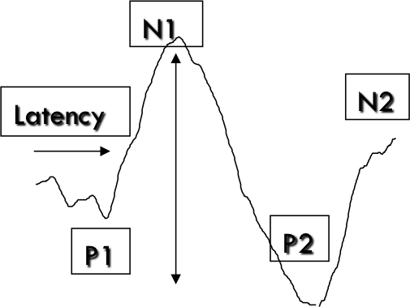
Amplitude
Fig 5
CEP Assessment: A probe (Fig 3 ) is placed in rectum and connected to a stimulator (Nihon-KohdenTM,Japan). Randomly, rectal and anal electrical stimulation will be performed to assess threshold for 1st sensation and pain by increments of 1 mA. The CEPs will be recorded using silver chloride surface electrodes, positioned at the vertex (Cz), and right ear lobe [27,52,53]. For rectal and anal CEP assessment, four runs of 50 stimuli will be given at 50% pain threshold.
Measures and Outcomes: Data (blinded) will be compared between baseline and post-therapy and the 3 frequencies for; i) CEP: a grand average of the 4 runs of CEPs for anal and rectal stimulation will be used to measure the latency of P1, P2, N1 and N2 and amplitudes and area under curve (Fig 5). ii) anal and rectal sensory thresholds. iii) Correlate CEP changes with FI episodes.
Statistical Analyses: Paired t-test or Wilcoxon signed rank test will compare the anal and rectal CEPs and MEPs before and after treatment in each group and between FI patients and historical controls. Pearson or Spearman correlation coefficients will examine the relationship between changes in CEP and MEP latencies and sensory thresholds and between the three frequencies as well as no of FI episodes and bowel symptoms.

Anticipated results & Interpretation: We expect to demonstrate mechanistic basis for improvement in FI after rTLMS/rTSMS as evidenced by: 1) shortened latency and increased amplitude of anal and rectal MEP’s after brain and peripheral stimulation as compared to baseline and historical controls indicating improved efferent brain and gut signaling. 2) shortened latency of anal and rectal CEP’s and decreased anal and rectal sensory thresholds will indicate improved afferent signaling, and scientific basis for enhanced stooling sensation and afferent neuromodulation. 3) greater magnitude of effect with 15 Hz indicating a dose dependent response with rTLMS/rTSMS. 4) strong correlation of FI symptoms with improved MEP and CEP responses.

Potential problems, pitfalls and solutions: 1) If treatment is ineffective, this proposal will provide valuable mechanistic insights regarding peripheral and central neuroenteric regulation in FI. 2) A lack of neurophysio-logical changes but improvement in FI will suggest an alternative mechanistic pathway for symptomatic improvement. 3) The neurophysiologic changes may improve but symptoms may not, suggesting that FI symptoms are not due to neuroenteric dysregulation. 4) If the 5Hz or 1 Hz frequency shows greater efficacy it will reaffirm our rationale for testing different frequencies and support the use of 5Hz for future trials. 5) Significant abnormalities in central signaling together with a lack of improvement in FI indicates that peripheral stimulation is not effective and repetitive transcranial (central) stimulation should be considered.

Data and Safety Monitoring Board (DSMB) and Plan: A DSMB will be set up and will meet quarterly to review safety. In case of adverse event, IRB, NIH Office of Biotechnology Activities and FDA will be informed.
DATA MANAGEMENT: Data will be collected on paper case report forms (appendices (1-12), and entered into a secure database, stored and backed up, with restricted access.
TIMELINE: NOV 2014-OCT 2015: (1) Recruit 30 subjects with FI for AIM 1 & AIM 2. (2) Interim analysis - AIM 1 and 2 (3) Commence monthly study group and bimonthly safety monitoring meetings.
NOV 2015–OCT 2016: (1) Recruit 18 subjects for AIMs 1 & 2 and complete enrollment (n=48). (2) Complete data analysis for AIMs 1 & 2, submit abstract and write manuscripts.
REFERENCES
[1] Whitehead WE, Borrud L, Goode PS, Meikle S, Mueller ER, Tuteja A, et al. Fecal incontinence in US adults: epidemiology and risk factors. Gastroenterology 2009;137:512–7, 517.e1–2. PMC2748224
[2] Ditah I, Devaki P, Luma HN, Ditah C, Njei B, Jaiyeoba C, et al. Prevalence, Trends, and Risk Factors for Fecal Incontinence in United States Adults, 2005-2010. Clin Gastroenterol Hepatol 2013:Epub ahead of print.
[3] Leung FW, Rao SSC. Fecal incontinence in the elderly. Gastroenterol Clin North Am 2009;38:503–11.
[4] Leung FW, Schnelle JF. Urinary and fecal incontinence in nursing home residents. Gastroenterol Clin North Am 2008;37:697–707.
[5] Dunivan GC, Heymen S, Palsson OS, von Korff M, Turner MJ, Melville JL, et al. Fecal incontinence in primary care: prevalence, diagnosis, and health care utilization. Am J Obstet Gynecol 2010;202:493.e1–6. PMC3855440
[6] Rao SS, Patel RS. How useful are manometric tests of anorectal function in the management of defecation disorders? Am J Gastroenterol 1997;92:469–75.
[7] Bharucha AE, Rao SSC. An update on anorectal disorders for gastroenterologists. Gastroenterology 2014;146:37–45.e2.
[8] Rao SSC, Coss-Adame E, Tantiphlachiva K, Attaluri A, Remes-Troche JM. Translumbar and transsacral magnetic neuro-stimulation for the assessment of neuropathy in fecal incontinence. Dis Colon Rectum 2013:[In press].
[9] Rao SSC. Diagnosis and management of fecal incontinence. American College of Gastroenterology Practice Parameters Committee. Am J Gastroenterol 2004;99:1585–604.
[10] Rao SSC, Erdogan A, Coss-Adame E, Dewitt A. Repetitive Translumbar Magnetic Stimulation (rTLMS) and Transsacral Magnetic Stimulation (rTSMS): A Novel Treatment for Levator Ani Syndrome (LAS). Am J Gastroenterol 2013;108:S182.
[11] Harris ML, Singh S, Rothwell J, Thompson DG, Hamdy S. Rapid rate magnetic stimulation of human sacral nerve roots alters excitability within the cortico-anal pathway. Neurogastroenterol Motil 2008;20:1132–9.
[12] Sheldon R, Kiff ES, Clarke a, Harris ML, Hamdy S. Sacral nerve stimulation reduces corticoanal excitability in patients with faecal incontinence. Br J Surg 2005;92:1423–31.
[13] Tjandra JJ, Chan MKY, Yeh CH, Murray-Green C. Sacral nerve stimulation is more effective than optimal medical therapy for severe fecal incontinence: a randomized, controlled study. Dis Colon Rectum 2008;51:494–502.
[14] Tan E, Ngo N-T, Darzi A, Shenouda M, Tekkis PP. Meta-analysis: sacral nerve stimulation versus conservative therapy in the treatment of faecal incontinence. Int J Colorectal Dis 2011;26:275–94.
[15] Matzel KE. Sacral nerve stimulation for faecal incontinence: its role in the treatment algorithm. Colorectal Dis 2011;13 Suppl 2:10–4.
[16] George AT, Kalmar K, Panarese A, Dudding TC, Nicholls RJ, Vaizey CJ. Long-term outcomes of sacral nerve stimulation for fecal incontinence. Dis Colon Rectum 2012;55:302–6.
[17] Mellgren A, Wexner SD, Coller JA, Devroede G, Lerew DR, Madoff RD, et al. Long-term efficacy and safety of sacral nerve stimulation for fecal incontinence. Dis Colon Rectum 2011;54:1065–75.
[18] Omar MI, Alexander CE. Drug treatment for faecal incontinence in adults. Cochrane Database Syst Rev 2013;6:CD002116.
[19] Bharucha AE, Seide BM, Zinsmeister AR. The effects of clonidine on symptoms and anorectal sensorimotor function in women with faecal incontinence. Aliment Pharmacol Ther 2010;32:681–8. PMC2932810.
[20] Brown SR, Wadhawan H, Nelson RL. Surgery for faecal incontinence in adults. Cochrane Database Syst Rev 2013;7:CD001757.
[21] Norton C, Cody JD. Biofeedback and/or sphincter exercises for the treatment of faecal incontinence in adults. Cochrane Database Syst Rev 2012;7:CD002111.
[22] Maeda Y, Laurberg S, Norton C. Perianal injectable bulking agents as treatment for faecal incontinence in adults. Cochrane Database Syst Rev 2013;2:CD007959.
[23] Bleier JIS, Kann BR. Surgical management of fecal incontinence. Gastroenterol Clin North Am 2013;42:815–36.
[24] Graf W, Mellgren A, Matzel KE, Hull T, Johansson C, Bernstein M. Efficacy of dextranomer in stabilised hyaluronic acid for treatment of faecal incontinence: a randomised, sham-controlled trial. Lancet 2011;377:997–1003.
[25] Remes-Troche JM, Paulson J, Yamada T, Hamdy S, Rao SSC. Anorectal-cortical function is impaired in patients with dyssynergic defecation. Gastroenterology 2007;132:A–20.
[26] Coss-Adame E, Rao SSC, Remes-Troche JM, Attaluri A, Valestin J, Tantiphlachiva K, et al. Does biofeedback therapy improve brain-gut axis in dyssynergic defecation? Neurogastroenterol Motil 2012;24:27.
[27] Coss-Adame E, Valestin J, Bradley C, Kreder KJ, Rao SSC. Investigation of the afferent anorectal-brain neuromuscular axis in irritable bowel syndrome (IBS) and interstitial cystitis (IC). Neurogastroenterol MotilityMotility 2012;24:24.
[28] Coss-Adame E, Valestin J, Bradley C, Kreder KJ, Rao SSC. Investigation of the efferent spinofugal axis by trans-lumbar and trans-sacral magnetic stimulation in irritable bowel syndrome (IBS) and interstitial cystitis (IC). Neurogastroenterol Motil 2012;24:175.
[29] Boyle DJ, Murphy J, Gooneratne ML, Grimmer K, Allison ME, Chan CLH, et al. Efficacy of sacral nerve stimulation for the treatment of fecal incontinence. Dis Colon Rectum 2011;54:1271–8.
[30] Maeda Y, Lundby L, Buntzen S, Laurberg S. Outcome of Sacral Nerve Stimulation for Fecal Incontinence at 5 Years. Ann Surg 2013:[Epub ahead of print].
[31] Vaizey CJ, Kamm MA, Roy AJ, Nicholls RJ. Double-blind crossover study of sacral nerve stimulation for fecal incontinence. Dis Colon Rectum 2000;43:298–302.
[32] Chen J, Zhou C, Wu B, Wang Y, Li Q, Wei Y, et al. Left versus right repetitive transcranial magnetic stimulation in treating major depression: a meta-analysis of randomised controlled trials. Psychiatry Res 2013;210:1260–4.
[33] Janicak PG, Dunner DL, Aaronson ST, Carpenter LL, Boyadjis TA, Brock DG, et al. Transcranial magnetic stimulation (TMS) for major depression: a multisite, naturalistic, observational study of quality of life outcome measures in clinical practice. CNS Spectr 2013;18:322–32.
[34] Rosa MO, Gattaz WF, Rosa MA, Rumi DO, Tavares H, Myczkowski M, et al. Effects of repetitive transcranial magnetic stimulation on auditory hallucinations refractory to clozapine. J Clin Psychiatry 2007;68:1528–32.
[35] Theodoroff SM, Folmer RL. Repetitive transcranial magnetic stimulation as a treatment for chronic tinnitus: a critical review. Otol Neurotol 2013;34:199–208.
[36] Fregni F, Potvin K, Dasilva D, Wang X, Lenkinski RE, Freedman SD, et al. Clinical effects and brain metabolic correlates in non-invasive cortical neuromodulation for visceral pain. Eur J Pain 2011;15:53–60. PMC3000866.
[37] Jayasekeran V, Singh S, Tyrrell P, Michou E, Jefferson S, Mistry S, et al. Adjunctive functional pharyngeal electrical stimulation reverses swallowing disability after brain lesions. Gastroenterology 2010;138:1737–46.
[38] Michou E, Mistry S, Jefferson S, Singh S, Rothwell J, Hamdy S. Targeting unlesioned pharyngeal motor cortex improves swallowing in healthy individuals and after dysphagic stroke. Gastroenterology 2012;142:29–38.
[39] Vasant DH, Mistry S, Michou E, Jefferson S, Rothwell JC, Hamdy S. Contralateral transcranial Direct Current Stimulation (tDCS) reverses the neurophysiological and behavioural swallowing effects after focal cortical inhibition of the human pharyngeal motor cortex. J Physiol 2013.
[40] Tantiphlachiva K, Attaluri A, Valestin J, Yamada T, Rao SSC. Translumbar and transsacral motor-evoked potentials: a novel test for spino-anorectal neuropathy in spinal cord injury. Am J Gastroenterol 2011;106:907–14. PMC3883059.
[41] Fulton M, Peters KM. Neuromodulation for voiding dysfunction and fecal incontinence: a urology perspective. Urol Clin North Am 2012;39:405–12.
[42] Laviana A, Jellison F, Kim J-H. Sacral neuromodulation for refractory overactive bladder, interstitial cystitis, and painful bladder syndrome. Neurosurg Clin N Am 2014;25:33–46.
[43] Ustinova EE, Fraser MO, Pezzone MA. Cross-talk and sensitization of bladder afferent nerves. Neurourol Urodyn 2010;29:77–81.
[44] Pezzone MA, Liang R, Fraser MO. A model of neural cross-talk and irritation in the pelvis: implications for the overlap of chronic pelvic pain disorders. Gastroenterology 2005;128:1953–64.
[45] Algladi T, Harris ML, Whorwell PJ, Issa B, Paine P, Hamdy S. Evidence for alteration in anorectal sensation to non-invasive repetitive lumbosacral and cortical magnetic stimulation in patients with IBS. Gastroenterology 2012;142:S–133.
[46] Rao SSC. Advances in diagnostic assessment of fecal incontinence and dyssynergic defecation. Clin Gastroenterol Hepatol 2010;8:910–9. PMC2964406.
[47] Rockwood TH, Church JM, Fleshman JW, Kane RL, Mavrantonis C, Thorson AG, et al. Patient and surgeon ranking of the severity of symptoms associated with fecal incontinence: the fecal incontinence severity index. Dis Colon Rectum 1999;42:1525–32.
[48] Bharucha AE, Locke GR, Seide BM, Zinsmeister AR. A new questionnaire for constipation and faecal incontinence. Aliment Pharmacol Ther 2004;20:355–64.
[49] Rockwood TH, Church JM, Fleshman JW, Kane RL, Mavrantonis C, Thorson AG, et al. Fecal Incontinence Quality of Life Scale: quality of life instrument for patients with fecal incontinence. Dis Colon Rectum 2000;43:9–16; discussion 16–7.
[50] Bharucha AE, Wald A, Enck P, Rao S. Functional anorectal disorders. Gastroenterology 2006;130:1510–8.
[51] Rao SSC, Azpiroz F, Diamant N, Enck P, Tougas G, Wald A. Minimum standards of anorectal manometry. Neurogastroenterol Motil 2002;14:553–9.
[52] Remes-Troche JM, Tantiphlachiva K, Attaluri A, Valestin J, Yamada T, Hamdy S, et al. A bi-directional assessment of the human brain-anorectal axis. Neurogastroenterol Motil 2011;23:240–8, e117–8. PMC3035753.
[53] Jasper HH. 10-20 electrode system of the International Federation. Electroencephalogr Clin Neurophysiol 1958;10:370–5.

