Figure 1, Supplementary Digital Content 3. Patient disposition.
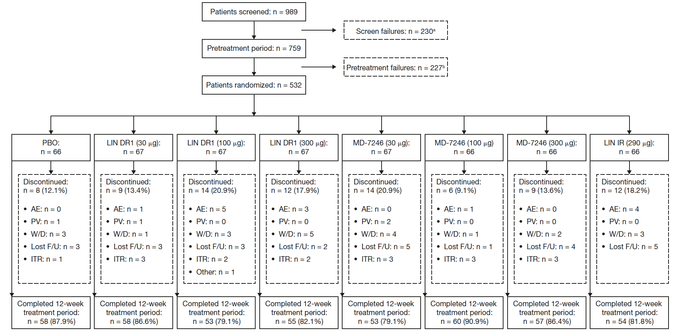
ªPatients who signed an informed consent form but did not qualify for the study. Rescreened patients who failed twice were only counted once.
^{b}Patients who signed an informed consent form and entered the pretreatment period but were not randomized into the study. Rescreened patients who failed during the pretreatment period were counted only in the pretreatment failure category. Rescreened patients who were randomized were not counted in either failure category.
AE, adverse event; DR1, delayed-release formulation 1; IR, immediate-release formulation; ITR, insufficient treatment response; LIN, linaclotide; Lost F/U, lost to follow-up; PBO, placebo; PV, protocol violation; W/D, withdrew consent

