**Supplementary Figure 1:** Funnel Plot for Risk of Included Studies



**Supplementary Figure 2:** Risk of Infantile Infections Following *in utero* Exposure to Biologic Therapy in Women with IBD Restricted to Only Anti-TNF Studies

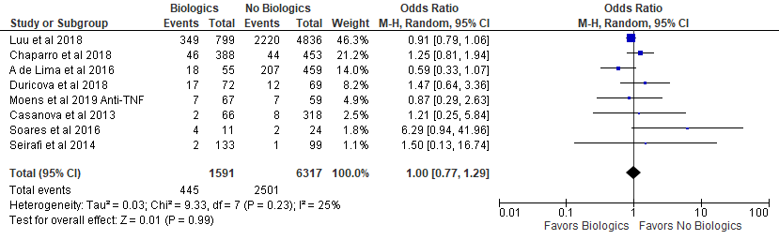

**Supplementary Figure 3:** Risk of Infantile Infections Following *in utero* Exposure to Biologic Therapy in Women with IBD Stratified by Certolizumab Exposure

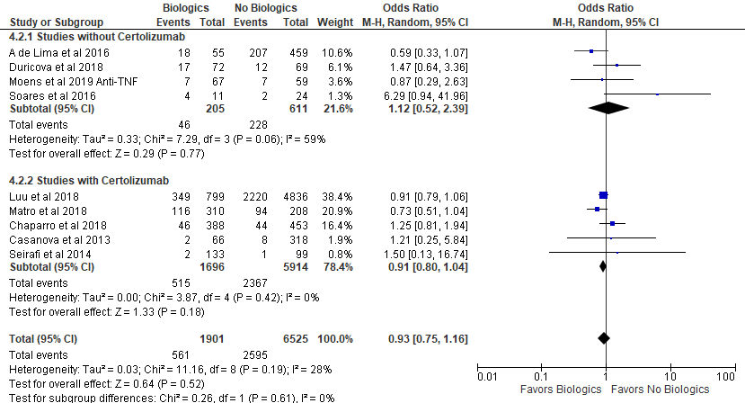

**Supplementary Figure 4:** Risk of Infantile Infections Following *in utero* Exposure to Biologic Therapy in Women with IBD Stratified by Study Design

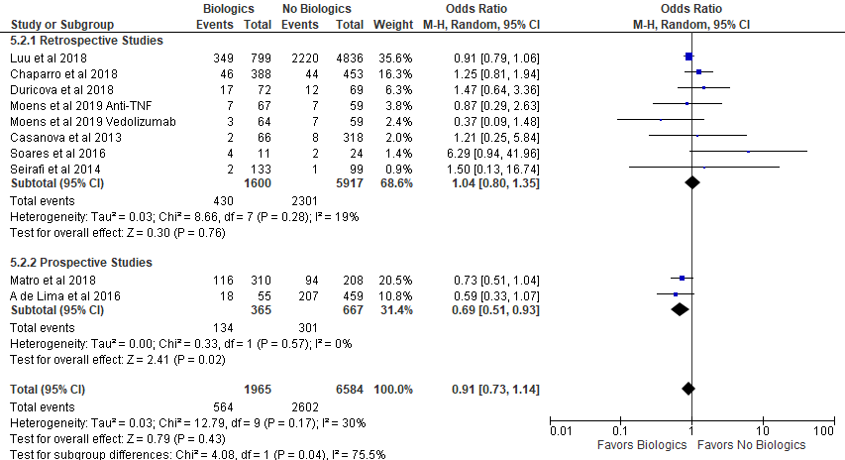

**Supplementary Figure 5:** Risk of Infantile Infections Following in utero Exposure to Biologics in Women with IBD Stratified by Study Risk of Bias

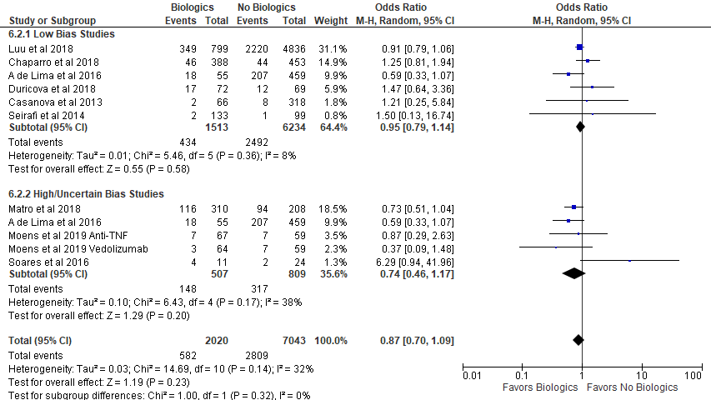

**Supplementary Figure 6:** Meta-Regression Analyses of Proportion of IBD Mothers on Steroids During Pregnancy and Odds of A) All Infantile Infections B) Acute Otitis Media C) Upper Respiratory Infections D) Urinary Tract Infections E) Gastrointestinal Infections F) Infantile Antibiotic Use G) Infection-Related Hospitalizations

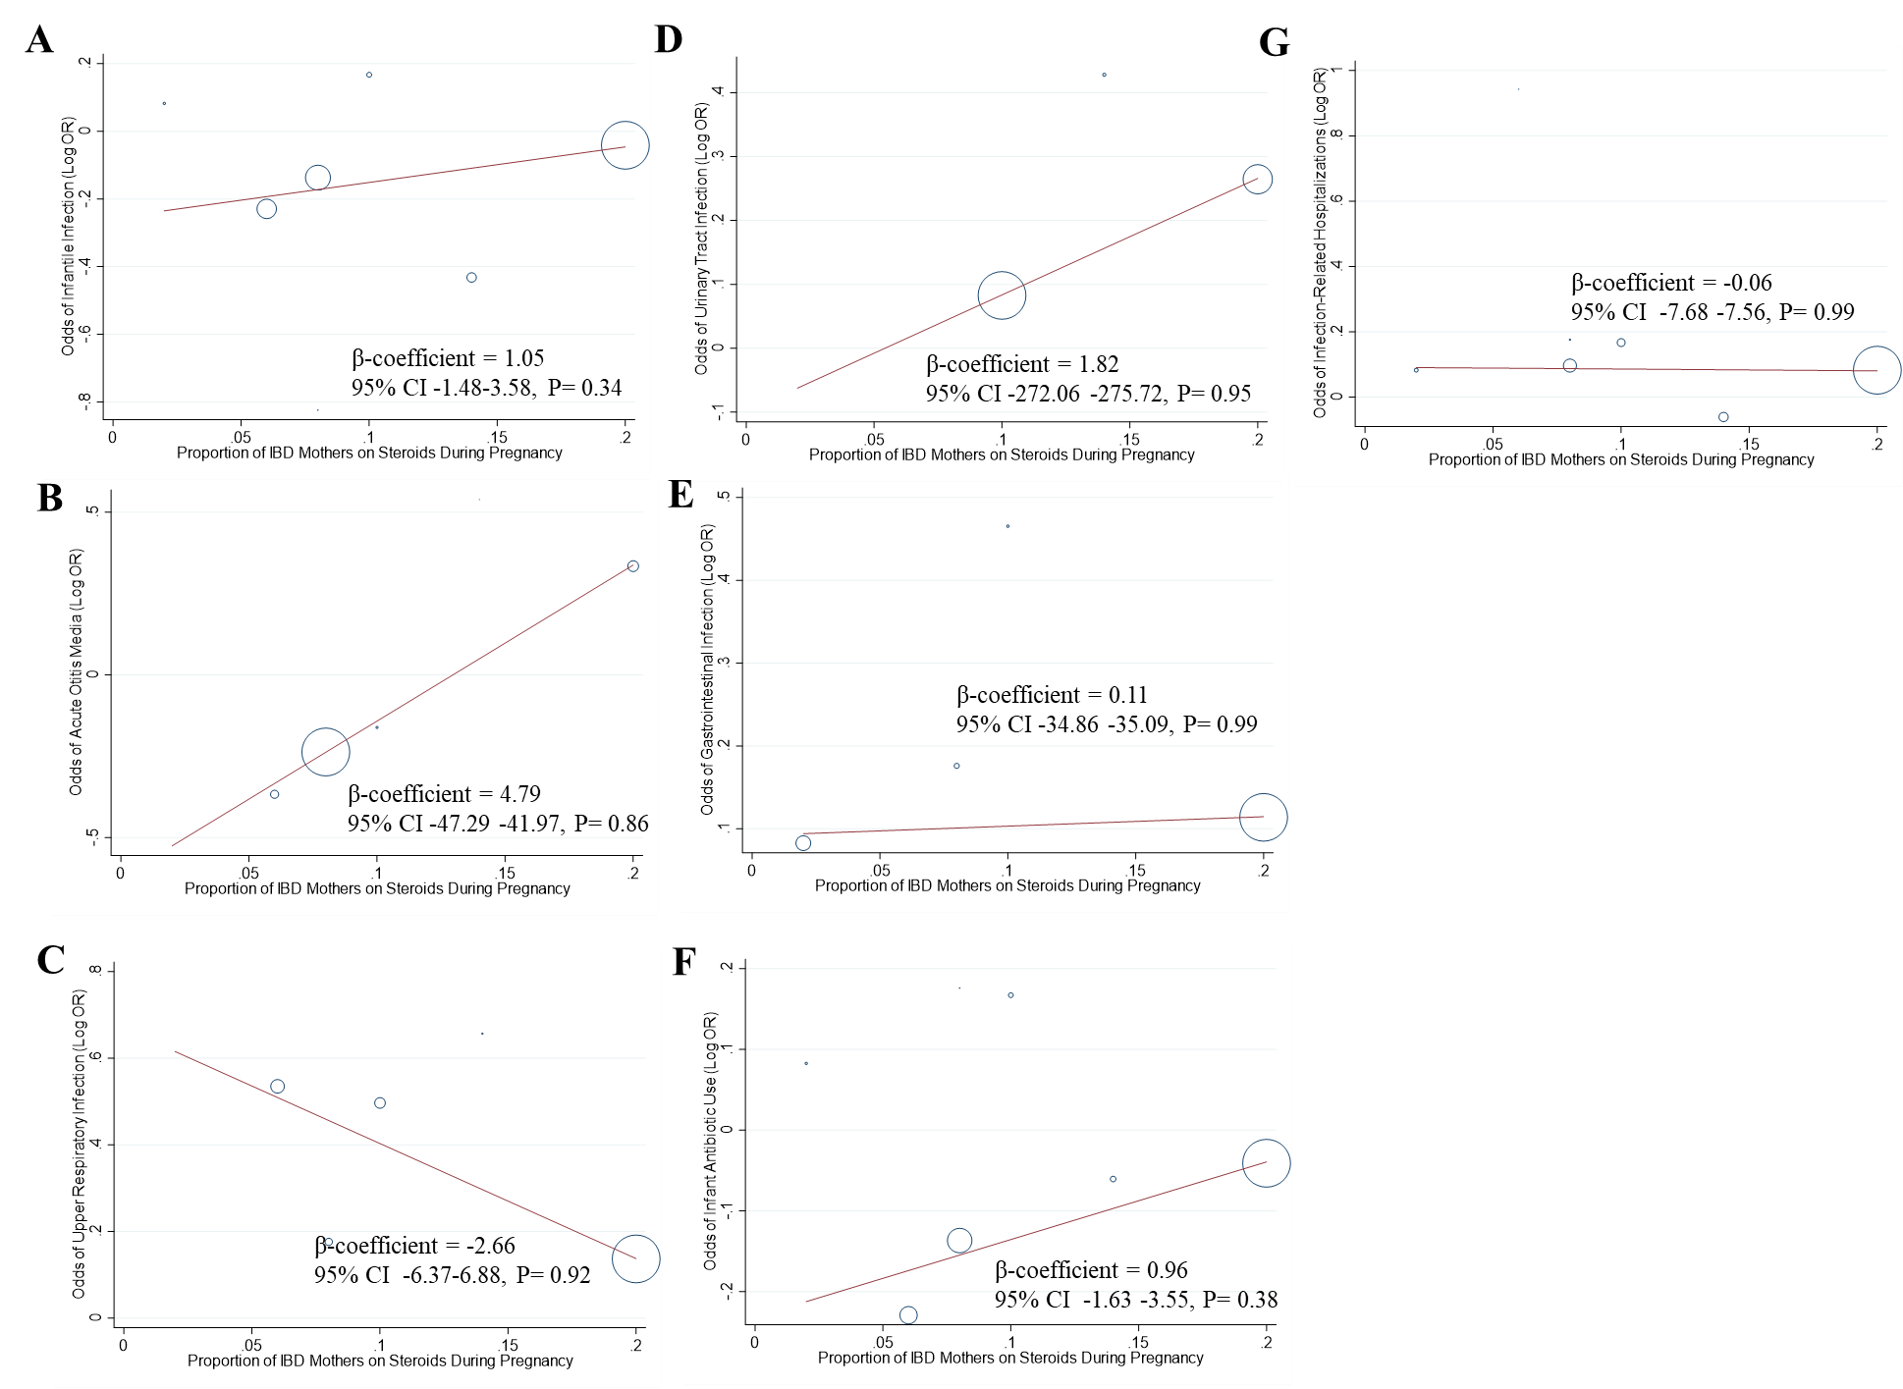

**Supplementary Figure 7:** Meta-Regression Analyses of Proportion of IBD Mothers with Active Disease During Pregnancy and Odds of A) All Infantile Infections B) Acute Otitis Media C) Upper Respiratory Infections D) Urinary Tract Infections E) Gastrointestinal Infections F) Infantile Antibiotic Use G) Infection-Related Hospitalizations

