Supplemental Table 1: Diagnosis and procedure codes for cirrhosis and decompensation.
Severity | Code | Code Type | Description
Cirrhosis | 571.2 | ICD-9 Dx | Alcoholic cirrhosis of liver
 | 571.5 | ICD-9 Dx | Cirrhosis of liver without mention of alcohol
Compensated cirrhosis | With a cirrhosis code, but with no code indicating decompensation events
Decompensated cirrhosis | 456.0 | ICD-9 Dx | Esophageal varices with bleeding
 | 456.20 | ICD-9 Dx | Esophageal varices in diseases classified elsewhere, with bleeding
 | 456.6 | ICD-9 Dx | Vulval/rectal varices
 | 348.3x | ICD-9 Dx | Encephalopathy, not elsewhere classified
 | 789.5 | ICD-9 Dx | Ascites
 | 789.59 | ICD-9 Dx | Other ascites
 | 572.2 | ICD-9 Dx | Hepatic encephalopathy
 | 572.3 | ICD-9 Dx | Portal hypertension
 | 572.4 | ICD-9 Dx | Hepatorenal syndrome
 | 782.4 | ICD-9 Dx | Jaundice, unspecified, not of newborn
 | 530.82 | ICD-9 Dx | Esophageal hemorrhage
 | 578.x | ICD-9 Dx | Gastrointestinal hemorrhage (rule: with gastric varices (ICD10 I86.4) or esophageal varices (456.x)
 | 567.23 | ICD-9 Dx | Spontaneous bacterial peritonitis
 | 276.1 | ICD-9 Dx | Hyponatremia
 | 273.8 | ICD-9 Dx | Hypoalbuminemia
 | 286 | ICD-9 Dx | Coagulopathy but without codes for anticoagulation
 | Pleural effusion (511.1, 511.8, 511.81, 511.9) and ascites (789.59) | ICD-9 Dx | Hepatic hydrothorax
 | 49080, 49081, 49082, 49083, 54.91- Percutaneous abdominal drainage | CPT, ICD-9 proc codes | Paracentesis
 | 43204, 42.33 | CPT, ICD-9 proc codes | Esophagoscopy, rigid or flexible, with injection sclerosis of esophageal varices, Endoscopic excision or destruction of lesion or tissue of esophagus
 | 42.91 | ICD-9 proc codes | Ligation of esophageal varices
 | 44.91 | ICD-9 proc codes | Ligation of gastric varices
 | 96.06 | ICD-9 proc codes | Insertion of Sengstaken tube
 | 37182, 37183, 39.1 | CPT, ICD-9 proc codes | TIPS (Intra-abdominal venous shunt, Insertion of transvenous intrahepatic portosystemic shunt, Revision of transvenous intrahepatic portosystemic shunt)
 | 37140 | CPT codes | Venous anastomosis, open; portocaval
 | 37160 | CPT codes | Venous anastomosis, open; caval-mesenteric
 | 37180 | CPT codes | Venous anastomosis, open; splenorenal, proximal
 | 37181 | CPT codes | Venous anastomosis, open; splenorenal, distal (selective decompression of esophagogastric varices, any technique)
 | 43205 | CPT codes | Esophagoscopy, rigid or flexible; with band ligation of esophageal varices
 | 43243 | CPT codes | Upper gastrointestinal endoscopy including esophagus, stomach, and either the duodenum and/or jejunum as appropriate; with injection sclerosis
 | 43244 | CPT codes | Upper gastrointestinal endoscopy including esophagus, stomach, and either the duodenum and/or jejunum as appropriate; with band ligation of esophageal/gastric varices
 | 43400 | CPT codes | Ligation, direct, esophageal varices
 | 43401 | CPT codes | Transection of esophagus with repair, for esophageal varices

Suppl Table 2: Frequency of recommended tests during long-term follow-up

(A) By gender and (B) By age

A | Overall long-term monitoring cohort  (n=45,435) | Male  (n=26,196) | Female  (n=19,239) | P-value
Clinic visits  q 6 months  q 12 months | 29.2%  58.8% | 29.2%  58.9% | 29.1%  58.8% | 0.85  0.83
ALT  q 6 months  q 12 months | 11.9%  40.3% | 13.1%  41.9% | 10.4%  38.1% | <0.001  <0.001
HBV DNA  q 6 months  q 12 months | 6.4%  28.0% | 6.7%  28.8% | 5.9%  27.0% | 0.002  <0.001
ALT and HBV DNA  q 6 months  q 12 months | 5.1%  25.1% | 5.4%  26.0% | 4.7%  23.9% | <0.001  <0.001
CBC (cirrhosis only)  q 6 months  q 12 months | 7.3%  30.7% | 8.1%  31.5% | 6.3%  29.6% | <0.001  <0.001
PT/INR (cirrhosis only)  q 6 months  q 12 months | 1.6%  9.2% | 1.8%  9.9% | 1.2%  8.4% | <0.001  <0.001
Creatinine (cirrhosis only)  q 6 months  q 12 months | 8.0%  31.5% | 9.3%  33.7% | 6.4%  28.4% | <0.001  <0.001
EGD (cirrhosis only)  q 36 months | 12.0% | 12.3% | 11.5% | 0.017

Abbreviations: ALT, alanine aminotransferase; CBC, complete blood count; EGD, esophagogastroduodenoscopy; GI/ID, gastroenterology/infectious diseases; HBV DNA, hepatitis B virus DNA; INR, international normalized ratio; PT, prothrombin time.

B | Overall long-term monitoring cohort  (n=45,435) | Age < 45  (n=22,368) | Age 45-64  (n=21,013) | Age ≥ 65  (n=2,054) | P-value
Clinic visits  q 6 months  q 12 months | 29.2%  58.8% | 23.3%  54.9% | 33.4%  61.8% | 50.2%  71.7% | <0.001  <0.001
ALT  q 6 months  q 12 months | 11.9%  41.9% | 10.6%  38.6% | 13.7%  43.2% | 8.3%  29.1% | <0.001  <0.001
HBV DNA  q 6 months  q 12 months | 6.4%  28.0% | 7.1%  31.1% | 6.0%  26.6% | 2.2%  9.2% | <0.001  <0.001
ALT and HBV DNA  q 6 months  q 12 months | 5.1%  25.1% | 5.7%  27.9% | 4.9%  23.7% | 1.9%  8.6% | <0.001  <0.001
CBC (cirrhosis only)  q 6 months  q 12 months | 7.3%  30.7% | 5.6%  28.0% | 9.1%  33.9% | 8.1%  27.8% | <0.001  <0.001
PT/INR (cirrhosis only)  q 6 months  q 12 months | 1.6%  9.2% | 1.1%  7.8% | 2.0%  10.6% | 2.4%  10.4% | <0.001  <0.001
Creatinine (cirrhosis only)  q 6 months  q 12 months | 8.0%  31.5% | 6.2%  27.7% | 10.0%  35.9% | 7.5%  27.2% | <0.001  <0.001
EGD (cirrhosis only)  q 36 months | 12.0% | 6.7% | 16.4% | 23.2% | <0.001

Abbreviations: ALT, alanine aminotransferase; CBC, complete blood count; EGD, esophagogastroduodenoscopy; GI/ID, gastroenterology/infectious diseases; HBV DNA, hepatitis B virus DNA; INR, international normalized ratio; PT, prothrombin time.

Suppl Fig 1. Percentage of patients with recommended testing during initial evaluation period.*
(A) By gender and (B) By age
**Denotes P-value <0.01
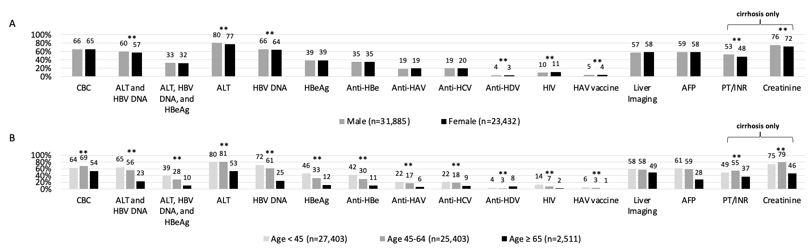

*Initial evaluation: Within 12 months of index CHB diagnosis date
AFP, alpha-fetoprotein; ALT, alanine aminotransferase; anti-HAV, hepatitis A virus antibody; anti-HBe, hepatitis B e antibody; anti-HCV, hepatitis C virus antibody; anti-HDV, hepatitis delta virus antibody; CBC, complete blood count; GI/ID, gastroenterologist or infectious disease; HAV, hepatitis A virus; HBeAg, hepatitis B e antigen; HIV, human immunodeficiency virus; INR, international normalized ratio; PT, prothrombin time.

Suppl Fig. 2. Adherence to hepatocellular carcinoma surveillance
(A) By gender and (B) By age
P<0.001 for all comparisons

