Table S2: Baseline endoscopist characteristics among intervention and control groups and standardized differences for all endoscopists and among lower performing endoscopists for the adenoma detection rate (ADR) indicator
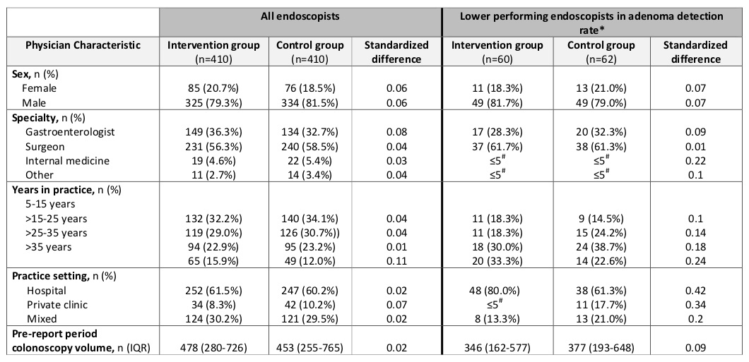

*Physicians with an overall PR of ≤25%
#Percentages not reported and/or range reported in order to maintain concealment of small cells

