Table S4: Baseline patient characteristics among intervention and control groups and standardized differences among lower performing endoscopists for the cecal intubation, bowel preparation and premature repeat after normal colonoscopy indicators
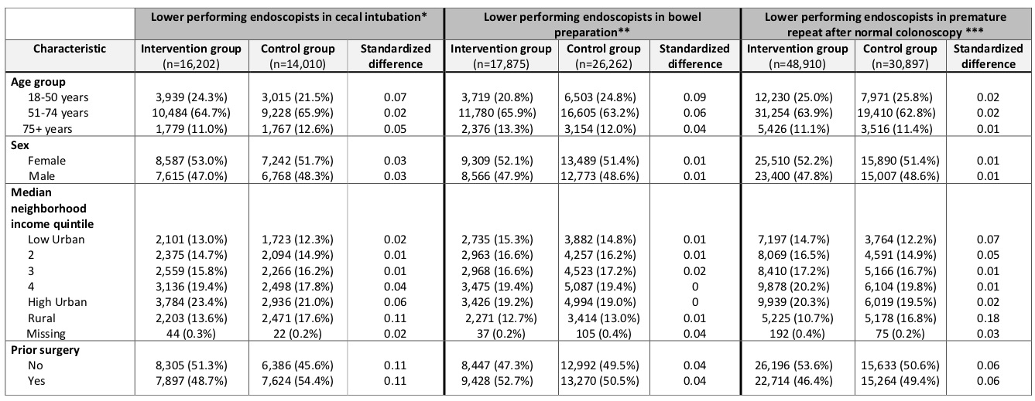
*Physicians in the lowest quartile of cecal intubation rate
**Physicians in the highest quartile of bowel preparation rate
***Physicians in the highest quartile of premature repeat after normal colonoscopy

