SUPPLEMENTAL FIGURES

Supplemental Figure 1 (Panel A and B). Rate of diarrhea in COVID-19 patients for each country participating in the study A) at baseline and B) at 1-month follow-up (rates of Sweden and India are not displayed due to the small sample size).
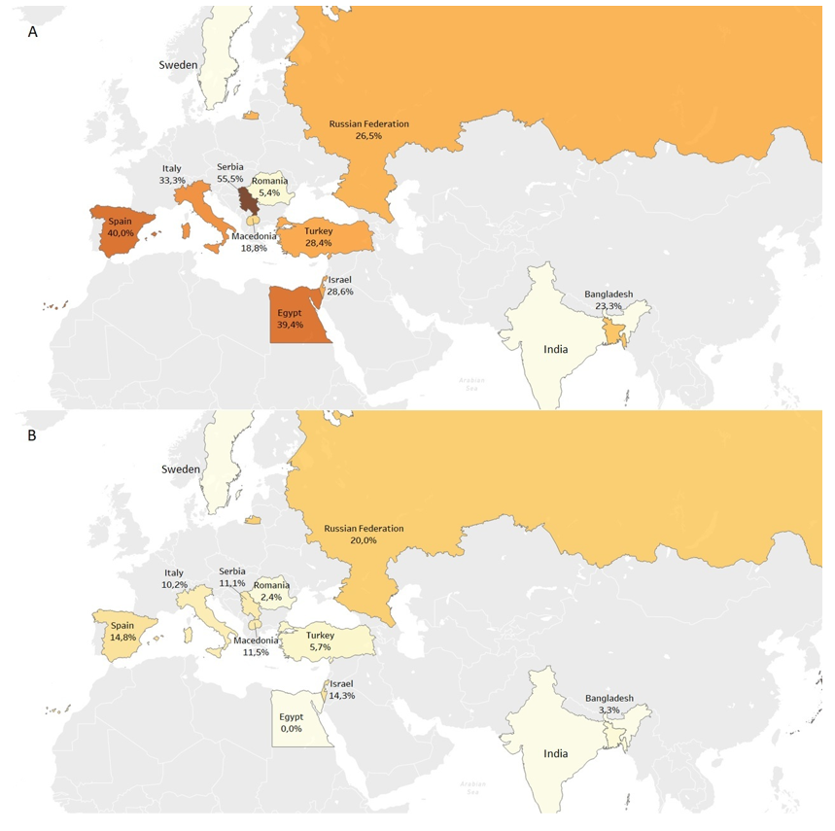

Supplemental Figure 2. Kaplan-Meier curves for overall survival of COVID-19 patients according to gastrointestinal symptoms presence.

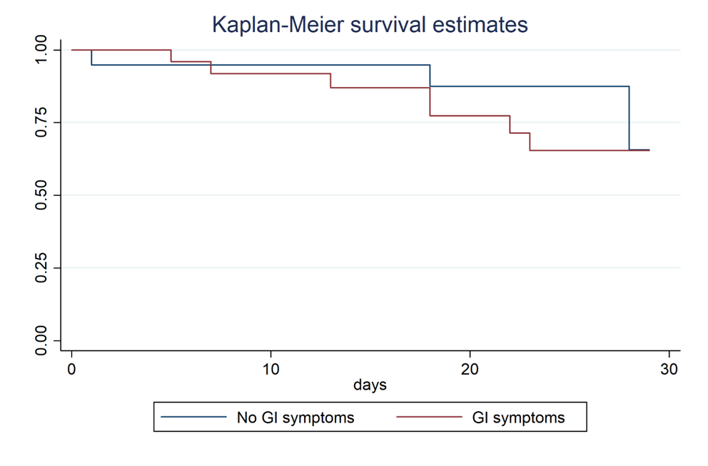

Supplemental Figure 3. Variations in gastrointestinal symptoms within the GSRS questionnaire complained by COVID-19 patients referring gastrointestinal symptoms at hospital admission and after 1-month follow-up.
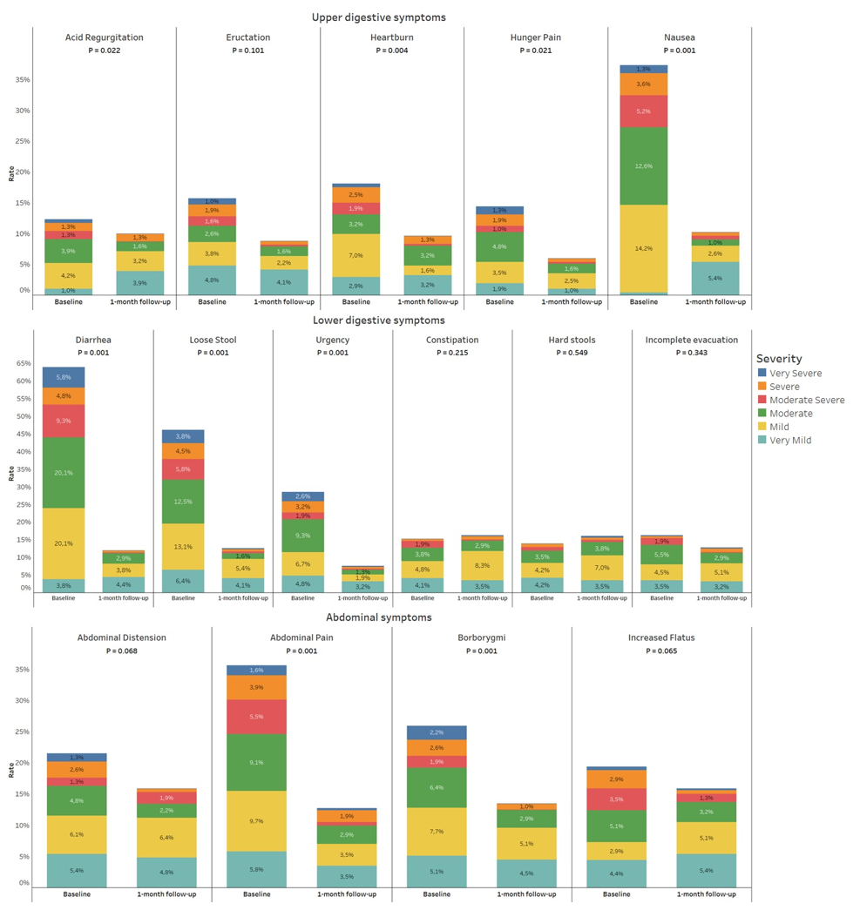

Supplemental Figure 4. Variations in gastrointestinal symptoms within the GSRS questionnaire complained by COVID-19 patients not referring gastrointestinal symptoms at hospital admission and after 1-month follow-up.
