Supplemental Materials

Supplemental Methods
The ‘UK Biobank’ (UKB) is a population-based cohort study, which recruited 502,505 UK volunteers between 2006 and 2010 (age range between 37 to 73 years). All participants provided written informed consent for the study. The UKB Study has approval from the Northwest Multi-Center Research Ethics Committee. Details of the methods, data availability, and access procedures for UKB are available on the study website (http://www.ukbiobank.ac.uk). All participants were encouraged to attend a clinical assessment centre for an initial examination, succeeded by a long-term follow-up. The UKB team measured height and weight during the baseline interview. Body Mass Index (BMI) was calculated by dividing weight (kg) by the square of standing height (m2). All participants gave informed consent for genotyping and data linkage to medical reports.

eTable 1. Definitions of Outcomes and Covariates
Entity | Source | Definition
Vitamin E | UKB data field 10025 | Mean mg intake among up to five questionnaires
Overall energy consumption | UKB data field 10002 | Mean kJ intake among up to five questionnaires (less than 100 kJ was excluded)
Carbohydrates | UKB data field 10005 | Mean g intake among up to five questionnaires
Fat | UKB data field 10004 | Mean g intake among up to five questionnaires
Protein | UKB data field 10003 | Mean g intake among up to five questionnaires
Alcohol consumption | UKB data field 10022 | Mean g intake among up to five questionnaires
Survival | date of death: UKB data field 40000  date of attending the assessment center: UKB data field 53 | Date of death or end of Follow up
Age | UKB data field 21022 plus time between Baseline examination UKB data field 53 and mean date of questionnaires 105010 | Age at attending the assessment center for the initial visit
Sex | UKB data field 31 | Sex of participant
BMI | UKB data field 21001 | BMI value is constructed from height and weight measured during the initial Assessment Centre visit
ICD10 codes | UKB data field 41270, | Summary of the diagnosis codes a participant has had recorded across all their hospital inpatient records
Smoking status | UKB data field 1239 | Self-reported smoking status

Dietary Intake information
We selected our study population based on the availability of nutritional assessment. A web-based 24-hour dietary questionnaire was emailed for a total of five times from 2009-2012 to participants who provided an email address to the UKB team. Of >250,000 participants who received the questionnaire, 210,025 responded at least once. Information on micro- and macronutrients were extracted by dietitians from the provided food questionnaires. Mean Vitamin E consumption, kcal, alcohol consumption, carbohydrate, sugar, protein, and fat intake were estimated using the mean of the nutrient’s intake detailed in the questionnaires of participants that responded at least once. We estimated the overall dietary quality by using the Mediterranean Diet Score(Suppl. Table 2) (1). Subjects who reported intake of a Vitamin E supplement in at least one questionnaire (Field ID 20084, Medication ID 480) were excluded from the analysis (n=356).

Definition of Endpoints
We used ongoing inpatient hospital records beginning in 1996 to identify diagnoses according to the WHO’s International Classification of Diseases 10 (ICD-10) coding systems. Next, we connected all reported ICD-10 codes with the date of a patient’s first diagnosis. Hospital inpatient data, national cancer registries, or death registration were used for follow-up. We evaluated the association between dietary intake of Vitamin E and diagnosis of NAFLD ICD10 code (K76.0- Fatty (change of) liver, not elsewhere classified. (n=956). Liver MRI was performed in subsets of participants (n=3 038), mean 2 years after the first questionnaire was performed. The end of follow-up in the UKB was defined either as death of a participant or the end of hospital inpatient visits (June of 2021). Death notifications (age at death and primary ICD diagnosis that led to death) were received through linkage to national death registries by the UK Biobank. The UKB Access Committee has approved the study (Project #71300).

eTable 2. Mediterranean diet score
Entity | Portion size | 0 Points | 1 point | 2 points | Source | Definition
Fruit | 150g | <1 portion/d | 1-1.5 portions/d | >2 portions/d | ID Fruit  104400 Fruit consumers  104410 Stewed fruit intake  104420 Prune intake  104430 Dried fruit intake  104440 Mixed fruit intake  104450 Apple intake  104460 Banana intake  104470 Berry intake  104480 Cherry intake  104490 Grapefruit intake  104500 Grape intake  104510 Mango intake  104520 Melon intake  104530 Orange intake  104540 Satsuma intake  104550 Peach/nectarine intake  104560 Pear intake  104570 Pineapple intake  104580 Plum intake  104590 Other fruit intake | Fruit consumption per questionnaire was added,  The mean fruit consumption between up to 5 questionnaires was calculated.
Vegetables | 100g | <1 portion/d | 1-2.5 portions/d | >2.5 portions/d | ID Vegetables  103990 Vegetable consumers  104060 Mixed vegetable intake  104070 Vegetable pieces intake  104080 Coleslaw intake  104090 Side salad intake  104100 Avocado intake  104130 Beetroot intake  104140 Broccoli intake  104150 Butternut squash intake  104160 Cabbage/kale intake  104170 Carrot intake  104180 Cauliflower intake  104190 Celery intake  104200 Courgette intake  104210 Cucumber intake  104220 Garlic intake  104230 Leek intake  104240 Lettuce intake  104250 Mushroom intake  104260 Onion intake  104270 Parsnip intake  104280 Pea intake  104290 Sweet pepper intake  104300 Spinach intake  104310 Sprouts intake  104320 Sweetcorn intake  104330 Sweet potato intake  104340 Fresh tomato intake  104350 Tinned tomato intake  104360 Turnip/swede intake  104370 Watercress intake  104380 Other vegetables intake | Consumption per questionnaire was added,  The mean consumption between up to 5 questionnaires was calculated.
Legumes | 70g | <1 portion/week | 1-2 portions/week | >2 portions/week | ID Legumes  104000 Baked bean intake  104010 Pulses intake  104110 Broad bean intake  104120 Green bean intake | Consumption per questionnaire was added,  The mean consumption between up to 5 questionnaires was calculated and multiplied by 7.
Cereals | 130g | <1 portion/d | 1-1.5 portions/d | >1.5 portions/d | Field ID Cereal  100840 Bran cereal intake  100770 Porridge intake  100760 Breakfast cereal consumed  100840 Bran cereal intake  100800 Muesli intake  100810 Oat crunch intake  100860 Other cereal intake  100830 Plain cereal intake  100770 Porridge intake  102370 Cereal bar intake  100850 Whole-wheat cereal intake  100850 Whole-wheat cereal intake  101260 Oatcakes intake | Consumption per questionnaire was added,  The mean consumption between up to 5 questionnaires was calculated.
fish | 100g | <1 portion/week | 1-2.5 portions/week | >2.5 portions/week | ID Fish  103140 Fish consumer  103150 Tinned tuna intake  103160 Oily fish intake  103170 Breaded fish intake  103180 Battered fish intake  103190 White fish intake  103200 Prawns intake  103210 Lobster/crab intake  103220 Shellfish intake  103230 Other fish intake | Consumption per questionnaire was added,  The mean consumption between up to 5 questionnaires was calculated.
Meat | 80g | >1.5 portions/d | 1-1.5 portions/d | <1 portion/d | Field ID meat  103000 Meat consumers  103010 Sausage intake  103020 Beef intake  103030 Pork intake  103040 Lamb intake  103050 Crumbed or deep-fried poultry intake  103060 Poultry intake  103070 Bacon intake  103080 Ham intake  103090 Liver intake  103100 Other meat intake | Consumption per questionnaire was added,  The mean consumption between up to 5 questionnaires was calculated.
Dairy | 180g | >1.5 portions/d | 1-1.5 portions/d | <1 portion/d | 102090 Yogurt intake  102080 Yogurt/ice-cream consumers  102120 Ice-cream intake  102480 Cheesy biscuits intake  102220 Cheesecake intake  100920 Type milk consumed  102830 Soft cheese intake  102910 Other cheese intake  102800 Cheese consumers  102880 Feta intake  102900 Goat's cheese intake  102820 Hard cheese intake  102850 Low fat cheese spread intake  102810 Low fat hard cheese intake  102890 Mozzarella intake  102840 Blue cheese intake  102800 Cheese consumers  102860 Cheese spread intake  102870 Cottage cheese intake | Consumption per questionnaire was added,  The mean consumption between up to 5 questionnaires was calculated.
Alcohol | 120g | >2 portions/d | 1-1.5 portions/d | <1 portion/d | Field ID Description  100580 Alcohol consumed  100590 Red wine intake  20096 Size of red wine glass drunk  100630 Rose wine intake  20097 Size of rose wine glass drunk  100670 White wine intake  20095 Size of white wine glass drunk  100710 Beer/cider intake  100720 Fortified wine intake  100730 Spirits intake  100740 Other alcohol intake | Consumption per questionnaire was added,  The mean consumption between up to 5 questionnaires was calculated.
Olive oil | / | Occasional use | Frequent use | Regular use | 20090 Type of oil used

Supplemental Table 3: Characteristics of participants by quartile of Vitamin E consumption
Percentile Group of Vitamin E/total energy intake | 1, (lowest)  n=52666 |  | 2,  n=52667 |  | 3,  n=52667 |  | 4, (highest)  n=52667 |  | p
 | Mean | SD | Mean | SD | Mean | SD | Mean | SD
Age (years) | 58 | 8 | 58 | 8 | 58 | 8 | 58 | 8 | <.0001
BMI (kg‎/m2) | 27.6 | 4.6 | 27.1 | 4.6 | 26.8 | 4.6 | 26.4 | 4.7 | <.0001
Male Sex (%) | 40 | / | 51 | / | 60 | / | 69 | / | <.0001
Date food questionnaire perfomed | 11-APR-2011 | 290 days | 27-MAY-2011 | 248 days | 04-JUN-2011 | 241 days | 16-MAY-2011 | 266 days | <.0001
Died (%) | 4.8 | / | 4.1 | / | 3.8 | / | 3.6 | / | <.0001
Survival (years) | 10.91 | 1.31 | 10.98 | 1.23 | 11.01 | 1.20 | 11.01 | 1.20 | <.0001
Vitamin E/total energy intake (%mg/kJ) | 0.06 | 0.01 | 0.09 | 0.01 | 0.11 | 0.01 | 0.16 | 0.03 | <.0001
KJ (kJ) | 8677 | 2672 | 8829 | 2533 | 8924 | 2549 | 8853 | 3135 | <.0001
Protein total energy intake (%) | 16 | 4 | 16 | 3 | 16 | 3 | 16 | 4 | <.0001
Carbohydrates/ total energy intake (%) | 47 | 9 | 48 | 8 | 49 | 8 | 49 | 9 | <.0001
Fat /total energy intake (%) | 31 | 7 | 33 | 6 | 34 | 6 | 35 | 7 | <.0001
Alcohol/ total energy intake (%) | 8 | 9 | 5 | 6 | 4 | 5 | 3 | 5 | <.0001
MDS | 7 | 2 | 7 | 2 | 8 | 2 | 8 | 2 | <.0001
Current smoking (%) | 14 | / | 10 | / | 9 | / | 8 | / | <.0001

Supplemental Table 4: PheWAS analysis
Odds ratios (ORs) and 95% confidence intervals (Cis) per SD increase of nutritional Vitamin E intake/daily energy intake are given. Only PheCodes that remained significant after adjustment for multiple testing are displayed.
P | OR | CI1 | CI2 | PheCode | Name
4.6E-26 | 0.80 | 0.77 | 0.83 | 496 | Chronic airway obstruction
5.0E-22 | 0.81 | 0.78 | 0.85 | 318 | Tobacco use disorder
1.1E-19 | 0.92 | 0.90 | 0.93 | 530 | Diseases of esophagus
6.6E-19 | 0.92 | 0.90 | 0.93 | 530.1 | Esophagitis, GERD and related diseases
2.7E-15 | 0.92 | 0.90 | 0.94 | 550.2 | Diaphragmatic hernia
1.8E-14 | 0.71 | 0.65 | 0.78 | 496.2 | Chronic bronchitis
2.4E-14 | 0.71 | 0.65 | 0.78 | 496.21 | Obstructive chronic bronchitis
3.1E-14 | 0.93 | 0.92 | 0.95 | 550 | Abdominal hernia
2.1E-13 | 0.69 | 0.63 | 0.76 | 496.1 | Emphysema
7.2E-13 | 0.91 | 0.89 | 0.94 | 530.11 | GERD
1.3E-12 | 0.93 | 0.91 | 0.95 | 535 | Gastritis and duodenitis
1.3E-08 | 0.79 | 0.73 | 0.86 | 555.1 | Regional enteritis
4.5E-08 | 0.94 | 0.93 | 0.96 | 411 | Ischemic Heart Disease
2.4E-07 | 0.94 | 0.92 | 0.96 | 564 | Functional digestive disorders
4.8E-07 | 0.91 | 0.87 | 0.94 | 535.6 | Duodenitis
5.6E-07 | 0.93 | 0.91 | 0.96 | 411.3 | Angina pectoris
5.8E-07 | 0.94 | 0.91 | 0.96 | 250.2 | Type 2 diabetes
7.8E-07 | 0.95 | 0.93 | 0.97 | 208 | Benign neoplasm of colon
8.3E-07 | 0.91 | 0.88 | 0.95 | 585 | Renal failure
9.4E-07 | 0.96 | 0.94 | 0.97 | 272 | Disorders of lipoid metabolism
1.1E-06 | 0.96 | 0.94 | 0.97 | 272.1 | Hyperlipidemia
1.3E-06 | 0.94 | 0.92 | 0.96 | 250 | Diabetes mellitus
1.6E-06 | 0.92 | 0.89 | 0.95 | 535.8 | Other specified gastritis
2.8E-06 | 0.94 | 0.91 | 0.96 | 574.1 | Cholelithiasis
3.0E-06 | 0.93 | 0.90 | 0.96 | 530.14 | Reflux esophagitis
5.1E-06 | 0.94 | 0.91 | 0.96 | 296.2 | Depression
5.4E-06 | 0.89 | 0.85 | 0.94 | 530.12 | Ulcer of esophagus
5.9E-06 | 0.94 | 0.91 | 0.96 | 296.22 | Major depressive disorder
7.5E-06 | 0.94 | 0.91 | 0.97 | 564.9 | Personal history of diseases of digestive system
7.6E-06 | 0.96 | 0.94 | 0.98 | 272.11 | Hypercholesterolemia
8.7E-06 | 0.92 | 0.89 | 0.95 | 41 | Bacterial infection NOS
1.0E-05 | 0.90 | 0.86 | 0.94 | 555 | Inflammatory bowel disease and other gastroenteritis and colitis
1.1E-05 | 0.94 | 0.91 | 0.97 | 296 | Mood disorders
1.1E-05 | 0.92 | 0.89 | 0.96 | 411.2 | Myocardial infarction
2.8E-05 | 0.90 | 0.85 | 0.94 | 585.1 | Acute renal failure
3.3E-05 | 0.84 | 0.78 | 0.91 | 165.1 | Cancer of bronchus; lung
3.5E-05 | 0.83 | 0.75 | 0.90 | 578.1 | Hematemesis
3.6E-05 | 0.95 | 0.92 | 0.97 | 574 | Cholelithiasis and cholecystitis
6.3E-05 | 0.95 | 0.92 | 0.97 | 558 | Noninfectious gastroenteritis
7.7E-05 | 0.43 | 0.29 | 0.66 | 302 | Sexual and gender identity disorders
8.7E-05 | 0.87 | 0.80 | 0.93 | 165 | Cancer within the respiratory system
1.3E-04 | 0.94 | 0.92 | 0.97 | 411.8 | Other chronic ischemic heart disease, unspecified
1.4E-04 | 0.81 | 0.73 | 0.90 | 276.41 | Acidosis
1.7E-04 | 0.86 | 0.79 | 0.93 | 443.9 | Peripheral vascular disease, unspecified
1.7E-04 | 0.82 | 0.75 | 0.91 | 276.4 | Acid-base balance disorder
1.8E-04 | 0.91 | 0.87 | 0.96 | 585.3 | Chronic renal failure [CKD]
2.0E-04 | 0.89 | 0.83 | 0.95 | 41.1 | Staphylococcus infections
2.1E-04 | 0.92 | 0.88 | 0.96 | 512 | Other symptoms of respiratory system
2.8E-04 | 0.94 | 0.91 | 0.97 | 706.2 | Sebaceous cyst
3.6E-04 | 0.93 | 0.89 | 0.97 | 564.1 | Irritable Bowel Syndrome
4.1E-04 | 0.92 | 0.88 | 0.97 | 512.7 | Shortness of breath
4.1E-04 | 0.94 | 0.91 | 0.97 | 706 | Diseases of sebaceous glands
5.2E-04 | 0.91 | 0.86 | 0.96 | 428 | Congestive heart failure; nonhypertensive
6.9E-04 | 0.91 | 0.87 | 0.96 | 571 | Chronic liver disease and cirrhosis
8.8E-04 | 0.96 | 0.94 | 0.98 | 626 | Disorders of menstruation and other abnormal bleeding from female genital tract
1.0E-03 | 0.96 | 0.94 | 0.98 | 785 | Abdominal pain
1.1E-03 | 0.88 | 0.82 | 0.95 | 41.11 | Methicillin sensitive Staphylococcus aureus
1.1E-03 | 0.93 | 0.89 | 0.97 | 760 | Back pain
1.2E-03 | 0.93 | 0.89 | 0.97 | 574.12 | Cholelithiasis with other cholecystitis
1.2E-03 | 0.94 | 0.90 | 0.98 | 665 | Obstetrical/birth trauma
1.3E-03 | 0.96 | 0.94 | 0.98 | 244 | Hypothyroidism
1.3E-03 | 0.91 | 0.85 | 0.96 | 571.5 | Other chronic nonalcoholic liver disease
1.3E-03 | 0.95 | 0.92 | 0.98 | 591 | Urinary tract infection
1.4E-03 | 0.93 | 0.88 | 0.97 | 470 | Septal Deviations/Turbinate Hypertrophy
1.4E-03 | 0.93 | 0.89 | 0.97 | 480.11 | Pneumococcal pneumonia
1.4E-03 | 0.96 | 0.94 | 0.98 | 244.4 | Hypothyroidism NOS
1.5E-03 | 0.92 | 0.87 | 0.97 | 521.1 | Dental caries
1.5E-03 | 0.92 | 0.87 | 0.97 | 521 | Diseases of hard tissues of teeth
1.5E-03 | 1.17 | 1.06 | 1.29 | 798 | Malaise and fatigue
1.5E-03 | 1.17 | 1.06 | 1.29 | 798.1 | Chronic fatigue syndrome
1.7E-03 | 0.94 | 0.90 | 0.98 | 211 | Benign neoplasm of other parts of digestive system
1.7E-03 | 0.91 | 0.86 | 0.97 | 573.7 | Abnormal results of function study of liver
1.7E-03 | 1.23 | 1.08 | 1.40 | 285.22 | Anemia in neoplastic disease
1.7E-03 | 0.81 | 0.71 | 0.93 | 260.6 | Anorexia
1.8E-03 | 1.65 | 1.21 | 2.27 | 722.3 | Schmorl's nodes
1.8E-03 | 0.90 | 0.84 | 0.96 | 696.4 | Psoriasis
1.8E-03 | 0.96 | 0.94 | 0.99 | 626.1 | Irregular menstrual cycle/bleeding
1.8E-03 | 0.90 | 0.84 | 0.96 | 696 | Psoriasis and related disorders
1.9E-03 | 0.59 | 0.42 | 0.82 | 440.9 | Atherosclerosis of aorta
1.9E-03 | 1.40 | 1.13 | 1.72 | 305.2 | Eating disorder
2.1E-03 | 0.93 | 0.89 | 0.97 | 327.3 | Sleep apnea
2.1E-03 | 0.91 | 0.86 | 0.97 | 345 | Epilepsy, recurrent seizures, convulsions
2.2E-03 | 0.94 | 0.91 | 0.98 | 300 | Anxiety disorders
2.4E-03 | 0.87 | 0.80 | 0.95 | 428.1 | Congestive heart failure (CHF) NOS
2.4E-03 | 0.87 | 0.80 | 0.95 | 442.1 | Aortic aneurysm
2.4E-03 | 0.95 | 0.93 | 0.98 | 278 | Overweight, obesity and other hyperalimentation
2.5E-03 | 0.89 | 0.83 | 0.96 | 189.21 | Malignant neoplasm of bladder
2.5E-03 | 0.70 | 0.56 | 0.88 | 38.1 | Gram negative septicemia
2.7E-03 | 0.90 | 0.84 | 0.96 | 594.3 | Calculus of ureter
2.9E-03 | 0.88 | 0.82 | 0.96 | 509.1 | Respiratory failure

Supplemental Table 5: Vitamin E intake is associated with reduced overall mortality
Effect per unit increase | p-value | OR | 95%CI
Vitamin E (per SD mg/KJ) | <.0001 | .947 | .924 | .971
Protein (%) | <.0001 | .965 | .954 | .976
Carbohydrates (%) | <.0001 | .981 | .972 | .991
Fat (%) | <.0001 | .979 | .969 | .989
Alcohol (%) | <.0001 | .973 | .963 | .983
Current smoking | <.0001 | 1.530 | 1.462 | 1.600
Male Sex | <.0001 | 1.528 | 1.461 | 1.599
BMI (kg‎/m2) | <.0001 | 1.039 | 1.035 | 1.044
Age (years) | <.0001 | 1.106 | 1.102 | 1.110
Mediterranean diet  score (points) | <.01 | 0.985 | .974 | .997

Supplemental Table 6: Vitamin E intake is associated with decreased ICD10 coded diagnosis of NAFLD diagnosed after the first questionnaire was performed
Effect per unit increase | p-value | OR | 95%CI
Vitamin E (per SD mg/KJ) | <.0001 | .875 | .812 | .942
Protein (%) | .955 | 1.002 | .937 | 1.071
Carbohydrates (%) | .863 | 1.005 | .946 | 1.069
Fat (%) | .797 | 1.008 | .947 | 1.174
Alcohol (%) | .568 | .981 | .920 | 1.047
Current smoking | .004 | 1.246 | 1.073 | 1.446
Male Sex | <.0001 | 1.291 | 1.129 | 1.475
BMI (kg‎/m2) | <.0001 | 1.139 | 1.129 | 1.149
Age (years) | <.0001 | 1.015 | 1.007 | 1.024
Mediterranean diet  score (points) | .002 | 1.000 | .967 | 1.034

Supplemental Table 7: Vitamin E intake is associated with protection from imaging diagnosed steatosis that was diagnosed after the first questionnaire was performed
Effect per unit increase | p-value | OR | 95%CI
Vitamin E (per SD mg/KJ) | <.0001 | .757 | .672 | .854
Protein (%) | .578 | 1.121 | .749 | 1.678
Carbohydrates (%) | .559 | 1.120 | .766 | 1.638
Fat (%) | .487 | 1.147 | .778 | 1.692
Alcohol (%) | .528 | 1.136 | .765 | 1.687
Current smoking | .076 | 1.246 | .977 | 1.588
Male Sex | <.0001 | 1.672 | 1.370 | 2.040
BMI (kg‎/m2) | <.0001 | 1.205 | 1.177 | 1.233
Age (years) | .167 | 1.009 | .996 | 1.022
Mediterranean diet  score (points) | .537 | 1.246 | .966 | 1.068

Supplemental Figure 1: The most strongly associated digestive PheCodes per SD Vitamin E consumption/total daily energy corrected for age, sex, BMI, smoking, alcohol consumption/total daily energy, fat/total daily energy, carbohydrates/total daily energy, protein/total daily energy, and MDS. Odds ratios (ORs) and 95% confidence intervals (Cis) per SD increase of nutritional Vitamin E/total daily energy intake are given. Only PheCodes that remained significant after adjustment for multiple testing are displayed.
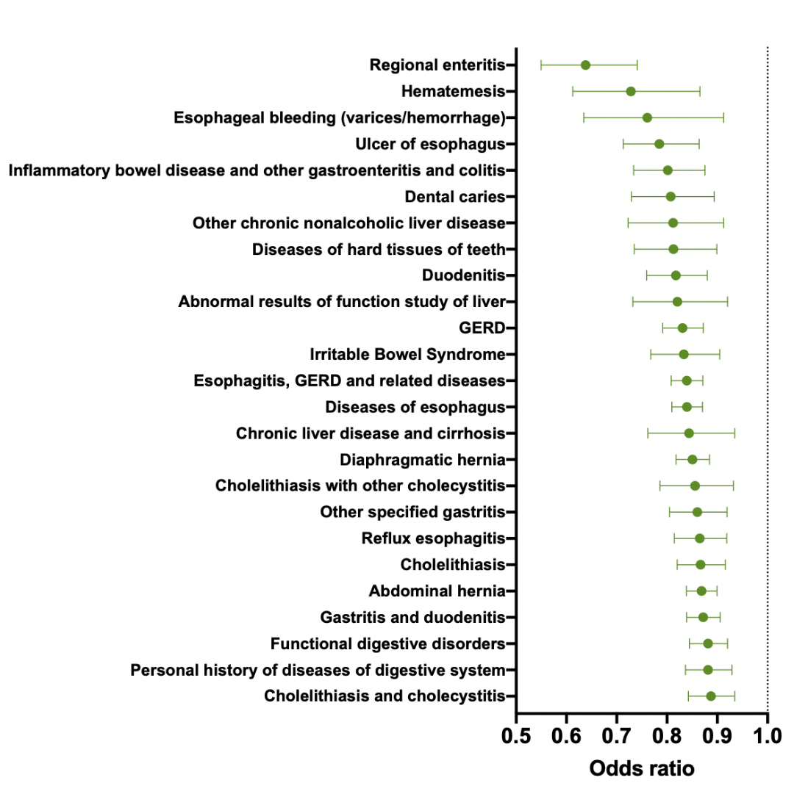

References

1. Sofi F, Macchi C, Abbate R, Gensini GF, Casini A. Mediterranean diet and health status: an updated meta-analysis and a proposal for a literature-based adherence score. Public Health Nutr. 2014;17(12):2769-82.

