Supplementary files
Effect of chronic comorbidities on follow-up colonoscopy after positive colorectal cancer screening results: a population-based cohort study

Supplementary Table 1. Description of administrative data sources
Supplementary Table 2. Chronic disease definitions in administrative data
Supplementary Table 3. Full cause-specific hazard regression models for the association between comorbidity and first follow-up colonoscopy within 12 months of the positive FOBT result
Supplementary Table 4. Full cause-specific hazard regression models for the association between comorbidity and first follow-up colonoscopy within 2 months of the positive FOBT result
Supplementary Table 5. Full cause-specific hazard regression models for the association between comorbidity and first follow-up colonoscopy within 6 months of the positive FOBT result
Supplementary Table 6. Full cause-specific hazard regression models for the association between comorbidity and first complete follow-up colonoscopy within 12 months of the positive FOBT result

Supplementary Figures 1.a-g. Cumulative incidence of follow-up colonoscopy by exposure groups

Supplementary Table 1. Description of administrative data sources

Database | Description
Laboratory Reporting Tool (LRT) | Captures information on FOBT kits administered as part of the Colon Cancer Check program since the program’s launch in April 2008. In contrast to the OHIP database, which captures the provision of laboratory tests, the LRT contains data on FOBT results.
Registered Persons Database (RPDB) | Contains basic demographic and vital information about anyone who has ever received an Ontario health card number.
Statistics Canada Census (CENSUS) | Contains information on rurality and neighbourhood income estimates.
Ontario Health Insurance Plan (OHIP) | Contains all physician services claimed under OHIP, including fee-for-service and shadow billings for physicians remunerated via capitation, since 1991.
Canadian Institute for Health Information – Discharge Abstract Database (CIHI-DAD) | Collects diagnostic and health service information on patient discharges from hospitals since 1988. Submission of these records to CIHI is mandated by provincial and territorial ministries of health across Canada (except Quebec).
Canadian Institute for Health Information – Same-Day Surgery (CIHI-SDS) | Collects data for day surgery institutions in Ontario since 1988; every record corresponds to one same-day surgery or procedure stay. Submission of these records to CIHI is mandated by provincial and territorial ministries of health across Canada (except Quebec).
Canadian Institute for Health Information – National Ambulatory Care Reporting System (CIHI-NACRS) | Collects information on patient visits to hospital and community based ambulatory care since 1988: day surgery, outpatient clinics and emergency departments. Submission of these records to CIHI is mandated by provincial and territorial ministries of health across Canada (except Quebec).
Ontario Mental Health Reporting System (OMHRS) | Mandated by provincial and territorial ministries of health across Canada to collect data on adult designated inpatient mental health beds since 2005. This includes beds in general, psychiatric, and specialty psychiatric facilities (except Quebec).
Client Agency Program Enrolment (CAPE) | Record of all patients that have been rostered to a primary care provider in a patient enrollment model practice.
Ontario Drug Benefit Claims (ODB) | Prescription drugs reimbursed under the Ontario Drug Benefit program (covers provincial residents ≥65 years or on welfare).
Canadian Organ Replacement Registry (CORR) | Mandated to collect information on donors and recipients of vital organ transplantation and renal replacement therapy (hemodialysis or peritoneal dialysis) since 1988.
Ontario Myocardial Infarction Database (OMID) | Captures acute myocardial infarction (AMI) hospitalizations using validated codes in the most responsible diagnosis field. This database was created to facilitate comparisons of AMI care and outcomes across institutions and hospitals of a relatively homogenous group of AMI patients.
Ontario Cancer Registry (OCR) | Mandated by the Cancer Act to collect information on all incident cancers (except for non-melanoma skin cancer) in Ontario since 1964 from hospital discharge abstracts, pathology reports, health records of regional cancer centers, and death certificates.
Ontario Crohn’s and Colitis Cohort (OCCC) | Service claims and diagnostic codes-based validated algorithm capturing Ontario patients with Crohn’s disease or ulcerative colitis.
Ontario Diabetes Database (ODD) | Service claims and diagnostic codes-based algorithm capturing Ontario persons with non-gestational diabetes.
Ontario Congestive Heart Failure Dataset (CHF) | Service claims and diagnostic codes-based algorithm capturing Ontario individuals with congestive heart failure.
Ontario Chronic Obstructive Pulmonary Disease Dataset (COPD) | Service claims and diagnostic codes-based algorithm capturing Ontario individuals with chronic obstructive pulmonary disease.
Ontario Dementia Dataset (DEMENTIA) | Service claims and diagnostic codes-based validated algorithm capturing Ontario individuals with Alzheimer’s and related dementias between the ages of 40 to 110 years.

Supplementary Table 2. Chronic disease definitions in administrative data

Exposure | Definition | Validity
Cardiovascular disease (CVD) ^{1,2} | Ischemic heart disease (IHD):  OHIP  OHIP diagnostic codes: 410, 412, 413  OHIP service codes: Z434, G298, R742, R743  CIHI  ICD-9 diagnostic codes: 410-414  ICD-10 diagnostic codes: I20-I25  CCP procedural codes: 48.02, 48.03, 48.09, 48.1, 48.2  CCI procedural codes: 1IJ50, 1IJ55, 1IJ57GQ, 1IJ26, 1IJ76, 1IJ80  OMID  Hospitalized for an acute myocardial infarction, with ICD-9 code 410 or ICD-10 code I21 as most responsible hospitalization.  Stroke or transient ischemic attack (TIA):  OHIP  OHIP diagnostic codes: 436, 432, 435  CIHI  ICD-9 diagnostic codes: 362.3, 430, 431, 434.0, 434.1, 434.9, 436, 435.0-435.3, 435.8, 435.9  ICD-10 diagnostic codes: I60.0-I60.9, I61.0-I61.6, I61.8, I61.9, I63.0-I63.5, I63.8, I63.9, I64, H34.1, G45.0-G45.3, G45.8, G45.9 | IHD: 77% sensitivity, 99% specificity  Stroke or TIA: 60% sensitivity, 99% specificity
Chronic obstructive pulmonary disease (COPD) ³ | COPD was defined using the Ontario COPD Cohort, which is based on 1 OHIP claim or 1 CIHI hospitalization in a 2-year period.  OHIP/ICD-9 diagnostic codes: 491, 492, 496  ICD-10 diagnostic codes: J41, J43, J44 | 85% sensitivity, 78% specificity
Congestive heart failure (CHF)⁴ | CHF was defined using the Ontario CHF Cohort, which is based on 1 CIHI hospitalization or 1 OHIP claim/NACRS emergency visit followed by 1 CIHI hospitalization, NACRS emergency visit, or OHIP claim within a 1-year period.  OHIP/ICD-9 diagnostic codes: 428  ICD-10 diagnostic codes: I500, I501, I509 | 85% sensitivity, 97% specificity
Diabetes⁵ | Diabetes was defined using the ODD cohort, which is based on 2 OHIP diagnostic codes or 1 OHIP service code or 1 CIHI hospitalization in a 2-year period.  OHIP/ICD-9 diagnostic code: 250  OHIP service codes: Q040, K029, K030  ICD-10 diagnostic codes: E10, E11, E13, E14 | 86% sensitivity, 97% specificity
End-stage renal disease (ESRD) ^{6,7} | Chronic renal dialysis:  OHIP  OHIP service codes: G332, G864, G326, G860, G862, G863, G865, G866  CIHI  CCI procedure codes: 5195, 6698  CCP procedure codes: 1PZ21  CORR  Treatment codes: 060, 111-113, 121-123, 131-133, 141, 151, 152, 221, 231, 241, 242, 251, 252, 311-313, 321-323, 332, 333, 413, 423, 433, 443, 453  Kidney transplant recipients:  OHIP  OHIP service codes: S435, S434  CIHI  CCI procedure code: 1PC85  CCP procedure code: 6759  CORR  Treatment code 171 + organ type 10, 11, 12, 18, 19 | Dialysis: 95% sensitivity, 97% specificity  Kidney transplant: 98% sensitivity, 99% specificity
Mental illness^{8–10} | Serious mental illness:  1 claim or hospitalization in OHIP, OMHRS, or CIHI in the past 2 years with diagnoses of bipolar disorder, schizophrenia, or other psychoses.  OHIP/ICD-9 diagnostic codes: 295, 296, 297, 298  ICD-10 diagnostic codes: F20, F22, F23, F25, F28, F29, F30, F31  Common mental illness:  1 claim or hospitalization in OHIP, OMHRS, or CIHI in the past 2 years with diagnoses of anxiety, depression, or substance use.  OHIP/ICD-9 diagnostic codes: 300-304, 306, 309, 311  ICD-10 diagnostic codes: F10-F16, F18, F19, F32-F34, F40-F45, F55 | Serious mental illness: 55.3% sensitivity, 99.4% specificity  Common mental illness: 67% sensitivity, 97% specificity

Abbreviations: Canadian Classification of Interventions, CCI; Canadian Classification of Procedures, CCP; International Classification of Diseases, ICD

References
1. Tu K, Mitiku T, Lee DS, Guo H, Tu JV. Validation of physician billing and hospitalization data to identify patients with ischemic heart disease using data from the Electronic Medical Record Administrative data Linked Database (EMRALD. Can J Cardiol. 2010;26(7):e225-e228. doi:10.1016/S0828-282X(10)70412-8
2. Tu K, Wang M, Young J, et al. Validity of Administrative Data for Identifying Patients Who Have Had a Stroke or Transient Ischemic Attack Using EMRALD as a Reference Standard. Can J Cardiol. 2013;29(11):1388-1394. doi:10.1016/j.cjca.2013.07.676
3. Gershon AS, Wang C, Guan J, Vasilevska-Ristovska J, Cicutto L, To T. Identifying Individuals with Physcian Diagnosed COPD in Health Administrative Databases. COPD J Chronic Obstr Pulm Dis. 2009;6(5):388-394. doi:10.1080/15412550903140865
4. Schultz SE, Rothwell DM, Chen Z, Tu K. Identifying cases of congestive heart failure from administrative data: a validation study using primary care patient records. Chronic Dis Inj Can. 2013;33(3):7.
5. Hux JE, Ivis F, Flintoft V, Bica A. Diabetes in Ontario: Determination of prevalence and incidence using a validated administrative data algorithm. Diabetes Care. 2002;25(3):512-516. doi:10.2337/diacare.25.3.512
6. Quinn RR, Laupacis A, Austin PC, et al. Using Administrative Datasets to Study Outcomes in Dialysis Patients: A Validation Study. Med Care. 2010;48(8):745-750.
7. Lam NN, McArthur E, Kim SJ, Knoll GA. Validation of Kidney Transplantation Using Administrative Data. Can J Kidney Health Dis. 2015;2:54. doi:10.1186/s40697-015-0054-9
8. Steele LS, Glazier RH, Lin E, work(s): MER. Using Administrative Data to Measure Ambulatory Mental Health Service Provision in Primary Care. Med Care. 2004;42(10):960-965.
9. Steele LS. Chapter 2: Measuring ambulatory mental health services using administrative data. In: Ambulatory mental health service use in an inner city setting: measurement, patterns and trends [dissertation]. Published online 2003.
10. Steele LS, Durbin A, Sibley LM, Glazier RH. Inclusion of persons with mental illness in patient- centred medical homes: cross-sectional findings from Ontario, Canada. Open Med. 2013;7(1):e9-e20.

Supplementary Table 3. Full cause-specific hazard regression models for the association between comorbidity and first follow-up colonoscopy within 12 months of the positive FOBT result

Variable | Unadjusted  HR (95% CI) | Adjusted 1  HR (95% CI) | Adjusted 2  HR (95% CI) | Adjusted 3  HR (95% CI)
Individual chronic conditions
Diabetes (incident) vs. no diabetes | 0.91 (0.89, 0.94) | 0.94 (0.91, 0.96) | - | -
Diabetes (prevalent) vs. no diabetes | 0.93 (0.92, 0.94) | 0.96 (0.95, 0.97) | - | -
ESRD vs. no ESRD | 0.63 (0.55, 0.72) | 0.71 (0.62, 0.82) | - | -
COPD vs. no COPD | 0.91 (0.90, 0.93) | 0.97 (0.95, 0.98) | - | -
CHF vs. no CHF | 0.72 (0.70, 0.75) | 0.77 (0.75, 0.80) | - | -
CVD vs. no CVD | 0.85 (0.84, 0.87) | 0.93 (0.91, 0.95) | - | -
Serious mental illness vs. no mental illness | 0.85 (0.82, 0.88) | 0.88 (0.85, 0.92) | 0.89 (0.85, 0.92) | -
Common mental illness vs. no mental illness | 0.93 (0.92, 0.94) | 0.97 (0.96, 0.99) | 0.97 (0.96, 0.99) | -
Number of major medical comorbiditiesª
Comorbidity 1 vs. 0 | 0.94 (0.93, 0.95) | - | 0.95 (0.94, 0.97) | -
Comorbidity 2 vs. 0 | 0.85 (0.83, 0.87) | - | 0.87 (0.85, 0.89) | -
Comorbidity 3 vs. 0 | 0.72 (0.69, 0.75) | - | 0.75 (0.72, 0.78) | -
Comorbidity ≥4 vs. 0 | 0.61 (0.56, 0.66) | - | 0.64 (0.58, 0.69) | -
Mental and medical comorbidity
Medical and mental health comorbidities vs. none | 0.84 (0.82, 0.85) | - | - | 0.88 (0.87, 0.90)
Medical comorbidities only vs. none | 0.91 (0.90, 0.93) | - | - | 0.93 (0.92, 0.94)
Mental health comorbidities only vs. none | 0.93 (0.92, 0.95) | - | - | 0.97 (0.95, 0.98)
Covariates
Age (per 1-unit increase) | 1.00 (0.99, 1.00) | 1.00 (0.99, 1.00) | 1.00 (0.99, 1.00) | 1.00 (0.99, 1.00)
Male vs. female | 1.02 (1.01, 1.03) | 1.02 (1.01, 1.03) | 1.02 (1.01, 1.03) | 1.02 (1.00, 1.03)
Rural residence vs. urban | 1.00 (0.98, 1.02) | 1.00 (0.99, 1.02) | 1.00 (0.99, 1.02) | 1.00 (0.99, 1.02)
Income quintile 1 vs. 5 | 0.87 (0.85, 0.88) | 0.85 (0.84, 0.87) | 0.85 (0.84, 0.87) | 0.85 (0.83, 0.86)
Income quintile 2 vs. 5 | 0.93 (0.91, 0.94) | 0.92 (0.90, 0.93) | 0.92 (0.90, 0.93) | 0.92 (0.90, 0.93)
Income quintile 3 vs. 5 | 0.97 (0.96, 0.99) | 0.96 (0.94, 0.98) | 0.96 (0.95, 0.98) | 0.96 (0.94, 0.98)
Income quintile 4 vs. 5 | 0.99 (0.97, 1.01) | 0.99 (0.97, 1.01) | 0.99 (0.97, 1.01) | 0.99 (0.97, 1.01)
Rostered to a PCP | 1.12 (1.08, 1.16) | 1.16 (1.12, 1.20) | 1.16 (1.12, 1.20) | 1.16 (1.12, 1.20)
History of non-CRC cancer: ≤5 vs. >10 years or none | 0.93 (0.90, 0.96) | 0.98 (0.95, 1.01) | 0.98 (0.95, 1.01) | 0.97 (0.95, 1.00)
History of non-CRC cancer: 6-10 vs. >10 years or none | 1.02 (0.98, 1.06) | 1.06 (1.02, 1.10) | 1.05 (1.01, 1.10) | 1.05 (1.01, 1.09)
Prior colonoscopy: ≤2 vs. >10 years or none | 0.38 (0.36, 0.39) | 0.39 (0.38, 0.40) | 0.39 (0.38, 0.40) | 0.39 (0.38, 0.40)
Prior colonoscopy: 3-5 vs. >10 years or none | 0.83 (0.81, 0.84) | 0.84 (0.82, 0.86) | 0.84 (0.83, 0.86) | 0.84 (0.82, 0.86)
Prior colonoscopy: 6-10 vs. >10 years or none | 1.09 (1.07, 1.11) | 1.08 (1.06, 1.10) | 1.08 (1.06, 1.10) | 1.07 (1.05, 1.10)
Index year (year of positive FOBT, per 1-unit increase) | 1.06 (1.05, 1.06) | 1.05 (1.05, 1.06) | 1.05 (1.05, 1.06) | 1.05 (1.05, 1.06)

ª Includes diabetes, ESRD, COPD, CHF, and CVD
Abbreviations: hazard ratio, HR; confidence interval, CI; end-stage renal disease, ESRD; cardiovascular disease, CVD; chronic obstructive pulmonary disease, COPD; colorectal cancer, CRC; congestive heart failure, CHF; primary care provider, PCP

Supplementary Table 4. Full cause-specific hazard regression models for the association between comorbidity and first follow-up colonoscopy within 2 months of the positive FOBT result

Variable | Unadjusted  HR (95% CI) | Adjusted 1  HR (95% CI) | Adjusted 2  HR (95% CI) | Adjusted 3  HR (95% CI)
Individual chronic conditions
Diabetes (incident) vs. no diabetes | 0.89 (0.86, 0.92) | 0.91 (0.88, 0.95) | - | -
Diabetes (prevalent) vs. no diabetes | 0.90 (0.88, 0.91) | 0.93 (0.91, 0.94) | - | -
ESRD vs. no ESRD | 0.48 (0.39, 0.60) | 0.55 (0.44, 0.69) | - | -
COPD vs. no COPD | 0.87 (0.86, 0.89) | 0.93 (0.91, 0.95) | - | -
CHF vs. no CHF | 0.68 (0.66, 0.71) | 0.76 (0.73, 0.80) | - | -
CVD vs. no CVD | 0.80 (0.77, 0.82) | 0.88 (0.85, 0.90) | - | -
Serious mental illness vs. no mental illness | 0.83 (0.79, 0.88) | 0.87 (0.82, 0.91) | 0.87 (0.83, 0.91) | -
Common mental illness vs. no mental illness | 0.92 (0.91, 0.94) | 0.97 (0.95, 0.99) | 0.97 (0.95, 0.99) | -
Number of major medical comorbiditiesª
Comorbidity 1 vs. 0 | 0.91 (0.89, 0.92) | - | 0.91 (0.90, 0.93) | -
Comorbidity 2 vs. 0 | 0.78 (0.75, 0.80) | - | 0.80 (0.77, 0.82) | -
Comorbidity 3 vs. 0 | 0.68 (0.64, 0.72) | - | 0.71 (0.67, 0.75) | -
Comorbidity ≥4 vs. 0 | 0.52 (0.46, 0.59) | - | 0.55 (0.48, 0.63) | -
Mental and medical comorbidity
Medical and mental health comorbidities vs. none | 0.80 (0.78, 0.82) | - | - | 0.84 (0.82, 0.86)
Medical comorbidities only vs. none | 0.86 (0.85, 0.88) | - | - | 0.88 (0.86, 0.89)
Mental health comorbidities only vs. none | 0.92 (0.90, 0.94) | - | - | 0.95 (0.93, 0.97)
Covariates
Age (per 1-unit increase) | 1.00 (0.99, 1.00) | 1.00 (0.99, 1.00) | 1.00 (0.99, 1.00) | 1.00 (0.99, 1.00)
Male vs. female | 1.02 (1.00, 1.03) | 1.03 (1.01, 1.04) | 1.02 (1.01, 1.04) | 1.02 (1.01, 1.03)
Rural residence vs. urban | 0.87 (0.85, 0.89) | 0.87 (0.85, 0.89) | 0.87 (0.85, 0.89) | 0.87 (0.85, 0.89)
Income quintile 1 vs. 5 | 0.88 (0.86, 0.90) | 0.87 (0.85, 0.89) | 0.87 (0.85, 0.89) | 0.86 (0.84, 0.88)
Income quintile 2 vs. 5 | 0.94 (0.92, 0.97) | 0.94 (0.91, 0.96) | 0.94 (0.92, 0.96) | 0.93 (0.91, 0.95)
Income quintile 3 vs. 5 | 0.98 (0.96, 1.00) | 0.97 (0.95, 0.99) | 0.97 (0.95, 0.99) | 0.97 (0.95, 0.99)
Income quintile 4 vs. 5 | 1.00 (0.97, 1.02) | 0.99 (0.97, 1.02) | 0.99 (0.97, 1.02) | 0.99 (0.97, 1.02)
Rostered to a PCP | 1.09 (1.04, 1.14) | 1.14 (1.09, 1.20) | 1.14 (1.09, 1.20) | 1.14 (1.09, 1.20)
History of non-CRC cancer: ≤5 vs. >10 years or none | 0.93 (0.89, 0.97) | 0.98 (0.94, 1.02) | 0.98 (0.94, 1.02) | 0.98 (0.94, 1.02)
History of non-CRC cancer: 6-10 vs. >10 years or none | 0.95 (0.90, 1.00) | 0.99 (0.94, 1.05) | 0.99 (0.94, 1.04) | 0.99 (0.94, 1.04)
Prior colonoscopy: ≤2 vs. >10 years or none | 0.40 (0.39, 0.42) | 0.43 (0.41, 0.45) | 0.43 (0.41, 0.45) | 0.43 (0.41, 0.45)
Prior colonoscopy: 3-5 vs. >10 years or none | 0.80 (0.78, 0.82) | 0.82 (0.80, 0.84) | 0.82 (0.80, 0.84) | 0.82 (0.80, 0.84)
Prior colonoscopy: 6-10 vs. >10 years or none | 1.04 (1.01, 1.06) | 1.02 (0.99, 1.04) | 1.02 (0.99, 1.04) | 1.02 (0.99, 1.04)
Index year (year of positive FOBT, per 1-unit increase) | 1.07 (1.07, 1.08) | 1.07 (1.06, 1.07) | 1.07 (1.06, 1.07) | 1.07 (1.06, 1.07)

ª Includes diabetes, ESRD, COPD, CHF, and CVD
Abbreviations: hazard ratio, HR; confidence interval, CI; end-stage renal disease, ESRD; cardiovascular disease, CVD; chronic obstructive pulmonary disease, COPD; colorectal cancer, CRC; congestive heart failure, CHF; primary care provider, PCP

Supplementary Table 5. Full cause-specific hazard regression models for the association between comorbidity and first follow-up colonoscopy within 6 months of the positive FOBT result

Variable | Unadjusted  HR (95% CI) | Adjusted 1  HR (95% CI) | Adjusted 2  HR (95% CI) | Adjusted 3  HR (95% CI)
Individual chronic conditions
Diabetes (incident) vs. no diabetes | 0.90 (0.88, 0.93) | 0.93 (0.90, 0.96) | - | -
Diabetes (prevalent) vs. no diabetes | 0.92 (0.91, 0.94) | 0.95 (0.94, 0.97) | - | -
ESRD vs. no ESRD | 0.48 (0.39, 0.60) | 0.68 (0.59, 0.79) | - | -
COPD vs. no COPD | 0.91 (0.89, 0.92) | 0.96 (0.95, 0.98) | - | -
CHF vs. no CHF | 0.71 (0.69, 0.73) | 0.76 (0.74, 0.79) | - | -
CVD vs. no CVD | 0.84 (0.82, 0.86) | 0.92 (0.90, 0.94) | - | -
Serious mental illness vs. no mental illness | 0.84 (0.80, 0.87) | 0.87 (0.84, 0.90) | 0.87 (0.84, 0.91) | -
Common mental illness vs. no mental illness | 0.92 (0.91, 0.94) | 0.97 (0.96, 0.98) | 0.97 (0.96, 0.99) | -
Number of major medical comorbiditiesª
Comorbidity 1 vs. 0 | 0.94 (0.92, 0.95) | - | 0.95 (0.94, 0.96) | -
Comorbidity 2 vs. 0 | 0.83 (0.82, 0.85) | - | 0.86 (0.84, 0.87) | -
Comorbidity 3 vs. 0 | 0.70 (0.67, 0.74) | - | 0.74 (0.70, 0.77) | -
Comorbidity ≥4 vs. 0 | 0.58 (0.53, 0.63) | - | 0.61 (0.55, 0.67) | -
Mental and medical comorbidity
Medical and mental health comorbidities vs. none | 0.82 (0.81, 0.84) | - | - | 0.87 (0.85, 0.89)
Medical comorbidities only vs. none | 0.91 (0.89, 0.92) | - | - | 0.92 (0.91, 0.93)
Mental health comorbidities only vs. none | 0.93 (0.92, 0.95) | - | - | 0.97 (0.95, 0.98)
Covariates
Age (per 1-unit increase) | 1.00 (0.99, 1.00) | 1.00 (0.99, 1.00) | 1.00 (0.99, 1.00) | 1.00 (0.99, 1.00)
Male vs. female | 1.02 (1.00, 1.03) | 1.02 (1.01, 1.03) | 1.02 (1.01, 1.03) | 1.01 (1.00, 1.03)
Rural residence vs. urban | 0.99 (0.97, 1.00) | 0.99 (0.97, 1.01) | 0.99 (0.97, 1.01) | 0.99 (0.97, 1.01)
Income quintile 1 vs. 5 | 0.88 (0.86, 0.90) | 0.85 (0.84, 0.87) | 0.86 (0.84, 0.87) | 0.85 (0.84, 0.87)
Income quintile 2 vs. 5 | 0.94 (0.92, 0.97) | 0.92 (0.90, 0.93) | 0.92 (0.90, 0.94) | 0.92 (0.90, 0.93)
Income quintile 3 vs. 5 | 0.98 (0.96, 1.00) | 0.96 (0.95, 0.98) | 0.96 (0.95, 0.98) | 0.96 (0.95, 0.98)
Income quintile 4 vs. 5 | 1.00 (0.97, 1.02) | 0.99 (0.97, 1.01) | 0.99 (0.97, 1.01) | 0.99 (0.97, 1.01)
Rostered to a PCP | 1.11 (1.07, 1.16) | 1.16 (1.12, 1.21) | 1.16 (1.12, 1.21) | 1.16 (1.12, 1.20)
History of non-CRC cancer: ≤5 vs. >10 years or none | 0.92 (0.89, 0.95) | 0.97 (0.94, 1.00) | 0.97 (0.94, 1.00) | 0.97 (0.94, 1.00)
History of non-CRC cancer: 6-10 vs. >10 years or none | 1.01 (0.97, 1.05) | 1.05 (1.01, 1.09) | 1.05 (1.01, 1.09) | 1.05 (1.01, 1.09)
Prior colonoscopy: ≤2 vs. >10 years or none | 0.37 (0.36, 0.39) | 0.39 (0.38, 0.40) | 0.39 (0.38, 0.41) | 0.39 (0.38, 0.40)
Prior colonoscopy: 3-5 vs. >10 years or none | 0.81 (0.80, 0.83) | 0.83 (0.81, 0.85) | 0.83 (0.81, 0.85) | 0.83 (0.81, 0.84)
Prior colonoscopy: 6-10 vs. >10 years or none | 1.08 (1.06, 1.10) | 1.06 (1.04, 1.08) | 1.06 (1.04, 1.09) | 1.06 (1.04, 1.08)
Index year (year of positive FOBT, per 1-unit increase) | 1.06 (1.05, 1.06) | 1.00 (1.01, 1.03) | 1.06 (1.05, 1.06) | 1.06 (1.05, 1.06)

ª Includes diabetes, ESRD, COPD, CHF, and CVD
Abbreviations: hazard ratio, HR; confidence interval, CI; end-stage renal disease, ESRD; cardiovascular disease, CVD; chronic obstructive pulmonary disease, COPD; colorectal cancer, CRC; congestive heart failure, CHF; primary care provider, PCP

Supplementary Table 6. Full cause-specific hazard regression models for the association between comorbidity and first complete follow-up colonoscopy within 12 months of the positive FOBT result

Variable | Unadjusted  HR (95% CI) | Adjusted 1  HR (95% CI) | Adjusted 2  HR (95% CI) | Adjusted 3  HR (95% CI)
Individual chronic conditions
Diabetes (incident) vs. no diabetes | 0.91 (0.89, 0.94) | 0.94 (0.91, 0.96) | - | -
Diabetes (prevalent) vs. no diabetes | 0.92 (0.91, 0.94) | 0.96 (0.95, 0.97) | - | -
ESRD vs. no ESRD | 0.63 (0.55, 0.72) | 0.72 (0.62, 0.82) | - | -
COPD vs. no COPD | 0.89 (0.88, 0.91) | 0.95 (0.94, 0.97) | - | -
CHF vs. no CHF | 0.71 (0.69, 0.73) | 0.77 (0.74, 0.79) | - | -
CVD vs. no CVD | 0.85 (0.83, 0.87) | 0.93 (0.91, 0.95) | - | -
Serious mental illness vs. no mental illness | 0.82 (0.79, 0.85) | 0.85 (0.82, 0.89) | 0.88 (0.84, 0.91) | -
Common mental illness vs. no mental illness | 0.92 (0.91, 0.93) | 0.97 (0.96, 0.98) | 0.97 (0.96, 0.99) | -
Number of major medical comorbiditiesª
Comorbidity 1 vs. 0 | 0.93 (0.92, 0.94) | - | 0.94 (0.93, 0.95) | -
Comorbidity 2 vs. 0 | 0.83 (0.82, 0.85) | - | 0.85 (0.83, 0.86) | -
Comorbidity 3 vs. 0 | 0.70 (0.67, 0.73) | - | 0.79 (0.76, 0.82) | -
Comorbidity ≥4 vs. 0 | 0.59 (0.54, 0.64) | - | 0.65 (0.60, 0.71) | -
Mental and medical comorbidity
Medical and mental health comorbidities vs. none | 0.82 (0.80, 0.83) | - | - | 0.87 (0.85, 0.88)
Medical comorbidities only vs. none | 0.90 (0.89, 0.92) | - | - | 0.91 (0.91, 0.93)
Mental health comorbidities only vs. none | 0.93 (0.91, 0.94) | - | - | 0.97 (0.95, 0.98)
Covariates
Age (per 1-unit increase) | 0.99 (0.99, 1.00) | 0.99 (0.99, 1.00) | 0.99 (0.99, 1.00) | 0.99 (0.99, 1.00)
Male vs. female | 1.04 (1.03, 1.06) | 1.05 (1.04, 1.06) | 1.05 (1.04, 1.06) | 1.04 (1.03, 1.05)
Rural residence vs. urban | 0.97 (0.96, 0.99) | 0.98 (0.96, 0.99) | 0.98 (0.96, 0.99) | 0.98 (0.96, 0.99)
Income quintile 1 vs. 5 | 0.86 (0.85, 0.88) | 0.85 (0.83, 0.87) | 0.85 (0.84, 0.87) | 0.85 (0.83, 0.86)
Income quintile 2 vs. 5 | 0.93 (0.91, 0.94) | 0.92 (0.90, 0.93) | 0.92 (0.90, 0.94) | 0.92 (0.90, 0.93)
Income quintile 3 vs. 5 | 0.97 (0.96, 0.99) | 0.96 (0.95, 0.98) | 0.96 (0.95, 0.98) | 0.96 (0.95, 0.98)
Income quintile 4 vs. 5 | 0.99 (0.97, 1.01) | 0.99 (0.97, 1.01) | 0.99 (0.97, 1.01) | 0.99 (0.97, 1.01)
Rostered to a PCP | 1.11 (1.07, 1.15) | 1.16 (1.12, 1.21) | 1.17 (1.12, 1.21) | 1.16 (1.12, 1.21)
History of non-CRC cancer: ≤5 vs. >10 years or none | 0.91 (0.88, 0.94) | 0.96 (0.93, 0.99) | 0.96 (0.93, 0.99) | 0.96 (0.93, 0.99)
History of non-CRC cancer: 6-10 vs. >10 years or none | 0.99 (0.95, 1.03) | 1.03 (0.99, 1.07) | 1.03 (0.99, 1.07) | 1.03 (0.99, 1.07)
Prior colonoscopy: ≤2 vs. >10 years or none | 0.37 (0.36, 0.38) | 0.39 (0.38, 0.40) | 0.39 (0.38, 0.40) | 0.39 (0.38, 0.40)
Prior colonoscopy: 3-5 vs. >10 years or none | 0.82 (0.81, 0.84) | 0.84 (0.83, 0.86) | 0.84 (0.83, 0.86) | 0.84 (0.83, 0.86)
Prior colonoscopy: 6-10 vs. >10 years or none | 1.10 (1.07, 1.11) | 1.08 (1.06, 1.10) | 1.08 (0.95, 1.10) | 1.08 (1.06, 1.10)
Index year (year of positive FOBT, per 1-unit increase) | 1.06 (1.05, 1.06) | 1.06 (1.05, 1.06) | 1.06 (1.05, 1.06) | 1.06 (1.05, 1.06)

ª Includes diabetes, ESRD, COPD, CHF, and CVD
Abbreviations: hazard ratio, HR; confidence interval, CI; end-stage renal disease, ESRD; cardiovascular disease, CVD; chronic obstructive pulmonary disease, COPD; colorectal cancer, CRC; congestive heart failure, CHF; primary care provider, PCP

Supplementary Figures 1.a-g. Cumulative incidence function plots for the associations between exposures and first follow-up colonoscopy

Supplementary Figure 1.a. Cumulative incidence of follow-up colonoscopy by medical and mental illness category
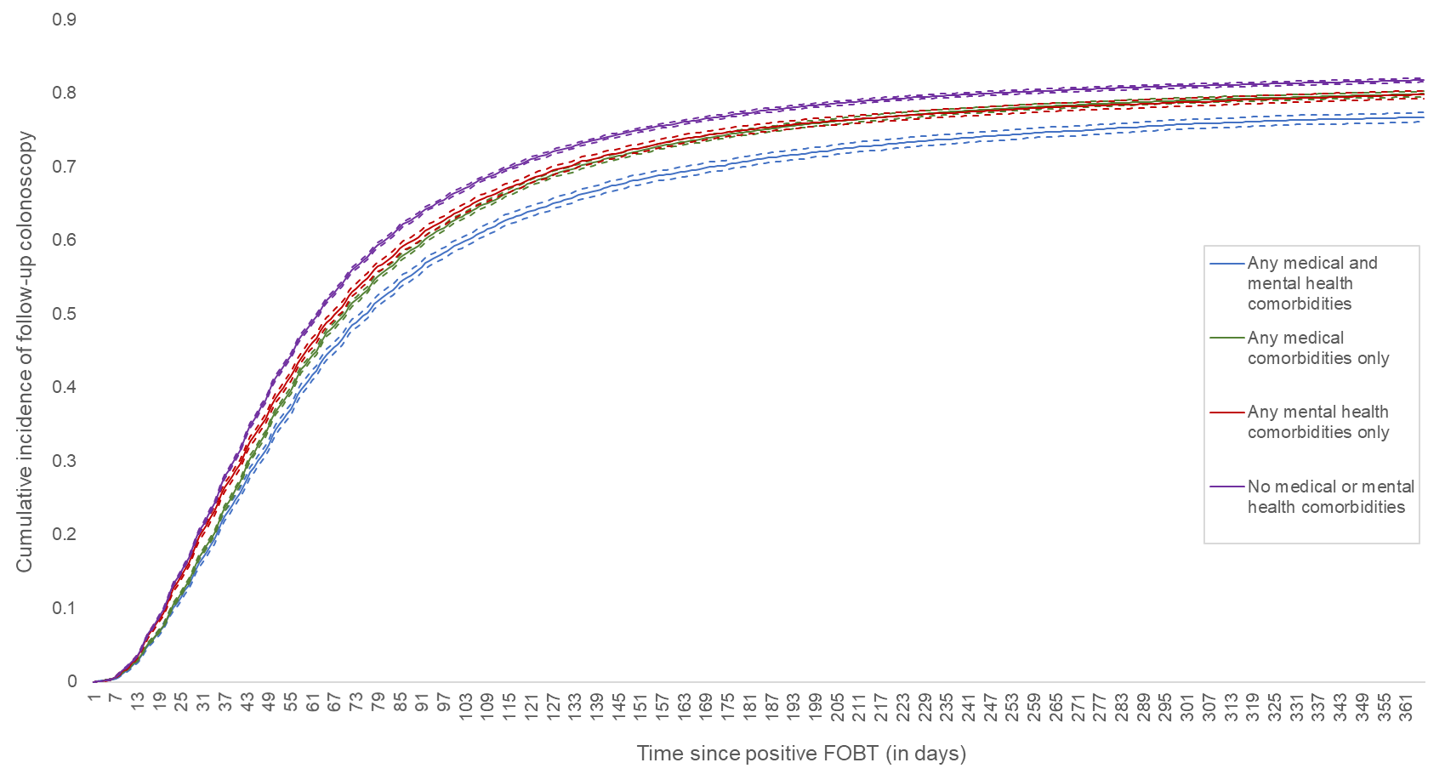
Abbreviation: fecal occult blood test, FOBT
Gray’s test for equality of cumulative incidence functions p<.0001. Note: dashed lines represent 95% confidence intervals.
Supplementary Figure 1.b. Cumulative incidence of follow-up colonoscopy by diabetes status
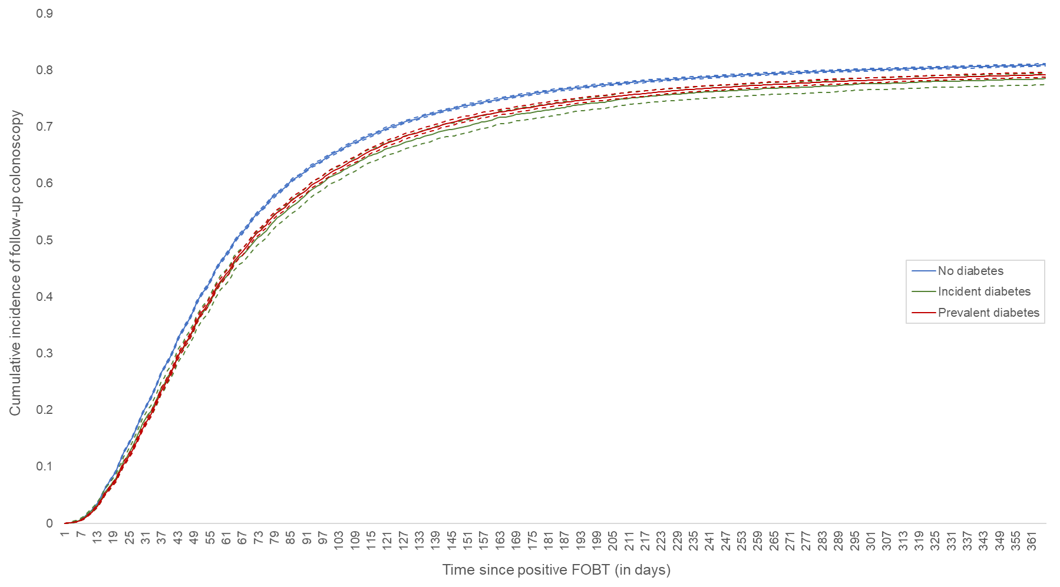
Abbreviation: fecal occult blood test, FOBT
Gray’s test for equality of cumulative incidence functions p<.0001. Note: dashed lines represent 95% confidence intervals.

Supplementary Figure 1.c. Cumulative incidence of follow-up colonoscopy by ESRD status
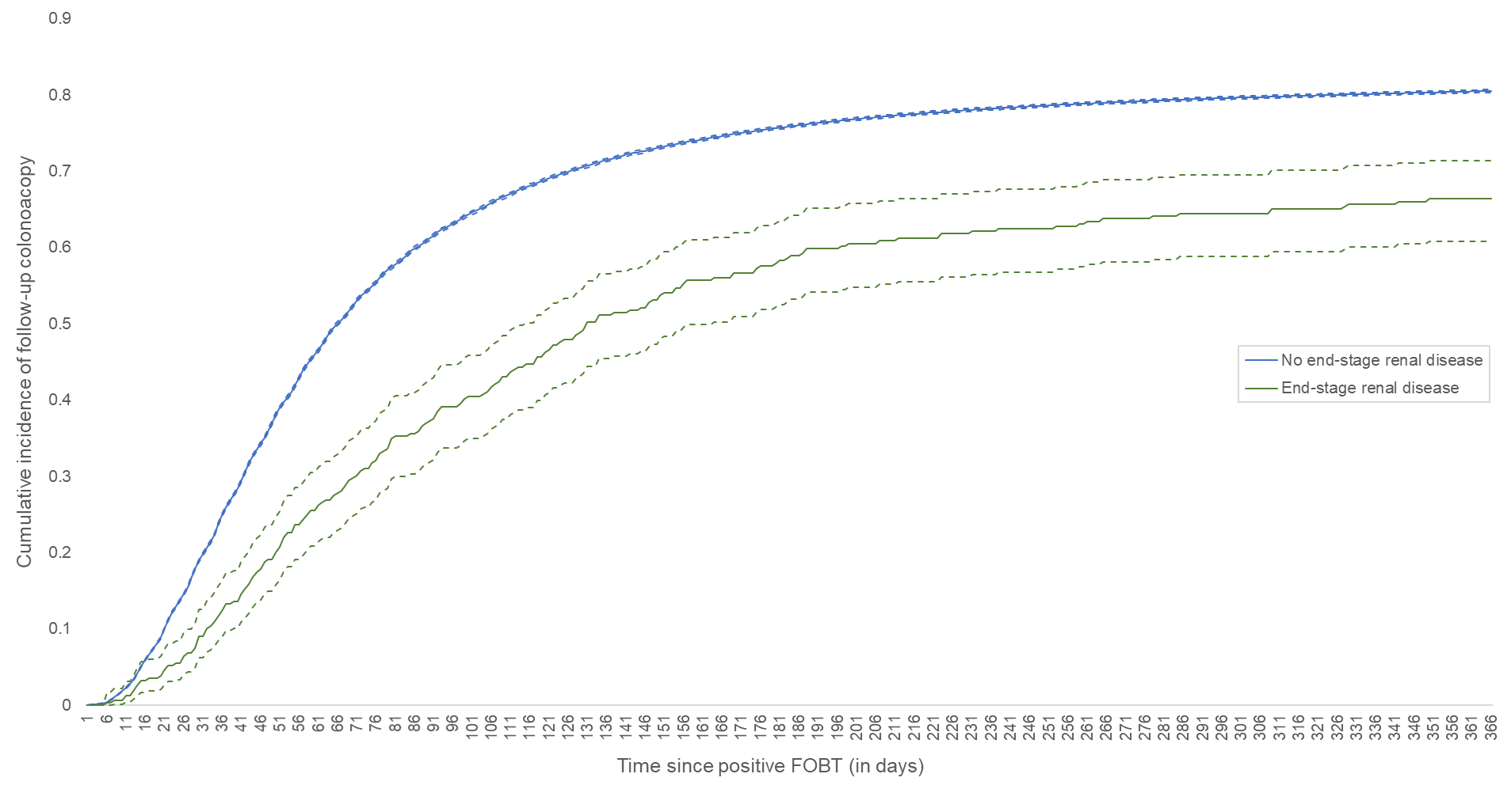

Abbreviations: end-stage renal disease, ESRD; fecal occult blood test, FOBT
Gray’s test for equality of cumulative incidence functions p<.0001. Note: dashed lines represent 95% confidence intervals.

Supplementary Figure 1.d. Cumulative incidence of follow-up colonoscopy by COPD status
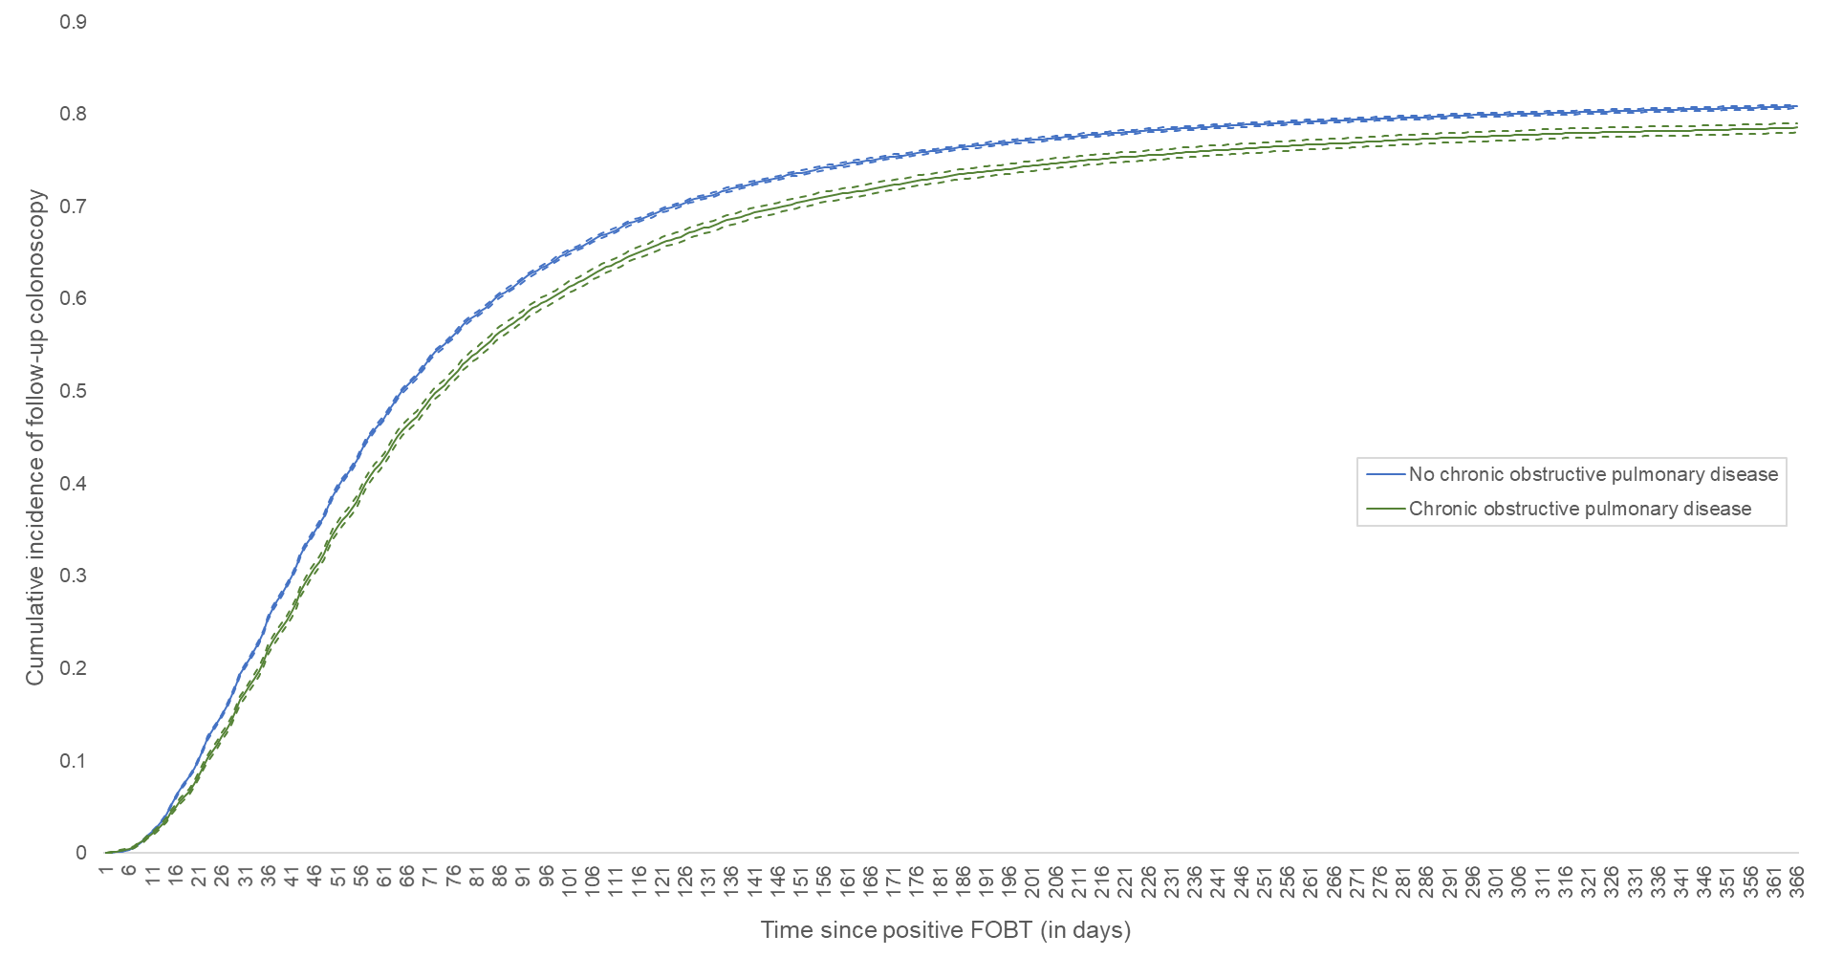
Abbreviations: chronic obstructive pulmonary disese, COPD; fecal occult blood test, FOBT
Gray’s test for equality of cumulative incidence functions p<.0001. Note: dashed lines represent 95% confidence intervals.

Supplementary Figure 1.e. Cumulative incidence of follow-up colonoscopy by CHF status
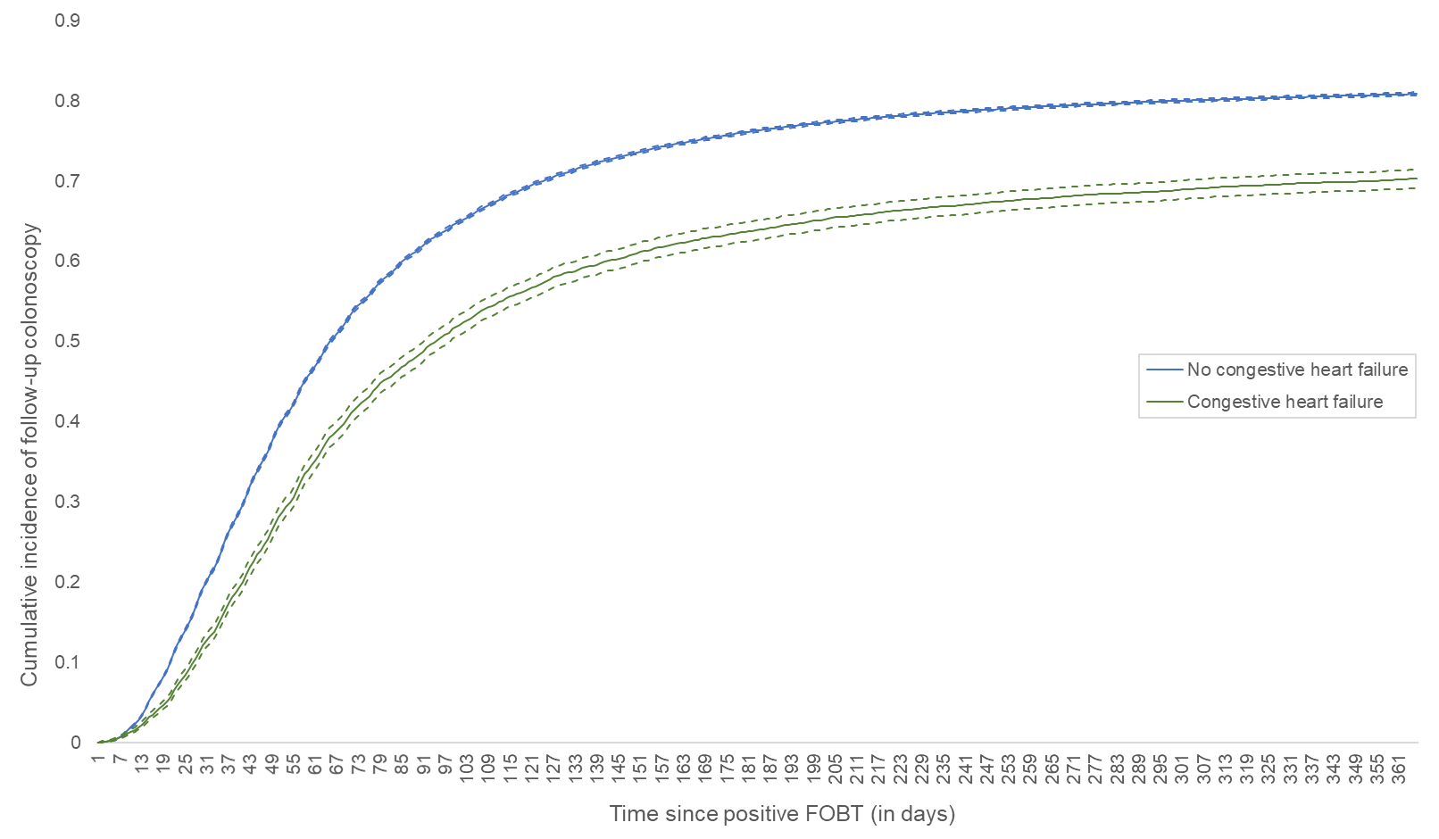
Abbreviations: congestive heart failure, CHF; fecal occult blood test, FOBT
Gray’s test for equality of cumulative incidence functions p<.0001. Note: dashed lines represent 95% confidence intervals.
Supplementary Figure 1.f. Cumulative incidence of follow-up colonoscopy by CVD status
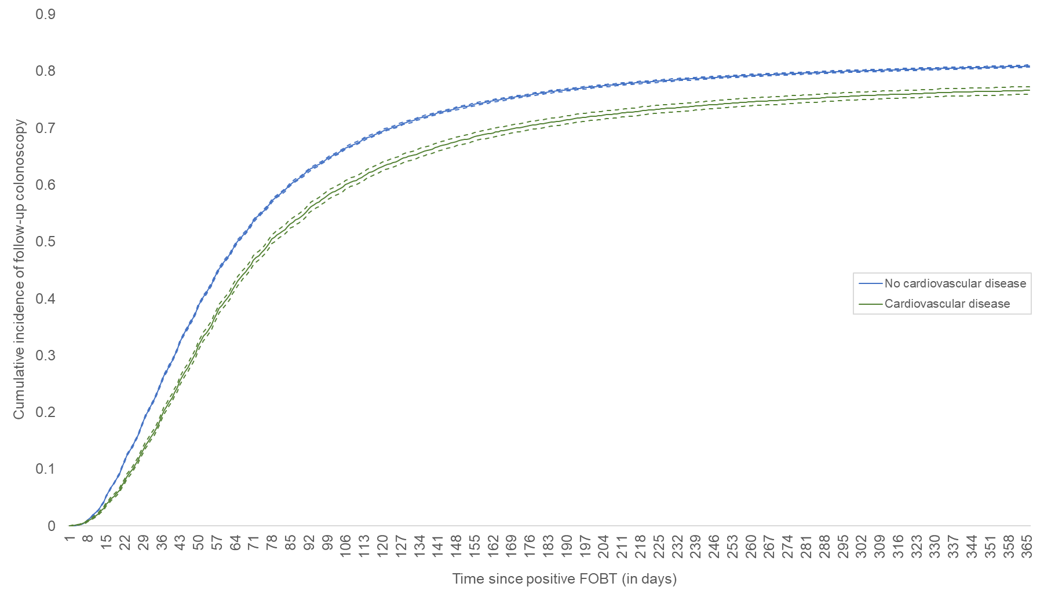
Abbreviations: cardiovascular disease, CVD; fecal occult blood test, FOBT
Gray’s test for equality of cumulative incidence functions p<.0001. Note: dashed lines represent 95% confidence intervals.

Supplementary Figure 1.g. Cumulative incidence of follow-up colonoscopy by mental illness category
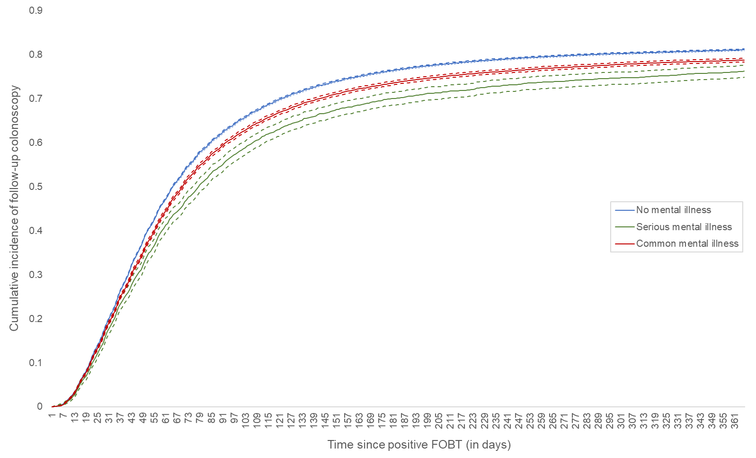
Abbreviation: fecal occult blood test, FOBT
Gray’s test for equality of cumulative incidence functions p<.0001. Note: dashed lines represent 95% confidence intervals.

