SDC 2: Screenshots of Eureka Technology Platform
Figures reproduced from Healthcare 2019: Kaplan HC, Opipari-Arrigan L, Schmid CH, Schuler CL, Saeed S, Braly KL, Burgis JC, Nguyen K, Pilley S, Stone J, Woodward G, Suskind DL. Evaluating the Comparative Effectiveness of Two Diets in Pediatric Inflammatory Bowel Disease: A Study Protocol for a Series of N-of-1 Trials. Healthcare. 2019; 7(4):129.
Screen shots of the participant facing mobile application data entry screens
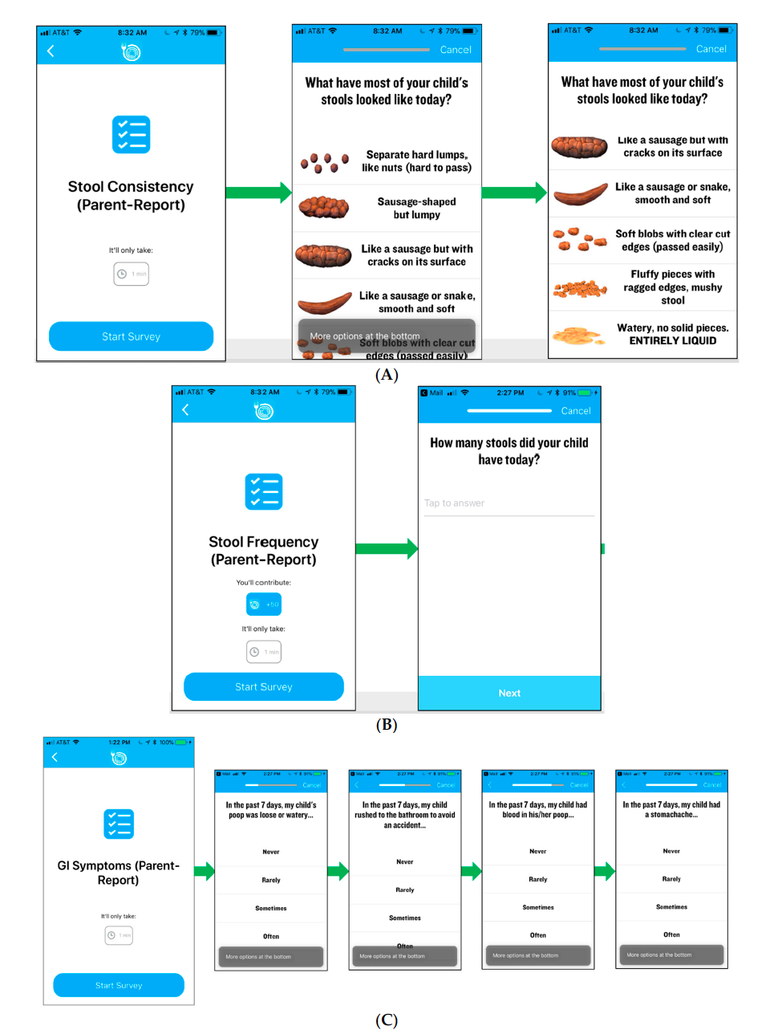
(A) stool consistency, (B) stool frequency and (C) gastrointestinal symptoms
Graphic displaying real-time individual patient reported outcome data through the participant Eureka app
Screen shots of timeline overview and reminders about the usual diet (baseline) and modified specific carbohydrate diet

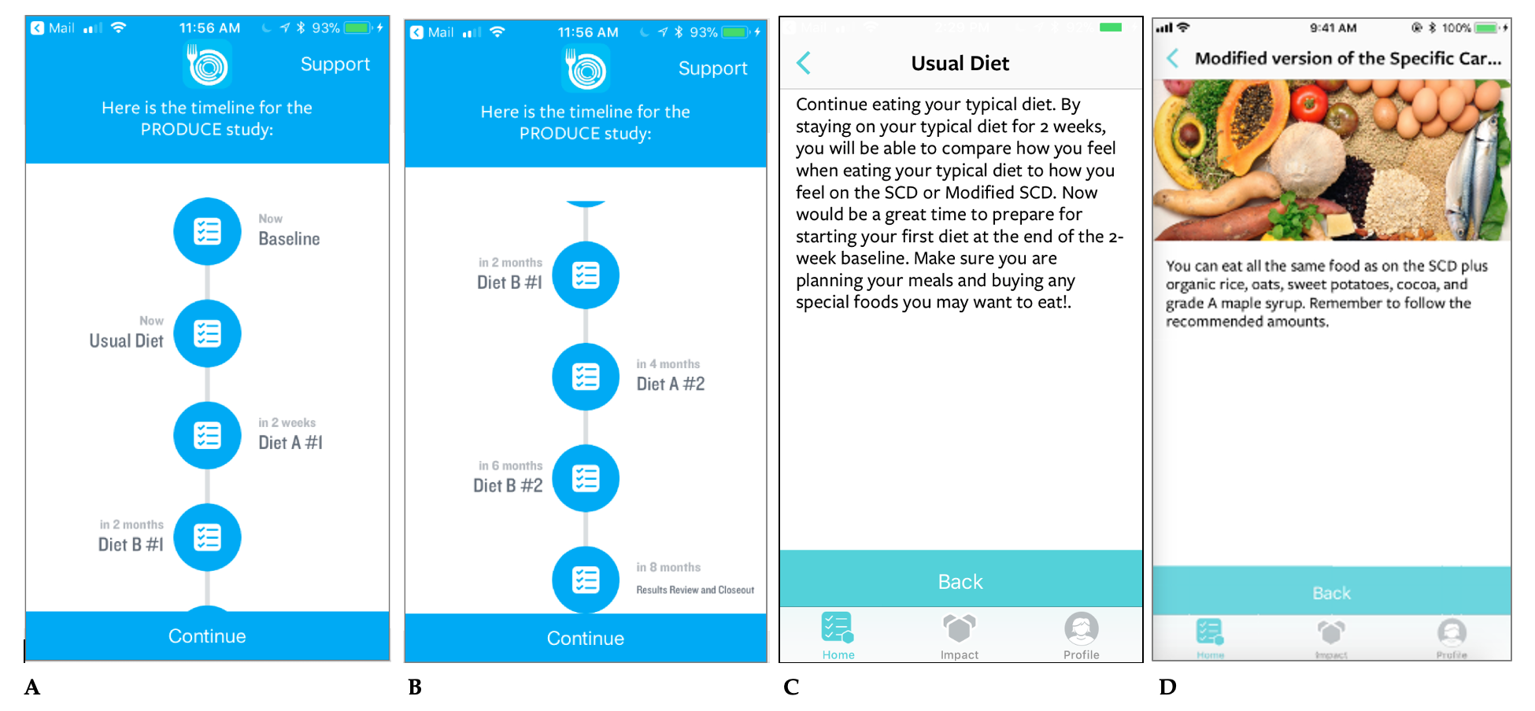
Screen shots of timeline overview (A and B), reminders about the baseline diet (C) and Modified Specific Carbohydrate Diet (D).

