SDC 6: Study CONSORT Table

CONSORT diagram for PRODUCE based on the CONSORT extension for reporting N-of-1 trials (CENT) 2015 Statement. BMJ. 2015;350:h1738. doi: https://doi.org/10.1136/bmj.h1736

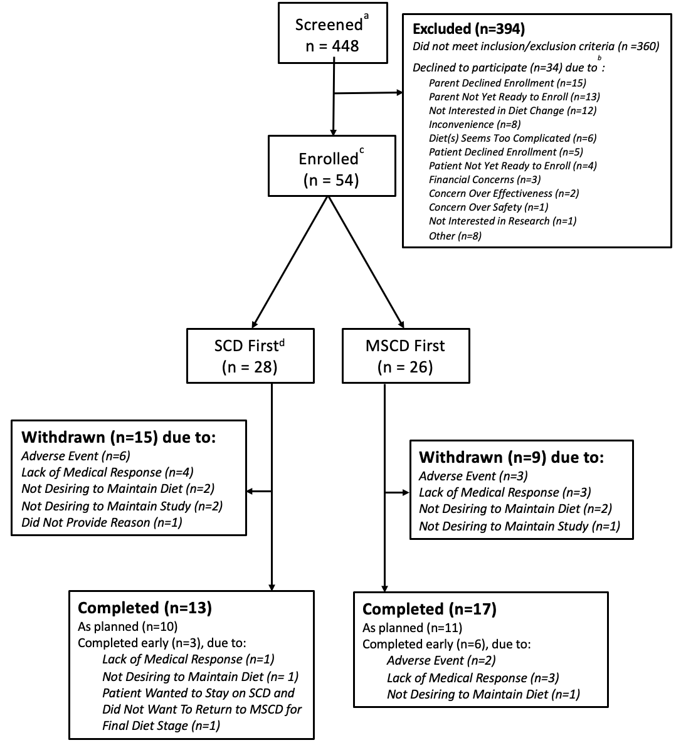
Abbreviations: MSCD – Modified Specific Carbohydrate Diet, SCD – Specific Carbohydrate Diet
ªSites did not conduct universal population screening
^{b}More than one reason to decline could be provided by each participant
^{c}Two participants were determined to be ineligible after completion of the study. Data from these participants were analyzed.
^{d}One participant randomized to the SCD (shown here) followed the diet sequency as if randomized to the MSCD

