SDC 7: Results for Stool Frequency, Stool Consistency, and Pain Interference
Pain Interference
Figure 1: Probability of Symptomatic Improvement in Pain Interference in Individual N-of-1 Trials.
Probability of symptomatic improvement for full completers, early completers, and withdrawals for three diet comparisons: (A) SCD versus Baseline/Usual Diet, (B) MSCD versus Baseline/Usual Diet, and (C) SCD versus MSCD. Within each diet comparison, individual trial probabilities are ordered by disease type and by extent of baseline symptoms (more to less). For withdrawals, participants with measurements only on baseline diet are not included in the figure. Note: ª indicates a child response was used in analysis, ^{b} indicates that the participant was randomized to begin with SCD, but began with MSCD.

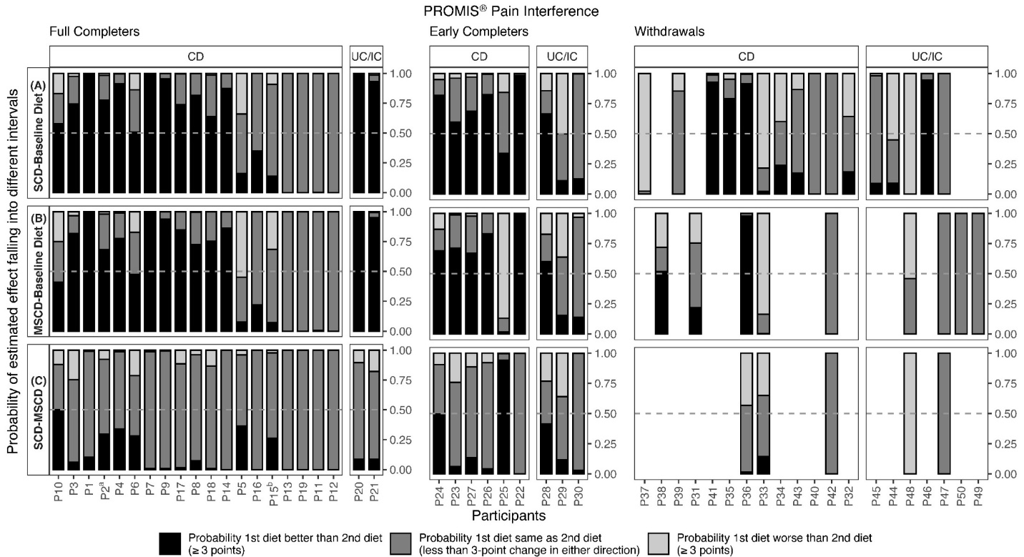

Table 1: Median posterior treatment difference and 95% Credible Interval for PROMIS® Pain Interference for individual N-of-1 trials
 | SCD vs. Baseline /Usual Diet |  | MSCD vs. Baseline/Usual Diet |  | SCD vs. MSCD
Patient | Treatment Difference | 95% CrI | Treatment Difference | 95% CrI | Treatment Difference | 95% CrI
Full Completers
1 | -12.5 | -17.4, -5.3 | -11.4 | -16.3, -4.7 | -1.1 | -4.1, 2.3
2 | -5.9 | -14.3, 2.2 | -4.5 | -11.0, 2.5 | -1.4 | -7.6, 4.9
3 | -5.4 | -12.7, 3.0 | -7.0 | -14.3, 4.0 | 1.6 | -5.0, 5.6
4 | -7.6 | -14.6, -0.7 | -5.5 | -12.3, 1.4 | -2.1 | -6.8, 2.4
5 | 1.4 | -8.1, 8.3 | 3.5 | -5.9, 10.1 | -2.1 | -7.7, 3.7
6 | -3.1 | -14.5, 8.0 | -2.6 | -14.7, 9.4 | -0.5 | -9.6, 8.4
7 | -10.1 | -14.6, -4.5 | -10.0 | -14.7, -4.3 | -0.1 | -2.5, 2.6
8 | -5.3 | -10.6, 0.1 | -4.6 | -11.1, 0.9 | -0.7 | -3.8, 3.5
9 | -7.0 | -10.9, -2.1 | -6.5 | -10.6, -1.8 | -0.4 | -2.5, 1.9
10 | -4.5 | -19.0, 11.8 | -1.5 | -15.2, 12.4 | -3.0 | -12.3, 7.9
11 | 0.2 | -1.9, 1.8 | -0.3 | -2.3, 1.0 | 0.6 | -0.8, 1.9
12 | -0.01 | -0.04, 0.01 | -0.0 | -0.04, 0.01 | 0.00 | -0.02, 0.02
13 | -0.01 | -0.04, 0.01 | -0.0 | -0.04, 0.01 | 0.00 | -0.01, 0.02
14 | -4.9 | -8.2 -1.4 | -4.9 | -8.2, -1.3 | 0.0 | -1.5, 1.4
15 | 0.1 | -6.2, 4.2 | 1.8 | -4.9, 6.0 | -1.7 | -5.7, 2.9
16 | -2.5 | -5.0, -0.1 | -2.0 | -4.6, 0.6 | -0.5 | -1.9, 0.7
17 | -4.6 | -9.7, 0.7 | -5.4 | -10.3, -0.4 | 0.7 | -2.6, 4.5
18 | -4.4 | -12.5, 2.3 | -5.5 | -13.4, 0.8 | 1.1 | -2.2, 4.6
19 | 0.01 | -0.07, 0.01 | 0.01 | -0.07, 0.01 | 0.00 | -0.02, 0.02
20 | -17.5 | -21.2, -12.9 | -17.5 | -23.2, -12.2 | 0.1 | -4.5, 5.4
21 | -12.4 | -22.5, 1.0 | -12.9 | -22.9, -0.7 | 0.5 | -4.7, 6.2
Early Completers
22 | -4.9 | -6.0, -3.2 | -5.1 | -6.2, -3.7 | 0.2 | -0.4, 1.2
23 | -3.9 | -11.3, 3.9 | -5.0 | -12.1, 2.1 | 1.2 | -4.2, 6.0
24 | -10.5 | -25.5, 5.6 | -7.5 | -24.1, 11.3 | -3.0 | -12.6, 6.0
25 | -1.2 | -10.5, 7.1 | 8.3 | -1.9, 16.5 | -9.5 | -17.0, -1.0
26 | -5.5 | -10.6, 0.7 | -5.3 | -10.8, -0.4 | -0.2 | -3.3, 5.3
27 | -5.2 | -14.2, 3.4 | -4.9 | -13.9, 2.9 | -0.3 | -5.1, 5.6
28 | -6.6 | -22.8, 12.7 | -5.1 | -21.5, 14.1 | -1.7 | -14.8, 13.0
29 | 3.0 | -7.2, 14.2 | 1.4 | -7.1, 10.9 | 1.7 | -6.7, 9.3
30 | -0.6 | -4.9, 2.2 | -0.7 | -5.0, 3.4 | 0.1 | -3.2, 2.1
Withdrawals
31 | - | - | 0.4 | -11.7, 13.0 | - | -
32 | 1.5 | -10.7, 8.8 | - | - | - | -
33 | 6.5 | -2.9, 15.9 | 5.2 | -0.4, 9.5 | 1.4 | -6.9, 10.4
34 | 1.5 | -12.3, 14.5 | - | - | - | -
35 | -8.1 | -22.1, 5.4 | - | - | - | -
36 | -7.7 | -13.5, -0.2 | -10.3 | -17.0, -3.1 | 2.6 | -2.3, 8.9
37 | 10.2 | 3.0, 15.7 | - | - | - | -
38 | - | - | -3.5 | -22.8, 19.3 | - | -
39 | 2.2 | 0.6, 4.1 | - | - | - | -
40 | 0.0 | -0.04, 0.03 | - | - | - | -
41 | -11.3 | -22.5, 0.8 | - | - | - | -
42 | 0.0 | -0.04, 0.03 | -0.01 | -0.04, 0.02 | 0.00 | -0.02, 0.03
43 | -0.5 | -6.0, 9.2 | - | - | - | -
44 | 3.6 | -7.2, 14.2 | - | - | - | -
45 | -1.0 | -4.4, 2.7 | - | - | - | -
46 | -4.1 | -5.1, -2.6 | - | - | - | -
47 | 0.00 | -0.04, 0.03 | 0.0 | -0.04, 0.05 | -0.01 | -0.05, 0.03
48 | 14.6 | 10.7, 18.0 | 3.1 | 0.8, 5.6 | 11.4 | 8.1, 14.7
49 | - | - | 0.01 | -0.05, 0.11 | - | -
50 | - | - | -0.01 | -0.06, 0.03 | - | -
51 | - | - | - | - | - | -
52 | - | - | - | - | - | -
53 | - | - | - | - | - | -
54 | - | - | - | - | - | -
Abbreviations: SCD – Specific Carbohydrate Diet, MSCD – Modified Specific Carbohydrate Diet, CrI – Bayesian Credible Interval

Figure 2: Aggregate Probability of Symptomatic Improvement in Pain Interference Pooled Across Participants
Aggregate probability of symptomatic improvement in pain interference for three diet comparisons: (A) SCD versus Baseline/Usual Diet, (B) MSCD versus Baseline/Usual Diet, and (C) SCD versus MSCD. Within each diet comparison, results are provided for the pooled, imputed sample (n=54), full completers (n=21), early completers (n=9), and withdrawals (n=24).

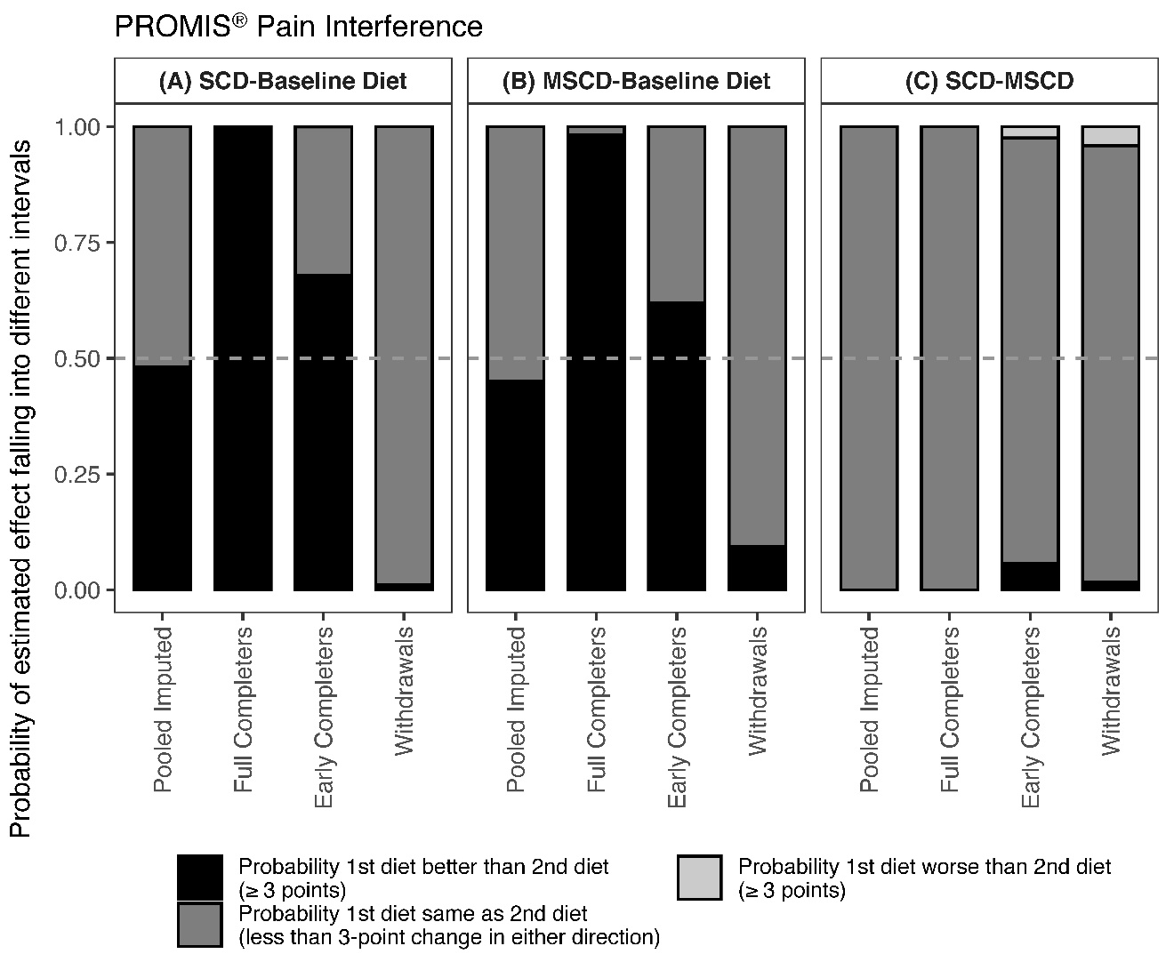

Figure 3: Average Median Difference and 95% Credible Interval for Change in Pain Interference Pooled Across Participants
Average difference and 95% credible interval of change in pain interference for three diet comparisons: (A) SCD versus Baseline/Usual Diet, (B) MSCD versus Baseline/Usual Diet, and (C) SCD versus MSCD. Within each diet comparison, results are provided for the pooled, imputed sample (n=54), full completers (n=21), early completers (n=9), and withdrawals (n=24). The shaded region in gray represents a difference that is not clinically meaningful (< 3-point change in either direction).

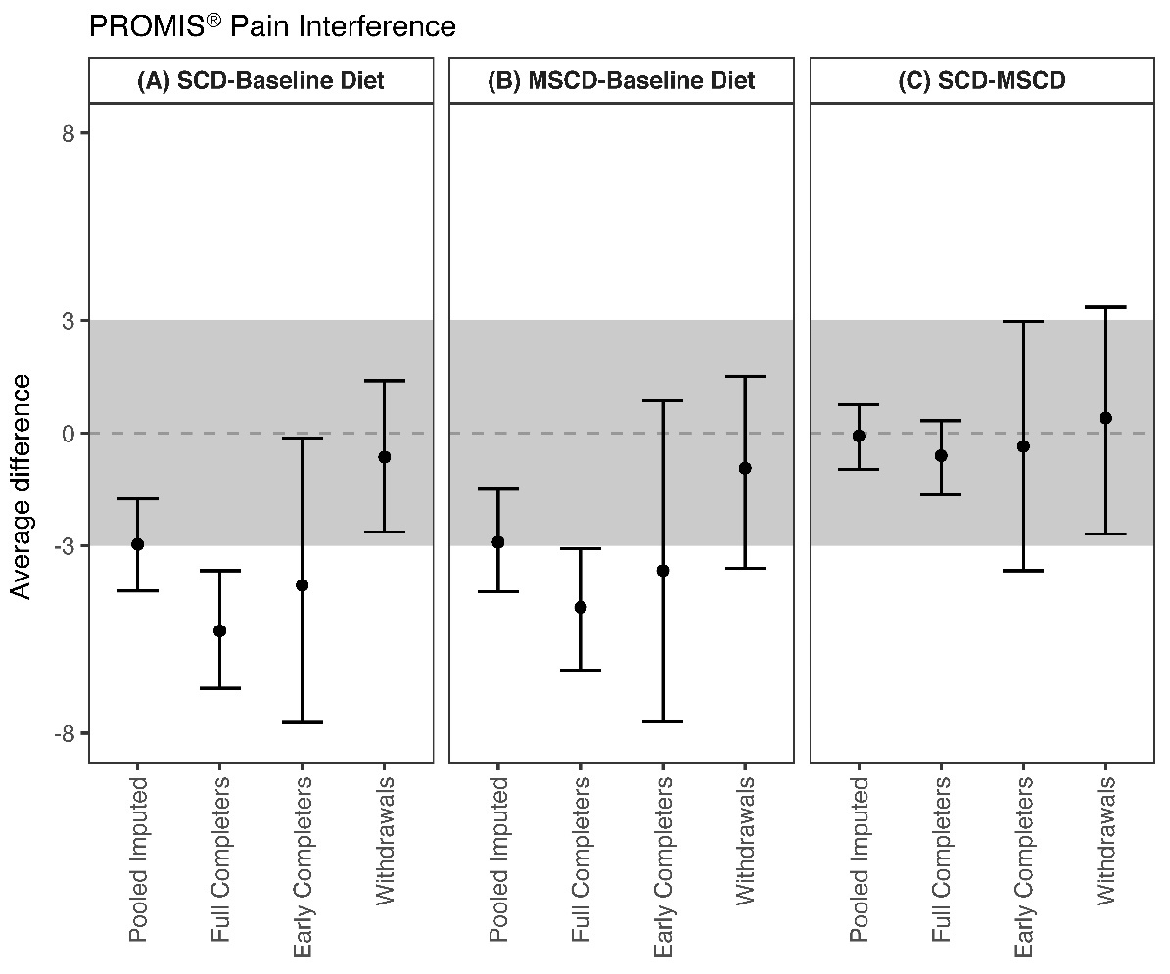

Description of Pain Interference Results
Individual Participant Results
Individual patient posterior probabilities for each diet comparison including SCD vs. baseline/usual diet (Panel A), MSCD vs. baseline/usual diet (Panel B), and SCD vs. MSCD (Panel C) are shown in Figure 1 and corresponding median posterior treatment difference and 95% CrI are shown in Table 1.
The probability of improvement in pain interference on the SCD versus the baseline/usual diet varied by individual (Figure 1, Panel A). Twelve of the full completers, 5 of the early completers, and 4 of the withdrawals were classified as responders, having a >50% probability of clinically meaningful improvement and a <10% probability of worsened pain interference on the SCD as compared to the baseline/usual diet.
Similar heterogeneity was seen in the individual probabilities of improvement in pain interference on the MSCD versus the baseline/usual diet (Figure 1, Panel B). Twelve of the full completers, 4 of the early completers, and one of the withdrawals had a >50% probability of clinically meaningful improvement and a <10% probability of worsened pain interference on the MSCD as compared to the baseline/usual diet.
There was minimal difference between the SCD and MSCD for most participants, with the SCD identified as better than the MSCD in one participant, and the MSCD superior in one participant for reducing pain interference. consistency.

Aggregate Results
Aggregate patient posterior probabilities for each diet comparison including SCD vs. baseline/usual diet (Panel A), MSCD vs. baseline/usual diet (Panel B), and SCD vs. MSCD (Panel C) are shown in Figure 2 and corresponding median posterior treatment difference and 95% CrI are shown in Figure 3 across the different groups of pooled patients including the pooled, imputed sample that includes all participants (n=54), full completers (n=21), early completers (n=9), and withdrawals (n=24).
For the pooled imputed analysis combining the individual N-of-1 trial data across all participants, we found that, on average there was a 48% probability that the SCD was better than the baseline/usual diet, a 52% probability that they were no different, and a <1% probability that the baseline/usual diet was better for improving pain interference (Figure 2, Panel A). This corresponds to an average treatment difference of -2.97 (95% CrI -4.2, -1.76) comparing the SCD to baseline/usual diet (Figure 3, Panel A). Regarding the MSCD versus baseline/usual diet, on average there was a 45% probability that the MSCD was better than the baseline/usual diet, a 55% probability that they were no different, and a <1% probability that the baseline/usual diet was better for improving pain interference (Figure 1, Panel B). This corresponds to an average treatment difference of -2.91 (95% CrI -4.24, -1.50) comparing the MSCD to baseline/usual diet (Figure 3, Panel B). There was no difference between the MSCD and SCD with respect to improvements in pain interference with a >99% probability of no difference (Figure 2, Panel C).
Additional secondary analyses examined full completers, early completers, and withdrawals separately. On average, full and early completers had the greatest probability of improvement on the SCD and MSCD compared to the baseline/usual diet (Figure 2, Panel A).

Stool Frequency
Figure 4: Probability of Symptomatic Improvement in Stool Frequency in Individual N-of-1 Trials.
Probability of symptomatic improvement for full completers, early completers, and withdrawals for three diet comparisons: (A) SCD versus Baseline/Usual Diet, (B) MSCD versus Baseline/Usual Diet, and (C) SCD versus MSCD. Within each diet comparison, individual trial probabilities are ordered by disease type and by extent of baseline symptoms (more to less). For withdrawals, participants with measurements only on baseline diet are not included in the figure. Note: ª indicates a child response was used in analysis, ^{b} indicates that the participant was randomized to begin with SCD, but began with MSCD.
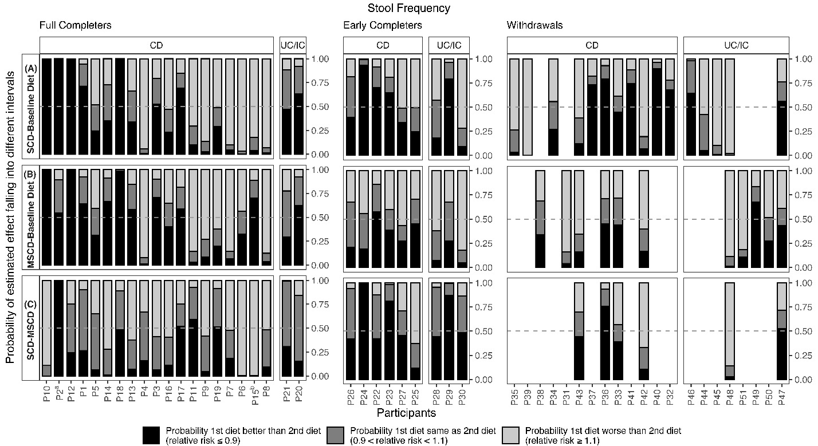

Figure 5: Risk Ratio and 95% Credible Interval for Change in Stool Frequency in Individual N-of-1 Trials.
Risk ratio and 95% Credible Interval (CrI) for full completers, early completers, and withdrawals for three diet comparisons: (A) SCD versus Baseline/Usual Diet, (B) MSCD versus Baseline/Usual Diet, and (C) SCD versus MSCD. Within each diet comparison, individual trial results are ordered by disease type and by extent of baseline symptoms (more to less). The shaded region in gray represents a difference that is not clinically meaningful (< 10% relative change in either direction). For withdrawals, participants with measurements only on baseline diet are not included in the figure. Note: ª indicates a child response was used in analysis, ^{b} indicates that the participant was randomized to begin with SCD, but began with MSCD.
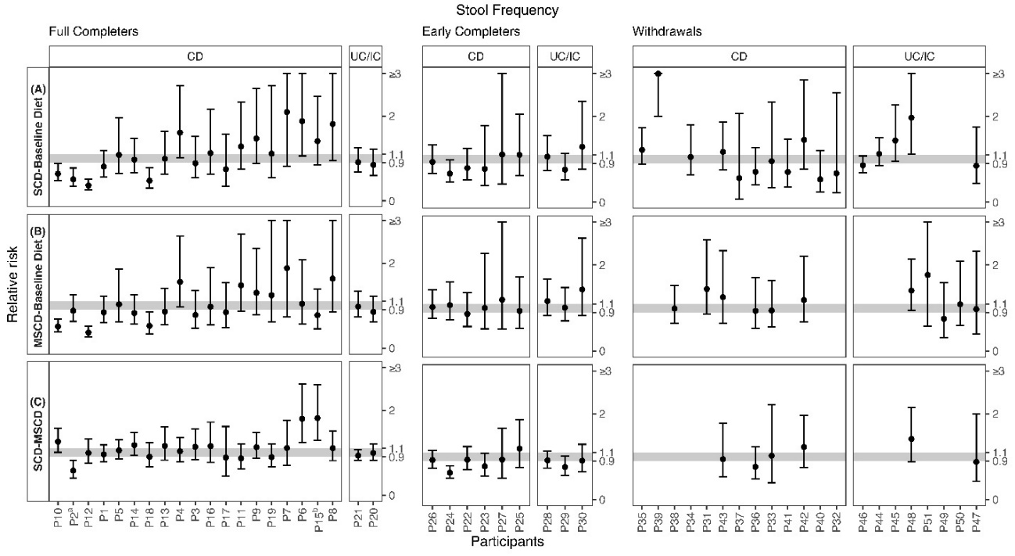
Figure 6: Aggregate Probability of Symptomatic Improvement in Stool Frequency Pooled Across Participants
Aggregate probability of symptomatic improvement in stool frequency for three diet comparisons: (A) SCD versus Baseline/Usual Diet, (B) MSCD versus Baseline/Usual Diet, and (C) SCD versus MSCD. Within each diet comparison, results are provided for the pooled, imputed sample (n=54), full completers (n=21), early completers (n=9), and withdrawals (n=24).

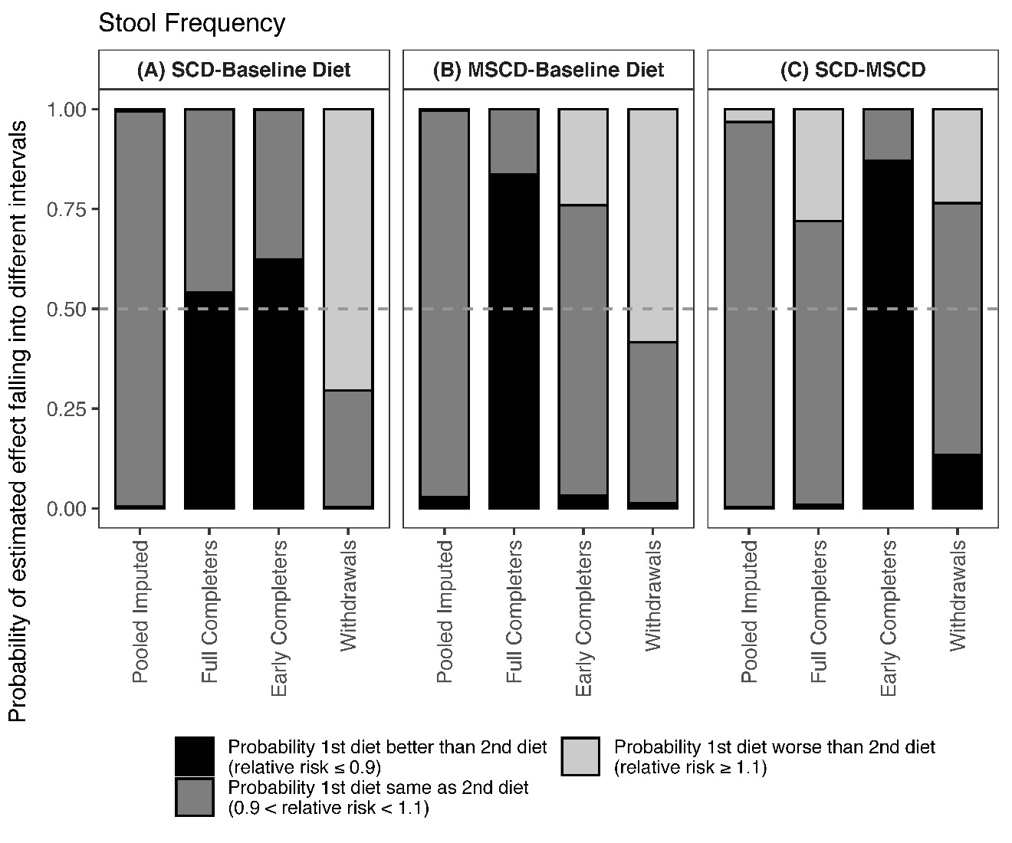
Figure 7: Risk Ratio and 95% Credible Interval for Change in Stool Frequency Pooled Across Participants
Risk ratio and 95% credible interval of change in stool frequency for three diet comparisons: (A) SCD versus Baseline/Usual Diet, (B) MSCD versus Baseline/Usual Diet, and (C) SCD versus MSCD. Within each diet comparison, results are provided for the pooled, imputed sample (n=54), full completers (n=21), early completers (n=9), and withdrawals (n=24). The shaded region in gray represents a difference that is not clinically meaningful (< 10% relative change in either direction).

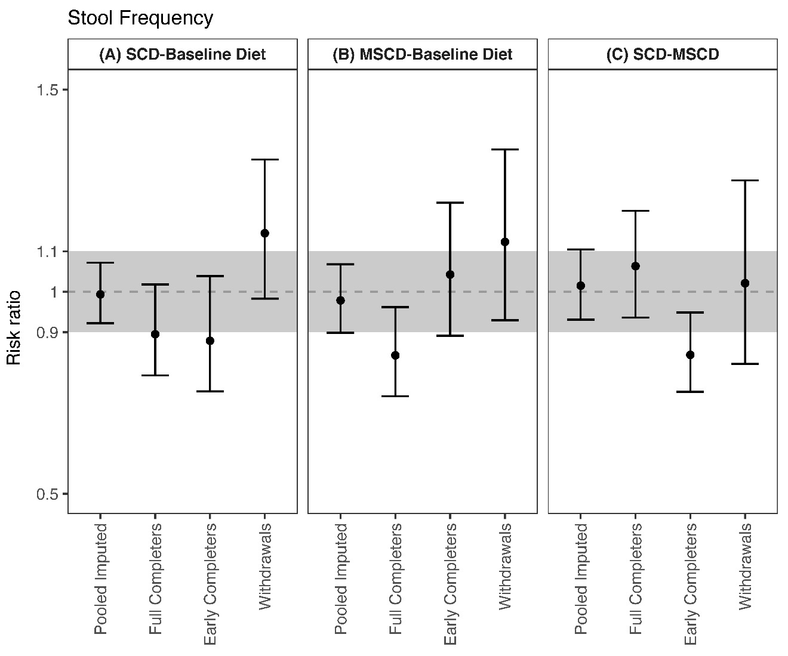

Description of Stool Frequency Results
Individual Participant Results
Individual patient posterior probabilities for each diet comparison including SCD vs. baseline/usual diet (Panel A), MSCD vs. baseline/usual diet (Panel B), and SCD vs. MSCD (Panel C) are shown in Figure 4 and corresponding median posterior treatment difference and 95% CrI are shown in Figure 5.
The probability of improvement in stool frequency on the SCD versus the baseline/usual diet varied by individual (Figure 4, Panel A). Six of the full completers and 3 of the early completers were classified as responders, having a >50% probability of clinically meaningful improvement and a <10% probability of worsened stool frequency on the SCD as compared to the baseline diet. There were also some withdrawals who had a clinically meaningful improvement in stool frequency on the SCD compared to the baseline diet (participants 36, 40 and 46).
Similar heterogeneity was seen in the individual probabilities of improvement in stool frequency on the MSCD versus the baseline diet (Figure 4, Panel B). Among the full completers, six had a >50% probability of clinically meaningful improvement and a <10% probability of worsened stool frequency on the MSCD as compared to the baseline diet. There were no early completers or withdrawals identified as responders to the MSCD compared to the baseline diet.
Unlike the findings for Pediatric IBD symptoms and pain interference where there was minimal difference between the SCD and MSCD for most participants, for stool frequency, across the entire group of participants, the SCD was identified as better than the in seven participants, and the MSCD superior in nine participants for reducing stool frequency.

Aggregate Results
Aggregate patient posterior probabilities for each diet comparison including SCD vs. baseline/usual diet (Panel A), MSCD vs. baseline/usual diet (Panel B), and SCD vs. MSCD (Panel C) are shown in Figure 6 and corresponding median posterior treatment difference and 95% CrI are shown in Figure 7 across the different groups of pooled patients including the pooled, imputed sample that includes all participants (n=54), full completers (n=21), early completers (n=9), and withdrawals (n=24).
For the pooled imputed analysis combining the individual N-of-1 trial data across all participants, we found that, on average there was a <1% probability that the SCD was better than the baseline/usual diet, a 99% probability that they were no different, and a <1% probability that the baseline/usual diet was better for reducing stool frequency (Figure 6, Panel A). This corresponds to an average risk ratio of 0.99 (95% CrI 0.92, 1.07) comparing the SCD to baseline/usal diet (Figure 7, Panel A). Results were similar comparing the MSCD to the baseline diet. On average there was a 3% probability that the MSCD was better than the baseline/usual diet, a 97% probability that they were no different, and a <1% probability that the baseline/usual diet was better for reducing stool frequency (Figure 6, Panel B). This corresponds to an average risk ratio of 0.98 (95% CrI 0.90, 1.07) comparing the MSCD to baseline/usual diet (Figure 7, Panel B). There was no significant difference between the SCD and MSCD for stool frequency (Figure 6, Panel C) with a 96% probability of no difference.
Additional secondary analyses examined full completers, early completers, and withdrawals separately. On average, full and early completers had the greatest probability of improvement on the SCD compared to the baseline/usual diet (Figure 6, Panel A). Only full completers had a high probability of response to the MSCD as compared to the baseline/usual diet (Figure 6, Panel B). On average, withdrawals demonstrated negligible probability of improvement comparing the SCD and MSCD to baseline/usual diet (Figure 6, Panels A and B). In fact, the fact that those withdrawing from the study had only a negligible probability of clinically meaningful improvement and a moderate probability that the baseline/usual diet was better likely indicates that participants were worsening with more stools as the study progressed. With the exception of a higher probability of reduced stool frequency on the SCD versus MSCD for early completers, none of the secondary analyses demonstrated major difference between the SCD and MSCD.

Stool Consistency
Figure 8: Probability of Symptomatic Improvement in Stool Consistency in Individual N-of-1 Trials.
Probability of symptomatic improvement in stool consistency for full completers, early completers, and withdrawals for three diet comparisons: (A) SCD versus Baseline/Usual Diet, (B) MSCD versus Baseline/Usual Diet, and (C) SCD versus MSCD. Within each diet comparison, individual trial probabilities are ordered by disease type and by extent of baseline symptoms (more to less). For withdrawals, participants with measurements only on baseline diet are not included in the figure. Note: ª indicates a child response was used in analysis, ^{b} indicates that the participant was randomized to begin with SCD, but began with MSCD.

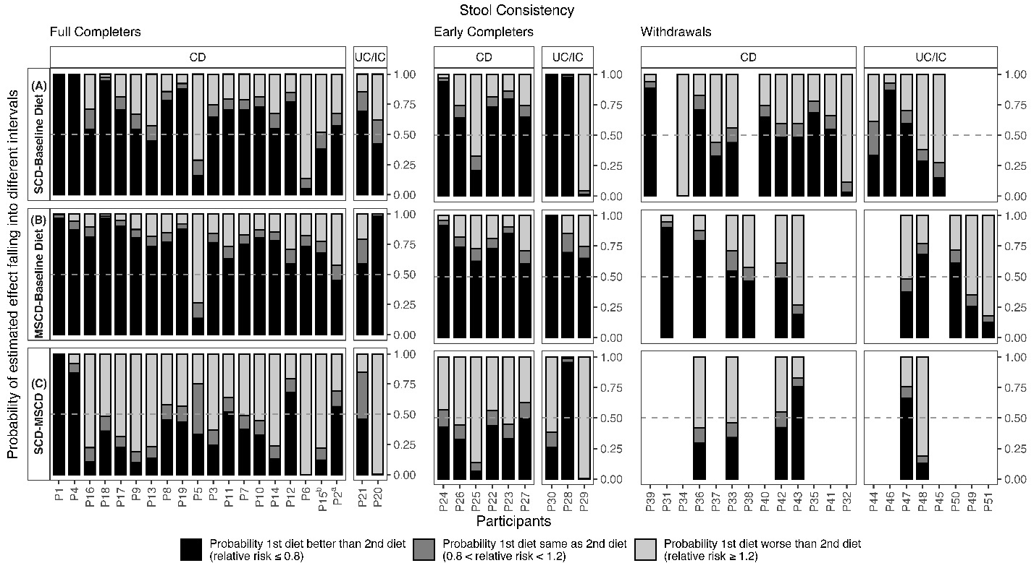

Figure 9: Risk Ratio and 95% Credible Interval for Change in Stool Consistency in Individual N-of-1 Trials.
Risk ratio and 95% Credible Interval (CrI) for full completers, early completers, and withdrawals for three diet comparisons: (A) SCD versus Baseline/Usual Diet, (B) MSCD versus Baseline/Usual Diet, and (C) SCD versus MSCD. Within each diet comparison, individual trial results are ordered by disease type and by extent of baseline symptoms (more to less). The shaded region in gray represents a difference that is not clinically meaningful (< 20% relative change in either direction). For withdrawals, participants with measurements only on baseline diet are not included in the figure. Note: ª indicates a child response was used in analysis, ^{b} indicates that the participant was randomized to begin with SCD, but began with MSCD.

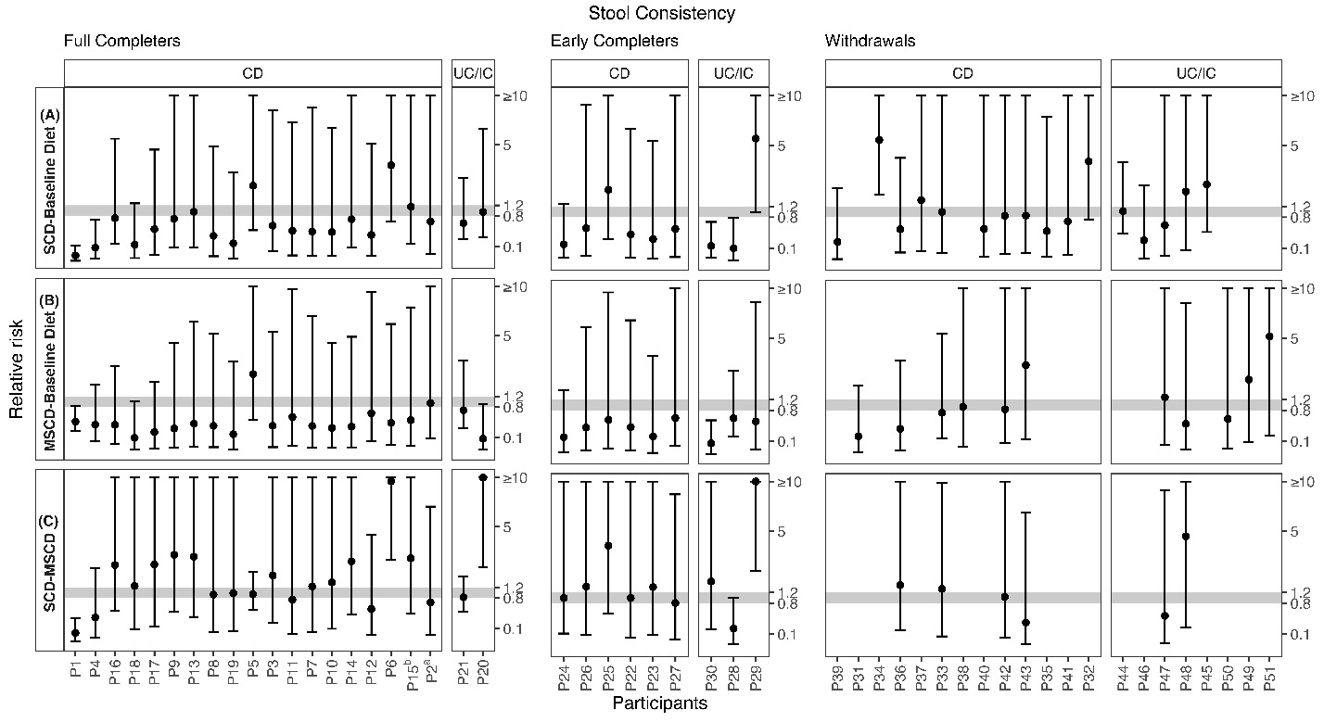

Figure 10: Aggregate Probability of Symptomatic Improvement in Stool Consistency Pooled Across Participants
Aggregate probability of symptomatic improvement in stool consistency for three diet comparisons: (A) SCD versus Baseline/Usual Diet, (B) MSCD versus Baseline/Usual Diet, and (C) SCD versus MSCD. Within each diet comparison, results are provided for the pooled, imputed sample (n=53), the pooled sample for the first diet period only (n=53), the pooled sample for the first two diet periods (early and full completers only, n=30), full completers (n=21), early completers (n=9), and withdrawals (n=23). One withdrawal with no measurement on stool consistency is not included in the analyses.

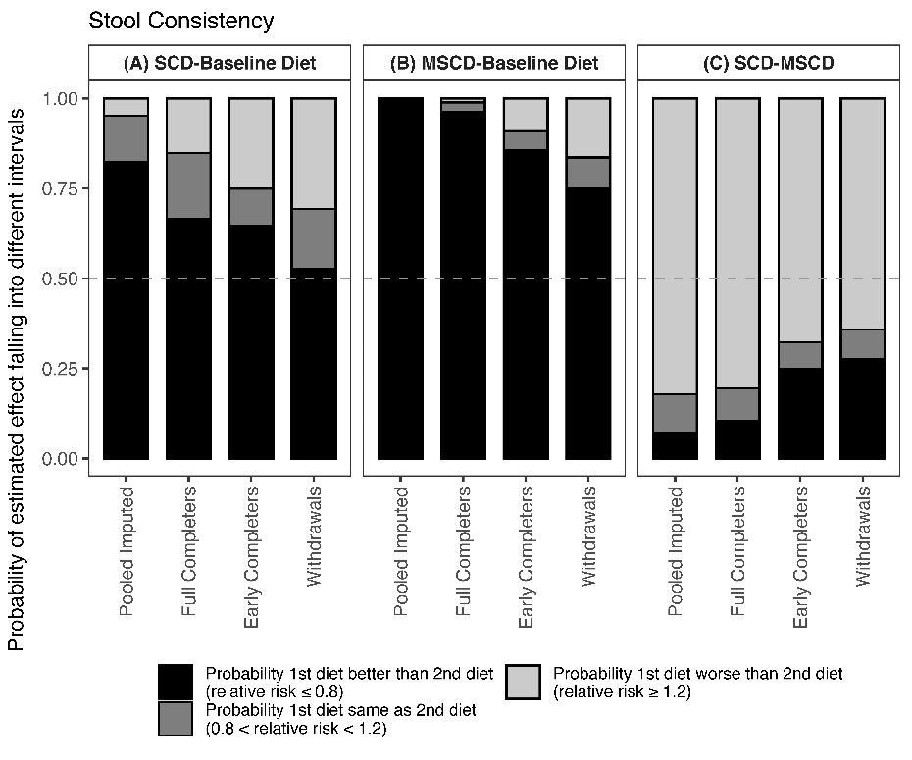

Figure 11: Risk Ratio and 95% Credible Interval for Change in Stool Consistency Pooled Across Participants
Risk ratio and 95% Credible Interval of change in stool frequency for three diet comparisons: (A) SCD versus Baseline/Usual Diet, (B) MSCD versus Baseline/Usual Diet, and (C) SCD versus MSCD. Within each diet comparison, results are provided for the pooled, imputed sample (n=53), the pooled sample for the first diet period only (n=53), the pooled sample for the first two diet periods (early and full completers only, n=30), full completers (n=21), early completers (n=9), and withdrawals (n=23). Note: average effects are technically odds ratios but because the prevalence is low, it can be approximated as a risk ratio. The shaded region in gray represents a difference that is not clinically meaningful (< 20% relative change in either direction). One withdrawal with no measurement on stool consistency is not included in the analyses.

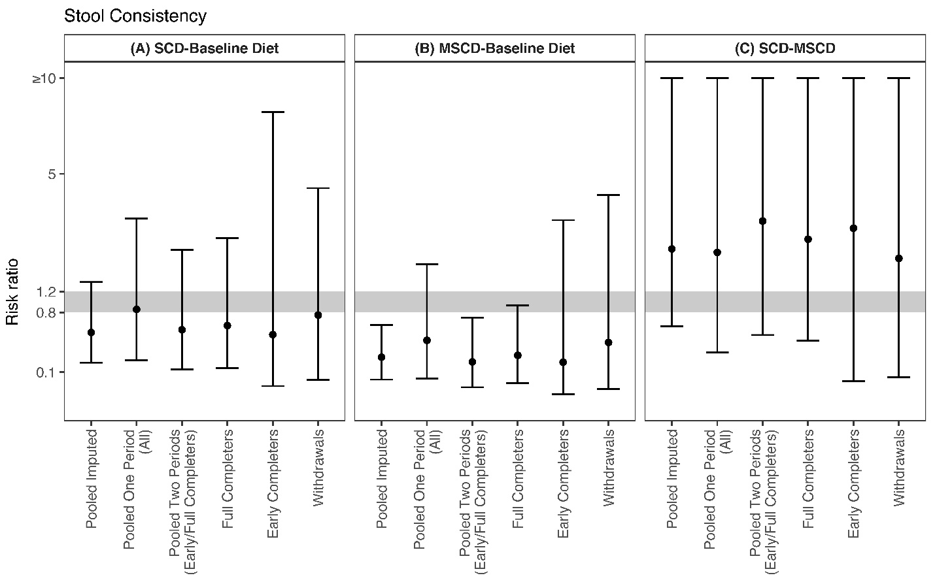
Description of Stool Consistency Results
Individual Participant Results
Individual patient posterior probabilities for each diet comparison including SCD vs. baseline/usual diet (Panel A), MSCD vs. baseline/usual diet (Panel B), and SCD vs. MSCD (Panel C) are shown in Figure 8 and corresponding median posterior treatment difference and 95% CrI are shown in Figure 9. Note that credible intervals were very wide for all participants.
The probability of improvement in stool consistency on the SCD versus the baseline/usual diet varied by individual (Figure 8, Panel A). Four of the full completers and 3 of the early completers were classified as responders, having a >50% probability of clinically meaningful improvement and a <10% probability of worsened stool consistency on the SCD as compared to the baseline/usual diet. There were also some withdrawals who had a clinically meaningful improvement in stool consistency on the SCD compared to the baseline diet (participants 39 and 46).
Similar heterogeneity was seen in the individual probabilities of improvement in stool consistency on the MSCD versus the baseline/usual diet (Figure 8, Panel B). Six of the full completers and 3 of the early completers had a >50% probability of clinically meaningful improvement and a <10% probability of worsened stool consistency on the MSCD as compared to the baseline/usual diet. There was one withdrawal (participant 31) who was identified as a responder to the MSCD compared to the baseline/usual diet for stool consistency.
There was minimal difference between the SCD and MSCD for most participants, with the SCD identified as better than the MSCD in three participants, and the MSCD superior in four participants for reducing stool consistency.

Aggregate Results
Aggregate patient posterior probabilities for each diet comparison including SCD vs. baseline/usual diet (Panel A), MSCD vs. baseline/usual diet (Panel B), and SCD vs. MSCD (Panel C) are shown in Figure 10 and corresponding median posterior treatment difference and 95% CrI are shown in Figure 11 across the different groups of pooled patients including the pooled, imputed sample that includes all participants (n=53), full completers (n=21), early completers (n=9), and withdrawals (n=23). Note that credible intervals were very wide for all aggregate risk ratios.
For the pooled imputed analysis combining the individual N-of-1 trial data across all participants, we found that, on average there was a 82% probability that the SCD was better than the baseline/usual diet, a 13% probability that they were no different, and a 5% probability that the baseline diet was better for improving stool frequency (Figure 10, Panel A). This corresponds to an average risk ratio of 0.49 (95% CrI 0.17, 1.41) comparing the SCD to baseline/usual diet (Figure 11, Panel A). Again, note the very wide credible interval. Results more strongly favored the MSCD over the baseline diet. On average there was a 99% probability that the MSCD was better than the baseline/usual diet, a <1% probability that they were no different, and a <1% probability that the baseline/usual diet was better for improving stool consistency (Figure 10, Panel B). This corresponds to an average risk ratio of 0.21 (95% CrI 0.06, 0.60) comparing the MSCD to baseline/usual diet (Figure 11, Panel B). The MSCD was superior to the SCD in improving stool consistency with an 82% probability the MSCD was better than the SCD compared to a 7% probability the SCD was better than the MSCD and an 11% probability they were no different (Figure 10, Panel C).
Additional secondary analyses examined full completers, early completers, and withdrawals separately. On average, full and early completers had the greatest probability of improvement on the SCD and MSCD compared to the baseline/usual diet, though there was also still a moderate probability of improvement for withdrawals (Figure 10, Panel A). Across all strata including full completers, early completers, and withdrawals, the MSCD had a greater probability of improving stool consistency than the SCD.

