SDC 8: Average Treatment Difference and 95% Credible Interval (CrI) in Pediatric IBD Symptom Scale Pooled Across Participants

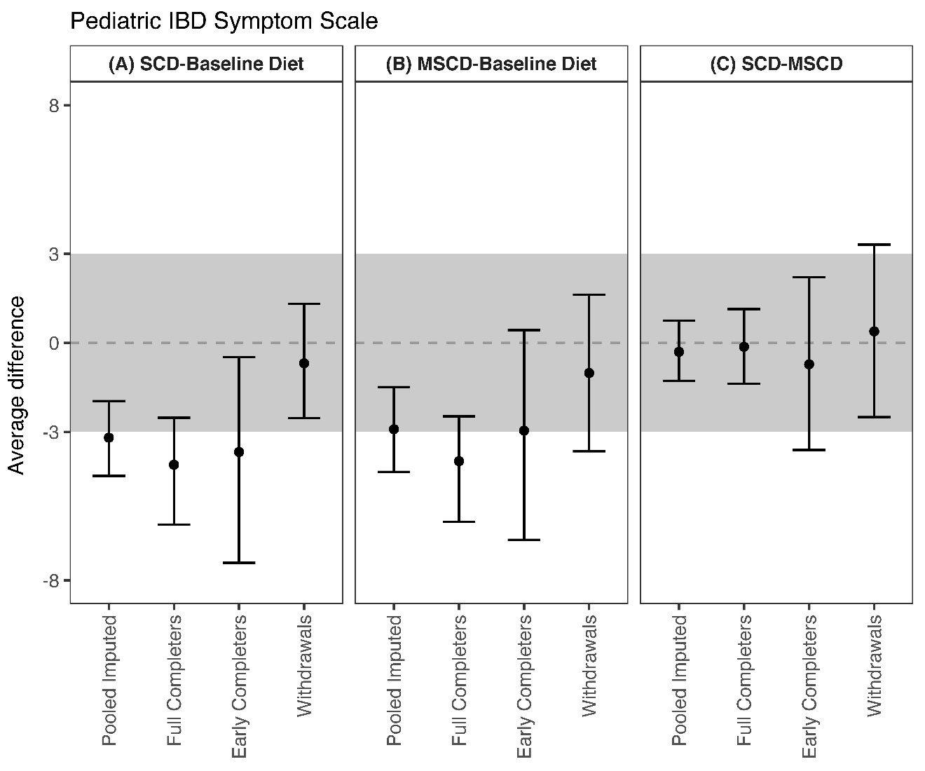

Average treatment difference and 95% Credible Interval in pediatric IBD symptoms for three diet comparisons: (A) SCD versus Baseline Diet, (B) MSCD versus Baseline Diet, and (C) SCD versus MSCD. Within each diet comparison, results are provided for the pooled, imputed sample (n=54), full completers (n=21), early completers (n=9), and withdrawals (n=24). The shaded region in gray represents a difference that is not clinically meaningful (less than +/- 3 points in either direction).

