SDC 9: Ratio of Geometric Means and 95% Credible Interval (CrI) for Fecal Calprotectin Pooled Across Participants

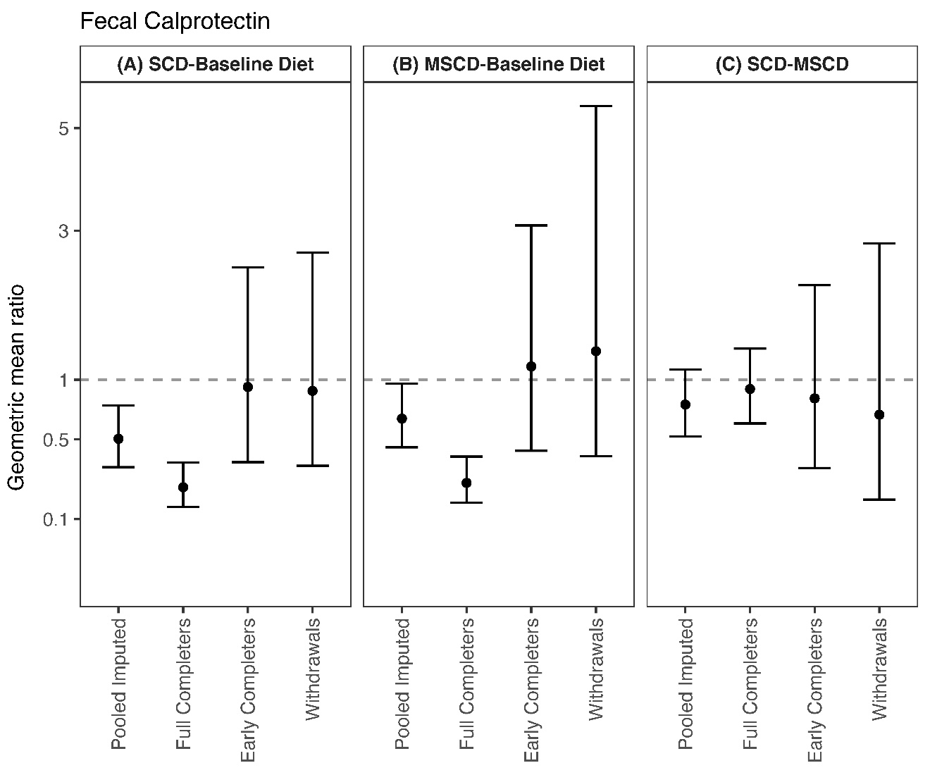

Ratio of geometric means and 95% Credible Interval for aggregate fecal calprotectin for three diet comparisons: (A) SCD versus Baseline Diet, (B) MSCD versus Baseline Diet, and (C) SCD versus MSCD. Within each diet comparison, results are provided for the pooled, imputed sample (n=54), full completers (n=21), early completers (n=9), and withdrawals (n=24).

