Legend of online supplementary materials

Supplementary Figure 1. Flowchart of the screening process
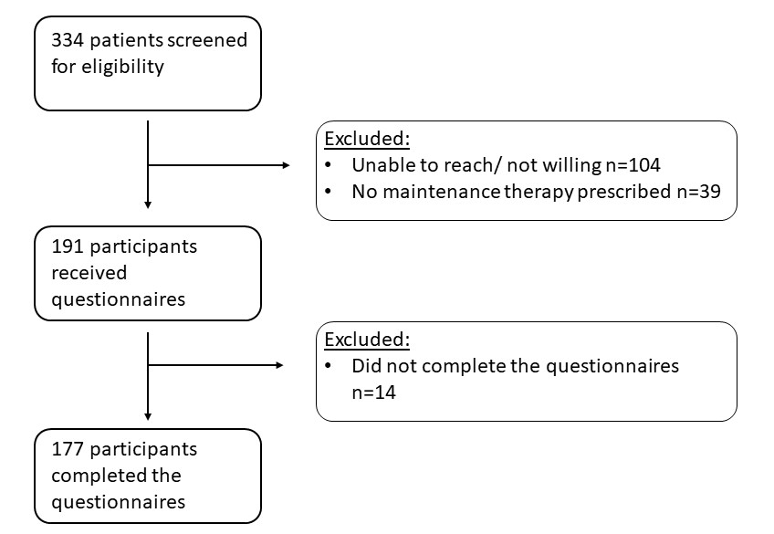

Supplemental Table 1. Differences between treatment adherent and poor adherent patients
Variables | Adherent  (n=102) | Poor adherence  (n=74) | p value
Age, median (IQR) | 45 (32-56) | 38 (30-48) | 0.007
Male, n (%) | 73 (71) | 53 (72) | 0.994
Married, n (%) | 53 (52) | 29 (39) | 0.141
Highly educated, n (%) | 67 (65) | 54 (73) | 0.303
Smoking, n (%) | 4 (4) | 5 (7) | 0.399
Other chronic diseases, median (IQR) | 1 (0-2) | 1 (0-2) | 0.487
Other chronic medication, median (IQR) | 0 (0-2) | 1 (0-2) | 0.663
Disease duration in years, median (IQR) | 5 (3-7) | 5 (3-8) | 0.219
Histologic active disease*, n (%) | 24 (34) | 19 (41) | 0.444
Dilatation ever, n (%) | 7 (7) | 7 (10) | 0.530
First treatment, n (%) | 33 (32) | 18 (24) | 0.246
Treatment duration in months, median (IQR) | 36 (19-73) | 39 (27-72) | 0.471
SDI, median (IQR) | 3 (0-5) | 4 (2-6) | 0.048
Treatment side effects, n (%) | 18 (18) | 15 (20) | 0.660
High concern, n (%) | 24 (23) | 26 (35) | 0.092
Low necessity, n (%) | 33 (33) | 45 (61) | <0.001
SDI Straumann Dysphagia Index
* Number of patients with histologic active disease (≥ 15 eosinophils/HPF) after start of treatment

Supplemental Table 2. Relationship between poor treatment adherence and
IPQ questions | Adherent  Median (IQR) | Poor adherence  Median (IQR) | p value | Univariate Logistic Regression  Odds ratio (95%CI) p value
IPQ 1  Consequences | 4 (2-7) | 5 (3-7) | 0.254 | 1.054 (0.948-1.173) | 0.332
IPQ 2  Timeline | 10 (8-10) | 10 (8-10) | 0.966 | 1.055 (0.882-1.262) | 0.557
IPQ 3  Personal control | 7 (4-9) | 6 (5-7) | 0.065 | 0.921 (0.826-1.027) | 0.137
IPQ 4  Treatment control | 8 (5-9) | 7 (5-8) | 0.030 | 0.880 (0.775-1.000) | 0.050
IPQ 5  Identity | 6 (2-8) | 6 (4-7) | 0.835 | 1.027 (0.921-1.144) | 0.634
IPQ 6  Concern | 5 (2-7) | 6 (3-7) | 0.353 | 1.047 (0.939-1.167) | 0.409
IPQ 7  Understanding | 7 (5-8) | 6 (5-8) | 0.407 | 0.967 (0.857-1.092) | 0.590
IPQ 8  Emotional response | 3 (1-6) | 3 (1-5) | 0.474 | 1.040 (0.937-1.153) | 0.464
illness perception
IPQ Illness Perception Questionnaire

Supplemental Table 3. Differences between adherent and poor adherent patients in medical treatment and dietary treatment group
Variables | Medical treatment |  |  | Dietary treatment
 | Adherent  (n=78) | Poor Adherence  (n=56) | p value | Adherent  (n=48) | Poor Adherence  (n=26) | p value
Age, median (IQR) | 46 (37-57) | 38 (30-48) | 0.002 | 38 (29-53) | 41 (33-51) | 0.571
Male, n (%) | 58 (74) | 39 (70) | 0.547 | 29 (60) | 19 (73) | 0.981
Married, n (%) | 47 (60) | 22 (39) | 0.017 | 17 (35) | 10 (39) | 0.524
Highly educated, n (%) | 47 (60) | 39 (70) | 0.264 | 38 (79) | 22 (85) | 0.634
Smoking, n (%) | 2 (3) | 5 (9) | 0.102 | 2 (4) | 0 (100)
Other chronic diseases, median (IQR) | 1 (0-2) | 1 (0-3) | 0.600 | 1 (0-2) | 1 (0-2) | 0.358
Other chronic medication, median (IQR) | 0 (0-2) | 1 (0-2) | 0.482 | 0 (0-2) | 0 (0-1) | 0.348
Disease duration in years, median (IQR) | 5 (3-8) | 6 (3-8) | 0.468 | 4 (2-6) | 5 (4-8) | 0.107
SDI, median (IQR) | 3 (0-5) | 4 (2-6) | 0.019 | 4 (2-6) | 4 (1-5) | 0.576
Histologic active disease*, n (%) | 16 (30) | 10 (30) | 0.947 | 13 (41) | 13 (72) | 0.032
Dilatation ever, n (%) | 8 (10) | 3 (5) | 0.308 | 4 (8) | 4 (15) | 0.038
First treatment, n (%) | 28 (36) | 15 (27) | 0.265 | 13 (27) | 6 (23) | 0.641
Food groups, median (IQR) |  |  |  | 2 (1-5) | 2 (2-5) | 0.734
Treatment duration in months, median (IQR) | 34 (20-75) | 39 (22-73) | 0.983 | 40 (21-68) | 41 (33-65) | 0.408
Treatment side effects, n (%) | 13 (17) | 11 (20) | 0.658 | 10 (21) | 4 (15) | 0.657
High concern n (%) | 24 (31) | 20 (36) | 0.548 | 7 (15) | 5 (19) | 0.201
Low necessity n (%) | 24 (31) | 35 (63) | <0.001 | 10 (21) | 11 (42) | 0.201

* Number of patients with histologic active disease (≥ 15 eosinophils/HPF) after start of treatment, histologic data available for 87 medical treated patients and for 50 dietary treated patients
Supplemental Table 4. Relationship between poor adherence to treatment and illness perception in medical treatment and
diet treatment group
IPQ; Illness Perception Questionnaire

Variables | Medical treatment |  |  |  |  | Dietary treatment
 | Adherent  Median (IQR) | Poor adherence  Median (IQR) | p value | Univariate logistic regression  Odds ratio (95%CI) p value |  | Adherent  Median (IQR) | Poor adherence  Median (IQR) | p value | Univariate logistic regression  Odds ratio (95%CI) p value
IPQ 1  Consequences | 4 (2-7) | 5 (2-7) | 0.357 | 1.055 (0.938-1.187) | 0.375 | 6 (4-8) | 6 (4-7) | 0.650 | 0.967 (0.801-1.167) | 0.724
IPQ 2  Timeline | 10 (8-10) | 10 (8-10) | 0.985 | 1.035 (0.842-1.272) | 0.743 | 10 (10-10) | 10 (8-10) | 0.540 | 0.909 (0.682-1.211) | 0.514
IPQ 3  Personal control | 7 (4-8) | 6 (4-7) | 0.180 | 0.933 (0.824-1.056) | 0.270 | 7 (4-8) | 7 (5-8) | 0.737 | 0.954 (0.791-1.150) | 0.621
IPQ 4  Treatment control | 8 (6-9) | 7 (5-8) | 0.044 | 0.876 (0.752-1.020) | 0.088 | 8 (5-9) | 7 (5-8) | 0.170 | 0.889 (0.728-1.086) | 0.250
IPQ 5  Identity | 5 (2-7) | 5 (3-7) | 0.631 | 1.039 (0.919-1.175) | 0.540 | 7 (4-8) | 6 (4-8) | 0.170 | 0.969 (0.804-1.167) | 0.739
IPQ 6  Concern | 5 (2-7) | 6 (3-7) | 0.634 | 1.030 (0.912-1.164) | 0.635 | 5 (3-7) | 6 (4-7) | 0.984 | 1.063 (0.882-1.282) | 0.520
IPQ 7  Understanding | 7 (4-8) | 6 (5-8) | 0.554 | 0.969 (0.838-1.120) | 0.668 | 7 (5-9) | 7 (5-8) | 0.211 | 0.952 (0.789-1.149) | 0.610
IPQ 8  Emotional response | 3 (1-5) | 4 (1-6) | 0.596 | 1.042 (0.929-1.169) | 0.482 | 5 (2-7) | 4 (3-5) | 0.708 | 0.987 (0.829-1.175) | 0.886

