Impact of a Web-Based Decision Aid on Shared Decision-Making in Patients with Inflammatory Bowel Disease: IBD&me Randomized Controlled Trial

Protocol v.4.0
February 28, 2019

Sponsor Pfizer Grant ID 37998665

Principal investigator Brennan Spiegel, MD, MSHS
Cedars-Sinai Center for Outcomes Research and Education
Cedars-Sinai Medical Center
Los Angeles, CA
Tel: 310-423-6467
Email: brennan.spiegel@cshs.org

Co-principal investigator Gil Melmed, MD, MS
Cedars-Sinai IBD Center
Cedars-Sinai Medical Center
Los Angeles, CA
Email: gil.melmed@cshs.org

Co-principal investigator Christopher Almario, MD, MSHPM
and data analyst Cedars-Sinai Center for Outcomes Research and Education
Cedars-Sinai Medical Center
Los Angeles, CA
Email: christopher.almario@csmc.edu

Research coordinator Michelle Chen, MPH
Email: michelle.chen2@cshs.org

Research unit Cedars-Sinai Center for Outcomes Research and Education
Cedars-Sinai Medical Center
Los Angeles, CA
Tel.: 310-423-6784

Table of Contents

A. Protocol Summary 4
B. List of Abbreviations 7
C. Background 8
D. Trial Objectives and Outcomes 10
D1. Primary objective: 10
D2. Primary outcome: 10
D3. Secondary objectives: 10
D4. Secondary outcomes: 10
E. Population and Sampling 11
E1. Description of the population 11
E2. Feasibility and recruitment sources 11
E3. Inclusion criteria: 11
E4. Exclusion criteria: 11
F. Trial Design 12
F1. Screening process for participant identification 12
F2. Recruitment 12
F3. Randomization 12
F4. Intervention 12
F5. Consultation with the physician 13
F6. Blinding 13
G. Data Collection 15
G1. Patient questionnaires 15
H. Statistical Analyses 16
H1. Sample size 16
H2. Analyses 16
I. Study Workflow and Logistics 18
I1. Preselection of subjects 18
I2. Follow-up 18
I3. Calendar 18
I4. Stopping participation 18
I5. Protocol amendments 19
J. Other 20
J1. Adverse events 20
J2. Legal and ethical considerations 20
J3. Data processing and storage of documents and data 20
J4. Financing and insurance 20
K. References 21
L. Supplementary Material 23
Appendix 1: IBD&me “Learn More” section 24
Appendix 2: IBD&me Decision Tree 25
Appendix 3: IBD&me personalized report 26
Appendix 4: SDM Q-9 27
Appendix 5: DCS 28
Appendix 6: PSQ-18 29
Appendix 7: IBD-Control 31
Appendix 8: Screening questionnaire 32
Appendix 9: Crohn’s & Colitis Foundation online resource 35
Appendix 10: Baseline questionnaire 36
Appendix 11: First follow-up questionnaire 39
Appendix 12: Second follow-up questionnaire 43

A. Protocol Summary

Title | Impact of a Web-Based Decision Aid On Shared Decision-Making in Patients with Inflammatory Bowel Disease: The IBD&me Randomized Controlled Trial
Coordinating investigator | Dr. Brennan Spiegel
Duration of study | 15 months
Duration of recruitment and data collection | Recruitment will progress for 6 months, with a total of 8 months of data collection from the first to last subject enrolled
Time spent per subject | 70-85 minutes  - Screening: 5 minutes  - Consent and inclusion: 10 minutes  - Navigation through website: 30 minutes for IBD&me; 15 minutes for Crohn’s and Colitis Foundation online resource  - First questionnaire: 15 minutes  - Second questionnaire: 5 minutes
Study objectives | Primary objective:  - To assess the impact of the IBD&me decision aid on patient perceptions of shared decision-making, compared to a standardized education arm  Secondary objectives:  - To assess decisional conflict and patient satisfaction one day after the clinic visit  - To compare disease control and IBD-related QoL two months after the clinic visit to baseline
Methodology | Pragmatic multicenter randomized controlled trial in IBD outpatient care: IBD&me vs. standard education website
Sample size | 152 patients
Eligibility criteria | Inclusion:  - 18 years of age or older  - Have UC, CD, indeterminate colitis, or inflammatory bowel disease unclassified (IBD-U)  - Have experienced IBD related symptoms in the 30 last days before screening  - Have an IBD-related clinic visit scheduled at least 7 days and no later than 3 months following screening  - Considering discussing biologic therapies for controlling his or her IBD at the next clinic visit  Exclusion:  - Does not speak English  - Does not have access to the Internet
Intervention arm | IBD&me is an online, freely available tool that allows patients to explore decision-making around biologic therapies for IBD at their own pace
Control arm | Standardized, high-quality educational material  from the Crohn’s & Colitis Foundation
Study workflow | Preselection of study subjects:  - Identification of eligible patients by means of a screening email 7 days before the scheduled clinic visit (for IBD Qorus patients, screening may not strictly follow this timeline due to logistical constraints)  Randomization:  - Performed using the REDCap randomization module after a patient has signed the electronic consent  Follow-up after clinic visit:  - Patients will be sent an email by research staff one day after the clinic visit inviting them to complete a follow-up questionnaire on REDCap; if necessary, reminders will be sent  - Patients will be sent another follow-up email two months (60 days) after the clinic visit to complete a second follow-up questionnaire on REDCap assessing disease control and health-related QoL; if necessary, reminders will be sent
Outcomes | Primary outcome:  - Patient perceptions of shared decision-making, as measured by the 9-item Shared Decision-Making Questionnaire (SDM-Q-9)  Secondary outcomes:  - Patient perceptions of decisional conflict, as measured using two subscales of the Decisional Conflict Scale (DCS)  - Patient satisfaction, as measured by four domains on the short-form Patient Satisfaction Questionnaire (PSQ-18)  - Disease control and IBD-related QoL, as measured by the IBD-Control questionnaire  - Clinical outcomes and changes in treatment
Statistical Analyses | All analyses will be conducted from an intention-to-treat perspective  - Quantitative data will be expressed as mean ± standard deviation or median with interquartile range, and categorical variables as counts and frequencies  - Percentage comparisons will be made using Chi-square tests or Pearson tests, or if necessary, using Fisher exact tests  - Student’s t-tests, or – if necessary – Wilcoxon tests, will be used to assess for significant differences in DCS, SDM-Q-9, and PSQ-18 scores between the IBD&me and standardized education groups  - Multivariable linear regression will be performed to identify patient characteristics (age, sex, race and ethnicity, education level, etc.), and process characteristics (IBD&me vs. education material comparator) that are independent predictors of higher SDM-Q-9 scores

B. List of Abbreviations

CD: Crohn’s disease

CCF: Crohn’s and Colitis Foundation

IBD: inflammatory bowel disease

QoL: quality of life

SDM: shared decision-making

UC: ulcerative colitis

C. Background

Inflammatory bowel disease (IBD) is a chronic condition associated with significant morbidity and decreased quality of life (QoL) (1, 2). Although there are many treatment options available for patients with ulcerative colitis (UC) and Crohn’s disease (CD), biologic therapies remain the mainstay of treatment for those with moderate-to-severe IBD (3, 4).

While the available biologics and small molecule therapies are effective in treating IBD, there have been few major head-to-head trials of these commonly-prescribed therapeutics. Because of the lack of comparative effectiveness data, IBD clinical care pathways endorse several first-line therapies (5, 6).

Adding to the complexity is the substantial variation among biologics and upcoming small molecules with respect to mechanism of action, mode of administration, and side effects, among other attributes. For example, the therapies can be categorized as anti-tumor necrosis factor (TNF), anti-integrin, anti-interleukin (IL) 12/anti-IL 23 agents, or Janus kinase inhibitors (5, 7, 8). Aside from mechanism of action, IBD therapies also differ in both the route (intravenous vs. subcutaneous vs. oral) and frequency of use. IBD therapeutics also have varying side-effect profiles, as there are differential rates of fatigue, skin rash, lymphoma, infections, and hyperlipidemia (5, 9).

As a result, it is often difficult for patients to navigate the array of treatment options with their physician and to choose a therapy that aligns with their unique treatment preferences. Moreover, the decision-making process will become even more complex as additional effective therapies are developed, tested, and approved for use in clinical practice.

Because there are multiple first-line IBD therapies, it is vital to elicit patient preferences by engaging in shared decision-making (SDM), a process in which clinicians and patients make healthcare choices together by balancing risks and expected outcomes with the patient’s preferences and values (10, 11). In IBD, employing SDM has potential to strengthen the patient-provider dialogue in a way that facilitates alignment between treatment decisions and patient preferences. When effectively employed, SDM can improve medication adherence, enhance QoL and clinical outcomes, and lower healthcare costs compared to a less personalized approach of assigning therapy (12-15).

Conjoint Analysis

Our group recently conducted a study using conjoint analysis – a technique that determines how respondents make complex decisions under conditions of uncertainty – that found systematically different approaches to biologic therapy decision making between patients with UC and CD (16). Moreover, across conditions we found widely divergent individual patient preferences when selecting among biologics. In attempting to identify predictors of individual patient choice, we found that demographic and IBD characteristics were largely unhelpful; 98% of respondents had unique decision-making profiles, again emphasizing the highly-personalized nature of decision making.

Because of the highly-individualized nature of decision making in IBD, along with healthcare’s increased emphasis on SDM, it is critical for clinicians to identify what matters most to patients when choosing among therapeutic options; this enables patients to select therapies that align with their values – a need that is recognized by patients and physicians alike (17, 18). Yet, it can be challenging to accurately establish a patient’s unique preference profile in the context of a brief clinic visit because no two IBD patients are alike. In the face of burgeoning administrative and clinical tasks, gastroenterologists often lack time and resources to engage in detailed discussions around therapies’ risks, benefits, and tradeoffs. Thus, there is a need for simple and efficient tools that elicit individual preferences and support the patient-provider interaction.

Decision aid: IBD&me website

To address this gap, we converted our conjoint analysis into a decision aid called IBD&me. IBD&me is a novel, online tool to enhance SDM between IBD patients and their providers when navigating among the available IBD therapies. The program enables patients to explore the risks and benefits of the different therapies (see Appendix 1), and then guides them through a conjoint survey called the IBD&me Decision Tree (see Appendix 2). Based on the respondent’s answer to the first comparison, an algorithm selects a new side-by-side comparison and asks the respondent to select the preferred profile. The process continues until the respondent reveals internal consistency and the technique collects sufficient data to rank preferences. Once patients complete the survey, the website generates a unique personalized report that can be shared with a doctor (see Appendix 3). The report has been designed to help clinicians efficiently understand what is most important to their patient when selecting a biologic medicine. According to the results of a previous pilot study, the time required to complete IBD&me is approximately 24 minutes.

We hypothesize that IBD&me, through optimizing SDM and improving the patient-provider interaction, will provide incremental benefits beyond those provided by high-quality educational material without an SDM tool.

D. Trial Objectives and Outcomes

D1. Primary objective:

The principal objective of this study is to assess the impact of IBD&me on patient perceptions of SDM as compared to a standardized education arm.

D2. Primary outcome:

Our primary outcome will be patient perceptions of SDM, as measured by the validated 9-item Shared Decision-Making Questionnaire (SDM-Q-9; see Appendix 4) one day after the clinic visit.

D3. Secondary objectives:
- To assess decisional conflict and patient satisfaction one day after the clinic visit
- To compare disease control and IBD-related QoL two months after the clinic visit to baseline (i.e., prior to clinic visit)
- To assess changes in treatment, if any, two months after the clinic visit

D4. Secondary outcomes:
- Patient perceptions of decisional conflict, as measured using the informed and values clarity subscales of the Decisional Conflict Scale (DCS; see Appendix 5)
- Patient satisfaction, as measured by four domains of the Patient Satisfaction Questionnaire relating to communication, general satisfaction, interpersonal manner, and time spent with the doctor (PSQ-18; see Appendix 6) one day after the clinic visit
- Disease control and IBD-related QoL, as measured by the IBD-Control questionnaire (see Appendix 7) prior to the clinic visit and two months after the clinic visit
- IBD therapy use prior to the clinic visit and two months after the clinic visit

E. Population and Sampling

E1. Description of the population

We will recruit IBD patients from participating IBD Qorus institutions and Cedars-Sinai IBD Center in the United States to participate in our RCT comparing use of IBD&me vs. standardized education.

E2. Feasibility and recruitment sources

The proposed study will be carried out by the following partners:
- The Cedars-Sinai IBD Center, a highly-specialized patient care and research facility that is exclusively focused on providing comprehensive diagnostic and treatment services for adults and children with IBD. Over the past 20 years, over 15,000 patients have joined the Cedars-Sinai IBD MIRIAD biorepository for clinical, translational, and genetic research for which patients have consented to be contacted for future research studies including surveys.
- IBD Qorus, a ground-breaking initiative by the Crohn’s & Colitis Foundation with 30 community based and academic IBD centers committed to improving the quality of care delivered to IBD patients, will play a central role in the research. To date, over 1,300 patients have consented to participate in IBD Qorus, with ongoing enrollment and programmatic growth such that enrollment over the next year is expected to increase significantly. Patients are asked to report their symptoms prior to each visit into an electronic data platform that is viewable by the provider during the visit. Patients consenting to the program also agree to be contacted for other related research activities.

E3. Inclusion criteria:
- Age 18 years or older
- Have UC, CD, indeterminate colitis, or inflammatory bowel disease unclassified (IBD-U)
- Have experienced IBD-related symptoms in the 30 last days before screening
- Have an IBD-related clinic visit scheduled at least 7 days and no later than 3 months following screening
- Considering discussing biologic therapies for controlling his or her IBD at the next clinic visit

E4. Exclusion criteria:
- Does not speak English
- Does not have Internet access

F. Trial Design

This is a pragmatic multicenter, patient-level, randomized controlled trial. Standardized questionnaires will be administered at baseline (prior to randomization), one day after the visit, and two months after the visit. The study protocol follows CONSORT guidelines (19).

F1. Screening process for participant identification

All patients enrolled in IBD Qorus or scheduled for a clinic visit at the Cedars-Sinai IBD Center will be contacted by email and asked to complete a screening questionnaire to determine whether they are eligible to participate in the study (see Appendix 8). The purpose of this questionnaire will be to identify patients who have IBD, who have experienced IBD-related symptoms in the last 30 days, and who are considering engaging in conversations concerning biologic therapies with an IBD physician.

F2. Recruitment

Eligible patients who are interested in participating in the study will be emailed a REDCap link to consent electronically. Subjects will then undergo randomization. This process bypasses the busy clinician office and does not rely on providers enrolling patients – a pragmatic design.

The recruitment phase will continue for five months or until the sample size has been reached.

F3. Randomization

Patients will be allocated to either one of two websites: IBD&me (intervention), or the Crohn’s & Colitis Foundation resource on biologic therapies (control arm).

The allocation sequence will be provided by an independent researcher with no involvement in the study. The randomization list will be computer-generated and stratified by recruitment site (Cedars-Sinai Medical Center or IBD Qorus) with permuted blocks of variable sizes. Study coordinators will allocate patients after they have signed the electronic consent by accessing the secure REDCap (Research Electronic Data Capture) randomization module. The allocation sequences will remain unknown to the researchers until the patient is randomized (concealed allocation).

F4. Intervention

Patients randomized to IBD&me will be directed to go through the website at least 2 days before their clinic appointment. Patients randomized to the control arm will be sent a PDF file at least 2 days before their clinic appointment; this file corresponds to the Crohn’s and Colitis Foundation’s (CCF) online resource on biologic therapies, which is a well-researched and clearly presented overview of IBD biologic therapies, but without an active SDM component (see Appendix 9). The website includes information on the different biologics, their mechanisms of action, and dosing frequency. It also describes the risks and special considerations for biologics.

All participants will receive a reminder via email one day before their scheduled clinic visit: 1) patients randomized to the intervention arm will be reminded to go through the IBD&me website before the clinic visit and to bring their personalized report with them to the visit, and 2) patients randomized to the control arm will be reminded to go through the CCF’s resource before the clinic visit and to bring it with them to the visit.

Participants will have three opportunities to revise the date of their clinic visit as originally reported in the screening questionnaire, so long as the revised date occurs within three months of the original date of screening; they will be prompted at least 2 days before the visit, one day before, and in the first follow-up questionnaire. The follow-up questionnaires will be sent based on this new visit date. For a more detailed breakdown of how subjects who report changes to the date of their clinic visit will be managed each of these three timepoints, see Table 1.

Table 1. Planned workflow for participants with revised clinic visit dates

Email with instructions  (at least 2 days pre-visit) | Reminder email  (1 day pre-visit) | First follow-up survey  (1 day post-visit)
Visit has been canceled, with no visit re-scheduled: patient is no longer eligible for the study
Visit has occurred prior to receipt of instructions (IBD Qorus only): patient will complete a truncated version of the first follow-up survey, and second follow-up survey (full)
Visit has been re-scheduled, but will occur within 3 months of screening: adapt timeline for follow-up surveys, but no other changes |  | Visit has been re-scheduled, but will occur within 3 months of screening: end first follow-up survey immediately and re-send later one day post-visit
Visit has been re-scheduled, and will not occur within 3 months of screening: patient is no longer eligible for the study

F5. Consultation with the physician

Physicians will be informed of the study protocol and that patients may bring some materials to the visit, but will be kept blinded by the research team as to whether their patients have been assigned to the control group or intervention group. Physicians will conduct the encounter per standard of care.

F6. Blinding

Given the study design and intervention, it is not possible to ensure the blinding of patients and physicians. However, we will attempt to address the limitations resulting from a lack of blinding:
- Patients and the physicians will be informed of the study protocol, but will not be provided accurate information about the specific primary outcome (i.e. comparison between IBD&me and the CCF resource). The informed consent document will keep participants blind to the study goals.
- Physicians will be kept blinded of the patient’s assignment group until the clinic visit.
- Data will be collected by an independent researcher. Study investigators and the data analyst will remain blinded until all follow-up data is obtained and the primary analysis is finalized.

G. Data Collection

There will be data collected at the time of inclusion in the study, and then at follow-up one day after the clinic visit and two months after the visit.

G1. Patient questionnaires

Upon inclusion in study

Covariate data (see Appendix 10):
- Patient demographics, including age, gender, race and ethnicity, education, marital status, employment status, income, etc.
- Symptoms experienced in the past 30 days, IBD-Control results, and current and prior IBD therapy use

The screening and baseline questionnaires will take about 5 and 10 minutes to complete, respectively.

One day post-visit

Patients will be sent an email by research staff to complete a survey in REDCap with the SDM-Q-9 (see Appendix 4), DCS (see Appendix 5), PSQ-18 (see Appendix 6), and questions about their use of other educational resources (see Appendix 11). This follow-up questionnaire will take about 15 minutes to complete.

Two months post-visit

Patients will be sent an email by research staff to complete a survey on changes in treatment and clinical outcomes, including disease control and IBD-related QoL (see Appendix 12). This follow-up questionnaire will take about 5 minutes to complete.

H. Statistical Analyses

H1. Sample size

There is no data available in the literature regarding the minimally clinically important difference on the SDM-Q-9 scale, but a half standard-deviation difference generally correlates with the minimally clinically important difference.

It is therefore necessary to randomize 64 patients in each arm in order to achieve a moderate effect size of 0.5 (half standard-deviation difference) in mean SDM-Q-9 scores between groups (alpha risk of 5% and power of 80%). Considering a dropout rate of 15%, the adjusted sample size will be 152 patients, or 76 patients in each arm.

H2. Analyses

Standard statistical techniques will be used to describe the characteristics of patients in both groups, and a CONSORT flow diagram will be shown to explain the trial and findings (19).

All analyses will be conducted from an intention-to-treat perspective. Since this is a pragmatic trial, we will track all patients who enroll using the intention-to-treat principle, including those who decide not to use the website and those who do not bring their report with them to the visit. As a secondary analysis, we will also evaluate per-protocol subjects, focusing on those who brought the report to their appointment.

As previously mentioned, participants will have three opportunities to revise the date of their clinic visit in the case of a missed or rescheduled appointment. IBD Qorus participants whose visit occurred prior to receipt of study instructions will be given the opportunity to complete the primary and secondary outcomes and will be analyzed according to the intention-to-treat principle. Participants whose visits have been canceled will not be included in the analysis, as they will no longer meet the eligibility criteria and will not be able to complete the follow-up questionnaires; these subjects will not receive compensation tied to completion of those questionnaires.

The following statistical analysis will be performed on both groups:
- Quantitative data will be expressed as mean ± standard type or median with interquartile range, and categorical variables as counts and frequencies.
- Percentage comparisons will be made using Chi-square tests or Pearson tests, or if necessary, using Fisher exact tests.
- Student’s t-tests, or – if necessary – Wilcoxon tests, will be used to assess for significant differences in DCS, SDM-Q-9, and PSQ-18 scores between the IBD&me and standardized education groups.
- Multivariable linear regression will be performed to identify patient characteristics (age, sex, race and ethnicity, education level, etc.), recruitment site (Cedars-Sinai Medical Center vs. IBD Qorus), and process characteristics (IBD&me vs. education material comparator) that are independent predictors of higher SDM-Q-9 scores.
- For those with up to two missing items for the primary outcome (i.e., SDM-Q-9), we will impute using the mean of the items that were filled out to calculate the raw score. No total score will be calculated if more than two items are missing.
- All tests of hypotheses will be two-sided, at a significance level of 0.05. Calculations will be done using R, version 3.3.1.

I. Study Workflow and Logistics

I1. Preselection of subjects

All patients who sign the informed consent form will be assigned a subject number sequentially by date of consent. Subjects will be identified by a code as follows:
- Number of study inclusion (3 digits)

For example, the second patient enrolled at the first site would be assigned the code 002. Patients who do not pass the screening phase will be listed as screen failures on the master list of consented patients.

I2. Follow-up

We will send subjects email reminders and contact them by phone as needed to complete the follow-up questionnaires.

I3. Calendar

The study will last 15 months in total, with a six-month period of subject recruitment and two-month follow-up per subject.

 | Month
 | 1 | 2 | 3 | 4 | 5 | 6 | 7 | 8 | 9 | 10 | 11 | 12 | 13 | 14 | 15
IRB submission
and approval
Develop study materials
Recruit patients and follow-up email
Data collection and analyses
Prepare and submit manuscript

I4. Stopping participation

Participation in the study will be interrupted in the following circumstances:
- Withdrawal of consent at the request of the subject
- Death of the subject

The appearance of a criterion of exclusion over the course of the study is not a criterion for stopping the study.

I5. Protocol amendments

Should amendments to the protocol be required, the amendments will be originated and documented by the Principal Investigator. It should also be noted that when an amendment to the protocol substantially alters the study design or the potential risk to the patient, a revised consent form might be required. The written amendment, and if required the amended consent form, must be sent to the IRB for approval prior to implementation.

J. Other

J1. Adverse events

There are no adverse events expected with the intervention.

J2. Legal and ethical considerations

Informed consent

Electronic informed consent shall be obtained before the implementation of any act needed for the research.

Final report of the research

The final research report will be written under the responsibility of the coordinating investigator, statistician, and the research coordinator. Once a consensus has been obtained, the final version must be endorsed by the signature of each of the investigators and sent to the sponsor as soon as possible after the definitive end of the research. A written report according to the reference plan of a competent authority shall be transmitted to the competent authority and the IRB within a year, after the end of the research, understood as the last follow-up of the last subject included.

J3. Data processing and storage of documents and data

We will collect all data on REDCap, a secure web application for managing online surveys and databases.

J4. Financing and insurance

Funding

This study is funded by Pfizer (Grant ID 37998665).

Patient compensation

Subject will be compensated $50 for participating in the study, to be paid via Amazon gift cards in increments as follows: $10 concurrently with receipt of email instructions for visiting IBD&me or CCF’s online resource, $30 upon completion of the first follow-up questionnaire, and $10 upon completion of the 2-month follow-up questionnaire.

K. References

- Floyd DN, Langham S, Séverac HC, Levesque BG. The economic and quality-of-life burden of Crohn's disease in Europe and the United States, 2000 to 2013: a systematic review. Dig Dis Sci. 2015;60(2):299-312.
- Bernklev T, Jahnsen J, Schulz T, Sauar J, Lygren I, Henriksen M, et al. Course of disease, drug treatment and health-related quality of life in patients with inflammatory bowel disease 5 years after initial diagnosis. Eur J Gastroenterol Hepatol. 2005;17(10):1037-45.
- Kornbluth A, Sachar DB, Gastroenterology PPCotACo. Ulcerative colitis practice guidelines in adults: American College Of Gastroenterology, Practice Parameters Committee. Am J Gastroenterol. 2010;105(3):501-23; quiz 24.
- Lichtenstein GR, Hanauer SB, Sandborn WJ, Gastroenterology PPCoACo. Management of Crohn's disease in adults. Am J Gastroenterol. 2009;104(2):465-83; quiz 4, 84.
- Sandborn WJ, Su C, Panes J. Tofacitinib as Induction and Maintenance Therapy for Ulcerative Colitis. N Engl J Med. 2017;377(5):496-7.
- Dassopoulos T, Cohen RD, Scherl EJ, Schwartz RM, Kosinski L, Regueiro MD. Ulcerative Colitis Care Pathway. Gastroenterology. 2015;149(1):238-45.
- Danese S, Vuitton L, Peyrin-Biroulet L. Biologic agents for IBD: practical insights. Nat Rev Gastroenterol Hepatol. 2015;12(9):537-45.
- Dulai PS, Sandborn WJ. Next-Generation Therapeutics for Inflammatory Bowel Disease. Curr Gastroenterol Rep. 2016;18(9):51.
- Moćko P, Kawalec P, Pilc A. Safety profile of biologic drugs in the therapy of Crohn disease: A systematic review and network meta-analysis. Pharmacol Rep. 2016;68(6):1237-43.
- Spatz ES, Elwyn G, Moulton BW, Volk RJ, Frosch DL. Shared decision making as part of value based care: New U.S. policies challenge our readiness. Z Evid Fortbild Qual Gesundhwes. 2017;123-124:104-8.
- Beneficiary Engagement and Incentives:Shared Decision Making (SDM) Model | Center for Medicare & Medicaid Innovation 2017 [https://innovation.cms.gov/initiatives/Beneficiary-Engagement-SDM/].
- Billioud V, Laharie D, Filippi J, Roblin X, Oussalah A, Chevaux JB, et al. Adherence to adalimumab therapy in Crohn's disease: a French multicenter experience. Inflamm Bowel Dis. 2011;17(1):152-9.
- Carter CT, Leher H, Smith P, Smith DB, Waters HC. Impact of persistence with infliximab on hospitalizations in ulcerative colitis. Am J Manag Care. 2011;17(6):385-92.
- Kane SV, Chao J, Mulani PM. Adherence to infliximab maintenance therapy and health care utilization and costs by Crohn's disease patients. Adv Ther. 2009;26(10):936-46.
- Kane S, Huo D, Aikens J, Hanauer S. Medication nonadherence and the outcomes of patients with quiescent ulcerative colitis. Am J Med. 2003;114(1):39-43.
- Almario CV, Keller MS, Chen M, Lasch K, Ursos L, Shklovskaya J, et al. Optimizing Selection of Biologics in Inflammatory Bowel Disease: Development of an Online Patient Decision Aid Using Conjoint Analysis. Am J Gastroenterol. 2018;113(1):58-71.
- Siegel CA, Lofland JH, Naim A, Gollins J, Walls DM, Rudder LE, et al. Novel Statistical Approach to Determine Inflammatory Bowel Disease: Patients' Perspectives on Shared Decision Making. Patient. 2016;9(1):79-89.
- Siegel CA. Shared decision making in inflammatory bowel disease: helping patients understand the tradeoffs between treatment options. Gut. 2012;61(3):459-65.
- Schulz KF, Altman DG, Moher D, Group C. CONSORT 2010 statement: updated guidelines for reporting parallel group randomised trials. BMJ. 2010;340:c332.

L. Supplementary Material

Appendix 1. IBD&me “Learn More” section

Appendix 2. IBD&me Decision Tree

Appendix 3. IBD&me personalized report

Appendix 4. 9-item Shared Decision Making Questionnaire (SDM Q-9)

Appendix 5. Decisional Conflict Scale (DCS)

Appendix 6. Short-Form Patient Satisfaction Questionnaire (PSQ-18)

Appendix 7. IBD-Control questionnaire

Appendix 8. Screening questionnaire

Appendix 9. Crohn’s & Colitis Foundation online resource

Appendix 10. Baseline questionnaire

Appendix 11. First follow-up questionnaire

Appendix 12. Second follow-up questionnaire

Appendix 1: IBD&me “Learn More” section

In the “Learn More” section, patients learn about important terms and concepts related to biologics. The page below shows the clinically available biologic therapies and their mechanisms of action.

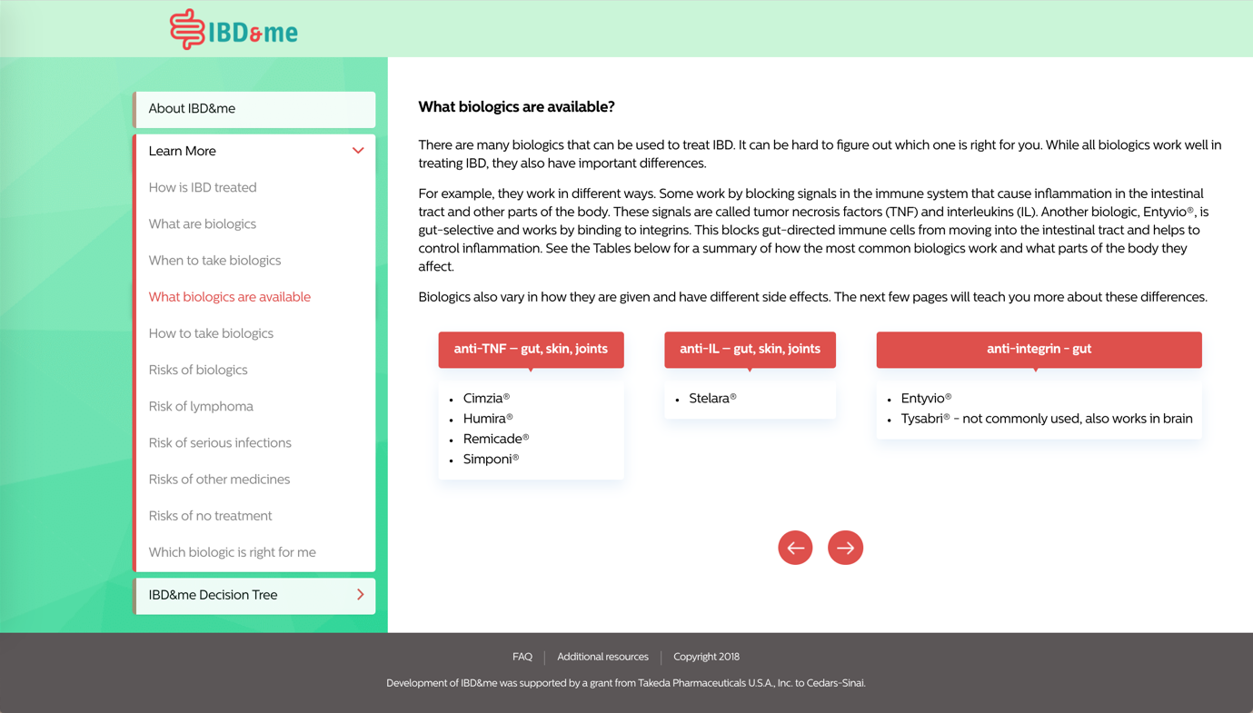

Appendix 2: IBD&me Decision Tree

The Decision Tree shows patients side-by-side comparisons of biologic medication attributes and asks respondents to select the preferred profile. In the example below, a patient must weigh frequency of administration and risk of lymphoma.

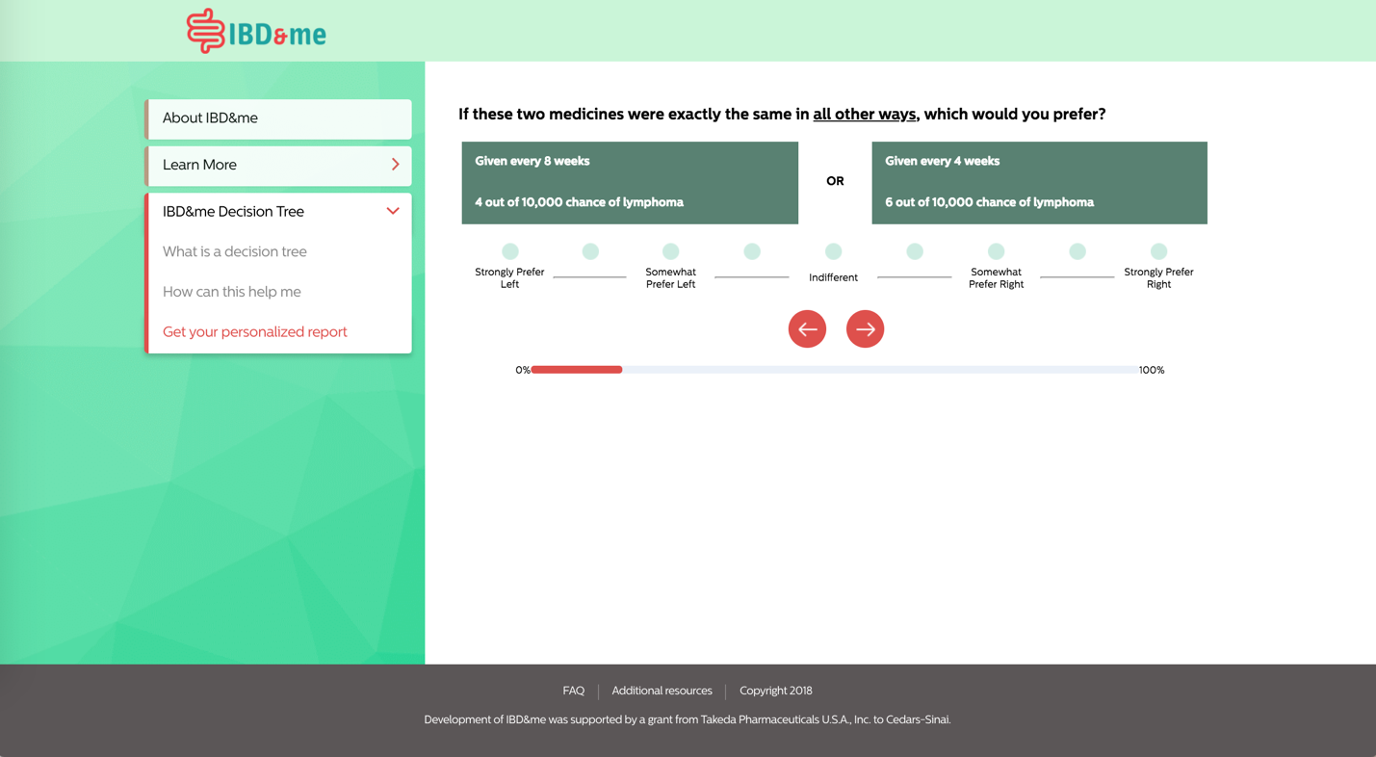

Appendix 3: IBD&me personalized report

The personalized report shows biologic medication attributes rank-ordered by their importance to the patient during the decision-making process.

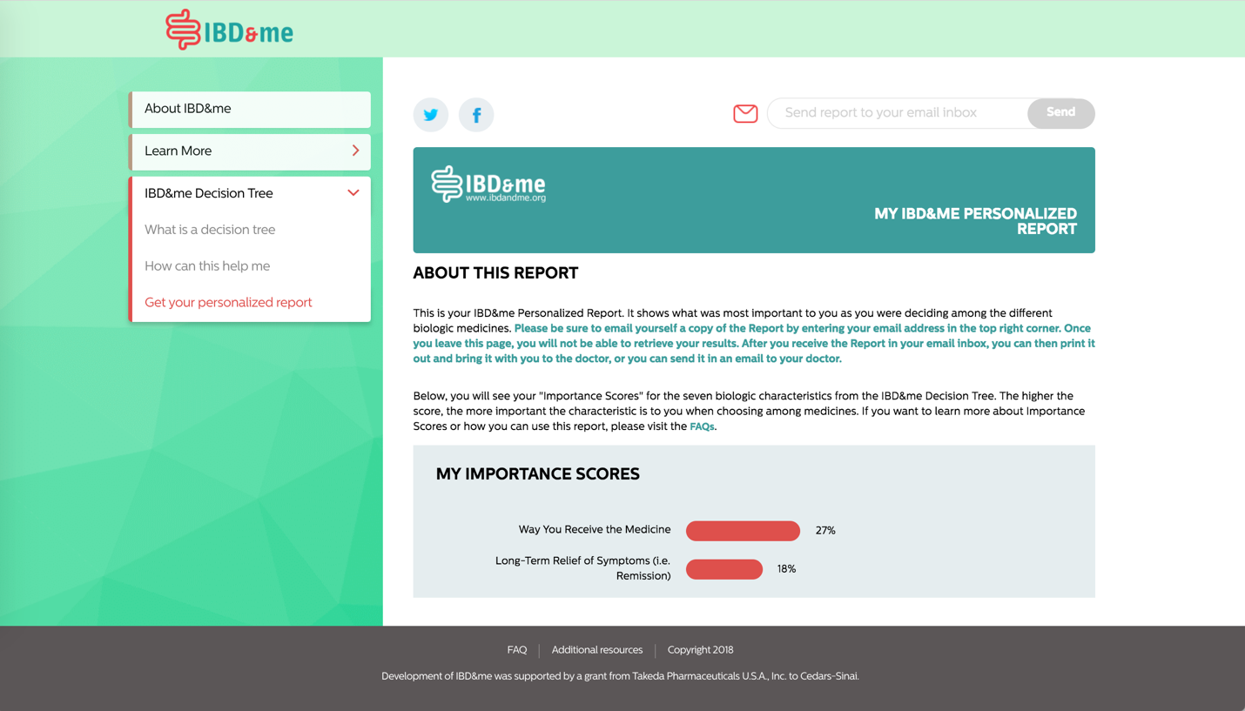

Appendix 4: SDM Q-9

Nine statements related to the decision-making during your visit with your IBD doctor are listed below. For each statement, please indicate how much you agree or disagree.

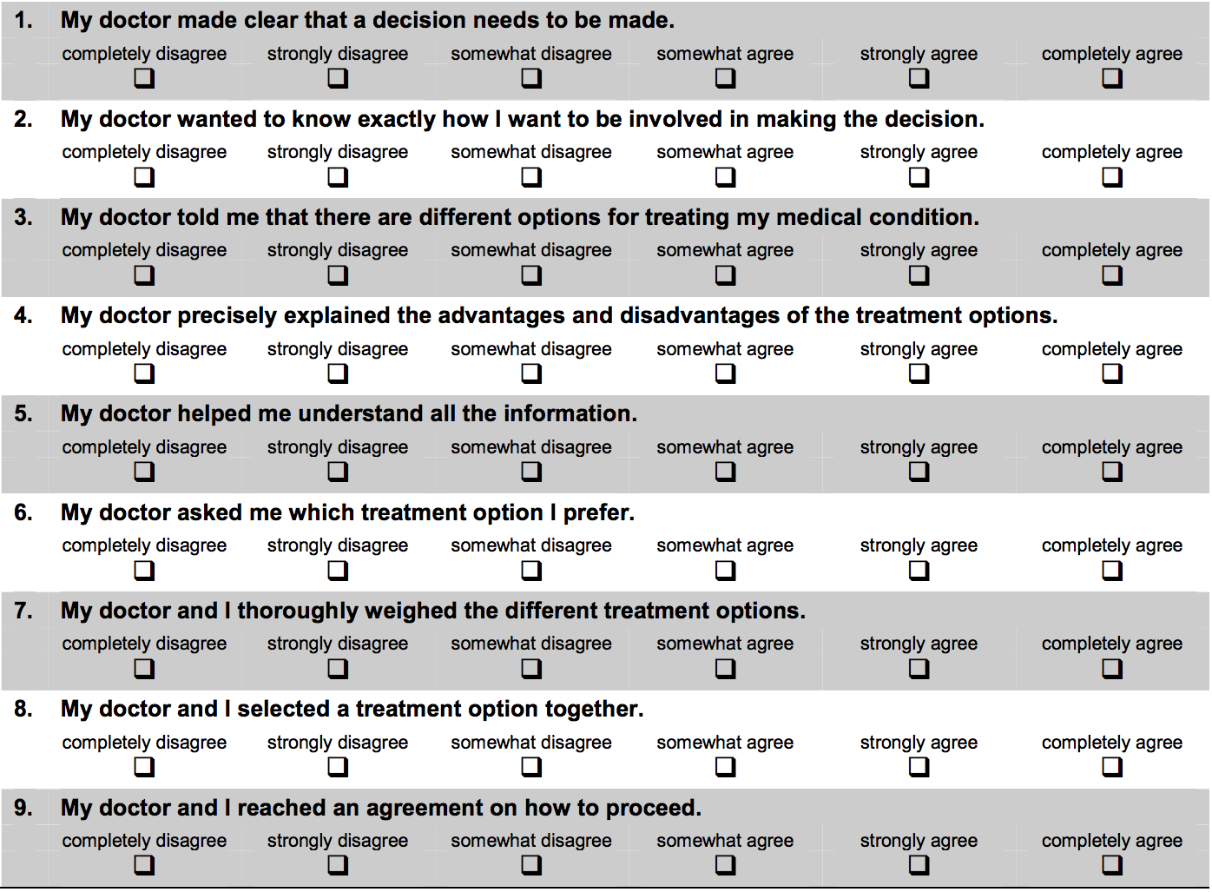

Appendix 5: DCS

Considering the different biologic treatment options, please answer the following questions:

- I know which biologic options are available to me.
  - Strongly agree
  - Agree
  - Uncertain
  - Disagree
  - Strongly disagree

- I know the benefits of each biologic option.
  - Strongly agree
  - Agree
  - Uncertain
  - Disagree
  - Strongly disagree

- I know the risks and side effects of each biologic option.
  - Strongly agree
  - Agree
  - Uncertain
  - Disagree
  - Strongly disagree

- I am clear about which benefits of biologics matter most to me.
  - Strongly agree
  - Agree
  - Uncertain
  - Disagree
  - Strongly disagree

- I am clear about which risks and side effects of biologics matter most to me.
  - Strongly agree
  - Agree
  - Uncertain
  - Disagree
  - Strongly disagree

- I am clear about which is more important to me (the benefits or the risks and side effects).
  - Strongly agree
  - Agree
  - Uncertain
  - Disagree
  - Strongly disagree

Appendix 6: PSQ-18

The following questions are some things people say about medical care. Please read each one carefully, keeping in mind the medical care you received during your most recent IBD clinic visit. We are interested in your feelings, good and bad, about the medical care you have received.

How strongly do you AGREE or DISAGREE with each of the following statements?

- My doctor is good about explaining the reason for medical tests.
- Strongly agree
- Agree
- Uncertain
- Disagree
- Strongly disagree

- The medical care I have been receiving is just about perfect.
- Strongly agree
- Agree
- Uncertain
- Disagree
- Strongly disagree

- My doctor acts too businesslike and impersonal toward me.
- Strongly agree
- Agree
- Uncertain
- Disagree
- Strongly disagree

- My doctor treats me in a very friendly and courteous manner.
- Strongly agree
- Agree
- Uncertain
- Disagree
- Strongly disagree

- Those who provide my medical care sometimes hurry too much when they treat me.
- Strongly agree
- Agree
- Uncertain
- Disagree
- Strongly disagree

- My doctor sometimes ignores what I tell him/her.
- Strongly agree
- Agree
- Uncertain
- Disagree
- Strongly disagree

- My doctor usually spends plenty of time with me.
- Strongly agree
- Agree
- Uncertain
- Disagree
- Strongly disagree

- I am dissatisfied with some things about the medical care I receive.
- Strongly agree
- Agree
- Uncertain
- Disagree
- Strongly disagree

Appendix 7: IBD-Control

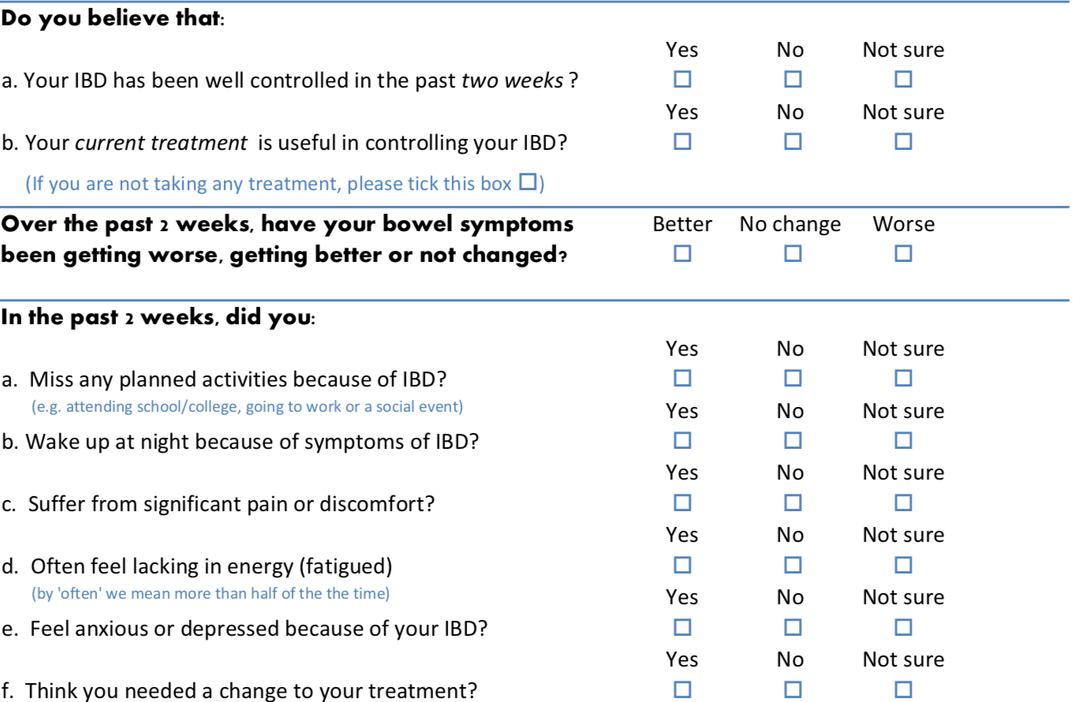

Appendix 8: Screening questionnaire

- What kind of inflammatory bowel disease (IBD) do you have?
- Ulcerative colitis (UC)
- Crohn’s disease (CD)
- Indeterminate colitis or IBD unclassified (IBD-U)
- I’m not sure
- I do not have IBD

Note: If UC, CD, indeterminate colitis, or IBD-U, continue the survey; otherwise, the patient is not eligible.

- What symptoms related to your IBD have you experienced in the last 30 days, if any? Select all that apply.
- Belly pain
- Diarrhea
- Bowel incontinence or leakage (soiling your underwear with stool)
- Urgency (having to run to the bathroom)
- Nausea and/or vomiting
- Joint pain
- Blood in stool or rectal bleeding
- Other: ____________________
- I am not experiencing any symptoms related to my IBD

Note: If any symptoms, continue the survey; if no symptoms, the patient is not eligible.

- What medicines are you currently taking for your IBD? Select all that apply.
- Topical (rectal) mesalamines (e.g. Canasa, Rowasa)
- Topical (rectal) steroids (e.g. Protocort, Cortifoam, Cortenema)
- Oral sulfasalazine
- Oral mesalamines/aminosalicylates (e.g. Asacol, Delzicol, Lialda, Apriso, Pentasa, Colazal, Azulfidine)
- Oral steroid tablets (e.g. prednisone, Deltasone, Medrol)
- Budesonide (e.g. Entocort, Uceris)
- Azathioprine or 6-mercaptopurine (e.g. Imuran)
- Cyclosporine
- Methotrexate
- Adalimumab (Humira)
- Certolizumab (Cimzia)
- Golimumab (Simponi)
- Infliximab (Remicade)
- Ustekinumab (Stelara)
- Vedolizumab (Entyvio)
- Tofacitinib (Xeljanz)
- Other: ____________________
- I am not currently taking any of these medicines

- Note: If already on a biologic, continue to the question directly below.

You are currently taking one or more of the following biologic medicines: adalimumab (Humira), certolizumab (Cimzia), golimumab (Simponi), infliximab (Remicade), ustekinumab (Stelara), vedolizumab (Entyvio).

At your next clinic visit, would you like to discuss other biologic medicines for controlling your IBD?
  - Yes, I would like to discuss other biologic medicines at my next clinic visit.
  - No, I do not plan on discussing other biologic medicines at my next clinic visit.
  - I’m not sure.

Note: If not already on a biologic, continue to the question directly below.

The following treatments are called biologic medicines: adalimumab (Humira), certolizumab (Cimzia), golimumab (Simponi), infliximab (Remicade), ustekinumab (Stelara), vedolizumab (Entyvio). Biologics are among the most effective type of medicines used to treat IBD, and are often used in those with moderate to severe symptoms.

At your next clinic visit, would you like to discuss biologic medicines for controlling your IBD?
  - Yes, I would like to discuss biologic medicines at my next clinic visit.
  - No, I do not plan on discussing biologic medicines at my next clinic visit.
  - I’m not sure.

Note: If first or third option selected, continue the survey; if second option selected, the patient is not eligible.

- Please enter the full name of your IBD doctor: __________

- Where is your IBD doctor located? __________

- Do you have an upcoming visit with your IBD doctor?
  - Yes
  - No
  - I’m not sure

Note: If first option selected, continue to #9; if second option selected, the patient is not eligible. If third option selected, continue to questions directly below and skip #9.

Could you tell us why you are unsure about the date of your visit?
    - My visit has not been scheduled yet.
    - I don’t remember the date of my visit and will need to check when it is.
    - Other: ____________________

A member of the study team will be following up with you to confirm your eligibility for this study. Please provide your contact information below.

Phone number: __________
Email address: __________

- When is your next scheduled visit with your IBD doctor? __________

Note: Format should be MM/DD/YYYY. If visit is <7 days or >60 days from date of survey completion, the patient is not eligible.

Appendix 9: Crohn’s & Colitis Foundation online resource

Available at: http://www.crohnscolitisfoundation.org/assets/pdfs/medications-biologic-therapy.pdf

Appendix 10: Baseline questionnaire

According to Cedars-Sinai Medical Center policy, we are required to collect the last 4 digits of your Social Security Number for tax purposes when distributing gift cards. The research team will not use this information for any purposes other than payment.

Please enter the last 4 digits of your Social Security Number: __________

About you

- What is your full name (first and last)?

- Please enter your email address: __________

- Please enter your phone number: __________

- What is your sex?
  - Male
  - Female

- Do you consider yourself Hispanic/Latino or not Hispanic/Latino?
  - Hispanic or Latino
  - Not Hispanic or Latino

- Which of the following five racial designations best describes you? More than one choice is acceptable.
  - American Indian or Alaska Native
  - Asian
  - Black or African American
  - Native Hawaiian or other Pacific Islander
  - White
  - Other: _______________

- What is your current marital status?
  - Single, never married
  - Married, domestic partnership, or long-term relationship
  - Widowed
  - Divorced or separated

- What is your total household yearly income?
  - Less than $10,000
  - Between $10,001 and $20,000
  - Between $20,001 and $50,000
  - Between $50,001 and $100,000
  - Between $100,001 and $200,000
  - More than $200,001
  - Prefer not to answer

- What is your employment status? Select all that apply.
  - Unemployed
  - Homemaker
  - Full-time employment or full-time student (40 or more hours per week)
  - Part-time employment or part-time student (less than 40 hours per week)
  - Retired
  - Unable to work or on disability
  - On leave of absence from work
  - Military
  - Other: _______________

- What is the highest degree or level of education you have completed?
  - Eighth grade or less
  - Completed some high school
  - High school graduate (includes equivalency)
  - Some college, no degree
  - Associate’s degree
  - Bachelor’s degree
  - Master’s degree or other advanced degree beyond a master’s degree

- What type of health insurance do you have? Select all that apply.
  - Insurance through a current or former employer or union (of this person or another family member)
  - Insurance purchased directly from an insurance company (by this person or another family member)
  - Medicare, for people 65 and older, or people with certain disabilities
  - Medicaid, Medical Assistance, or any kind of government-assistance plan for this with low incomes or a disability
  - TRICARE or other military health care
  - VA (including those who have ever used or enrolled for VA health care)
  - Indian Health Service
  - I do not have health insurance
  - Other: _______________

About your IBD

- When were you first diagnosed with IBD?
- Within the last year
- Between 1 and 5 years ago
- Between 5 and 10 years ago
- More than 10 years ago

- Have you previously had surgery to remove a part of your intestines because of your IBD?
- Yes
- No

- What medicines have you used in the past but are not currently using for your IBD? Select all that apply.
- Topical (rectal) mesalamines (e.g. Canasa, Rowasa)
- Topical (rectal) steroids (e.g. Protocort, Cortifoam, Cortenema)
- Oral sulfasalazine
- Oral mesalamines/aminosalicylates (e.g. Asacol, Delzicol, Lialda, Apriso, Pentasa, Colazal, Azulfidine)
- Oral steroid tablets (e.g. prednisone, Deltasone, Medrol)
- Budesonide (e.g. Entocort, Uceris)
- Azathioprine or 6-mercaptopurine (e.g. Imuran)
- Cyclosporine
- Methotrexate
- Adalimumab (Humira)
- Certolizumab (Cimzia)
- Golimumab (Simponi)
- Infliximab (Remicade)
- Ustekinumab (Stelara)
- Vedolizumab (Entyvio)
- Tofacitinib (Xeljanz)
- Other: ____________________
- I have not used any of these medicines in the past

About your quality of life

Subjects will also fill out the IBD-Control questionnaire (see Appendix 6) as part of the baseline survey.

Appendix 11: First follow-up questionnaire

For subjects in the intervention arm:

- Did you attend your clinic visit with Dr. [name] on [date of visit]?
  - Yes
  - No, I rescheduled this visit.
  - No, I canceled this visit and do not have any upcoming visits.

Note: If yes, skip to question #2; if second option selected, continue to the question directly below; if third option selected, conclude survey.

What is the new date of your visit? __________

Note: If next visit is within three months of screening date, conclude survey and re-send one day after new visit date; otherwise, conclude survey.

- Did you receive an invitation to go through a website called IBD&me before this clinic visit?
  - Yes
  - No

Note: If yes, continue to the question below; otherwise, skip to question #4.

- Did you look at the IBD&me website before your visit with your doctor?
  - Yes
  - No

- Note: If the patient answered “No” to #3, continue to the question directly below.
Could you briefly explain why you did not visit the IBD&me website?

Note: If the patient answered “Yes” to #3, continue to the question directly below.

Did you bring your IBD&me personalized report to your visit with your doctor?
  - Yes
  - No

Note: If the patient answered “No” to this question, continue to the first question directly below and skip the second question. If the patient answered “Yes” to this question, skip the first question and continue to the second question.

Could you explain why you did not bring the IBD&me personalized report to your visit?
    - I visited the website, but left before receiving the personalized report.
    - I visited the website and received my personalized report, but I did not want to share it with my doctor.
    - I visited the website and received my personalized report, but I forgot to bring it with me.
    - Other: ____________________

Note: The first two answer choices branch to a free text field asking patients why they took this action.

Please tell us a little bit more about your visit.
    - I did not show my personalized report to my doctor during the visit.
    - I showed my personalized report to my doctor, but we did not discuss it during the visit.
    - I showed my personalized report to my doctor, and we discussed it during the visit.
    - Other: ____________________

Note: All answers except “Other” branch to a free text field asking patients either why they took this action (first two answer choices) or how the visit went (third answer choice).

- How likely are you to recommend IBD&me to another patient with IBD?

1 | 2 | 3 | 4 | 5 | 6 | 7
Not at all likely |  |  | Neutral |  |  | Extremely likely
O | O | O | O | O | O | O

For subjects in the control arm:

- Did you attend your clinic visit with Dr. [name] on [date of visit]?
  - Yes
  - No, I rescheduled this visit for a future time.
  - No, I canceled this visit and do not have any upcoming visits.

Note: If yes, skip to question #2; if second option selected, continue to the question directly below; if third option selected, conclude survey.

What is the new date of your visit? __________

Note: If next visit is within three months of screening date, conclude survey and re-send one day after new visit date; otherwise, conclude survey.

- Did you receive a PDF document about biologics titled "Fact Sheet" before this clinic visit?
  - Yes
  - No

Note: If yes, continue to the question below; otherwise, skip to question #4.

- Did you read this fact sheet about biologics before your visit with your doctor?
  - Yes
  - No

- Note: If the patient answered “No” to #3, continue to the question directly below.
Could you explain briefly why you did not read the biologics fact sheet?

Note: If the patient answered “Yes” to #3, continue to the question directly below.

Did you bring the biologics fact sheet to your visit with your doctor?
  - Yes
  - No

Note: If the patient answered “No” to this question, continue to the first question directly below and skip the second question. If the patient answered “Yes” to this question, skip the first question and continue to the second question.

Could you briefly explain why you did not bring the biologics fact sheet to your visit?

Please tell us a little bit more about your visit.
    - I did not show the biologics fact sheet to my doctor during the visit.
    - I showed the biologics fact sheet to my doctor, but we did not discuss it during the visit.
    - I showed the biologics fact sheet to my doctor, and we discussed it during the visit.
    - Other: ____________________

Note: All answers except “Other” branch to a free text field asking patients either why they took this action (first two answer choices) or how the visit went (third answer choice).

- How likely are you to recommend the biologics fact sheet to another patient with IBD?

1 | 2 | 3 | 4 | 5 | 6 | 7
Not at all likely |  |  | Neutral |  |  | Extremely likely
O | O | O | O | O | O | O

For subjects in both arms:

- Did you access any other online educational materials or resources that provide information about biologic medicines before your most recent visit?
- Yes
- No

Note: If yes, continue to the question below.

Please list the names of the other materials or resources you used: _______________

- Based on your discussion with your doctor, which medicines are you currently taking or will be taking soon for your IBD? Select all that apply.
- Topical (rectal) mesalamines (e.g. Canasa, Rowasa)
- Topical (rectal) steroids (e.g. Protocort, Cortifoam, Cortenema)
- Oral sulfasalazine
- Oral mesalamines/aminosalicylates (e.g. Asacol, Delzicol, Lialda, Apriso, Pentasa, Colazal, Azulfidine)
- Oral steroid tablets (e.g. prednisone, Deltasone, Medrol)
- Budesonide (e.g. Entocort, Uceris)
- Azathioprine or 6-mercaptopurine (e.g. Imuran)
- Cyclosporine
- Methotrexate
- Adalimumab (Humira)
- Certolizumab (Cimzia)
- Golimumab (Simponi)
- Infliximab (Remicade)
- Ustekinumab (Stelara)
- Vedolizumab (Entyvio)
- Tofacitinib (Xeljanz)
- Other: ____________________
- I am not sure yet
- I am not taking any medicines for my IBD

- If you have any comments about your treatment plan, please provide them in the space below (optional): _______________

All subjects will also fill out the SDM-Q9, DCS, and PSQ-18 (see Appendix 4, 5, and 6, respectively) as part of this follow-up survey.

Appendix 12: Second follow-up questionnaire

- What symptoms related to your IBD have you experienced in the last 30 days, if any? Select all that apply.
- Belly pain
- Diarrhea
- Bowel incontinence or leakage (soiling your underwear with stool)
- Urgency (having to run to the bathroom)
- Nausea and/or vomiting
- Joint pain
- Blood in stool or rectal bleeding
- Other: ____________________
- I am not experiencing any of these symptoms

- What medicines, if any, are you currently taking for your IBD? Select all that apply.
- Topical (rectal) mesalamines (e.g. Canasa, Rowasa)
- Topical (rectal) steroids (e.g. Protocort, Cortifoam, Cortenema)
- Oral sulfasalazine
- Oral mesalamines/aminosalicylates (e.g. Asacol, Delzicol, Lialda, Apriso, Pentasa, Colazal, Azulfidine)
- Oral steroid tablets (e.g. prednisone, Deltasone, Medrol)
- Budesonide (e.g. Entocort, Uceris)
- Azathioprine or 6-mercaptopurine (e.g. Imuran)
- Cyclosporine
- Methotrexate
- Adalimumab (Humira)
- Certolizumab (Cimzia)
- Golimumab (Simponi)
- Infliximab (Remicade)
- Ustekinumab (Stelara)
- Vedolizumab (Entyvio)
- Tofacitinib (Xeljanz)
- Other: ____________________
- I am not taking any medicines for my IBD

- In the last 2 months, have you had surgery related to your IBD?
- Yes
- No

- In the last 2 months, have you had to go to the Emergency Department for your IBD?
- Yes
- No

Subjects will also fill out the IBD-Control questionnaire (see Appendix 7) as part of this follow-up survey.

