Supplemental material
Figure S1. Flow of patients. Flow of patients for study inclusion and completion of additional testing, treatment, and follow-up. FLIP – functional lumen imaging probe; HRM – high-resolution manometry; CCv4.0 - Chicago Classification version 4.0; EGJOO – esophagogastric junction outflow obstruction; BEDQ – brief esophageal dysphagia questionnaire; ES – Eckardt score; PD – pneumatic dilation; POEM – peroral endoscopic myotomy; LHM – laparoscopic Heller’s myotomy.
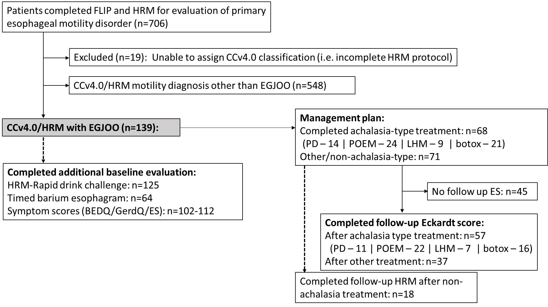

Figure S2. Clinical outcome defined by Eckardt score dysphagia item, by treatment approach and FLIP Panometry motility classification among patients with manometric EGJ outflow obstruction (EGJOO) per Chicago Classification v4.0. Among patients with normal EGJ opening, 2/3 (67%) with achalasia-type treatment (both treated with botulinum toxin injection) had a good outcome (i.e. dysphagia score 0 or 1), while 80% (8/10 patients) with non-achalasia type treatment had a good outcome. Among patients with a HRM+FLIP Panometry impression of ‘conclusive EGJOO’, 88% (38/43) had a good outcome after achalasia-type treatment, while 17% (2/12) patients had a good outcome after non-achalasia type treatment. LES – lower esophageal sphincter; POEM – peroral endoscopic myotomy; CR – contractile response. Figure used with permission from the Esophageal Center of Northwestern.
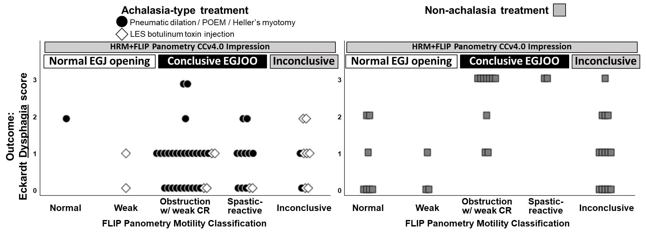

Figure S3. Clinical outcomes by treatment approach and additional complementary test results among patients with manometric EGJ outflow obstruction per Chicago Classification v4.0. LES – lower esophageal sphincter; POEM – peroral endoscopic myotomy; IRP – integrated relaxation pressure; PEP – panesophageal pressurization. Figure used with permission from the Esophageal Center of Northwestern.
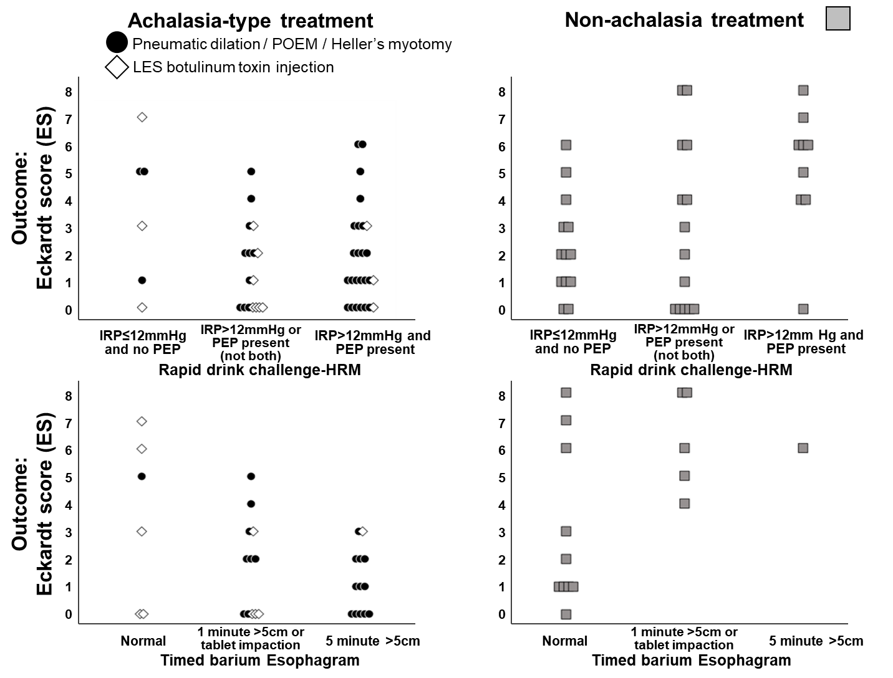

Table S1. Clinical characteristics by FLIP Panometry Motility classification among patients with EGJ outflow obstruction on high resolution manometry (HRM). *P<0.05, **P<0.001 on comparison between five FLIP Panometry motility classifications. ª P=0.052.
BEDQ – CR – contractile response; Brief Esophageal Dysphagia Questionnaire; IRP – integrated relaxation pressure; PEP – panesophageal pressurization.
FLIP motility classification | Normal | Weak | Obstruction with weak CR | Spastic-reactive | Inconclusive
Patient characteristics
n (%) | 20 (14) | 10 (7) | 49 (35) | 19 (14) | 41 (29)
Age, mean (SD) years* | 51 (15) | 66 (13) | 58 (15) | 67 (9) | 60 (14)
Sex; n (%) female | 13 (65) | 7 (70) | 23 (47) | 11 (58) | 25 (61)
Additional baseline testing
HRM, median supine IRP, mmHg, median (IQR)* | 21 (18-28) | 23 (20-26) | 28 (22-35) | 24 (20-32) | 22 (18-26)
HRM, median upright IRP, mmHg, median (IQR)** | 18 (15-24) | 19 (13-25) | 32 (21-37) | 22 (17-35) | 20 (17-27)
HRM, Basal EGJ pressure (end-expiration), mmHg, median (IQR)* | 36 (22-45) | 21 (14-26) | 32 (22-52) | 31 (20-45) | 30 (19-36)
HRM EGJ morphology, n (%)  Type I  Type II or III | 15 (75)  5 (25) | 5 (50)  5 (50) | 42 (86)  7 (14) | 14 (74)  5 (26) | 34 (83)  7 (17)
HRM-primary peristalsis/contractility pattern, n (%)*  Normal  Ineffective  Hypercontractile  Premature | 17 (85)  0  2 (10)  1 (5) | 9 (90)  1 (10)  0  0 | 24 (49)  5 (10)  8 (16)  12 (25) | 7 (37)  1 (5)  3 (16)  8 (42) | 22 (53)  0  8 (20)  11 (27)
HRM-rapid drink challenge (RDC)  RDC-IRP, mmHg, median (IQR)**  RDC-IRP > 12mmHg, n (%)*  PEP>30mmHg, n (%)**  --  HRM-RDC IRP and PEP, n (%)**  RDC-IRP<12mmHg AND PEP absent  RDC-IRP>12mmHg or PEP present (not both)  RDC-IRP>12mmHg AND PEP present | [n=19]  7 (4-13)  5 (26)  5 (26)  --  11 (58)  6 (32)  2 (11) | [n=8]  11 (9-14)  3 (38)  2 (25)  --  5 (63)  1 (13)  2 (25) | [n=44]  16 (11-27)  31 (71)  34 (79)  --  4 (9)  14 (33)  25 (58) | [n=17]  11 (7-15)  7 (41)  15 (88)  --  1 (6)  10 (59)  6 (35) | [n=38]  12 (9-16)  16 (42)  24 (63)  --  9 (24)  18 (47)  11 (29)
Timed barium esophagram, n (%)*  5 min column >5cm  1 min column >5cm OR tablet impaction  Normal | [n=11]  0  2 (18)  9 (82) | [n=6]  0  1 (17)  5 (83) | [n=24]  13 (54)  9 (38)  2 (8) | [n=11]  2 (18)  8 (73)  1 (9) | [n=12]  1 (8)  5 (42)  6 (50)
Baseline symptom scores
[completed Eckardt score]  Eckardt score, median (IQR)  Eckardt score ≥3, n (%) | [n=16]  3 (2-7)  11 (69) | [n=7]  3.5 (2-4)  5 (71) | [n=33]  6 (3-7)  28 (85) | [n=15]  5 (3-7)  13 (87) | [n=34]  4 (3-6)  25 (74)
[completed BEDQ]  BEDQ score, median (IQR)ª  BEDQ score ≥10 n (%)* | [n=17]  10 (5-18)  9 (53) | [n=8]  5 (1-5)  1 (13) | [n=35]  16 (8-23)  26 (74) | [n=17]  17 (11-23)  14 (82) | [n=36]  18 (9-23)  27 (75)
[completed GerdQ]  GerdQ score, median (IQR)  GerdQ score ≥9, n (%) | [n=17)  9 (6-11)  10 (59) | [n=7]  9 (6-11)  4 (57) | [n=33]  9 (8-12)  23 (70) | [n=14]  9 (8-10)  7 (50) | [n=31]  7 (6-10)  13 (42)

