Supplementary Table 1 - Backwards stepwise selection for covariates (p<0.15 for inclusion in adjusted model)
Variable | OR (95% CI) | p-value
Prior anti-TNF exposure | 0.58 (0.37-0.90) | 0.015
Disease duration | 1.03 (1.00-1.06) | 0.019
Baseline Mayo score | 0.92 (0.82-1.02) | 0.128
Baseline fecal calprotectin |  | 0.182
Baseline C-reactive protein |  | 0.578
Baseline albumin | 1.12 (1.07-1.17) | <0.001
Concomitant immunomodulator use |  | 0.289
Concomitant corticosteroid use |  | 0.196

Supplementary Table 2 – Mayo scores and fecal calprotectin at week 14 among patients with delayed PMS remission (week 14)
 | Delayed PMS remitters to vedolizumab |  |  | Delayed PMS remitters to adalimumab |  | p-value
 | Ultimately achieve remission at week 52 (n=25) | Ultimately do not achieve remission at week 52 (n=25) | p-value | Ultimately achieve remission at week 52 (n=27) | Ultimately do not achieve remission at week 52 (n=17)
Partial Mayo Score at week 14, mean (SD) | 0.68 (0.48) | 0.72 (0.46) | 0.764 | 0.63 (0.49) | 0.71 (0.47) | 0.613
Total Mayo score at week 14, mean (SD) | 1.52 (0.87) | 2.64 (1.29) | <0.001 | 1.52 (1.12) | 2.24 (1.35) | 0.063
Severe endoscopic disease (Mayo 3) at week 14, n (%) | 0 | 11 (44.0) | <0.001 | 1 (3.7) | 6 (35.3) | 0.005
Fecal calprotectin at week 14 (mg/kg), median (IQR) | 202.5 (51.0-620.0) | 332.5 (105.0-909.0) | 0.525 | 136.0 (44.5-563.5) | 307.5 (92.5-884.5) | 0.480
Fecal calprotectin ≥ 250 mg/kg at week 14, n (%) | 12 (48.0) | 17 (68.0) | 0.152 | 13 (48.2) | 12 (70.6) | 0.143

Supplementary Table 3 - Sensitivity analysis examining delayed PMS remission (week 14) vs. not in PMS remission (week 14) among vedolizumab patients and achievement of outcomes at week 52
Outcome at Week 52 | Delayed PMS remission* (Week 14) | Not in PMS remission* (Week 14) | p-value
Clinical remission (PMS of 0), n (%) | 25/50 (50.0) | 51/236 (21.6) | <0.001
Endoscopic improvement, n (%) | 29/50 (58.0) | 77/236 (32.6) | 0.001
Histo-endoscopic mucosal improvement, n (%) | 20/50 (40.0) | 58/236 (24.6) | 0.026
*Defined as PMS ≤ 1

Supplementary Table 4 - Sensitivity analysis examining early PMS response (instead of remission) at week 4/6 vs. delayed PMS response (week 14) among vedolizumab patients and achievement of outcomes at week 52
Outcome at Week 52 | Early PMS Response* (Week 4 or 6) | Delayed PMS Response*  (Week 14) | p-value | p-value adjusted**
Clinical remission (PMS of 0), n (%) | 125/266 (47.0) | 8/32 (25.0) | 0.018 | 0.023
Endoscopic improvement, n (%) | 141/266 (53.0) | 14/32 (43.8) | 0.322 | 0.338
Histo-endoscopic mucosal improvement, n (%) | 114/266 (42.9) | 11/32 (34.4) | 0.358 | 0.395
*Defined as a reduction in the partial Mayo of ≥2 points and of ≥25% from baseline, with an accompanying decrease in rectal bleeding subscore of ≥1 point or absolute rectal bleeding subscore of ≤1 point
**Adjusted for baseline albumin, prior anti-TNF exposure, baseline Mayo score and disease duration

Supplementary Table 5 - Sensitivity analysis examining early PMS remission at week 2/4 (instead of week 4/6) vs. delayed PMS remission (week 14) among vedolizumab patients and achievement of outcomes at week 52
Outcome at Week 52 | Early PMS remission* (Week 2 or 4) | Delayed PMS remission*  (Week 14) | p-value unadjusted | p-value adjusted**
Clinical remission (PMS of 0), n (%) | 46/62 (74.2) | 46/85 (54.1) | 0.013 | 0.010
Endoscopic improvement, n (%) | 48/62 (77.4) | 51/85 (60.0) | 0.026 | 0.033
Histo-endoscopic mucosal improvement, n (%) | 43/62 (69.4) | 39/85 (45.9) | 0.005 | 0.012
*Defined as PMS ≤ 1
**Adjusted for baseline albumin, prior anti-TNF exposure, baseline Mayo score and disease duration

Supplementary Table 6 - Sensitivity analysis examining achievement of outcomes at week 52 among vedolizumab patients stratified by PMS remission status among those without steroid use at baseline
Outcome at Week 52 | Early PMS remission* (Week 4 or 6) | Delayed PMS remission* (Week 14) | p-value
Clinical remission (PMS of 0), n (%) | 47/69 (68.1) | 15/32 (46.9) | 0.041
Endoscopic improvement, n (%) | 49/69 (71.0) | 17/32 (53.1) | 0.079
Histo-endoscopic mucosal improvement, n (%) | 43/69 (62.3) | 13/32 (40.6) | 0.041
*Defined as PMS ≤ 1

Supplementary Table 7 - Sensitivity analysis examining achievement of outcomes at week 52 among biologic-naïve vedolizumab patients stratified by PMS remission status
Outcome at Week 52 | Early PMS remission* (Week 4 or 6) | Delayed PMS remission* (Week 14) | p-value
Clinical remission (PMS of 0), n (%) | 59/85 (69.4) | 20/36 (55.6) | 0.143
Endoscopic improvement, n (%) | 62/85 (72.9) | 21/36 (58.3) | 0.113
Histo-endoscopic mucosal improvement, n (%) | 54/85 (63.5) | 16/36 (44.4) | 0.052
*Defined as PMS ≤ 1

Supplementary Table 8 - Sensitivity analysis examining delayed PMS remission (week 14) vs. not in PMS remission (week 14) among adalimumab patients and achievement of outcomes at week 52
Outcome at Week 52 | Delayed PMS remission* (Week 14) | Not in PMS remission* (Week 14) | p-value
Clinical remission (PMS of 0), n (%) | 27/44 (61.4) | 39/276 (14.1) | <0.001
Endoscopic improvement, n (%) | 31/44 (70.5) | 58/276 (21.0) | <0.001
Histo-endoscopic mucosal improvement, n (%) | 24/44 (54.6) | 31/276 (11.2) | <0.001

Supplementary Table 9 - Sensitivity analysis examining early PMS response (instead of remission) at week 4/6 vs. delayed PMS response (week 14) among adalimumab patients and achievement of outcomes at week 52
Outcome at Week 52 | Early PMS Response* (Week 4 or 6) | Delayed PMS Response*  (Week 14) | p-value | p-value adjusted**
Clinical remission (PMS of 0), n (%) | 78/222 (35.1) | 7/30 (23.3) | 0.199 | 0.151
Endoscopic improvement, n (%) | 98/222 (44.1) | 9/30 (30.0) | 0.141 | 0.123
Histo-endoscopic mucosal improvement, n (%) | 65/222 (29.3) | 7/30 (23.3) | 0.499 | 0.365
*Defined as a reduction in the partial Mayo of ≥2 points and of ≥25% from baseline, with an accompanying decrease in rectal bleeding subscore of ≥1 point or absolute rectal bleeding subscore of ≤1 point
**Adjusted for baseline albumin, prior anti-TNF exposure, baseline Mayo score and disease duration

Supplementary Table 10 - Sensitivity analysis examining early PMS remission at week 2/4 (instead of week 4/6) vs. delayed PMS remission (week 14) among adalimumab patients and achievement of outcomes at week 52
Outcome at Week 52 | Early PMS remission* (Week 2 or 4) | Delayed PMS remission*  (Week 14) | p-value unadjusted | p-value adjusted**
Clinical remission (PMS of 0), n (%) | 25/54 (46.3) | 32/56 (57.1) | 0.279 | 0.221
Endoscopic improvement, n (%) | 30/54 (55.6) | 37/56 (66.1) | 0.260 | 0.277
Histo-endoscopic mucosal improvement, n (%) | 20/54 (37.0) | 29/56 (51.8) | 0.121 | 0.203
*Defined as PMS ≤ 1
**Adjusted for baseline albumin, prior anti-TNF exposure, baseline Mayo score and disease duration

Supplementary Table 11 - Sensitivity analysis examining achievement of outcomes at week 52 among adalimumab patients stratified by PMS remission status among those without steroid use at baseline
Outcome at Week 52 | Early PMS remission* (Week 4 or 6) | Delayed PMS remission* (Week 14) | p-value
Clinical remission (PMS of 0), n (%) | 15/36 (41.7) | 15/30 (50.0) | 0.498
Endoscopic improvement, n (%) | 18/36 (50.0) | 19/30 (63.3) | 0.277
Histo-endoscopic mucosal improvement, n (%) | 13/36 (36.1) | 15/30 (50.0) | 0.256
*Defined as PMS ≤ 1

Supplementary Table 12 - Sensitivity analysis examining achievement of outcomes at week 52 among biologic-naïve adalimumab patients stratified by PMS remission status
Outcome at Week 52 | Early PMS remission* (Week 4 or 6) | Delayed PMS remission* (Week 14) | p-value
Clinical remission (PMS of 0), n (%) | 25/58 (43.1) | 25/41 (61.0) | 0.080
Endoscopic improvement, n (%) | 30/58 (51.7) | 29/41 (70.7) | 0.058
Histo-endoscopic mucosal improvement, n (%) | 21/58 (36.2) | 22/41 (53.7) | 0.084
*Defined as PMS ≤ 1

Supplementary Figure 1 – Outcomes at week 52 among vedolizumab patients stratified by time to PMS remission
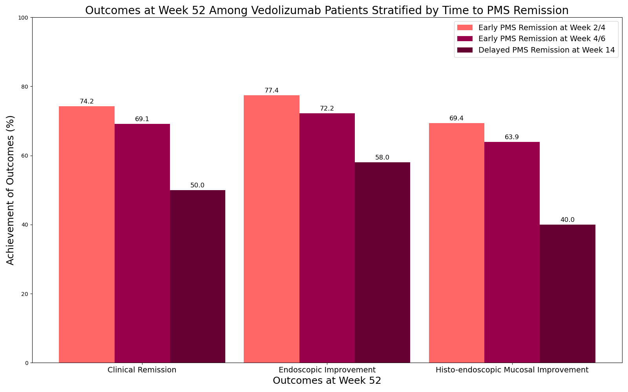

Supplementary Figure 2 – Outcomes at week 52 among adalimumab patients stratified by time to PMS remission
