Supplementary Material

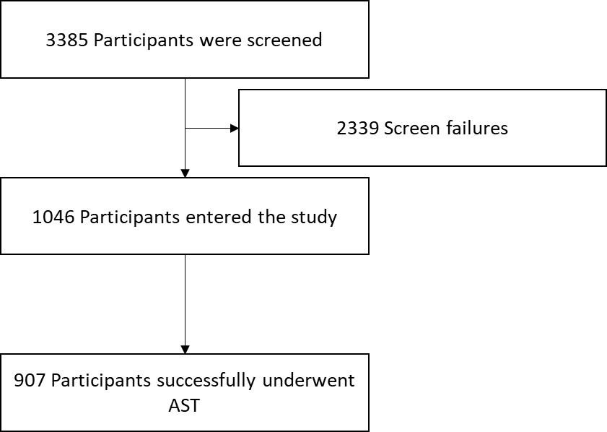

Supplemental Figure 1. Participant flow diagram. For the full patient flow for the pHalcon-HP study, please see Chey WD, et al. Vonoprazan Triple and Dual Therapy for Helicobacter pylori Infection in the United States and Europe: Randomized Clinical Trial. Gastroenterology. 2022 Jun 6:S0016-5085(22)00609-6. doi: 10.1053/j.gastro.2022.05.055. Epub ahead of print. PMID: 35679950

