Supplementary Material

Table of Contents
Page 2. Table S1. Study characteristics by acute pancreatitis status
Page 3. Table S2. Incidence of pancreatic cancer by year and acute pancreatitis status
Page 4. Table S3. Incidence of pancreatic cancer by year and acute pancreatitis etiology
Page 5. Table S4. Post-AP risk of PDAC in smokers and alcohol drinkers S4A. Current Smokers vs Non-smokers
Page 6. Table S4. Post-AP risk of PDAC in smokers and alcohol drinkers S4B. Alcoholics versus non-alcoholics
Page 7. Figure S1. Study cohort timeline and follow-up.
Page 8. Figure S2. Post-acute pancreatitis cumulative incidence of pancreatic cancer by smoking and alcohol status. Figure S2A. Smokers vs Non-Smokers
Page 9. Figure S2. Post-acute pancreatitis cumulative incidence of pancreatic cancer by smoking and alcohol status. Figure S2B. Alcoholics vs Non-alcoholics

Page 10. Sensitivity Analysis. Table S5. PDAC risk following AP using primary inpatient diagnosis codes:
Page 10. Sensitivity Analysis. Table S6. Risk of pancreatic cancer by acute pancreatitis status using two ICD 9 codes for pancreatic cancer and chronic pancreatitis.

Satish Munigala¹, Sami Almaskeen², Divya S. Subramaniam¹, Sriya Bandi³, Benjamin Bowe⁴, Hong Xian⁵, Sunil G. Sheth⁶, Thomas E. Burroughs¹ and Banke Agarwal⁸
Table S1. Study characteristics by acute pancreatitis status

 | Controls |  | AP group |  | CP group |  | APCP group
 | Patients at risk (n) | Patients diagnosed with PDAC | Patients at risk (n) | Patients diagnosed with PDAC | Patients at risk (n) | Patients diagnosed with PDAC | Patients at risk (n) | Patients diagnosed with PDAC
3rd year | 7099764 | 2062 (0.03%) | 27394 | 27 (0.10%) | 12545 | 18 (0.14%) | 8156 | 26 (0.32%)
4th year | 6557889 | 1829 (0.03%) | 23037 | 28 (0.12%) | 10758 | 19 (0.18%) | 6888 | 16 (0.23%)
5th year | 6005044 | 1704 (0.03%) | 19050 | 16 (0.08%) | 9164 | 9 (0.10%) | 5768 | 22 (0.38%)
6th year | 5484040 | 1676 (0.03%) | 15594 | 15 (0.10%) | 7760 | 7 (0.09%) | 4725 | 5 (0.11%)
7th year | 5027007 | 1567 (0.03%) | 12556 | 16 (0.13%) | 6584 | 7 (0.11%) | 3858 | 5 (0.13%)
8th year | 4586699 | 1522 (0.03%) | 10082 | 13 (0.13%) | 5633 | 6 (0.11%) | 3087 | 6 (0.11%)
9th year | 4137403 | 1321 (0.03%) | 7858 | 7 (0.09%) | 4684 | 4 (0.09%) | 2466 | 5 (0.20%)
10th year | 3696791 | 1222 (0.03%) | 5992 | 7 (0.12%) | 3871 | 7 (0.18%) | 1939 | 4 (0.21%)

AP- acute pancreatitis, CP- chronic pancreatitis, APCP- acute pancreatitis with pre-existing chronic pancreatitis, PDAC- pancreatic cancer, %- row percentage of n for each group.

Table S2. Incidence of pancreatic cancer by year and acute pancreatitis status

Follow-up period | Incidence per 1000 person-years |  |  |  | AP group |  |  |  | CP group |  |  |  | APCP group
 | Controls | AP  group | CP group | APCP  group | Unadjusted  HR  (95% CI) | P-value | Adjusted  HR*  (95% CI) | P-value | Unadjusted  HR  (95% CI) | P-value | Adjusted  HR*  (95% CI) | P-value | Unadjusted  HR  (95% CI) | P-value | Adjusted  HR*  (95% CI) | P-value
Year 3 | 0.30 | 1.07 | 1.55 | 3.47 | 3.56  (2.43-5.20) | <0.001 | 2.01  (1.36-2.96) | 0.001 | 5.14  (3.23-8.17) | <0.001 | 3.48  (2.15-5.62) | <0.001 | 11.48  (7.80-16.90) | <0.001 | 7.05  (4.74-10.51) | <0.001
Year 4 | 0.29 | 1.33 | 1.91 | 2.53 | 4.59  (3.16-6.66) | <0.001 | 2.49  (1.69-3.67) | <0.001 | 6.57  (4.18-10.32) | <0.001 | 4.74  (3.01-7.47) | <0.001 | 8.69  (5.31-14.21) | <0.001 | 5.17  (3.13-8.55) | <0.001
Year 5 | 0.30 | 0.93 | 1.07 | 4.20 | 3.12  (1.91-5.10) | <0.001 | 1.85  (1.12-3.05) | 0.017 | 3.59  (1.87-6.91) | <0.001 | 2.65  (1.37-5.11) | 0.004 | 14.16  (9.30-21.56) | <0.001 | 8.95  (5.81-13.78) | <0.001
Year 6 | 0.32 | 1.07 | 0.98 | 1.17 | 3.35  (2.02-5.58) | <0.001 | 1.70  (1.01-2.84) | 0.045 | 3.08  (1.46-6.46) | 0.003 | 2.14  (1.02-4.51) | 0.045 | 3.67  (1.52-8.82) | 0.004 | 1.92  (0.80-4.65) | 0.147
Year 7 | 0.33 | 1.42 | 1.14 | 1.45 | 4.34  (2.65-7.11) | <0.001 | 2.25  (1.36-3.71) | 0.002 | 3.52  (1.68-7.39) | 0.001 | 2.49  (1.18-5.24) | 0.016 | 4.45  (1.85-10.70) | 0.001 | 2.39  (0.99-5.77) | 0.054
Year 8 | 0.35 | 1.46 | 1.16 | 1.80 | 4.18  (2.42-7.21) | <0.001 | 2.16  (1.24-3.76) | 0.006 | 3.33  (1.50-7.43) | 0.003 | 2.37  (1.06-5.30) | 0.035 | 5.20  (2.17-12.46) | 0.002 | 2.71  (1.12-6.57) | 0.027
Year 9 | 0.34 | 1.01 | 0.93 | 2.27 | 3.02  (1.44-6.34) | 0.004 | 1.49  (0.70-3.15) | 0.298 | 2.78  (1.04-7.42) | 0.041 | 1.99  (0.75-5.32) | 0.17 | 6.75  (2.80-16.23) | <0.001 | 3.42  (1.41-8.28) | 0.006
Year 10 | 0.35 | 1.37 | 2.01 | 2.33 | 3.87  (1.84-8.13) | <0.001 | 2.04  (0.97-4.32) | 0.062 | 5.68  (2.70-11.94) | <0.001 | 4.23  (2.01-8.90) | <0.001 | 6.61  (2.48-17.64) | <0.001 | 3.63  (1.36-9.73) | 0.01

* versus controls (remaining patients in the database without AP or CP), adjusted for age (age at the time of entry into the study), gender, race, smoking, alcohol, gallstones, and diabetes. AP- acute pancreatitis, CP- chronic pancreatitis; APCP- acute pancreatitis with pre-existing chronic pancreatitis; HR- Hazard ratio, PDAC- pancreatic cancer.

Table S3. Incidence of pancreatic cancer by year and acute pancreatitis etiology

AP- acute pancreatitis, CI- confidence interval, HR- Hazard ratio, PDAC- pancreatic cancer.
* versus controls (remaining patients in the database without AP or CP), adjusted for age (age at the time of entry into the study), gender, race, smoking, alcohol, and diabetes.

Follow-up | AP group |  | Non-gallstone AP |  |  |  | Gallstone AP
 | No of PDAC | Incidence | No of PDAC | Incidence | Adjusted HR*  (95% CI) | P-value | No of PDAC | Incidence | Adjusted HR*  (95% CI) | P-value
Year 3 | 27 | 1.12 | 17 | 1.09 | 3.02 (1.87-4.87) | <0.001 | 10 | 1.05 | 2.56 (1.37-4.76) | 0.003
Year 4 | 28 | 1.40 | 17 | 1.31 | 3.72 (2.30-6.01) | <0.001 | 11 | 1.37 | 3.44 (1.90-6.23) | <0.001
Year 5 | 14 | 0.80 | 10 | 0.93 | 2.57 (1.38-4.80) | 0.003 | 6 | 0.91 | 2.27 (1.02-5.07) | 0.045
Year 6 | 14 | 1.06 | 7 | 0.81 | 1.97 (0.93-4.14) | 0.075 | 8 | 1.48 | 3.44 (1.72-6.90) | <0.001
Year 7 | 14 | 1.33 | 8 | 1.15 | 2.75 (1.37-5.52) | 0.004 | 8 | 1.85 | 4.13 (2.06-8.28) | <0.001
Year 8 | 10 | 1.21 | 5 | 0.91 | 1.98 (0.82-4.77) | 0.129 | 8 | 2.35 | 5.00 (2.50-10.01) | <0.001
Year 9 | 5 | 0.78 | 3 | 0.70 | 1.61 (0.52-5.01) | 0.41 | 4 | 1.53 | 3.46 (1.30-9.22) | 0.013
Year 10 | 6 | 1.27 | 6 | 1.88 | 4.13 (1.85-9.23) | <0.001 | 1 | 0.52 | 1.10 (0.16-7.81) | 0.925

Table S4. Post-AP risk of PDAC in smokers and alcohol drinkers

S4A. Current Smokers vs Non-smokers

 | Non-smokers | Current Smokers |  | Unadjusted  HR  (95% CI) |  | Adjusted  HR  (95% CI)
Controls | 0.25% | 0.28% |  | 1.20  (1.15-1.24)  P<0.001 |  | 1.43  (1.38-1.48)  P<0.001
AP group | 0.45% | 0.38% |  | 0.87  (0.57-1.31) P=0.50 |  | 1.20  (0.76-1.88)  P=0.44
Unadjusted HR  HR (95% CI) | 3.32  (2.46-4.48) | 3.09  (2.46-3.90)
 | P<0.001 | P<0.001
Adjusted HR* (95% CI) | 1.73  (1.28-2.35) | 1.94  (1.53-2.45)
 | P<0.001 | P<0.001

AP- acute pancreatitis; CI- confidence intervals, HR- hazard ratio.
*all adjusted HR’s were computed after adjusting for age, race, gender, diabetes mellitus and gallstone disease. For controls and AP group, HR’s were computed for current smokers using non-smokers as reference group. For non-smokers, current smokers, non-alcoholics and alcoholics, HR’s were computed for AP group using controls as a reference category.

S4B. Alcoholics versus non-alcoholics

 | Non-Alcoholic | Alcoholics |  | Unadjusted  HR  (95% CI) |  | Adjusted  HR  (95% CI)
Controls | 0.22% | 0.28% |  | 1.14  (1.09-1.18)  P<0.001 |  | 1.22  (1.17-1.28)  P<0.001
AP Group | 0.42% | 0.35% |  | 0.84  (0.56-1.24)  P=0.38 |  | 1.15  (0.73-1.80)  P=0.56
Unadjusted HR  HR (95% CI) | 3.59  (2.84-4.53) | 3.43  (2.67-4.42)
 | P<0.001 | P<0.001
Adjusted HR* (95% CI) | 1.61  (1.27-2.04) | 2.27  (1.76-2.93)
 | P<0.001 | P<0.001

AP- acute pancreatitis; CI- confidence intervals, HR- hazard ratio.
*all adjusted HR’s were computed after adjusting for age, race, gender, diabetes mellitus and gallstone disease. For controls and AP group, HR’s were computed for current smokers and alcoholics using non-smokers and non-alcoholics as reference groups, respectively. For non-smokers, current smokers, non-alcoholics and alcoholics, HR’s were computed for AP group using controls as a reference category.

Figure S1. Study cohort timeline and follow-up
Washout period
No prior AP or PDAC
PDAC ≤2 years of study entry not evaluated
PDAC
assessment period

Controls Follow-up

AP Follow-up

CP Follow-up

APCP Follow-up

Censor at study end (December 2015), PDAC occurrence or death
T2
Start of follow-up
T0
Study entry

1st VA encounter or
Beginning of the database (September 1999)

AP- acute pancreatitis; CP- chronic pancreatitis; APCP- acute pancreatitis with pre-existing chronic pancreatitis; PDAC- pancreatic cancer; VA- Veterans affairs.

Figure S2. Post-acute pancreatitis cumulative incidence of pancreatic cancer by smoking and alcohol status

Figure S2A. Smokers vs Non-Smokers

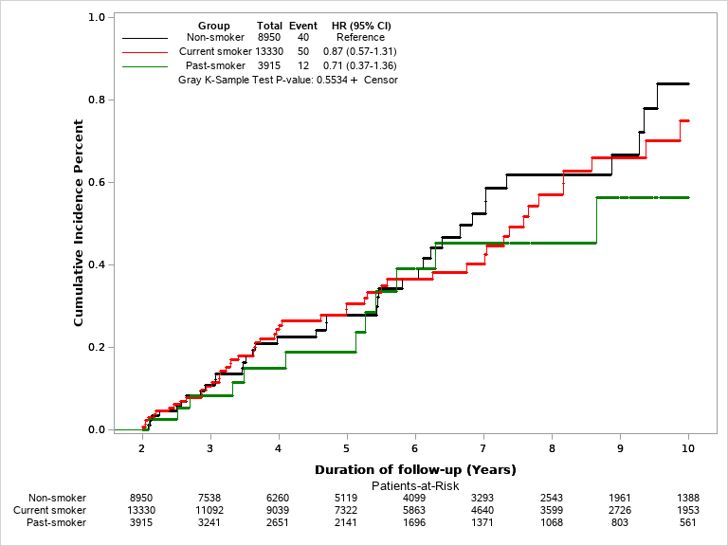

CI- Confidence intervals, HR- Hazard ratio
NOTE: Hazard ratios presented on the figures are unadjusted hazard ratios from Cox-proportional model. Gray K-Sample Test P-value is for comparing the cumulative incidence between the groups

Figure S2B. Alcoholics vs Non-alcoholics

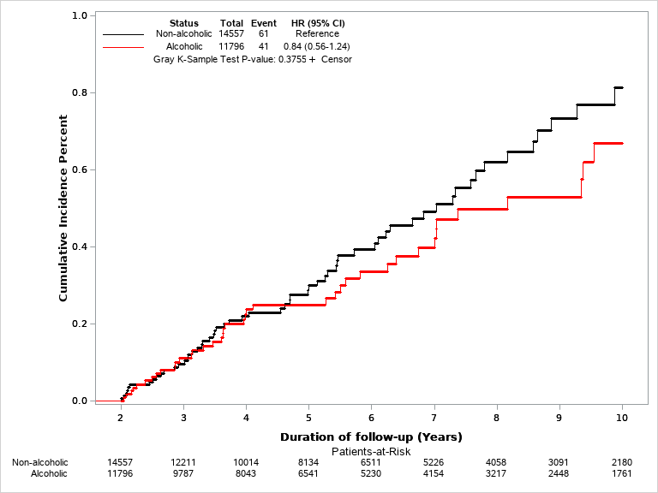

CI- Confidence intervals, HR- Hazard ratio
NOTE: Hazard ratios presented on the figures are unadjusted hazard ratios from Cox-proportional model. Gray K-Sample Test P-value is for comparing the cumulative incidence between the group
Table S5. Sensitivity analysis of PDAC risk >2 years after AP
 | Current Data |  |  |  | Data using inpatient primary ICD 9 diagnosis codes only for defining AP
Group | N | PDAC  N (%) | Adjusted HR  (95% CI) | P-value | N | PDAC  N (%) | Adjusted HR (95% CI) | P-value
Controls | 7099764 | 16168 (0.23%) | Reference | - | 7099764 | 16168 (0.23%) | Reference | -
AP | 27394 | 133 (0.49%) | 1.85 (1.55-2.20) | <0.001 | 17054 | 87 (0.51%) | 1.91 (1.54-2.36) | <0.001
APCP | 8156 | 92 (1.13%) | 4.29 (3.49-5.28) | <0.001 | 5821 | 76 (1.31%) | 4.89 (3.89-6.13) | <0.001
CP | 12545 | 82 (0.65%) | 2.83 (2.27-3.52) | <0.001 | 12545 | 82 (0.65%) | 2.83 (2.27-3.52) | <0.001

Table S6. Sensitivity analysis of PDAC risk >2 years after AP
 | Current Data |  |  |  | Data using two ICD 9 for defining PDAC and CP diagnosis
Group | N | PDAC  N (%) | Adjusted HR  (95% CI) | P-value | N | PDAC  N (%) | Adjusted HR (95% CI) | P-value
Controls | 7099764 | 16168 (0.23%) | Reference | - | 7094059 | 10463 (0.15%) | Reference | -
AP | 27394 | 133 (0.49%) | 1.85 (1.55-2.20) | <0.001 | 26729 | 81 (0.30%) | 1.68 (1.35-2.10) | <0.001
APCP | 8156 | 92 (1.13%) | 4.29 (3.49-5.28) | <0.001 | 4360 | 38 (0.87%) | 4.67 (3.39-6.44) | <0.001
CP | 12545 | 82 (0.65) | 2.83 (2.27-3.52) | <0.001 | 5779 | 32 (0.55%) | 3.54 (2.50-5.01) | <0.001

