Supplemental Table 1. Factors associated with loss of response to tofacitinib during maintenance therapy
Covariable | Adjusted HR [95% CI] | p-value
Baseline disease activity at tofacitinib induction  Severe clinical activity (PMS ≥7)  Severe endoscopic activity (MES=3) | 0.98 [0.50, 1.94]  3.60 [1.70, 7.62] | 0.97  0.001
Disease extent  Left-sided or proctitis  Pancolitis | Reference  0.94 [0.52, 1.72] | 0.85
Disease duration  <2 years  2 to ≤5 years  >5 years | Reference  1.61 [0.60, 4.37]  1.64 [0.74, 3.67] | 0.34  0.22
Prior treatment  Biologic naïve  Previous biologic failure | Reference  3.89 [1.28, 11.86] | 0.02
Clinical treatment response  Achievement of 3-month corticosteroid-free remission | 0.90 [0.48, 1.65] | 0.73
Endoscopic treatment response  MES = 2 or 3  MES = 1 (endoscopic improvement)  MES = 0 (endoscopic remission) | Reference  1.26 [0.61, 2.60]  0.40 [0.20, 0.80] | 0.53  0.009

Abbreviations: CI confidence interval; MES Mayo Endoscopic Subscore; PMS Partial Mayo Score
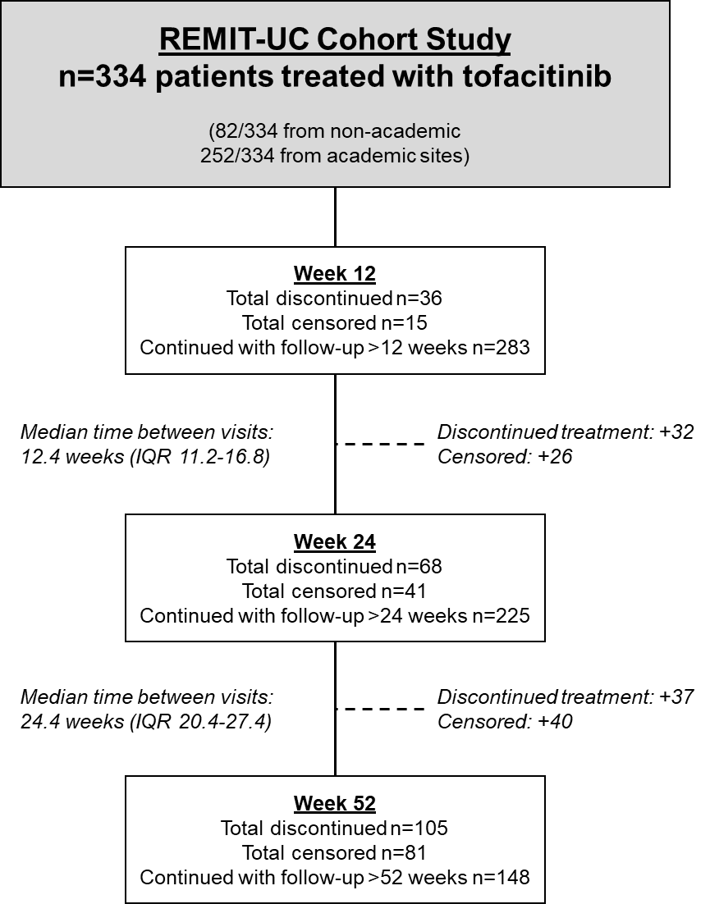

Supplemental Figure 1. Follow-up of patients during the REMIT-UC study. Censored patients include those who continued treatment but did not have follow-up to the specified time point.

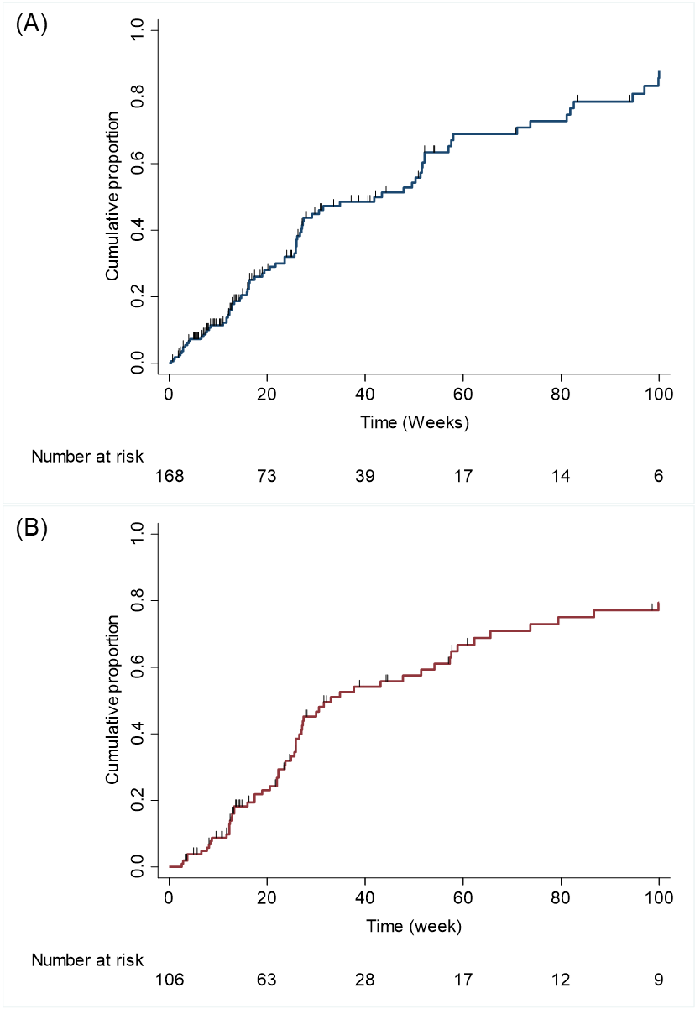
Supplemental Figure 2. Cumulative probability of C-reactive protein normalization (< 5 mg/L) (A) or fecal calprotectin (<250 µg/g) (B) in tofacitinib-treated patients with elevated biomarkers at baseline
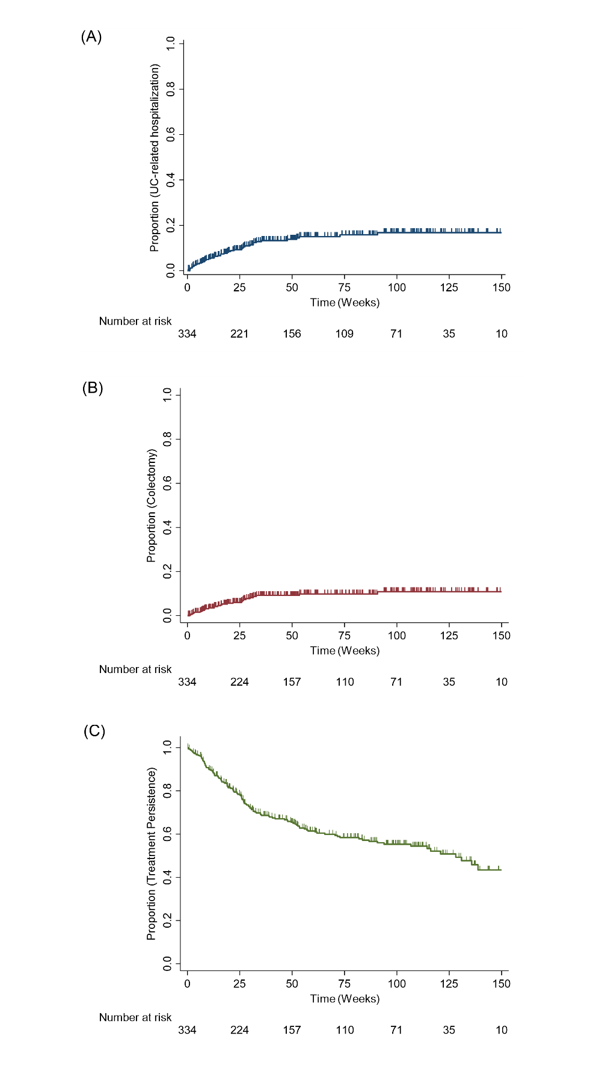
Supplemental Figure 3. Probability of ulcerative colitis related hospitalization (A), colectomy (B) and treatment persistence (C) in patients treated with tofacitinib

