Online Supplemental Data
Racial and ethnic disparities in years of potential life loss among patients with cirrhosis during the COVID-19 pandemic in the United States
Yunyu Zhao,# Yee Hui Yeo,# Jamil Samaan, Fan Lv, Xinyuan He, Jinli Liu, Mei Li, Ning Gao, Justin Park, Ju Dong Yang, Walid S Ayoub, Lei Zhang, Michelle C Odden, Fanpu Ji* and Mindie H. Nguyen*

Table of Content
Supplementary Table 1. Characteristics of cirrhosis-related deaths in adults (≥25 years) in the United States, 1/2012-12/2021.
Supplementary Table 2. Annual percentage change (APC) in cirrhosis-related age-standardized mortality rate (ASMR) for the United States adults (≥25 years) overall and by age, by sex or by race/ethnicity, 2012-2021.
Supplementary Table 3. Annual percentage change (APC) in years of potential life lost (YPLL) from premature deaths (<65 years of age) attributable to cirrhosis in adults (≥25 years) in the United States by race and ethnicity, 2012-2021.
Supplementary Figure 1. All cause age-standardized mortality for cirrhosis per 100,000 persons in adults (≥25 years) in the United States by sex, by age or by race and ethnicity, 2012-2021.
Supplementary Figure 2. Years of potential life loss from premature deaths attributable to cirrhosis per 100,000 persons in the U.S. adults by race and ethnicity between 1/2018 and 12/2021 monthly.
Supplementary Methods

Supplementary Table 1. Characteristics of cirrhosis-related deaths in adults (≥25 years) in the United States, 1/2012-12/2021

1/2012-12/2021
(N = 872,965) (%)
25-44 | 59,448 (6.8)
45-64 | 411,627 (47.2)
≥65 | 401,890 (46.0)
Female | 337,769 (38.7)
Male | 535,196 (61.3)
Non-Hispanic White | 625,449 (71.6)
Non-Hispanic Black | 85,878 (9.8)
Hispanic | 122,907 (14.1)
Non-Hispanic Asian | 20,854 (2.4)
Non-Hispanic AI/AN | 17,027 (2.0)
Data are presented as number (percent, %).
Abbreviation: Non-Hispanic AI/AN, non-Hispanic American Indian/Alaska Native.

Supplementary Table 2. Annual percentage change (APC) in cirrhosis-related age-standardized mortality rate (ASMR) for the United States adults (≥25 years), overall and by age, by sex or by race/ethnicity, 2012-2021

 | Time segment 1  2012 to last pre-pandemic period  2012~2019 | P value | Time segment 2  Last pre-pandemic period and after  2019~2021 | P value
 | APC (95% CI) |  | APC (95% CI)
Overall | 1.1 (0.7, 1.4) | 0.001 | 11.2 (8.3, 14.2) | <0.001
Age
25-44 years | 3.5 (2.7, 4.2) | <0.001 | 27.7 (20.8, 34.9) | <0.001
45-64 years | -0.5 (-1.3, 0.3) | 0.129 | 9.4 (3.3, 15.7) | 0.007
≥65 years | 2.3 (2.0, 2.5) | <0.001 | 7.4 (5.6, 9.2) | <0.001
Sex
Female | 1.6 (1.3, 2.0) | <0.001 | 11.1 (8.2, 14.0) | <0.001
Male | 0.8 (0.4, 1.2) | 0.005 | 9.8 (6.5, 13.3) | <0.001
Race and Ethnicity
Non-Hispanic White | 1.6 (1.2, 2.0) | <0.001 | 11.2 (8.2, 14.4) | <0.001
Non-Hispanic Black | -1.0 (-1.9, -0.1) | 0.036 | 10.9 (3.5, 18.8) | 0.012
Hispanic | 0.2 (-0.2, 0.6) | 0.302 | 10.9 (7.5, 14.4) | <0.001
Non-Hispanic Asian | -0.9 (-2.9, 1.2) | 0.101 | 2.3 (0.3, 4.3) | 0.033
Non-Hispanic AI/AN | 3.0 (2.0, 4.0) | 0.001 | 30.9 (21.6, 40.8) | <0.001
The temporal trend analysis was performed by using joinpoint analysis.
APCs and P-values were estimated by Monte Carlo permutation test.
Abbreviation: Non-Hispanic AI/AN, non-Hispanic American Indian/Alaska Native.

Supplementary Table 3. Annual percentage change (APC) in years of potential life lost (YPLL) from premature deaths (<65 years of age) attributable to cirrhosis in adults (≥25 years) in the United States by race and sex, 2012-2021

 |  | Time segment 1  2012 to last pre-pandemic period  2012~2019 | P value | Time segment 2  Last pre-pandemic period and after  2019~2021 | P value
 |  | APC (95% CI) |  | APC (95% CI)
Non-Hispanic White | Total | 2.1 (1.7, 2.6) | <0.001 | 17.4 (13.6, 21.2) | <0.001
 | Female | 4.0 (3.3, 4.7) | <0.001 | 15.6 (9.9, 21.6) | 0.001
 | Male | 1.0 (0.5, 1.5) | 0.003 | 18.3 (14.0, 22.8) | <0.001
Non-Hispanic Black | Total | -1.8 (-2.6, -1.1) | 0.001 | 18.5 (12.0, 25.4) | 0.001
 | Female | -0.3 (-2.2, 1.7) | 0.728 | 19.7 (3.6, 38.4) | 0.024
 | Male | -3.0 (-3.5, -2.5) | <0.001 | 17.2 (13.2, 21.4) | <0.001
Hispanic | Total | -0.1 (-0.7, 0.6) | 0.777 | 20.6 (15.0, 26.5) | <0.001
 | Female | 0.5 (-1.2, 2.3) | 0.456 | 20.7 (6.3, 37.0) | 0.013
 | Male | -0.4 (-0.8, -0.0) | 0.048 | 20.3 (17.0, 23.8) | <0.001
Non-Hispanic Asian | Total | 1.9 (-0.2, 3.9) | 0.068 | 1.9 (-0.2, 3.9) | 0.068
 | Female | 2.2 (0.5, 3.9) | 0.016 | 2.2 (0.5, 3.9) | 0.016
 | Male | 1.6 (-1.1, 4.3) | 0.218 | 1.6 (-1.1, 4.3) | 0.218
Non-Hispanic AI/AN | Total | 5.3 (4.6, 6.1) | <0.001 | 35.9 (28.8, 43.3) | <0.001
 | Female | 5.8 (3.1, 8.5) | 0.002 | 33.2 (10.4, 60.8) | 0.011
 | Male | 4.9 (2.7, 7.2) | 0.002 | 38.1 (17.8, 61.8) | 0.003
The temporal trend analysis was performed by using joinpoint analysis.
APCs and P-values were estimated by Monte Carlo permutation test.
Abbreviation: Non-Hispanic AI/AN, non-Hispanic American Indian/Alaska Native.

Supplementary Figure 1. All cause age-standardized mortality for cirrhosis per 100,000 persons in adults (≥25 years) in the United States by sex, by age or by race and ethnicity, 2012-2021. Data shown for observed values (solid line ___) versus predicted values (dotted line - - -) for 2020 and 2021 based on 2012~2019 trend for each subgroup.
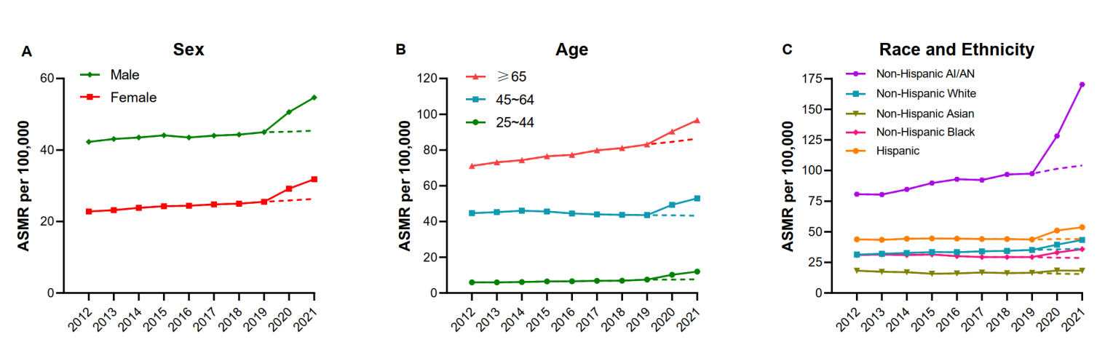

Supplementary Figure 2. Years of potential life loss from premature deaths attributable to cirrhosis per 100,000 persons in the U.S. adults by race and ethnicity between 1/2018 and 12/2021 monthly. The prediction of YPLLs between 4/2020 and 12/2021 was performed according to the YPLLs in 1/2018-3/2020 via a k-nearest neighbor estimation method. Pairwise comparison between trends was performed to assess the difference between observed and predicted YPLLs.

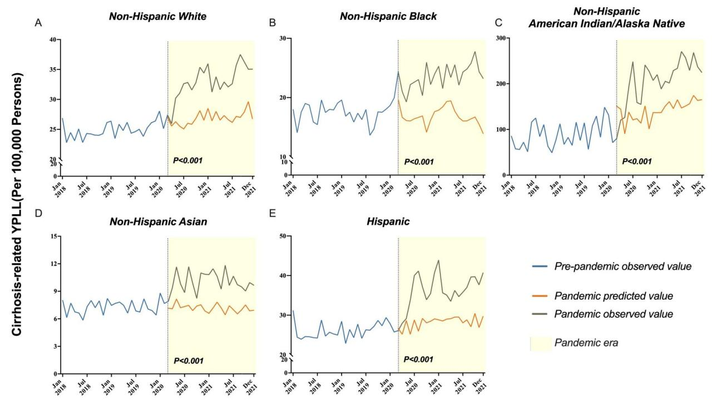

Supplementary Methods
We grouped decedents into five major racial/ethnic groups (non-Hispanic American Indian/Alaska Native (AI/AN), non-Hispanic Asian, non-Hispanic Black, Hispanic, and non-Hispanic White). Of note, the CDC introduced a new category of “more than one race” in 2021. However, this group only constituted 0.6% of the total death in 2021. Therefore, we excluded this group from our analysis. For the purpose of our analysis, we defined the “COVID-19 pandemic” for the years 2020 and 2021 or the months from 4/2020 to 12/2021.
We calculated the crude mortality rate by dividing the number of deaths by the total number of the population. We estimated the age-standardized mortality rate (ASMR) by the direct method using the 2000 U.S. Census population as the reference.
To calculate YPLL, we first stratified the deaths into 5-year age groups starting at 65 and down to 25 (i.e., 64-60, 59-55, 54-50, etc.). We then subtracted the median age (MA) of each stratum by 65. The value in each stratum was multiplied by the total number of cirrhosis-related deaths (D) observed in its corresponding age group. Next, we divided this value by the total number of the population (P) of the corresponding age group to obtain the age-specific YPLL. Age standardization was then performed by multiplying the age-specific YPLL by the proportion of the corresponding age group (F) as represented in the total U.S. population according to the 2000 US Census. Lastly, we summed up the age-standardized YPLLs of all 5-year age groups to obtain the age-standardized YPLL of the total population aged <65 years. The formula for the calculation of YPLL is as follow, YPLL = Σ ({[D (65 – MA)] / P * F).
Projected ASMRs or YPLLs were estimated via a suitable model including the ordinary least squares (OLS) method for year analysis and k-nearest neighbor estimation method for monthly analysis (1). R square was used to determine the model fit. The selection of models was determined by the trend of mortality rates. Finally, we computed excess mortality by subtracting the projected ASMR/YPLL from the observed ASMR/YPLL.
To determine the temporal trend of mortality among decedents with cirrhosis, we applied a joinpoint regression model, in which the grid-search method to fit the regression function was used, assuming that the variance remains constant and there are uncorrelated errors (2). We combined this method with the Monte Carlo Permutation test to determine whether the overall trend was best depicted by one or more segments to determine the annual percentage change (APC) with a 95% confidence interval (CI) of each segment and their associated P values. The positivity/negativity and magnitude of APC denote the direction and steepness of the trend.
We used the SPSS version 26.0 (IBM Corp. Released 2019. Armonk, NY: IBM Corp), the R 4.0.2 statistical software, the joinpoint analysis software (version 4.9.1.0; National Cancer Institute, Bethesda, MD) for all analyses in this study. A two-sided P value of less than 0.05 was considered statistically significant.

References
- Stone MB, R. J. Cross-validated sequentially constructed prediction embracing ordinary least squares, partial least squares and principal components regression. Journal of the Royal Statistical Society 1990;52:237-58.
- Kim HJ, Fay MP, Feuer EJ, et al. Permutation tests for joinpoint regression with applications to cancer rates. Stat Med 2000;19:335-51.

