Supplementary Document

Title: American Gastroenterological Association-American College of Gastroenterology Clinical Practice Guideline: Pharmacological Management of Chronic Idiopathic Constipation

Table of Contents
Content | Page number
Supplementary Table 1: Panel members, their expertise, and roles | 2
Table of excluded studies | 3
Meta-analysis, Characteristics of included studies, GRADE profiles and Evidence to Decision Framework for recommendation 1 | 4 to 12
Meta-analysis, Characteristics of included studies, GRADE profiles and Evidence to Decision Framework for recommendation 2 | 13 to 16
Meta-analysis, Characteristics of included studies, GRADE profiles and Evidence to Decision Framework for recommendation 3 | 17 to 21
Meta-analysis, Characteristics of included studies, GRADE profiles and Evidence to Decision Framework for recommendation 4 | 22 to 27
Meta-analysis, Characteristics of included studies, GRADE profiles and Evidence to Decision Framework for recommendation 5 | 29 to 33
Meta-analysis, Characteristics of included studies, GRADE profiles and Evidence to Decision Framework for recommendation 6 | 34 to 37
Meta-analysis, Characteristics of included studies, GRADE profiles and Evidence to Decision Framework for recommendation 7 | 38 to 43
Meta-analysis, Characteristics of included studies, GRADE profiles and Evidence to Decision Framework for recommendation 8 | 44 to 48
Meta-analysis, Characteristics of included studies, GRADE profiles and Evidence to Decision Framework for recommendation 9 | 49 to 53
Meta-analysis, Characteristics of included studies, GRADE profiles and Evidence to Decision Framework for recommendation 10 | 54 to 59

Supplementary Table 1: Panel members, their expertise, and roles
Panel Member | GI society | Expertise | Interventions/Roles
M. Hassan Murad |  | Senior Methodologist | Oversight of evidence synthesis and development of recommendations
Subcommittee 1
Lin Chang | AGA | Content expert | Reviewed the evidence for Fiber: Psyllium, Bran, Methylcellulose, Inulin;  Osmotic or Surfactant Laxatives: Polyethylene Glycol, Lactulose
Lucinda Harris | ACG | Content expert
Aamer Imdad | AGA | Methodologist
Amit Patel | AGA | Content expert
Subcommittee 2
William D. Chey | ACG | Content expert | Reviewed the evidence for Osmotic or Surfactant Laxatives: Magnesium Oxide, Docusate; Stimulant Laxatives: Bisacodyl, Senna, Sodium Picosulphate
Anthony Lembo | AGA | Content expert
Katarina Greer | ACG | Methodologist
Christopher Almario | ACG | Content Expert
Susan Diem |  | Primary care
Subcommittee 3
Adil E. Bharucha | AGA | Content expert | Reviewed the evidence for Secretagogues: Lubiprostone, Linaclotide, Plecanatide; 5-HT4 agonists: Prucalopride
Eric Shah | ACG | Content expert
Brain Hanson | AGA | Methodologist
Cynthia Ko | AGA | Content Expert
Abbreviations: AGA: American Gastroenterological Association; ACG: American College of Gastroenterology; GI: gastroenterology
Supplementary Table 2: Table of Excluded studies
Study | title | Reason for exclusion
- Sayuk 2021 | Plecanatide improves abdominal symptoms in individuals with chronic idiopathic constipation and irritable bowel syndrome with constipation, including those experiencing severe bloating, pain, and discomfort | Exclusion reason: abstract only, post-hoc analysis
- Per-005-21 2021 | Clinical study, double-blind, randomized to evaluate the efficacy and safety of sodium picosulphate 2.5mg /100ml (markos purgant lemonade), placebo controlled in patients with functional chronic constipation | Exclusion reason: ongoing study. Results not available ;
- Lembo 2022 | Efficacy and safety of prucalopride in patients with chronic idiopathic constipation stratified by age: a post hoc analysis of phase 3 and 4 clinical trials | Exclusion reason: abstract only, post-hoc analysis ;
- Brenner 2021 | Treatment satisfaction and improvement in quality of life with plecanatide among patients with chronic idiopathic constipation and irritable bowel syndrome with constipation: analyses from four phase 3 trials | Exclusion reason: abstract only, post-hoc analysis
- Harris 2021 | Plecanatide improved stool consistency in patients with chronic idiopathic constipation regardless of baseline bsfs: a post-hoc analysis | Exclusion reason: abstract only, post-hoc analysis
- Shah 2021 | Plecanatide produces a more rapid and durable clinical response compared to placebo in patients with chronic idiopathic constipation: a post-hoc analysis of two randomized controlled trials | Exclusion reason: abstract only, post-hoc analysis of the two included trials
- Cash 2021 | Plecanatide is effective in severely constipated patients with chronic idiopathic constipation and irritable bowel syndrome with constipation | Exclusion reason: abstract only, post-hoc analysis of the two plecanatide trials
- Brenner 2021 | Plecanatide provides meaningful improvement in patients with chronic idiopathic constipation and irritable bowel syndrome with constipation reporting reduced quality of life: analyses from four randomized phase 3 trials | Exclusion reason: abstract only;
- Brenner 2021 | Plecanatide provided clinically meaningful improvements in health-related quality of life in patients with chronic idiopathic constipation and irritable bowel syndrome with constipation: a post-hoc analysis | Exclusion reason: abstract only, post-hoc analysis of 3 prior trials; no citation in abstract to state which trials;
- Shah 2021 | Evaluating the impact of cost on the treatment algorithm for chronic idiopathic constipation: cost-effectiveness analysis | Exclusion reason: wrong outcomes;
- Chictr2000039848 2020 | The investigation of the effects of medilac, lactulose and lactulose combined with medilacon on the intestinal flora and intestinal dynamics in patients with fc | Exclusion reason: abstract only, ongoing study ;
- Liu 2021 | Electroacupuncture vs prucalopride for severe chronic constipation: a multicenter, randomized, controlled, noninferiority trial | Exclusion reason: wrong comparator;) no placebo group
- Abdullah 2021 | Efficacy and safety of peg 3350 vs lactulose in chronic constipation: a randomized clinical study | Exclusion reason: wrong comparator, peg vs. Lactulose
- Goodoory 2021 | Efficacy of senna and magnesium oxide for the treatment of chronic idiopathic constipation | Exclusion reason: wrong study design, letter to editor
- Chey 2021 | Exploratory comparative effectiveness trial of green kiwifruit, psyllium, or prunes in us patients with chronic constipation | Exclusion reason: wrong comparator; there is no placebo comparator to include this in our analysis (3 randomization groups include kiwi, psyllium and prunes);
- Vanderschoot 2022 | The effect of fiber supplementation on chronic constipation in adults: an updated systematic review and meta-analysis of randomized controlled trials | Exclusion reason: wrong study design;
- Tanaka 2022 | Rationale and design of a multicentre, 12-week, randomised, double-blind, placebo-controlled, parallel-group, investigator-initiated trial to investigate the efficacy and safety of elobixibat for chronic constipation | Exclusion reason: wrong intervention;
- Shi 2019 | Comparative efficacy of pharmacological and nonpharmacological treatments for chronic idiopathic constipation in china: a bayesian network meta-analysis | Exclusion reason: wrong study design
- Yang 2021 | Different doses of prucalopride in treating chronic idiopathic constipation: a meta-analysis and bayesian analysis | Exclusion reason: wrong study design
- Hinson 2020 | Evaluation of major adverse cardiac events from clinical studies of prucalopride in patients with chronic idiopathic constipation | Exclusion reason: abstract only, no data to review.;
- Franklin 2019 | Plecanatide for patients with chronic idiopathic constipation and irritable bowel syndrome-constipation: analysis of abdominal bloating from four randomized phase 3 clinical trials | Exclusion reason: wrong study design; this is a sub analysis of a previously reported study. The sub analysis is on abdominal bloating and this is note one of our outcomes of interest.
- Luthra 2019 | Efficacy of drugs in chronic idiopathic constipation: a systematic review and network meta-analysis | Exclusion reason: wrong study design, systematic review and meta-analysis
- Passos 2020 | Systematic review with meta-analysis of lubiprostone for patients with constipation | Exclusion reason: wrong study design; systematic review
- Goodoory 2020 | Efficacy of senna and magnesium oxide for the treatment of chronic idiopathic constipation | Exclusion reason: wrong study design;
- Roman 2008 | [The effect of a fibre enriched dietary milk product in chronic primary idiopatic constipation]. | Study was excluded as the intervention group received both insulin and Maltodextrin and we could not differentiate if the effect was due to Inulin or Maltodextrin.
- Hamilton 1998 | Clinical evaluation of methylcellulose as a bulk laxative. Dig Dis Sci. 1988 Aug;33(8):993-8. | Study was excluded because the study was not a randomized trial and did not have an appropriate comparison.

Forest Plots (Meta-analysis), Characteristics of included studies, GRADE profiles and Evidence to Decision Framework for each recommendation

Fiber supplementation of Management of Chronic Idiopathic Constipation

Recommendation 1: In adults with CIC, the panel suggests the use of fiber supplementation over management without fiber supplements (Conditional recommendation, low certainty of evidence)

Implementation considerations
• Dietary assessment is important to determine total fiber intake from diet and supplements
• Fiber supplements can be used as first-line therapy for CIC, particularly for individuals with low dietary fiber intake
• Among the evaluated fiber supplements, only psyllium appears to be effective (with very limited and uncertain data on bran and inulin)
• Adequate hydration should be encouraged with the use of fiber

Figure 1.1: Effect of Fiber supplements for treatment of Chronic idiopathic constipation: Spontaneous Bowel Moments
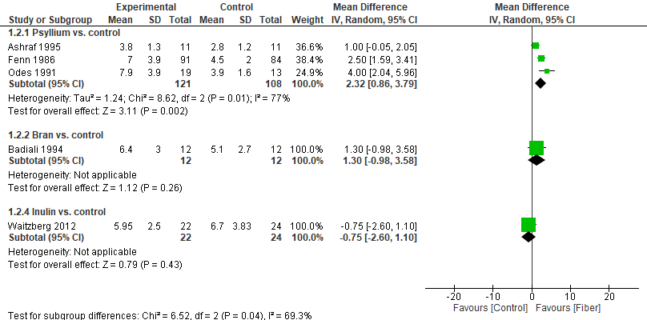

Figure 1.2: Effect of Fiber supplements for treatment of Chronic idiopathic constipation: Responder Rate
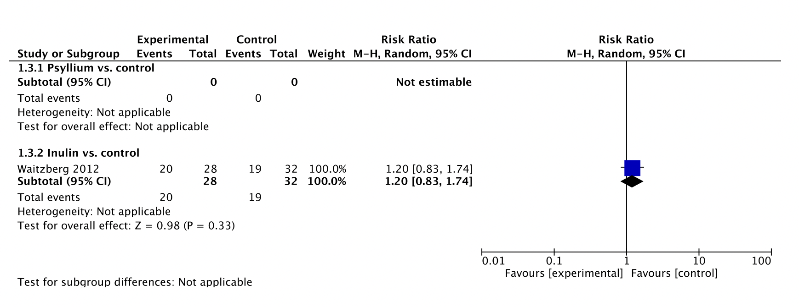

Figure 1.3: Effect of Fiber supplements for treatment of Chronic idiopathic constipation: Withdrawal from study due to diarrhea
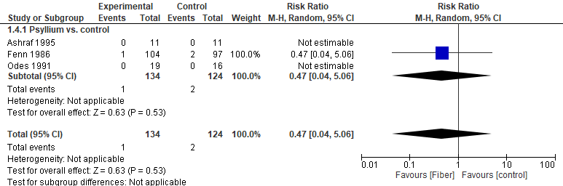

Figure 1.4: Effect of Fiber supplements for treatment of Chronic idiopathic constipation: Serious Adverse Events
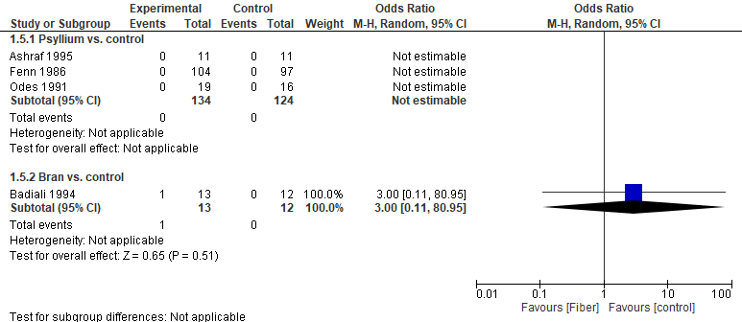

Figure 1.5: Effect of Fiber supplements for treatment of Chronic idiopathic constipation: Global relief
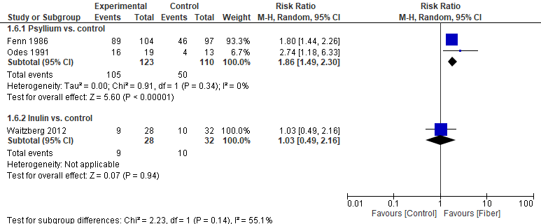

Figure 1.6: Effect of Fiber supplements for treatment of Chronic idiopathic constipation: Stool consistency
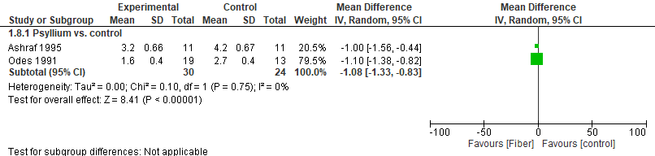
Footnotes: The lower scores indicate softer stools.

Table 1.1 of included studies: Studies with Fiber supplementation
Study and Settings | Patients | Intervention (dose, frequency, duration) | Outcomes | Notes (risk of bias, data limitation)
Badiali, D., et al. (1995) | 24 patients with chronic nonorganic constipation | Bran - 6.6g 3x daily or placebo for 2 four-week periods | spontaneous bowel movements; serious adverse effects | Cross over trial, Data was included from both periods. Method of randomization was not described clearly.
Linetzky Waitzberg, D., et al. (2012) | 60 females aged 18-65 with at least 3 months of constipation | Inulin - 15 g/d of inulin or maltodextrin (placebo) divided in 3 doses a day for 3 weeks | spontaneous bowel movements; responder rate; global relief | The methods of randomization and allocation concealment were not clearly described. SBM/week data was at week 3 of follow up
Marteau, P., et al, (2011) | 50 elderly people aged 50–70 years and suffering from  constipation according to the Rome definition (3  stools/week and/or straining in defecation) | Inulin - 7.5 g BID for 4 weeks | Side effects, Improvement in symptoms. | No data were included in the meta-analysis from this study. The study did not report data at the end period of the study but after 5 days of use. Study was at high risk of bias because of selective reporting. The methods of randomization were also not clear.
Ashraf, W. et al., (1995); US | 22 patients with chronic idopathic constipation | Psyllium 5g BID of psyllium or placebo for 8 weeeks | spontaneous bowel movements; stool consistency | Low risk of bias. Values of SBM/week were given in the text but only for Psyllium group. Values for Placebo were extracted from the figure 2. The values for stool consistency were given in figure 3 and were approximated from the same figure at 12 weeks of follow up. Study reported SEs and we calculated the SDs
Fenn, G.C., et al. (1986); UK | 201 patients between ages of 18 and 70 with functional constipation | Psyllium - 3.6g of Regulan or placebo TID for 14 days; Subject could reduce the dosage if the treatment caused watery stools | spontaneous bowel movements; global relief; withdrawal due to diarrhea | Low risk of bias. The data for SBM/week given in table 2 was for two weeks. We divided by 2 to get weekly data. Medians were taken means and we used the SDs from a similar study. The data on global relief was given in table 4 of the published paper and was based on subjective reporting by patients.
Odes, H.S and Z Madar (1991); Israel | 35 patients with constipation | Psyllium - 500mg celandine-aloevera-psyllium or placebo 1-3x daily depending on response | spontaneous bowel movements; global relief; stool consistency | Methods of randomization were not clearly described. The intervention group included celandine-aloevera-psyllium

Table 1.2: GRADE Evidence Profile: Effect of Fiber (Bran) on Chronic Idiopathic Constipation
Certainty assessment |  |  |  |  |  |  | № of patients |  | Effect |  | Certainty | Importance
№ of studies | Study design | Risk of bias | Inconsistency | Indirectness | Imprecision | Other considerations | Bran | No Bran | Relative  (95% CI) | Absolute  (95% CI)
CSBM per week NOT REPORTED
SBM per week
1 | randomised trials | seriousª | not serious | not serious | very serious^{b} | none | 12 | 12 | MD 1.3 SBM/week higher  (0.98 lower to 3.58 higher) |  | ⨁◯◯◯  Very low
Responder rate NOT REPORTED
Diarrhea (adverse event) NOT REPORTED
Serious adverse events
1 | randomised trials | seriousª | not serious | not serious | very serious^{c} | none | 1/13 (7.7%) | 0/12 (0.0%) | RR 2.79  (0.12 to 62.48) | Not estimatable | ⨁◯◯◯  Very low
Global relief outcome NOT REPORTED
Quality of life NOT REPORTED
Stool form NOT REPORTED
CI: confidence interval; MD: mean difference; RR: risk ratio
Explanations
a. The only included study mentioned that the study was a randomized controlled trial however did not describe the methods of randomization.
b. The only included study had 24 participants in total
c. There was only one event and the total number of participants in the included studies was 25. The confidence interval around the summary estimate was very wide

Table 1.3: GRADE Evidence Profile: Effect of Fiber (Inulin) on Chronic Idiopathic Constipation
Certainty assessment |  |  |  |  |  |  | № of patients |  | Effect |  | Certainty | Importance
№ of studies | Study design | Risk of bias | Inconsistency | Indirectness | Imprecision | Other considerations | Inulin | No Inulin | Relative  (95% CI) | Absolute  (95% CI)
CSBM per week NOT REPORTED
SBM per week
1 | randomised trials | seriousª | not serious | not serious | very serious^{b} | none | 22 | 24 | - | MD 0.75 SBM/week lower  (2.6 lower to 1.1 higher) | ⨁◯◯◯  Very low
Responder rate
1 | randomised trials | seriousª | not serious | not serious | serious^{c} | none | 20/28 (57.1%) | 19/32 (62.5%) | RR 1.21  (0.83 to 1.74) | 119 more per 1,000  (from 101 fewer to 439 more) | ⨁⨁◯◯  Low
Diarrhea (adverse event) NOT REPORTED
Global relief outcome
1 | randomised trials | seriousª | not serious | not serious | very serious^{b} | none | 9/28 (32.1%) | 10/32 (31.3%) | RR 1.03  (0.49 to 2.16) | 9 more per 1,000  (from 159 fewer to 363 more) | ⨁◯◯◯  Very low
Serious adverse events NOT REPORTED
Quality of life NOT REPORTED
Stool form NOT REPORTED

Table 1.4: GRADE Evidence Profile: Effect of Fiber (Psyllium) on Chronic Idiopathic Constipation
Certainty assessment |  |  |  |  |  |  | № of patients |  | Effect |  | Certainty | Importance
№ of studies | Study design | Risk of bias | Inconsistency | Indirectness | Imprecision | Other considerations | Psyllium | No Psyllium | Relative  (95% CI) | Absolute  (95% CI)
CSBM per week NOT REPORTED
SBM per week
3 | randomised trials | seriousª | not serious^{b} | not serious | serious^{c} | none | 121 | 108 | MD 2.32 SBM/week higher  (0.86 higher to 3.79 higher) |  | ⨁⨁◯◯  Low
Responder rate NOT REPORTED
Diarrhea (adverse event)
3 | randomised trials | seriousª | not serious | not serious | very serious^{d} | none | 1/134 (0.7%) | 2/124 (1.6%) | RR 0.47  (0.04 to 5.06) | 9 fewer per 1,000  (from 15 fewer to 65 more) | ⨁◯◯◯  Very low
Serious adverse events
3 | randomised trials | seriousª | not serious | not serious | serious^{e} | none | 0/134 (0.0%) | 0/124 (0.0%) | not estimable |  | ⨁⨁◯◯  Low
Global relief outcome
2 | randomised trials | serious^{f} | not serious | not serious | serious^{g} | none | 105/123 (85.4%) | 50/110 (45.5%) | RR 1.86  (1.49 to 2.30) | 391 more per 1,000  (from 223 more to 591 more) | ⨁⨁◯◯  Low
Quality of life NOT REPORTED
Stool form
2 | randomised trials | seriousª | not serious | not serious | serious^{h} | none | 30 | 24 | MD 1.08 consistency lower  (1.33 lower to 0.83 lower) |  | ⨁⨁◯◯  Low
CI: confidence interval; MD: mean difference; RR: risk ratio
Explanations
a. Two of the included studies were at high risk of bias due to concerns for a significant number of exclusions before the participants were randomized, which was an issue of indirectness, but we decided to just downgrade for risk of bias and not both risk of bias and indirectness. There were also concerns about methods described for randomization and allocation concealment.
b. Even though the statistical heterogeneity base don I² was 77 %, we did not downgrade because all the studies showed a favorable effect
c. The confidence interval around the summary estimate was wide and the same size was small.
d. The number of events was very small in both the intervention and control groups. The confidence interval around the summary estimates was very wide and included a null effect.
e. No events were reported in any of the included studies
f. One of the included study was at high risk of bias due to high attrition
g. The confidence interval around the summary estimate was wide.
h. The number of participants in the analysis were small and the confidence interval around the summary estimate was wide

Table 1.5: Evidence to Decision Framework

Strategy/treatment/test/intervention: Fiber
Alternative strategy: Management without Fiber
Domain | The effects | Judgment
How substantial are the desirable anticipated effects of the strategy? | Data were available for Psyllium, Inulin and Bran and no data were available for Methylcellulose. There was no data for CSBM from any of the included studies. The data for SBM was about 1 to 2 more SBM/week. | Small
How substantial are the undesirable anticipated effects? | The data were limited and the available data did not show an increased risk. Bloating is a common side effect and might happen with higher doses. | Small
Do the desirable effects outweigh the undesirable effects? | The benefits probably outweigh the risks. | Probably yes
 | Studies about the topic/Panel input
Is there important uncertainty or variability about how much people value the main outcomes? | Patients vary a lot in terms of how they care about frequency. Likely heterogeneous. | Possibly important uncertainty or variability
What is the overall certainty of the evidence of effects? | There was limited data for the outcome from a very low number of studies with small sample size. | Very low
How large are the resource requirements associated with the intervention? | Fibers are mostly available over the counter (OTC) and inexpensive. | Small costs
How large is the incremental cost relative to the net benefit? | No study available to look at the cost effectiveness of fiber supplements | Unknown
What would be the impact  on health inequities? | The intervention is widely available and relatively inexpensive | Improved
Is the option acceptable  to key stakeholders? | The fiber supplements are widely available and accessible. | Yes
Is the option feasible to implement? | People who are on low fiber diet may not tolerate fiber well. Patients with milder disease might respond better and the ones with severe disease may not respond. | Yes

PEG for Management of Chronic Idiopathic Constipation

Recommendation 2: In adults with CIC, the panel recommends the use of polyethylene glycol (PEG) compared to management without PEG. (Strong recommendation, moderate certainty of evidence)
Implementation considerations
• A trial of fiber supplement can be considered for mild constipation before PEG use, or in combination with PEG.
- Response to PEG has been shown to be durable over 6 months
- Side effects include abdominal distension, loose stool, flatulence, and nausea

Figure 2.1: Effect of Poly-Ethylene Glycol (PEG) supplements for treatment of Chronic idiopathic constipation: Complete Spontaneous Bowel Moments (CSBM)
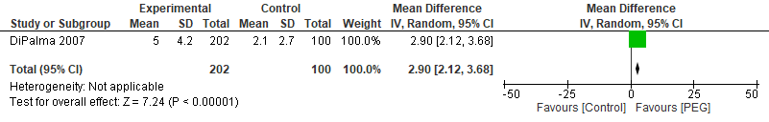

Figure 2.2: Effect of Poly-Ethylene Glycol (PEG) supplements for treatment of Chronic idiopathic constipation: Spontaneous Bowel Moments (SBM)
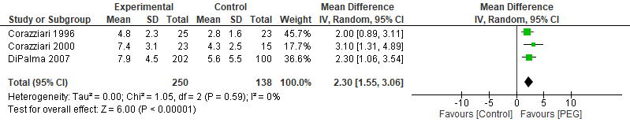

Figure 2.3: Effect of Poly-Ethylene Glycol (PEG) supplements for treatment of Chronic idiopathic constipation: Responder Rate
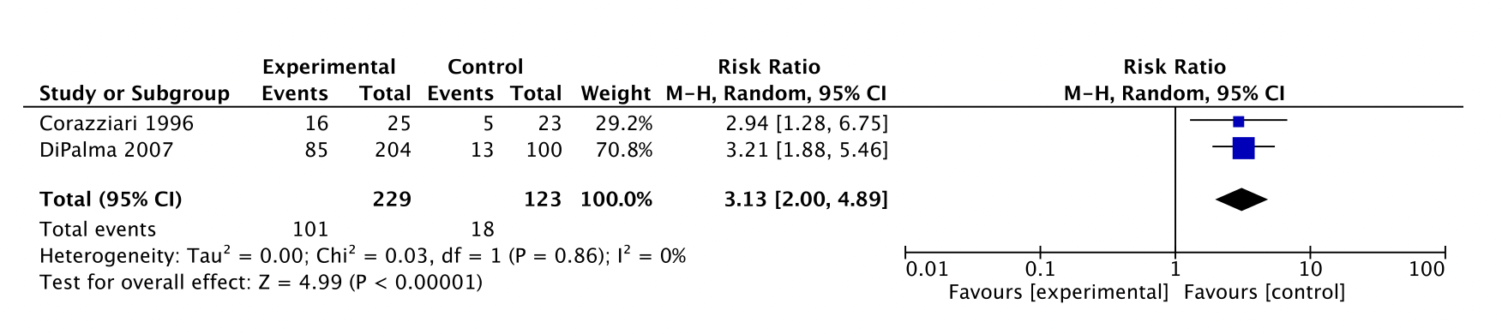

Figure 2.4: Effect of Poly-Ethylene Glycol (PEG) supplements for treatment of Chronic idiopathic constipation: Serious Adverse Events
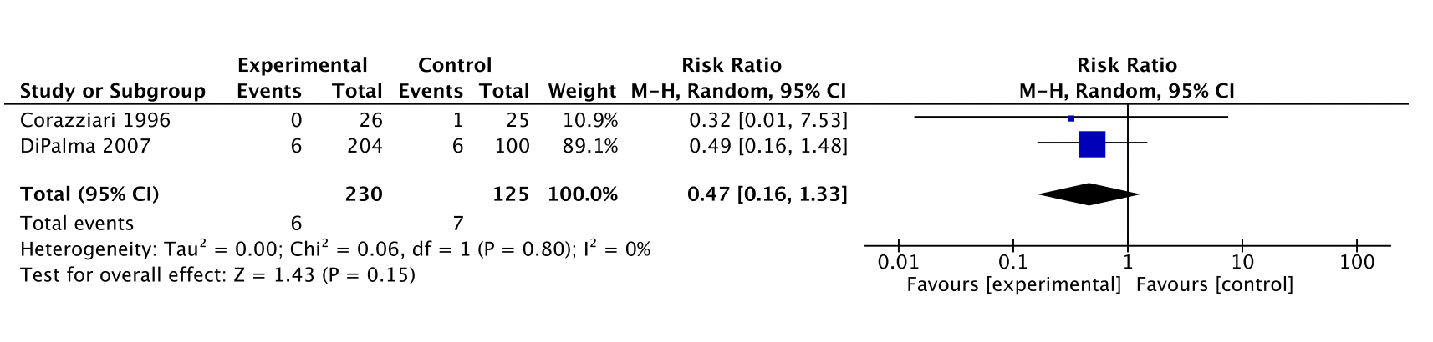

Figure 2.5: Effect of Poly-Ethylene Glycol (PEG) supplements for treatment of Chronic idiopathic constipation: Global relief
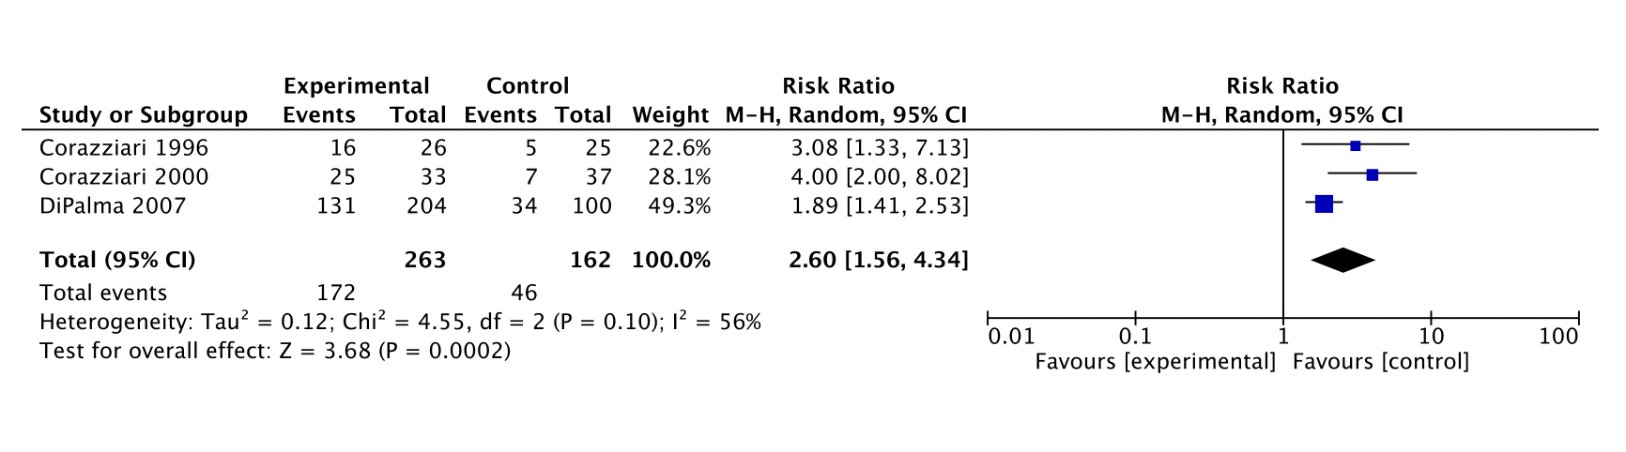

Table 2.1: Characteristic of included studies
Study and Settings | Patients | Intervention (dose, frequency, duration) | Outcomes (give all the outcomes reported from this study and the ones not reported, also comment on magnitude of effect) | Notes (risk of bias, data limitation)
Corazziari, E., et al. (1996) | 55 patients aged 18-70 with chronic constipation | P.E.G - 17.5g of PEG or placebo 2x daily for 8 weeks | complete spontaneous bowel movements; responder rate; serious adverse effects | Low risk of bias. The data on serious adverse events was taken from the first paragraph of the result section. We included one event leading to hospitalization in the control group. The data on responder rate was defined as normalization of bowel frequency.
Corazziari, E. et al. (2000); Italy | 70 patients aged 18-70 with chronic constipation | P.E.G - 17.5g of PEG 2x daily for 20 weeks | complete spontaneous bowel movements; serious adverse effects | Low risk of bias
Dipalma, J.A. et al. (2007) | 304 patients with chronic constipation based on ROME criteria | PEG - 17 g daily or placebo for 6 months | complete spontaneous bowel movements; responder rate; serious adverse effects | The data on serious adverse event were given in the second last paragraph of the discussion section.  The data on responder rate was taken from post hoc analysis according to FDA endpoints (PMID 36120087)

Table 2.2: GRADE evidence Profile: Effect of Polyethylene Glycol (PEG) supplementation for Chronic Idiopathic constipation in adults
Certainty assessment |  |  |  |  |  |  | № of patients |  | Effect |  | Certainty | Importance
№ of studies | Study design | Risk of bias | Inconsistency | Indirectness | Imprecision | Other considerations | Poly-Ethylene Glycol (PEG) | Placebo | Relative  (95% CI) | Absolute  (95% CI)
CSBM per week
1 | randomised trials | not serious | not serious | not serious | seriousª | none | 202 | 100 | MD 2.9 CSBM/week higher  (2.12 higher to 3.68 higher) |  | ⨁⨁⨁◯  Moderate
SBM per week
3 | randomised trials | not serious | not serious^{b} | not serious | serious^{c} | none | 250 | 138 | MD 2.3 SBM/week higher  (1.55 higher to 3.06 higher) |  | ⨁⨁⨁◯  Moderate
Responder rate (one study defined response as normalization of bowel moments and other defined based on FDA endpoints)
2 | randomised trials | not serious | not serious | not serious | serious^{d} | none | 101/229 (44.1%) | 18/123 (14.6%) | RR 3.13  (2.00 to 4.89) | 312 more per 1,000  (from 146 more to 569 more) | ⨁⨁⨁◯  Moderate
Diarrhea (adverse event)
1 | randomised trials | not serious | not serious | not serious | very serious^{e} | none | 7/33 (21.2%) | 2/37 (5.4%) | RR 3.92  (0.88 to 17.58) | 158 more per 1,000  (from 6 fewer to 896 more) | ⨁⨁◯◯  Low
Serious adverse events
2 | randomised trials | not serious | not serious | not serious | very serious^{e} | none | 6/230 (2.6%) | 1/100 (0.8%) | RR 0.47  (0.16 to 1.33) | 4 fewer per 1,000  (from 7 fewer to 3 more) | ⨁⨁◯◯  Low
Quality of life – NOT REPORTED
Stool form – NOT REPORTED
Global relief
3 | randomised trials | not serious | not serious | serious^{f} | not serious | none | 172/263 (65.4%) | 46/162 (28.4%) | RR 2.60  (1.56 to 4.34) | 454 more per 1,000  (from 159 more to 948 more) | ⨁⨁⨁◯  Moderate
CI: confidence interval; MD: mean difference; RR: risk ratio
Explanations
a. Only one study reported the data for this outcome and the sample was small overall.
b. The direction of effect was in the same direction in all the studies. The statistical heterogeneity based on I2 was 0%
c. Three included studies for this outcome and the sample size was small.
d. Two studies were included for this outcome and the overall sample size was small and the confidence interval around the summary estimate was wide.
e. The confidence interval around the summary estimate was wide and include both high and low risk of serious adverse events.

f. The heterogeneity was 56 %

Table 2.3: Evidence to Decision Framework

Strategy/treatment/test/intervention: Poly-Ethylene Glycol (PEG)
Alternative strategy: Management without Poly-Ethylene Glycol (PEG)
Domain | The effects | Judgment
How substantial are the desirable anticipated effects of the strategy? | Increase in CSBM, SBM by at least 2 episodes per week and the responder and global relief was higher. | Moderate
How substantial are the undesirable anticipated effects? | Limited data for AE’s. Patients may experience bloating, gas and diarrhea.  Minimal data on SAE. | Small
Do the desirable effects outweigh the undesirable effects? |  | Yes
 | Studies about the topic/Panel input
Is there important uncertainty or variability about how much people value the main outcomes? | Patients vary a lot in terms of how they care about frequency. Likely heterogeneous. Some patients may not take it because of concern about abdominal pain. | Possibly important uncertainty or variability
What is the overall certainty of the evidence of effects? | Most outcomes were moderate. | Moderate
How large are the resource requirements associated with the intervention? | Inexpensive, with OTC options. | Small costs
How large is the incremental cost relative to the net benefit? | No data were available to make an assessment in this regard | Unknown
What would be the impact  on health inequities? | Widely available and relatively inexpensive. No data on different racial groups, but no biological rationale to assume otherwise. | Probably improved
Is the option acceptable  to key stakeholders? | Widely available and OTC | Yes
Is the option feasible to implement? | Less expensive than most other drugs. Patients should be cognizant of AEs such as gas and diarrhea. | Yes

Mg oxide for the Management of Chronic Idiopathic Constipation

Recommendation 3: In adults with CIC the panel suggests the use of magnesium oxide over management without magnesium oxide. (Conditional recommendation, very low certainty of evidence certainty)

Implementation considerations
• The trials were conducted for 4 weeks, although longer term use is probably appropriate

• The panel suggests starting at a lower dose which may be increased if necessary

• Avoid use in patients with renal insufficiency

Figure 3.1: Effect of Magnesium oxide for treatment of Chronic idiopathic constipation: Complete Spontaneous Bowel Movements
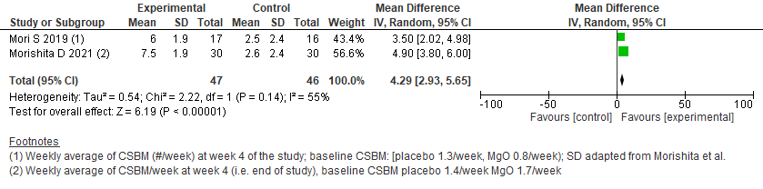

Figure 3.2: Effect of Magnesium oxide for treatment of Chronic idiopathic constipation: Spontaneous Bowel Movements
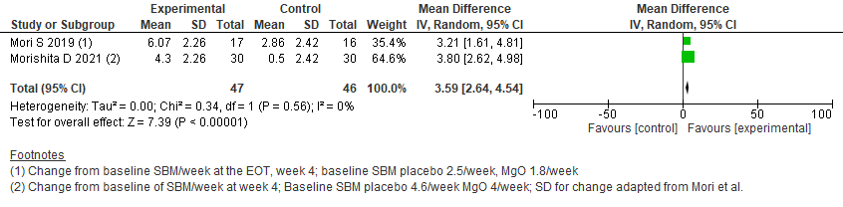

Figure 3.3: Effect of Magnesium oxide for treatment of Chronic idiopathic constipation: Responder rate
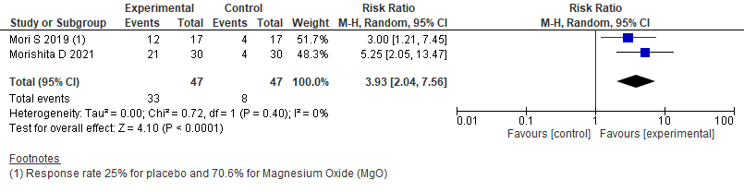

Figure 3.4: Effect of Magnesium oxide for treatment of Chronic idiopathic constipation: Diarrhea (adverse event)
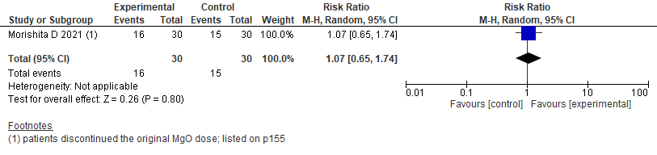

Figure 3.5: Effect of Magnesium oxide for treatment of Chronic idiopathic constipation: Quality of life
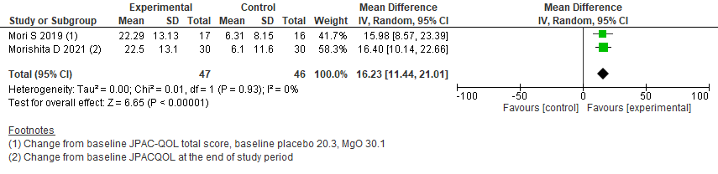
Figure 3.6: Effect of Magnesium oxide for treatment of Chronic idiopathic constipation: Bristol stool form scale
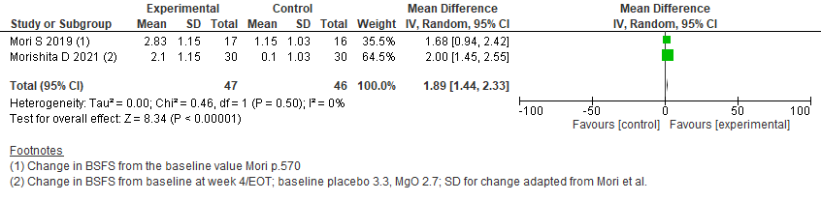

Table 3.1: Characteristics of included studies
Study and Settings | Patients | Intervention | Outcomes | Notes
Mori, S. et al. (2019); Japan | 34 female patients with mild to moderate constipation | magnesium oxide - 0.5 gm TID or placebo for 4 weeks | Complete spontaneous bowel movements; spontaneous bowel movements; responder rate; quality of life; Bristol stool form scale | Low risk of bias. Full text but very few details included.
Morishita, D., et al. (2021); Japan | 90 patients with CIC who met the Rome IV criteria | magnesium oxide - 0.5gm TID or placebo for 4 weeks | Complete spontaneous bowel movement; spontaneous bowel movement; responder rate; diarrhea; quality of life; Bristol stool form scale | Low risk of bias. University center study, possible referral bias

Table 3.2: GRADE evidence Profile: Effect of Magnesium oxide supplementation for Chronic Idiopathic Constipation in adults
Certainty assessment |  |  |  |  |  |  | № of patients |  | Effect |  | Certainty | Importance
№ of studies | Study design | Risk of bias | Inconsistency | Indirectness | Imprecision | Other considerations | Mg Oxide | Control | Relative  (95% CI) | Absolute  (95% CI)
Weekly average of CSBM
2 | randomised trials | not serious | seriousª | serious^{b} | serious^{c} | none | 47 | 47 | - | 4.29 CSBM higher  (2.93 higher to 5.65 higher) | ⨁◯◯◯  Very low
Change from baseline SBM/week
2 | randomised trials | not serious | serious^{d} | serious^{e} | serious^{c} | none | 47 | 47 | - | 3.59 SBM/week more at EOT  (2.64 more to 4.54 more) | ⨁◯◯◯  Very low
Responder rate
2 | randomised trials | not serious | not serious | not serious | serious^{c} | none | 33/47 (70.2%) | 8/47 (17.0%) | RR 3.93  (2.04 to 7.56) | 499 more per 1,000  (from 177 more to 1,000 more) | ⨁⨁⨁◯  Moderate
Adverse events-Diarrhea leading to adjustment of initial treatment dose
1 | randomised trials | not serious^{f} | serious^{g} | not serious | not serious | none | 16/30 (53.3%) | 15/30 (50.0%) | RR 1.07  (0.65 to 1.74) | 35 more per 1,000  (from 175 fewer to 370 more) | ⨁⨁⨁◯  Moderate
Serious adverse events
2 | randomised trials | serious^{h} |  |  | serious^{c} | none | 0/47 (0.0%) | 0/47 (0.0%) | not estimable |  | -
Change from baseline JPAC-QOL
2 | randomised trials | not serious | not serious | serious^{i} | serious | none | 47 | 47 | - | 16.23 JPAC-QOL points higher  (11.44 higher to 21.01 higher) | ⨁⨁◯◯  Low
Change of BSFS after treatment
2 | randomised trials | not serious | not serious^{j} | serious^{e} | serious^{c} | none | 47 | 47 | - | 1.89 BSFS points higher than baseline  (1.44 higher to 2.33 higher) | ⨁⨁◯◯  Low
CI: confidence interval; MD: mean difference; RR: risk ratio, JPAC: Japanese version of the Patient Assessment of Constipation Quality of Life questionnaire
Explanations a. There was significant statistical heterogeneity in the pooled data. b. Standard deviation for the data is not provided and had to be extrapolated from another study (Kamm et al 2011) c. Study size is small. d. There was significant statistical heterogeneity in the pooled data. e. Morishita study SD is adapted from Mori et al. f. The numbers given are for the patients who discontinued the original dose to which they were randomized (1.5gm/day) however they did not discontinue the drug all together. g. Data reported for 1 study only h. No serious adverse events reported in either study, possible reporting bias. i. There was significant statistical heterogeneity in the pooled data. j. I² for the two trials when pooled was 0%.

Table 3.3: evidence to Decision Framework

Strategy/treatment/test/intervention: Mg Oxide
Alternative strategy: Management without Mg Oxide
Domain | The effects | Judgment
How substantial are the desirable anticipated effects of the strategy? | 4 Week trials, large dose  Large increase in CSBM (>4) and SBM (>3)  Large responder rate >50%  Improved JPAQ-QoL  1.9 improvement (large) in stool form, perhaps relates to dose/development of diarrhea  Data are from only from a single trial from Japan, baseline symptoms were not severe, may not be generalizable | Large
How substantial are the undesirable anticipated effects? | Diarrhea leading to dose reduction 35 more per 1,000  No SAEs reported | Moderate
Do the desirable effects outweigh the undesirable effects? |  | Probably yes
 | Studies about the topic/Panel input
Is there important uncertainty or variability about how much people value the main outcomes? | Patients vary a lot in terms of how they care about frequency. Likely heterogeneous. | Possibly important uncertainty or variability
What is the overall certainty of the evidence of effects? |  | Very low
How large are the resource requirements associated with the intervention? | Inexpensive, possibly $20 for a bottle of 100, 5-10 cents/dose | Small costs
How large is the incremental cost relative to the net benefit? | Inexpensive and effective in most people | Small ICER
What would be the impact  on health inequities? | Widely available and relatively inexpensive. No data on different racial groups, but no biological rationale to assume otherwise. | Probably improved
Is the option acceptable  to key stakeholders? | Possible toxicity in patients with renal insufficiency. Also large doses would be inappropriate during pregnancy. | Probably Yes
Is the option feasible to implement? | It is difficult to determine the right dosage. | Probably Yes
ICER: Incremental cost-effectiveness ratio
Lactulose for Management of Chronic Idiopathic Constipation
Recommendation 4: In adults with CIC who fail or are intolerant to over-the-counter (OTC) therapies, the panel suggests the use of lactulose over management without lactulose (Conditional recommendation, very low certainty of evidence)

Implementation considerations
• Avoid use in patients with significant pre-existing bloating or flatulence
• Bloating and flatulence are dose-dependent and common side effects which may limit its use in clinical practice

Figure 4.1: Effect of Lactulose supplements for treatment of Chronic idiopathic constipation: Spontaneous Bowel Moments (SBM)
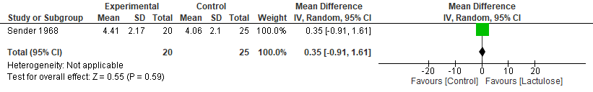

Figure 4.2: Effect of Lactulose supplements for treatment of Chronic idiopathic constipation: Responder Rate
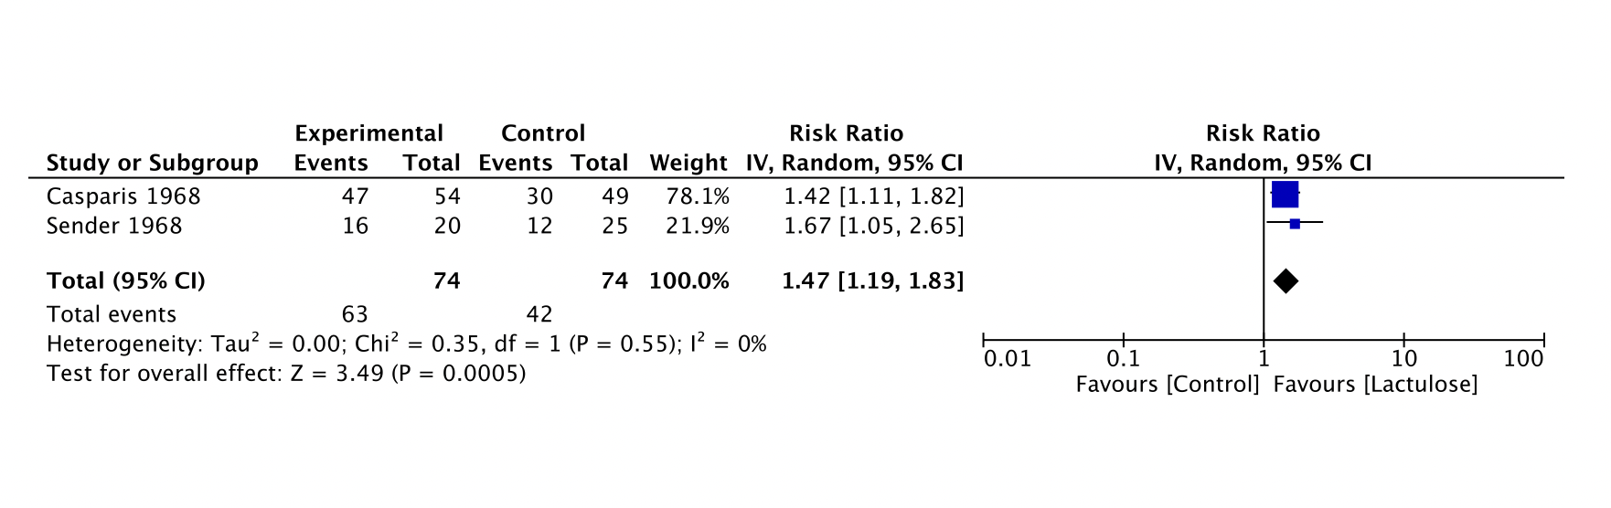

Figure 4.3: Effect of Lactulose supplements for treatment of Chronic idiopathic constipation: Global relief
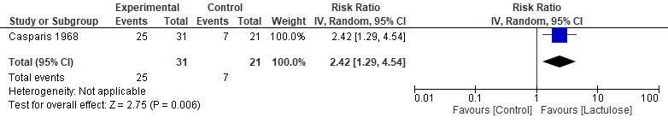

Table 4.1: Characteristics of included studies
Study and Settings | Patients | Intervention (dose, frequency, duration) | Outcomes (give all the outcomes reported from this study and the ones not reported, also comment on magnitude of effect) | Notes (risk of bias, data limitation)
Sanders, J.F. (1978) | 55 elderly constipated patients | lactulose 30 ml daily of lactulose syrup or 50% glucose syrup for 12 weeks | spontaneous bowel movements; responder rate | Responder rate was defined as > 1 SBM increase from baseline in one study and lack of need of other laxatives in other study. The study did not report methods of randomization.
Wesselius-De Casparis, A. (1968) | 103 elerly patients that were regularly taking laxatives for chronic constipation | lactulose - 15 ml - 30 ml of either 50% lactulose syrup or 50% glucose syrup depending on response | responder rate; global relief | Low risk of bias overall. The treatment success was defined as no further need of laxatives.

Table 4.2: GRADE evidence Profile: Effect of Lactulose supplementation for Chronic Idiopathic constipation in adults
Certainty assessment |  |  |  |  |  |  | № of patients |  | Effect |  | Certainty | Importance
№ of studies | Study design | Risk of bias | Inconsistency | Indirectness | Imprecision | Other considerations | Lactulose | No Lactulose | Relative  (95% CI) | Absolute  (95% CI)
CSBM per week – NOT REPORTED
SBM per week- NOT REPORTED
1 | randomised trial | seriousª | not serious | not serious | very serious^{b} | none | 20 | 25 | MD 0.35 SBM/week higher  (0.91 lower to 1.61 higher) |  | ⨁◯◯◯  Very low
Responder rate, (defined as > 1 SBM from baseline in one study and lack of need of other laxatives in other study)
2 | randomised trials | serious^{c} | not serious | not serious | serious^{d} | none | 61/74 (82.4%) | 42/74 (56.8%) | RR 1.47  (1.19 to 1.83) | 267 more per 1,000  (from 108 more to 471 more) | ⨁⨁◯◯  Low
Diarrhea (adverse event) – NOT REPORTED
Serious adverse events – NOT REPORTED
Quality of life- NOT REPORTED
Stool form- NOT REPORTED
Global relief
1 | randomised trials | seriousª | not serious | not serious | serious^{e} | none | 25/31 (80.6%) | 7/21 (33.3%) | RR 2.42  (1.29 to 4.54) | 473 more per 1,000  (from 97 more to 1,000 more) | ⨁⨁◯◯  Low
CI: confidence interval; MD: mean difference; RR: risk ratio
Explanations
a. The only included study in this analysis did not report the methods of randomization and blinding.
b. The confidence interval around the summary estimate was wide and included a null affect.
c. One of the two included studies had a high risk of bias. The other study had an unclear risk of bias
d. The total participants and number of events were small in both the intervention and the control group
e. The number of events were small and the confidence interval around the summary estimate was wide

Table 4.3: Evidence to Decision table:

Strategy/treatment/test/intervention: Lactulose
Alternative strategy: Management without lactulose
Domain | The effects | Judgment
How substantial are the desirable anticipated effects of the strategy? | Very limited data to define the efficacy of lactulose vs. Placebo. Limited effect on SBM/week, study defined responder rate increased by 47 % compared to control.  A Cochrane review published in 2010 of 10 RCTs showed that PEG has better efficacy than lactulose in terms of stool frequency per week, stool form and relief in abdominal pain. | Small
How substantial are the undesirable anticipated effects? | Minimal data on adverse events or SAE. Bloating is a very common side effects seen in clinical practice. | Moderate
Do the desirable effects outweigh the undesirable effects? | There is limited data available from the published studies | Unknown
 | Studies about the topic/Panel input
Is there important uncertainty or variability about how much people value the main outcomes? | Patients vary a lot in terms of how they care about frequency. Likely heterogeneous. Some patients may not take it because of concern about abdominal pain. | Possibly important uncertainty or variability
What is the overall certainty of the evidence of effects? | Very low | Very low
How large are the resource requirements associated with the intervention? | Some brand name might be expensive | Small costs
How large is the incremental cost relative to the net benefit? | No data were available to make an assessment in this regard | Unknown
What would be the impact  on health inequities? | No data were available to make an assessment in this regard | Unknown
Is the option acceptable  to key stakeholders? | No data were available to make an assessment in this regard | Probably Yes
Is the option feasible to implement? | Less expensive than most other drugs. Patients should be cognizant of AEs such as bloating and diarrhea. | Probably Yes

Bisacodyl of Management of Chronic Idiopathic Constipation

Recommendation 5: In adults with CIC, the panel recommends the use of bisacodyl or sodium picosulphate for short term or rescue therapy, over management without bisacodyl or sodium picosulphate. (Strong recommendation, moderate certainty of evidence)

Implementation considerations
• Short term use is defined as daily use for 4 weeks or less. While long term use is probably appropriate, data are needed to better understand tolerance and side effects.
• Abdominal cramps and pain may be common. The panel suggests starting at a lower dose and increasing the dose as tolerated.
• This is a good option for occasional use or rescue therapy in combination with other pharmacological agents for CIC.

Figure 5.1: Effect of Bisacodyl/SPS for treatment of Chronic idiopathic constipation: Complete Spontaneous Bowel Moments
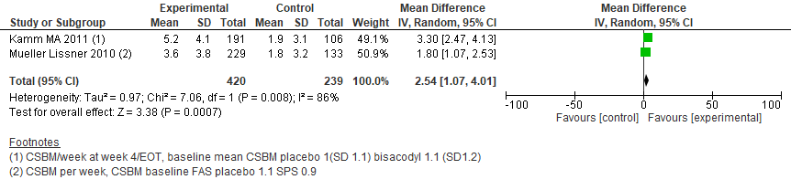

Figure 5.2: Effect of Bisacodyl/SPS for treatment of Chronic idiopathic constipation: Spontaneous Bowel Moments
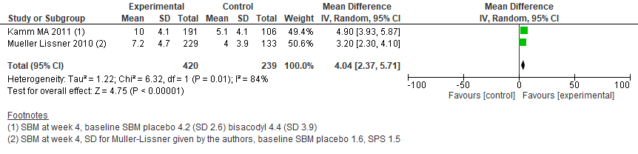

Figure 5.3: Effect of Bisacodyl/SPS for treatment of Chronic idiopathic constipation: Responder rate
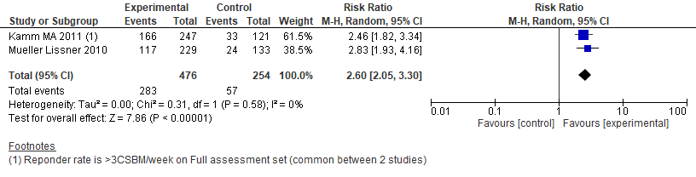

Figure 5.4: Effect of Bisacodyl/SPS for treatment of Chronic idiopathic constipation: Diarrhea (adverse event)
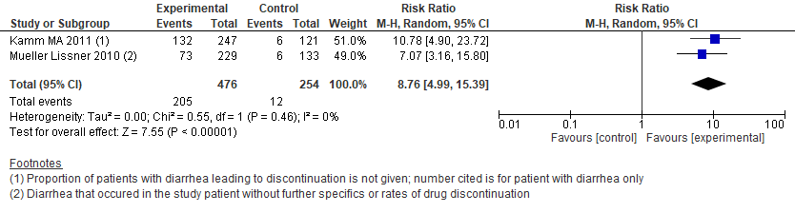

Figure 5.5: Effect of Bisacodyl/SPS for treatment of Chronic idiopathic constipation: Severe adverse events
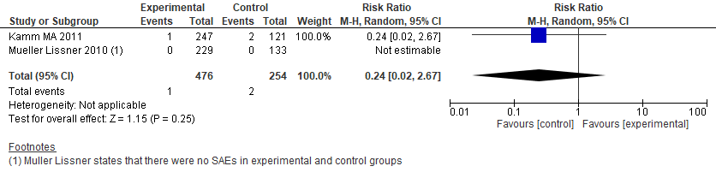

Figure 5.6: Effect of Bisacodyl/SPS for treatment of Chronic idiopathic constipation: Quality of life
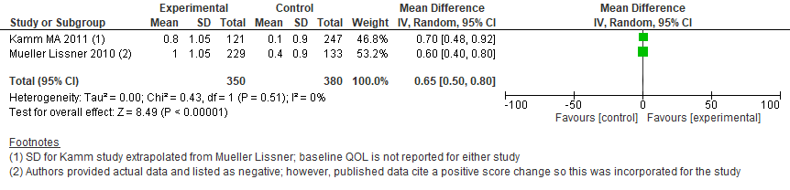

Figure 5.7: Effect of Bisacodyl/SPS for treatment of Chronic idiopathic constipation: Global relief outcome
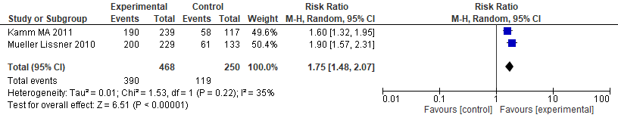

Figure 5.8: Effect of Bisacodyl/SPS for treatment of Chronic idiopathic constipation: Bristol stool form scale
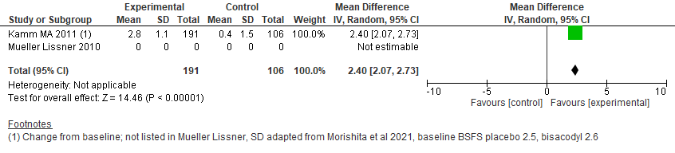

Table 5.1: Characteristics of included studies
Study and Settings | Patients | Intervention (dose, frequency, duration) | Outcomes | Notes (risk of bias, data limitation)
Kamm, M.A., et al. (2011) | 368 patients 18 years or older, and suffering from chronic constipation (as defined by the Rome III criteria) | bisacodyl - 10 mg of bisacodyl once daily or placebo for 10 weeks | Complete spontaneous bowel movements; spontaneous bowel movements; responder rate; diarrhea; severe adverse events; quality of life; global relief; bristol stool form scale | Multiple SD for data had to be adapted from other similar studies. SDs for continuous outcome were used from Mueller-Lissner et al.  Kamm et al list “diarrhea” or number of patients with AEs leading to drug discontinuation.  Responder rate was defined as CSBM > 3/week
Mueller-Lissner, S., et al. (2010) | 367 patients with chronic constipation presenting to their general practitioner and fulfilling the Rome III diagnostic criteria | sodium picosulfate - 18 drops = 10 mg of SPS or matching placebo once daily for 4 weeks. Patients allowed to reduce dose to half based on response | Complete spontaneous bowel movements; spontaneous bowel movements; responder rate; diarrhea; severe adverse events; quality of life; global relief | The number of patients experiencing diarrhea leading to discontinuation is not listed for either study. For the Mueller-Lissner et al study 367 patients were randomized, FAS was 229 SPS treated patients and 133 placebo treated patients. Per protocol population was 131 patients given SPS and 71 treated with placebo. Attrition bias is a significant concern.
Abbreviation: CSBM: Complete spontaneous bowel moment.

Table 5.2: GRADE evidence Profile: Effect of Bisacodyl/SPS supplementation for Chronic Idiopathic constipation in adults
Certainty assessment |  |  |  |  |  |  | № of patients |  | Effect |  | Certainty | Importance
№ of studies | Study design | Risk of bias | Inconsistency | Indirectness | Imprecision | Other considerations | Bisacodyl | control | Relative  (95% CI) | Absolute  (95% CI)
Weekly CSBM
2 | randomised trials | seriousª | not serious | not serious | not seriousª | none | 420 | 239 | 2.54 CSBM higher  (1.07 higher to 4.1 higher) |  | ⨁⨁⨁◯  Moderate
Change of SBM from baseline
2 | randomised trials | seriousª | not serious | not serious | not serious | none | 420 | 239 | 4.04 SBM higher  (2.37 higher to 5.71 higher) |  | ⨁⨁⨁◯  Moderate
Responder rate defined as ≥ 3 CSBM/week
2 | randomised trials | seriousª | not serious | not serious | not serious | none | 283/476 (59.5%) | 57/254 (22.4%) | RR 2.60  (2.05 to 3.30) | 359 more per 1,000  (from 236 more to 516 more) | ⨁⨁⨁◯  Moderate
Diarrhea (adverse event)
2 | randomised trials | seriousª | not serious | serious^{b} | serious^{c} | none | 205/476 (43.1%) | 12/254 (4.7%) | RR 8.76  (4.99 to 15.39) | 367 more per 1,000  (from 189 more to 680 more) | ⨁◯◯◯  Very low
Serious adverse events
2 | randomised trials | seriousª | serious^{d} | not serious | serious^{e} | none | 1/476 (0.2%) | 2/254 (0.8%) | RR 0.24  (0.02 to 2.67) | 6 fewer per 1,000  (from 8 fewer to 13 more) | ⨁◯◯◯  Very low
Quality of life (Change in PAC-QOL score from baseline)
2 | randomised trials | serious^{a,b,f} | not serious | serious^{g} | not serious | none | 350 | 380 | 0.65 PAC-QOL points higher  (0.5 higher to 0.8 higher) |  | ⨁⨁◯◯  Low
Global relief outcome
2 | randomised trials | serious^{a,f} | not serious | not serious | not serious | none | 390/468 (83.3%) | 119/250 (47.6%) | RR 1.75  (1.48 to 2.07) | 357 more per 1,000  (from 228 more to 509 more) | ⨁⨁⨁◯  Moderate
BSFS change from baseline
1 | randomised trials | seriousª | not serious | not serious | not serious | none | 191 | 106 | 2.4 points higher  (2.07 higher to 2.73 higher) |  | ⨁⨁⨁◯  Moderate
CI: confidence interval; MD: mean difference; RR: risk ratio SPS: Sodium Pico-sulphate
Explanations a. 368 patients were randomized, 12 patients were excluded based on their e diaries. Full assessment set contained 239 Bisacodyl patients/117 placebo treated. Per protocol set contained 195 Bisacodyl patients/89 placebo treated patients. 44 patients were excluded from the Bisacodyl arm and 28 from the placebo arm. 56 patients prematurely dropped out from the study in the Bisacodyl arm and 15 in the placebo arm. The attrition throughout the study was significant. b. The number of patients experiencing diarrhea leading to discontinuation is not listed for either study. Kamm et al list “diarrhea” or number of patients with AEs leading to drug discontinuation. Mueller Lissner et al list number of patients with diarrhea as well. c. Confidence interval for the degree of diarrhea between the two study groups is imprecise. d. More adverse events are occurring in the placebo arm as opposed to the experimental group e. Confidence interval is wide and includes 0 f. For the Mueller-Lissner et al study 367 patients were randomized, FAS was 229 SPS treated patients and 133 placebo treated patients. Per protocol population was 131 patients given SPS and 71 treated with placebo. Attrition bias is a significant concern. g. Multiple SD for data had to be adapted from other similar studies. Mueller-Lissner et al provided the missing data and they were used for calculations in Kamm et al.

Table 5.3: Evidence to Decision Framework

Strategy/treatment/test/intervention: Bisacodyl
Alternative strategy: Management without bisacodyl
Domain | The effects | Judgment
How substantial are the desirable anticipated effects of the strategy? | Increase in CSBM, SBM, global relief, QoL and responder rate of 359 more per 1,000. PAC-QoL difference of 0.65 (MCID 0.5). The outcome results are influenced by AE’s. | Moderate
How substantial are the undesirable anticipated effects? | Diarrhea 367 more per 1,000. Minimal data on SAE. | Moderate
Do the desirable effects outweigh the undesirable effects? | The diarrhea outcome evaluated did not lead to stopping the medication | Probably yes
 | Studies about the topic/Panel input
Is there important uncertainty or variability about how much people value the main outcomes? | Patients vary a lot in terms of how they care about frequency. Likely heterogeneous. Some patients may not take it because of concern about abdominal pain. | Possibly important uncertainty or variability
What is the overall certainty of the evidence of effects? | Varies from low to moderate, most outcomes were moderate. For long term use (>4 weeks), the evidence is indirect and the certainty is judged as low. | Low  Moderate
How large are the resource requirements associated with the intervention? | Inexpensive, with OTC options in some countries. 50-75cent/pill | Small costs
How large is the incremental cost relative to the net benefit? | Inexpensive and effective in most people. SAE’s are common but not severe. | Small ICER
What would be the impact  on health inequities? | Widely available and relatively inexpensive. No data on different racial groups, but no biological rationale to assume otherwise. | Probably improved
Is the option acceptable  to key stakeholders? | Providers and patients have concern about chronic use and toxicity of stimulant laxatives—continuous arguments between two camps. A few physicians think it may be dangerous for chronic use. Short term therapy is much more acceptable. | Probably Yes
Is the option feasible to implement? | Less expensive than most other drugs. Patients should be cognizant of AEs such as abdominal pain and diarrhea. No clear dose range, should start low, abdominal pain is higher at higher doses. | Probably Yes
ICER: Incremental cost-effectiveness ratio
Senna for Management of Chronic Idiopathic Constipation
Recommendation 6: In adults with CIC, the panel suggests the use of senna over management without senna (Conditional recommendation, low certainty of evidence)

Implementation considerations
• While the trials were conducted for 4 weeks, longer term use is probably appropriate but data are needed to better understand tolerance and side effects.
• The dose evaluated in trials is higher than commonly used doses in practice. The panel suggests starting at lower dose and increase if no response.

Figure 6.1: Effect of Senna for treatment of Chronic idiopathic constipation: Complete Spontaneous Bowel Movements
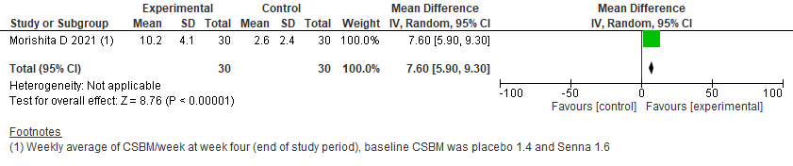

Figure 6.2: Effect of Senna for treatment of Chronic idiopathic constipation: Spontaneous Bowel Movements
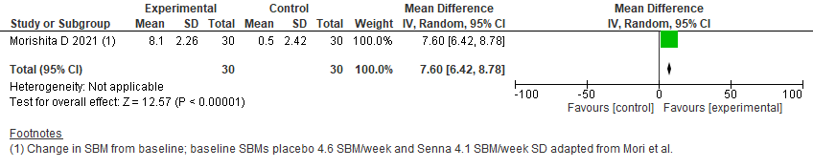

Figure 6.3: Effect of Senna for treatment of Chronic idiopathic constipation: Responder rate
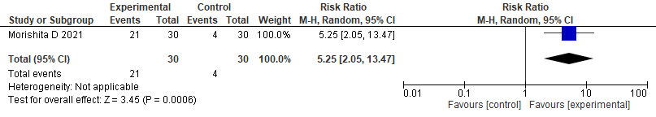

Figure 6.4: Effect of Senna for treatment of Chronic idiopathic constipation: Diarrhea (adverse event)
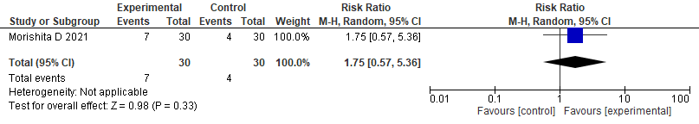

Figure 6.5: Effect of Senna for treatment of Chronic idiopathic constipation: Quality of life
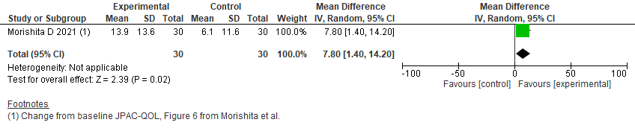

Figure 6.6: Effect of Senna for treatment of Chronic idiopathic constipation: Bristol stool form scale
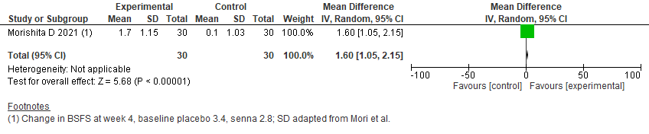

Table 6.1: Characteristics of included studies
Study and Settings | Patients | Intervention (dose, frequency, duration) | Outcomes | Notes
Morishita, D., et al. (2021); Japan | 90 patients with CIC who met the Rome IV criteria | Senna - 1.0 gm of senna or placebo three times a day for 28 days | complete spontaneous bowel movement; spontaneous bowel movement; response rate; diarrhea; quality of life; bristol stool form scale | Low risk of bias. University center study, possible referral bias

Table 6.2: GRADE evidence Profile: Effect of Senna supplementation for Chronic Idiopathic Constipation in adults

Certainty assessment |  |  |  |  |  |  | № of patients |  | Effect |  | Certainty | Importance
№ of studies | Study design | Risk of bias | Inconsistency | Indirectness | Imprecision | Other considerations | Senna | control | Relative  (95% CI) | Absolute  (95% CI)
Weekly average CSBM at EOT (week 4)
1 | randomised trial | not serious | not serious | serious | seriousª | none | 30 | 30 | - | 7.6 CSBMs more  (5.9 more to 9.3 more) | ⨁⨁◯◯  Low
Change in SBM from baseline at week 4
1 | randomised trial | not serious | not serious | serious | seriousª | none | 30 | 30 | - | 7.6 SBMs more  (6.42 higher to 8.78 higher) | ⨁⨁◯◯  Low
Responder Rate
1 | randomised trial | serious | not serious | not serious | serious^{b} | none | 21/30 (70.0%) | 4/30 (13.3%) | RR 5.25  (2.05 to 13.47) | 567 more per 1,000  (from 140 more to 1,000 more) | ⨁⨁◯◯  Low
Diarrhea (adverse event)
1 | randomised trial | not serious | not serious | not serious | serious^{b} | none | 4/30 (13.3%) | 7/30 (23.3%) | RR 1.75  (0.57 to 5.36) | 175 more per 1,000  (from 100 fewer to 1,000 more) | ⨁⨁⨁◯  Moderate
Serious adverse events
1 | randomised trial | ª |  |  | serious | none | 0/30 (0.0%) | 0/30 (0.0%) | not estimable |  | -
Change from baseline JPAC-QOL
1 | randomised trial | not serious | not serious | serious | seriousª | none | 30 | 30 | - | 7.8 JPAC-QOL points higher  (1.4 higher to 14.2 higher) | ⨁⨁◯◯  Low
Change in BSFS at EOT (at week 4)
1 | randomised trial | not serious | not serious | serious | seriousª | none | 30 | 30 | - | 1.6 BSFS points higher  (1.05 higher to 2.15 higher) | ⨁⨁◯◯  Low
CI: confidence interval; MD: mean difference; RR: risk ratio, JPAC: Japanese version of the Patient Assessment of Constipation Quality of Life questionnaire
Explanations a. Study size is small. b. Confidence interval is very wide leading to imprecision.

Table 6.3: Evidence to Decision Framework

Strategy/treatment/test/intervention: Senna
Alternative strategy: Management without senna
Domain | The effects | Judgment
How substantial are the desirable anticipated effects of the strategy? | 4 Week trial  Large increase in CSBM and SBM (>7)  Large responder rate >50%  1.6 improvement (large) in stool form  Data are from only from a single trial from Japan, baseline symptoms were not severe, dosing was 1 g per day and different preparation than in US, may not be generalizable | Large
How substantial are the undesirable anticipated effects? | Diarrhea leading to dose reduction 175 more per 1,000  No SAEs reported  Mild abdominal pain and diarrhea were reported in the trial as AEs | Moderate
Do the desirable effects outweigh the undesirable effects? |  | Probably yes
 | Studies about the topic/Panel input
Is there important uncertainty or variability about how much people value the main outcomes? | Patients vary a lot in terms of how they care about frequency. Likely heterogeneous. | Possibly important uncertainty or variability
What is the overall certainty of the evidence of effects? |  | Very low
How large are the resource requirements associated with the intervention? | Inexpensive, 2 cents/dose | Small costs
How large is the incremental cost relative to the net benefit? | Inexpensive and effective in most people | Small ICER
What would be the impact  on health inequities? | Widely available and relatively inexpensive. No data on different racial groups, but no biological rationale to assume otherwise. | Probably improved
Is the option acceptable  to key stakeholders? | Providers and patients have concern about chronic use and toxicity of stimulant laxatives—continuous arguments between two camps. A few physicians think it may be dangerous for chronic use. Short term therapy is much more acceptable | Probably Yes
Is the option feasible to implement? | Patients should be cognizant of AEs such as abdominal pain and diarrhea. Preparation and dose varies. | Probably Yes
ICER: Incremental cost-effectiveness ratio

Lubiprostone for the Management of Constipation

Recommendation 7: In adults with CIC who do not respond to OTC agents, the panel suggests the use of lubiprostone over management without lubiprostone. Conditional recommendation, low certainty of evidence

Implementation considerations
• Can be used as a replacement or as an adjunct to OTC agents.
- Duration of treatment in trials was 4 weeks but the drug label does not provide a limit.

Figure 7.1: Effect of Lubiprostone for treatment of Chronic idiopathic constipation: Spontaneous Bowel Movements (SBM)
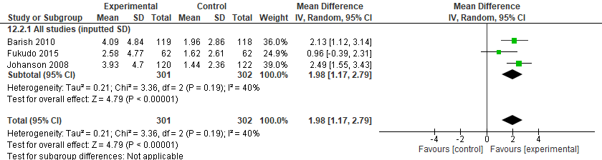
Figure 7.2: Effect of Lubiprostone for treatment of Chronic idiopathic constipation: Responder rate (Johanson 2008 responder rate ≥ 3; Barish 2010 and Fukudo 2015 responder rate ≥ 4)
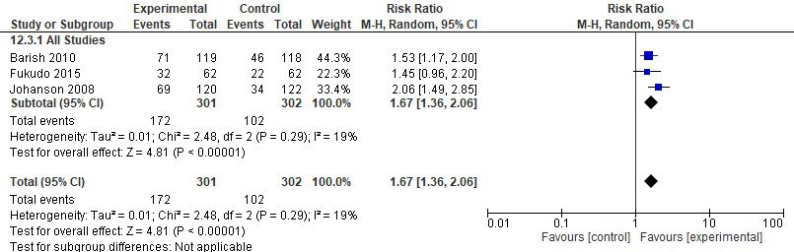
Figure 7.3: Effect of Lubiprostone for treatment of Chronic idiopathic constipation: diarrhea leading to treatment discontinuation
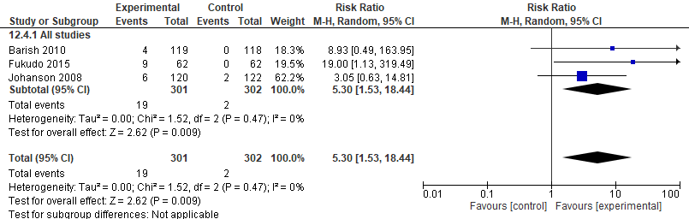
Figure 7.4: Effect of Lubiprostone for treatment of Chronic idiopathic constipation: Serious adverse events (SAE)
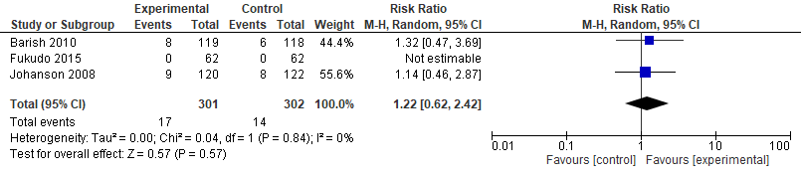
Figure 7.5: Effect of Lubiprostone for treatment of Chronic idiopathic constipation: Stool form (mean change from baseline) using 0 to 4-point scale (very loose to very hard where lower score is better)
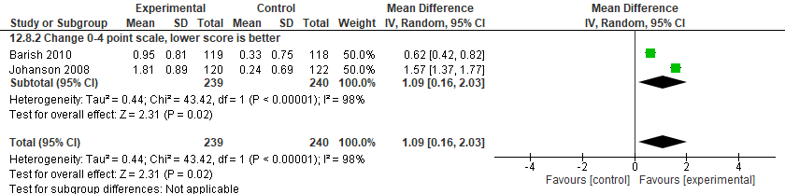
Figure 7.6: Effect of Lubiprostone for treatment of Chronic idiopathic constipation: Global Relief (0 = not effective at all; 1 = a little bit effective; 2 = moderately effective; 3 = quite a bit effective; 4 = very effective)
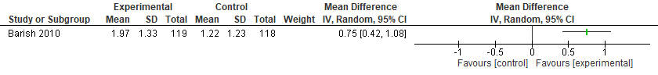

Table 7.1: Characteristic of included studies
Study and Settings | Patients | Intervention | Outcomes | Notes
Barish, C.F., et al. (2010); Uknown location | 237 patients with chronic constipation | Lubiprostone - 24 mcg or placebo BID for 4 weeks | spontaneous bowel movements; responder rate; diarrhea; serious adverse events; stool form; global relief | Low risk of bias.
Fukudo, S., et al. (2015); Japan | 124 patients with CIC defined as a subpopulation of the Rome III–defined functional bowel disorders with constipation | Lubiprostone - 24 mcg or placebo BID for 4 weeks | spontaneous bowel movements; responder rate; diarrhea; serious adverse events | Low risk of bias.
Johanson, J.F., et al. (2008) | 242 patients with constipation defined as an average of <3 SBMs per week | Lubiprostone - 25 mcg 2x daily for 4 weeks | spontaneous bowel movements; responder rate; diarrhea; serious adverse events; stool form | Low risk of bias.

Table 7.2: GRADE evidence Profile: Effect of Lubiprostone for Chronic Idiopathic Constipation in adults

Certainty assessment |  |  |  |  |  |  | № of patients |  | Effect |  | Certainty | Importance
№ of studies | Study design | Risk of bias | Inconsistency | Indirectness | Imprecision | Other considerations | Lubiprostone | control | Relative  (95% CI) | Absolute  (95% CI)
SBM per week (mean change from baseline)
3 | randomised trials | not serious | not serious | not serious | seriousª | none | 301 | 302 | - | MD 1.98 SBM/week higher  (1.17 higher to 2.79 higher) | ⨁⨁⨁◯  Moderate
Responder rate (Johanson 2008 responder rate ≥ 3; Barish 2010 and Fukudo 2015 responder rate ≥ 4)
3 | randomised trials | not serious | not serious | serious^{b} | serious^{c} | none | 172/301 (57.1%) | 102/302 (33.8%) | RR 1.67  (1.36 to 2.06) | 226 more per 1,000  (from 122 more to 358 more) | ⨁⨁◯◯  Low
Adverse event: diarrhea leading to treatment discontinuation
3 | randomised trials | not serious | not serious | not serious | very serious^{c} | none | 19/301 (6.3%) | 2/302 (0.7%) | RR 5.30  (1.53 to 18.44) | 28 more per 1,000  (from 4 more to 115 more) | ⨁⨁◯◯  Low
Serious adverse events (SAE)
3 | randomised trials | not serious | not serious | not serious | very serious^{c} | none | 17/301 (5.6%) | 14/302 (4.6%) | RR 1.22  (0.62 to 2.42) | 10 more per 1,000  (from 18 fewer to 66 more) | ⨁⨁◯◯  Low
Stool form (mean change from baseline) using 0 to 4-point scale (very loose to very hard where lower score is better)
2 | randomised trials | not serious | serious^{d} | not serious^{d} | very serious^{c} | none | 239 | 240 | - | MD 1.09 lower  (0.16 lower to 2.03 lower) | ⨁◯◯◯  Very low
Global Relief (0 = not effective at all; 1 = a little bit effective; 2 = moderately effective; 3 = quite a bit effective; 4 = very effective)
1 | randomised trials | not serious | not serious | not serious | very serious^{c} | none | 119 | 118 | - | MD 0.75 higher  (0.42 higher to 1.08 higher) | ⨁⨁◯◯  Low
CI: confidence interval; MD: mean difference; RR: risk ratio
Explanations
a. Small number of patients.
b. Responder rate is ≥4 SBM per week (Barish and Fukudo) and ≥3 SBM (Johanson). No element of 1 more than baseline, therefore, not comparable to other agents by responder rate definition.
c. Small number of events.
d. Using a scale 0-4 and not the typical BSFS.

Table 7.3: evidence to Decision Framework

Strategy/treatment/test/intervention: Lubiprostone
Alternative strategy: Management without Lubiprostone
Domain | The effects | Judgment
How substantial are the desirable anticipated effects of the strategy? | 4 week outcomes only, no CSBM data  Increase in SBM > 2  Responder rate 109 (newer criteria, 3+1) to 165 more per 1000 (Other criteria, >3)  Improved stool form and global relief | Small
How substantial are the undesirable anticipated effects? | Diarrhea that leads to discontinuation, difference of approximately 38 per 1,000. | Small
Do the desirable effects outweigh the undesirable effects? |  | Probably yes
 | Studies about the topic/Panel input
Is there important uncertainty or variability about how much people value the main outcomes? | Data are minimal on this. Patients are likely heterogeneous in how they value the treatment-associated increase of a single BM per week. Studies did not assess how satisfied patients were with BM’s. | Possibly important uncertainty or variability
What is the overall certainty of the evidence of effects? |  | Low
How large are the resource requirements associated with the intervention? |  | Moderate costs
How large is the incremental cost relative to the net benefit? | $72,053/QALY gained although there is less certainty about ICER (differences in the trial design vs other drugs).  Insurer perspective  Am J Gastroenterol. 2021 Oct 1;116(10):2118-2127. doi:10.14309/ajg.0000000000001403. | Large ICER
What would be the impact  on health inequities? | This may not covered by some insurers, requires prior authorization, and may not be on some formularies. | Probably worsened
Is the option acceptable  to key stakeholders? |  | Probably Yes
Is the option feasible to implement? | Cost and prior authorization may be barriers. | Probably Yes
ICER: Incremental cost-effectiveness ratio

Linaclotide for the Management of Constipation

Recommendation 8: In adults with CIC who do not respond to OTC agents, the panel recommends the use of linaclotide over management without linaclotide. Strong recommendation, moderate certainty of evidence
Implementation considerations
• Can be used as a replacement or as an adjunct to OTC agents.
• Duration of treatment in trials was 12 weeks but the drug label does not provide a limit.

Figure 8.1 Effect of Linaclotide for treatment of Chronic idiopathic constipation: Complete Spontaneous Bowel Movements (CSBM)
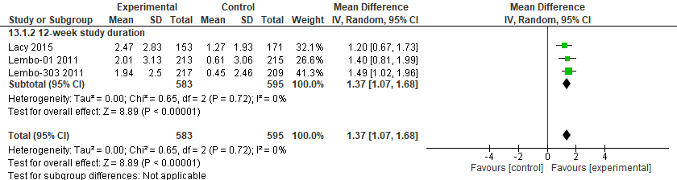

Figure 8.2: Effect of Linaclotide for treatment of Chronic idiopathic constipation: Spontaneous Bowel Movements (SBM)
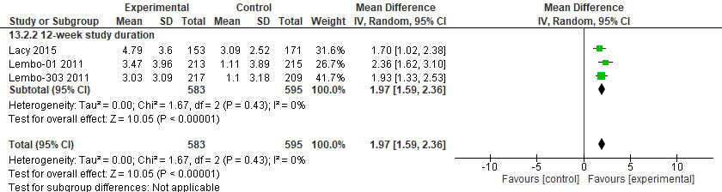

Figure 8.3: Effect of Linaclotide for treatment of Chronic idiopathic constipation: Responder rate (≥ 3 CSBM per week and ≥ 1 CBSM over baseline for 9 of 12 weeks)
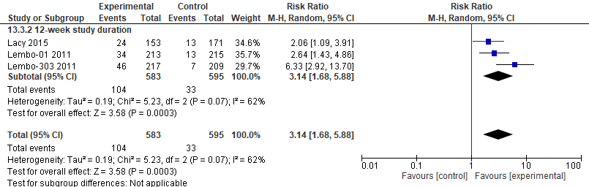

Figure 8.4: Effect of Linaclotide for treatment of Chronic idiopathic constipation: diarrhea leading to treatment discontinuation
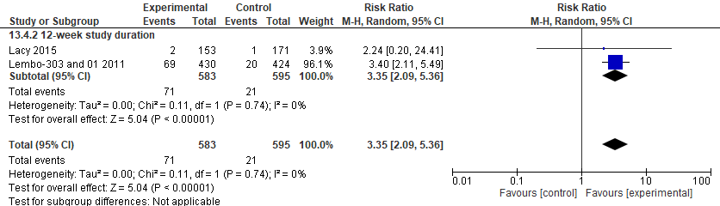

Figure 8.5: Effect of Linaclotide for treatment of Chronic idiopathic constipation: Serious adverse events (SAE)
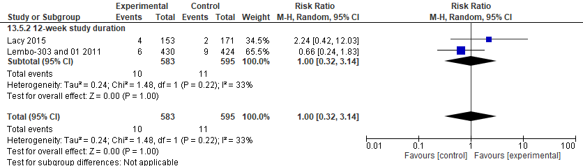

Figure 8.6: Effect of Linaclotide for treatment of Chronic idiopathic constipation: Quality of life, PAC-QOL, lower is better
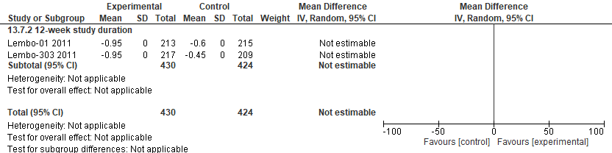

Figure 8.7: Effect of Linaclotide for treatment of Chronic idiopathic constipation: Stool form (mean change from baseline) using Bristol Stool Form Scale (BSFS) where higher is better
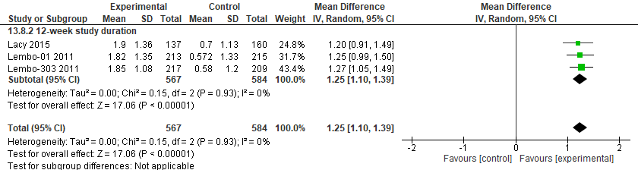

Figure 8.8: Effect of Linaclotide for treatment of Chronic idiopathic constipation: Global Relief
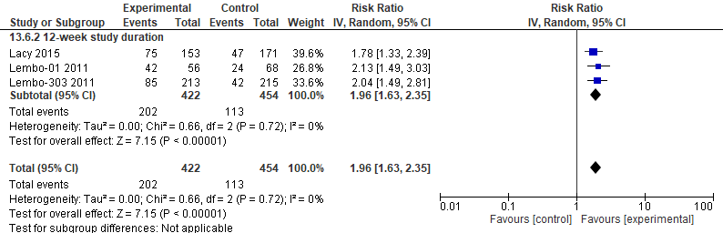

Table 8.1: Characteristics of included studies
Study and Settings | Patients | Intervention (dose, frequency, duration) | Outcomes | Notes
Lacy, B.E., et al. (2011); US and Canada | 483 patients who met Rome II criteria for chronic constipation upon entry with an average abdominal bloating score ≥5 | Linaclotide - 145/290 mcg or placebo daily for 12 weeks | Complete spontaneous bowel movements; spontaneous bowel movements; responder rate; diarrhea; serious adverse events; stool form; global relief | Low risk of bias.
Lembo, A.J. et al (2011); US | 1276 patients with chronic constipation | Linaclotide - 145/290 mcg or placebo daily for 12 weeks | Complete spontaneous bowel movements; spontaneous bowel movements; responder rate; diarrhea; serious adverse events; stool form; global relief; quality of life | Low risk of bias. Reports of two trials published in the same manuscript.

Table 8.2. Grade Evidence Profile: Effect of Linaclotide on Chronic Idiopathic Constipation
Certainty assessment |  |  |  |  |  |  | № of patients |  | Effect |  | Certainty | Importance
№ of studies | Study design | Risk of bias | Inconsistency | Indirectness | Imprecision | Other considerations | Linaclotide | control | Relative  (95% CI) | Absolute  (95% CI)
CSBM per week (mean change from baseline)
3 | randomised trials | not serious | not serious | not serious | not serious | none | 583 | 595 | - | MD 1.37 CSBM/per week higher  (1.07 higher to 1.68 higher) | ⨁⨁⨁⨁  High
SBM per week (mean change from baseline)
3 | randomised trials | not serious | not serious | not serious | not serious | none | 583 | 595 | - | 1.97 SBM/week higher  (1.59 higher to 2.36 higher) | ⨁⨁⨁⨁  High
Responder rate (≥ 3 CSBM per week and ≥ 1 CBSM over baseline for 9 of 12 weeks)
3 | randomised trials | not serious | not serious | not serious | seriousª | none | 104/583 (17.8%) | 33/595 (5.5%) | RR 3.14  (1.68 to 5.88) | 119 more per 1,000  (from 38 more to 271 more) | ⨁⨁⨁◯  Moderate
Adverse event: diarrhea leading to treatment discontinuation
3 | randomised trials | not serious | not serious | not serious | serious^{b} | none | 71/583 (12.2%) | 21/595 (3.5%) | RR 3.35  (2.09 to 5.36) | 83 more per 1,000  (from 38 more to 154 more) | ⨁⨁⨁◯  Moderate
Serious adverse events (SAE)
3 | randomised trials | not serious | not serious | not serious | very serious^{b} | none | 10/583 (1.7%) | 11/595 (1.8%) | RR 1.00  (0.32 to 3.14) | 0 fewer per 1,000  (from 13 fewer to 40 more) | ⨁⨁◯◯  Low
Quality of life, PAC-QOL, lower is better
2 | randomised trials | not serious | not serious | not serious | very serious^{c} | none | 430 | 424 | - | 0  (0 to 0 ) | ⨁⨁◯◯  Low
Stool form (mean change from baseline) using Bristol Stool Form Scale (BSFS) where higher is better
3 | randomised trials | not serious | not serious | not serious | not serious | none | 567 | 584 | - | MD 1.25 higher  (1.1 higher to 1.39 higher) | ⨁⨁⨁⨁  High
Global Relief
3 | randomised trials | not serious | not serious | not serious | not serious | none | 202/422 (47.9%) | 113/454 (24.9%) | RR 1.96  (1.63 to 2.35) | 239 more per 1,000  (from 157 more to 336 more) | ⨁⨁⨁⨁  High
CI: confidence interval; MD: mean difference; RR: risk ratio
Explanations
a. Small number of events and wide confidence interval.
b. Small number of events.
c. Standard deviations not available for any study.

Table 8.3: Evidence to Decision Table

Strategy/treatment/test/intervention: Linaclotide
Alternative strategy: Management without Linaclotide
Domain | The effects | Judgment
How substantial are the desirable anticipated effects of the strategy? | Increase in CSBM, SBM > 1.  Global relief about 200-300/1,000 better  Responder rate 109 (newer criteria, 3+1) to 165 more per 1000 (Other criteria, >3)  No data on QoL  (Based on indirect evidence (i.e., trials in IBS-C), likely better than osmotic and stimulant laxatives in patients with CIC and abdominal pain | Moderate
How substantial are the undesirable anticipated effects? | Diarrhea that leads to discontinuation, increased from 3% (placebo) to 10%. Almost half of the responder difference per 1,000. | Moderate
Do the desirable effects outweigh the undesirable effects? | Diarrhea is a reversible side effect. Probably not a first line drug. | Probably yes
 | Studies about the topic/Panel input
Is there important uncertainty or variability about how much people value the main outcomes? | Data are minimal on this. Patients are likely heterogeneous in how they value the treatment-associated increase of a single BM per week. It is not clear how many of those with global relief were also counted as responders. | Possibly important uncertainty or variability
What is the overall certainty of the evidence of effects? |  | Moderate
How large are the resource requirements associated with the intervention? |  | Moderate costs
How large is the incremental cost relative to the net benefit? | $309,968/QALY gained 145 mcg daily  $345,401/QALY gained 72 mcg daily  Insurer perspective  Am J Gastroenterol. 2021 Oct 1;116(10):2118-2127. doi:10.14309/ajg.0000000000001403. | Large ICER
What would be the impact  on health inequities? | This may not covered by some insurers, requires prior authorization, and may not be on some formularies. | Probably worsened
Is the option acceptable  to key stakeholders? |  | Probably Yes
Is the option feasible to implement? | Cost, prior authorization, side effects and discontinuation are all barriers. | Probably Yes
ICER: Incremental cost-effectiveness ratio

Plecanatide for the Management of Constipation
Recommendation 9: In adults with CIC who do not respond to OTC agents, the panel recommends the use of plecanatide over management without plecanatide. (Strong recommendation, Moderate certainty of evidence)
Implementation considerations
• Can be used as a replacement or as an adjunct to OTC agents.
• Duration of treatment in trials was 12 weeks but the drug label does not provide a limit.

Figure 9.1 Effect of Plecanatide for treatment of Chronic idiopathic constipation: Complete Spontaneous Bowel Movements (CSBM)
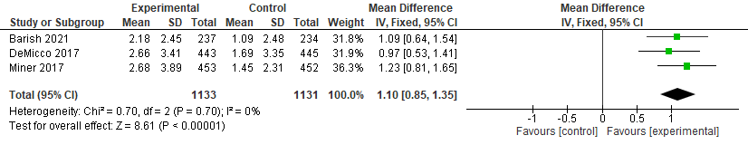

Figure 9.2: Effect of Plecanatide for treatment of Chronic idiopathic constipation: Spontaneous Bowel Movements (SBM)
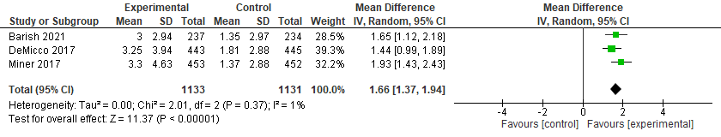
Figure 9.3: Effect of Plecanatide for treatment of Chronic idiopathic constipation: Responder rate (≥ 3 CSBM per week and ≥ 1 CBSM over baseline for ≥ 9 of 12 weeks including ≥ 3 of the last 4 weeks)
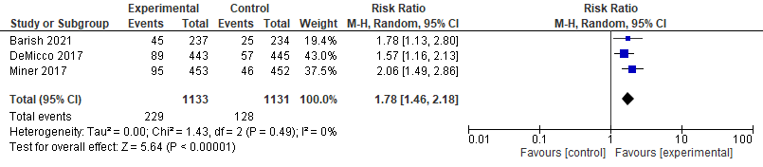

Figure 9.4: Effect of Plecanatide for treatment of Chronic idiopathic constipation: diarrhea leading to treatment discontinuation
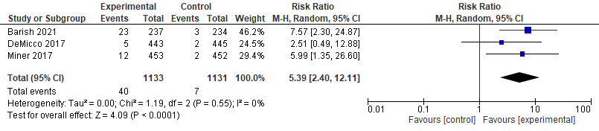

Figure 9.5: Effect of Plecanatide for treatment of Chronic idiopathic constipation: Serious adverse events (SAE)
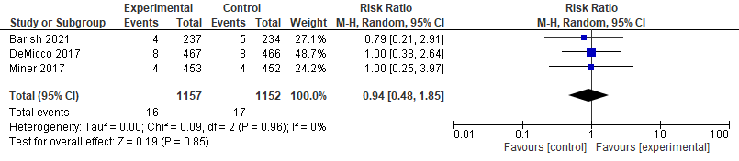

Figure 9.6: Effect of Plecanatide for treatment of Chronic idiopathic constipation: Quality of life, PAC-QOL, lower is better
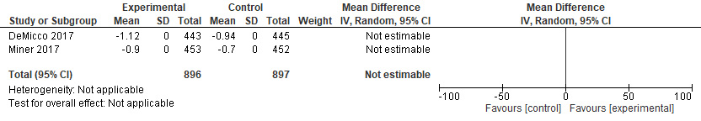

Figure 9.7: Effect of Plecanatide for treatment of Chronic idiopathic constipation: Stool form (mean change from baseline) using Bristol Stool Form Scale (BSFS) where higher is better

Table 9.1: Characteristics of included studies
Study and Settings | Patients | Intervention | Outcomes | Notes
Barish, C., et al. (2021); US | 951 patients aged 18-75 years and diagnosed with CIC based on modified Rome III criteria | Plecanatide - 0.3/1/3 mg daily for 12 weeks | complete spontaneous bowel movements; spontaneous bowel movements; responder rate; diarrhea; serious adverse events | Low risk of bias
DeMicco, M., et al. (2017) | 1410 patients meeting modified Rome III CIC criteria | Plecanatide - 3/ 6 mg or placebo daily for 12 weeks | complete spontaneous bowel movements; spontaneous bowel movements; responder rate; diarrhea; serious adverse events; quality of life; stool form | Low risk of bias
Miner, P.B., Jr., et al. (2017); US and Canada | 1,394 patients with CIC by modified Rome II functional constipation criteria | Plecanatide - 3/6 mg or placebo daily for 12 weeks | complete spontaneous bowel movements; spontaneous bowel movements; responder rate; diarrhea; serious adverse events; quality of life; stool form | Low risk of bias

Table 9.2. Grade Evidence Profile: Effect of Plecanatide on Chronic Idiopathy Constipation in adults
Certainty assessment |  |  |  |  |  |  | № of patients |  | Effect |  | Certainty | Importance
№ of studies | Study design | Risk of bias | Inconsistency | Indirectness | Imprecision | Other considerations | Plecanatide | control | Relative  (95% CI) | Absolute  (95% CI)
CSBM per week (mean change from baseline)
3 | randomised trials | not serious | not serious | not serious | not serious | none | 1133 | 1131 | - | MD 1.1 CSBM/week higher  (0.85 higher to 1.35 higher) | ⨁⨁⨁⨁  High
SBM per week (mean change from baseline)
3 | randomised trials | not serious | not serious | not serious | not serious | none | 1133 | 1131 | - | MD 1.66 SBM/week higher  (1.37 higher to 1.94 higher) | ⨁⨁⨁⨁  High
Responder rate (≥ 3 CSBM per week and ≥ 1 CBSM over baseline for ≥ 9 of 12 weeks including ≥ 3 of the last 4 weeks)
3 | randomised trials | not serious | not serious | not serious | not serious | none | 229/1133 (20.2%) | 128/1131 (11.3%) | RR 1.78  (1.46 to 2.18) | 88 more per 1,000  (from 52 more to 134 more) | ⨁⨁⨁⨁  High
Adverse event: diarrhea leading to treatment discontinuation
3 | randomised trials | not serious | not serious | not serious | seriousª | none | 40/1133 (3.5%) | 7/1131 (0.6%) | RR 5.39  (2.40 to 12.11) | 27 more per 1,000  (from 9 more to 69 more) | ⨁⨁⨁◯  Moderate
Serious adverse events (SAE)
3 | randomised trials | not serious | not serious | not serious | seriousª | none | 16/1133 (1.4%) | 17/1131 (1.5%) | RR 0.94  (0.48 to 1.85) | 1 fewer per 1,000  (from 8 fewer to 13 more) | ⨁⨁⨁◯  Moderate
Quality of life, lower is better
2 | randomised trials | not serious | not serious | not serious | not serious | none | 1133 | 1131 | - | MD 0  (0 to 0 ) | ⨁⨁⨁⨁  High
Stool form (mean change from baseline) using Bristol Stool Form Scale (BSFS) where higher is better
3 | randomised trials | not serious | serious^{b} | not serious | not serious | none | 1112 | 1118 | - | MD 0.83 higher  (0.6 higher to 1.05 higher) | ⨁⨁⨁◯  Moderate
CI: confidence interval; MD: mean difference; RR: risk ratio
Explanations
a. Very low number of events.
b. There was significant statistical heterogeneity in the pooled data. The I2 was 73%.

Table 9.3: evidence to Decision Framework

Strategy/treatment/test/intervention: Plecanatide
Alternative strategy: Management without Plecanatide
Domain | The effects | Judgment
How substantial are the desirable anticipated effects of the strategy? | 12-week data  1-2 SBM and CSBM  Improved responder rate stool form and global relief  Responder rate 109 (newer criteria, 3+1) to 165 more per 1000 (Other criteria, >3) | Moderate
How substantial are the undesirable anticipated effects? | Diarrhea that leads to discontinuation, difference of approximately 29 per 1,000. Considered in relation to responder rate and class effect. | Moderate
Do the desirable effects outweigh the undesirable effects? |  | Yes
 | Studies about the topic/Panel input
Is there important uncertainty or variability about how much people value the main outcomes? | Data are minimal on this. Patients are likely heterogeneous in how they value the treatment-associated increase of a single BM per week. | Possibly important uncertainty or variability
What is the overall certainty of the evidence of effects? |  | High
How large are the resource requirements associated with the intervention? |  | Moderate costs
How large is the incremental cost relative to the net benefit? | $187,276/QALY gained  Insurer perspective  Am J Gastroenterol. 2021 Oct 1;116(10):2118-2127. doi:10.14309/ajg.0000000000001403. | Large ICER
What would be the impact  on health inequities? | This may not covered by some insurers, requires prior authorization, and may not be on some formularies. | Probably worsened
Is the option acceptable  to key stakeholders? |  | Probably Yes
Is the option feasible to implement? | Cost and prior authorization may be barriers. | Probably Yes

Pruclopride for the Management of Constipation

Recommendation 10: In adults with CIC who do not respond to OTC agents, the panel recommends the use of prucalopride over management without prucalopride. (Strong recommendation, moderate certainty of evidence)

Implementation considerations
• Duration of treatment in trials was 4-24 weeks but the drug label does not provide a limit.
• Can be used as a replacement or as an adjunct to OTC agents.

Figure 10.1 Effect of Prucalopride for treatment of Chronic idiopathic constipation: Complete Spontaneous Bowel Movements (CSBM)
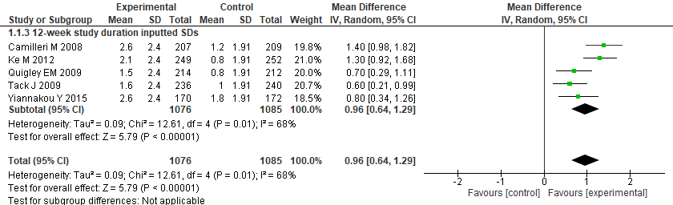

Figure 10.2: Effect of Prucalopride for treatment of Chronic idiopathic constipation: Responder rate (responder rate ≥ 3 CSBM per week)
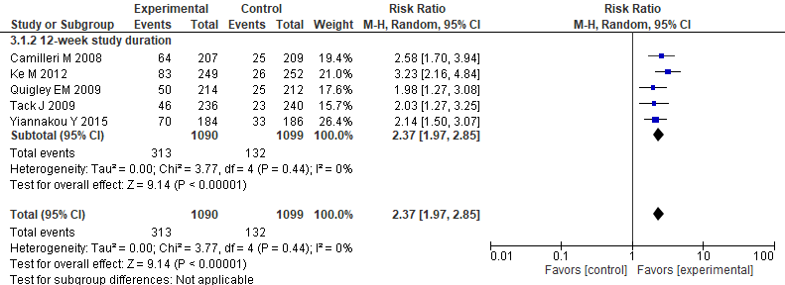

Figure 10.3: Effect of Prucalopride for treatment of Chronic idiopathic constipation: Alternative Endpoint A (≥ 3 CSBM per week and ≥ 1 CSBM per week more than baseline in 75% of study weeks)
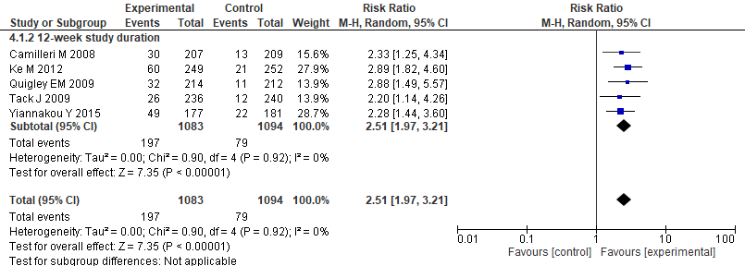

Figure 10.4: Effect of Prucalopride for treatment of Chronic idiopathic constipation: diarrhea leading to treatment discontinuation
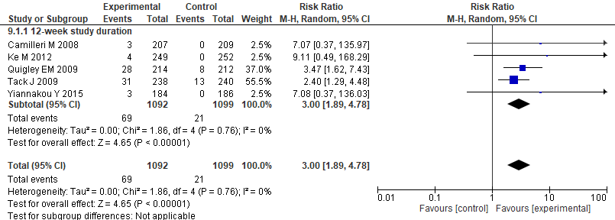

Figure 10.5: Effect of Prucalopride for treatment of Chronic idiopathic constipation: Serious adverse events (SAE)
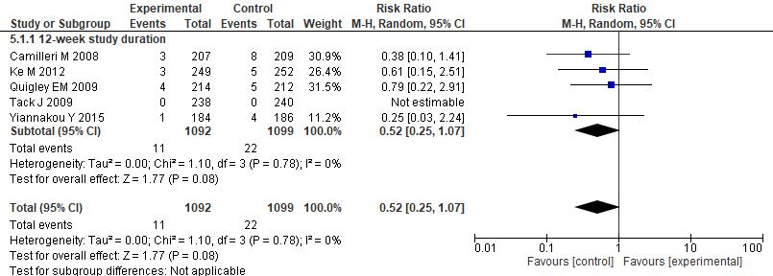

Figure 10.6: Effect of Prucalopride for treatment of Chronic idiopathic constipation: Quality of life, PAC-QOL, lower is better
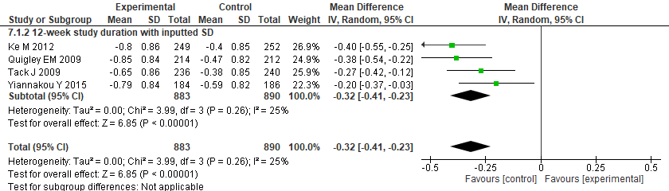

Figure 10.7 Effect of Prucalopride for treatment of Chronic idiopathic constipation: Global Relief (number of patients who felt treatment was extremely or quite a bit effective)
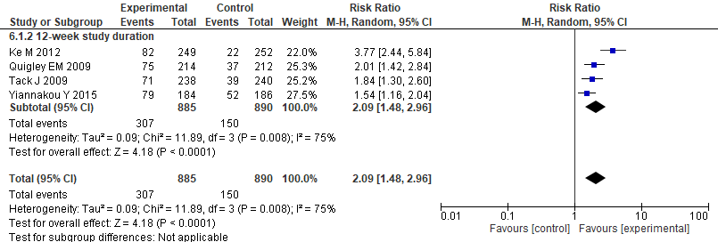

Table 10.1: Characteristic of included studies
Study and Settings | Patients | Intervention (dose, frequency, duration) | Outcomes | Notes
Camilleri, M., et al. (2008); US | 628 patients with severe chronic constipation (< or =2 spontaneous, complete bowel movements per week) | Prucalopride - 2/4 mg or placebo daily for 12 weeks | complete spontaneous bowel movements; responder rate; alternative endpoint A; diarrhea; serious adverse events | High risk of bias. "The study was designed by Johnson & Johnson,  and the academic author and one industry author participated in the development of the study design and protocol in 1998. Data gathering  and analysis were performed by Johnson & Johnson, and the analysis was finalized by Movetis.  Since the data had never been published, in 2007, Movetis sought collaboration of the academic  author to review the study files and data, and a joint decision was made that these data were of general interest and should be published.  The authors vouch for the completeness and veracity of the data and data analyses."
Ke, M. et al. (2012); Asia-Pacific Region | 501 adult patients with CC (≤2 spontaneous bowel movements per week) | Prucalopride - 2 mg or placebo daily for 12 weeks. | complete spontaneous bowel movements; responder rate; alternative endpoint A; diarrhea; serious adverse events; quality of life; global relief | Low risk of bias.
Quigley, E.M., et al. (2009); US | 651 patients men and women over 18 years of age (excluding women who were pregnant or breast feeding), with a history of self-reported chronic constipation for at least 6 months | Prucalopride - 2/4 mg or placebo daily for 12 weeks | complete spontaneous bowel movements; responder rate; alternative endpoint A; diarrhea; serious adverse events; quality of life; global relief | Low risk of bias. Delay in reporting of results due to J and J sale to Moventis and other safety/toxicology work for "FDA"
Tack, J., et al. (2009); 7 countries (Europe?) | 713 patients with chronic constipation definded as two or fewer spontaneous complete bowel movements (SCBM)/week | Prucalopride - 2/4 mg or plaebo daily for 12 weeks | complete spontaneous bowel movements; responder rate; alternative endpoint A; diarrhea; serious adverse events; quality of life; global relief | Low risk of bias. Delay in reporting of results due to J and J sale to Moventis and other safety/toxicology work for "FDA"?
Yiannakou, Y., et al. (2015); Europe | 374 men aged 18 years and older with chronic constipation were eligible for inclusion in the study. Chronic constipation was defined, according to the Rome III criteria (3), as two or fewer SCBMs per week | Prucalopride - 2 mg or placebo daily for 12 weeks; 1 mg starting does for elderly (>65), increased to 2 mg if insufficient response. | complete spontaneous bowel movements; responder rate; alternative endpoint A; diarrhea; serious adverse events; quality of life; global relief | High risk of bias. ITT but  excluded 12 patients from one site where a serious breach in good  clinical practice was identified before unblinding.

Table 10.2: GRADE evidence Profile: Effect of Prucalopride for Chronic Idiopathic Constipation in adults
Certainty assessment |  |  |  |  |  |  | № of patients |  | Effect |  | Certainty | Importance
№ of studies | Study design | Risk of bias | Inconsistency | Indirectness | Imprecision | Other considerations | Prucalopride | control | Relative  (95% CI) | Absolute  (95% CI)
CSBM per week (mean change from baseline at end of 12 weeks)
5 | randomised trials | not serious | not serious | not serious | not serious | none | 1076 | 1085 | - | MD 0.96 CSBM/week higher  (0.64 higher to 1.29 higher) | ⨁⨁⨁⨁  High
Responder rate (≥ 3 CSBM per week)
5 | randomised trials | not serious | not serious | not serious | not serious | none | 313/1090 (28.7%) | 132/1099 (12.0%) | RR 2.37  (1.97 to 2.85) | 165 more per 1,000  (from 117 more to 222 more) | ⨁⨁⨁⨁  High
Alternative Endpoint A (≥ 3 CSBM per week and ≥ 1 CSBM per week more than baseline in 75% of study weeks)
5 | randomised trials | not serious | not serious | not serious | not serious | none | 1974/1083 (182.3%) | 79/1094 (7.2%) | RR 2.51  (1.97 to 3.21) | 109 more per 1,000  (from 70 more to 160 more) | ⨁⨁⨁⨁  High
Adverse event: diarrhea leading to treatment discontinuation
5 | randomised trials | not serious | not serious | not serious | seriousª | none | 10/640 (1.6%) | 0/647 (0.0%) | RR 7.71  (1.41 to 42.15) | 0 fewer per 1,000  (from 0 fewer to 0 fewer) | ⨁⨁⨁◯  Moderate
 |  |  |  |  |  |  |  | 0.1% |  | 7 more per 1,000  (from 0 fewer to 41 more)
Serious Adverse Events (SAE)
5 | randomised trials | not serious | not serious | not serious | seriousª | none | 11/1092 (1.0%) | 22/1099 (2.0%) | RR 0.52  (0.25 to 1.07) | 10 fewer per 1,000  (from 15 fewer to 1 more) | ⨁⨁⨁◯  Moderate
Quality of life, PAC-QOL, lower is better
4 | randomised trials | not serious | not serious | not serious | not serious | none | 883 | 890 | - | MD 0.32 PAC-QOL lower  (0.41 lower to 0.23 lower) | ⨁⨁⨁⨁  High
Global Relief (number of patients who felt treatment was extremely or quite a bit effective)
4 | randomised trials | not serious | not serious | not serious | serious^{a,b} | none | 307/885 (34.7%) | 150/890 (16.9%) | RR 2.09  (0.15 to 3.0) | 184 more per 1,000  (from 144 fewer to 330 more) | ⨁⨁⨁◯  Moderate
CI: confidence interval; MD: mean difference; RR: risk ratio
Explanations
a. Low event rate.
b. There was significant statistical heterogeneity in the pooled data. The I2 was 75 %

Table 10.3: evidence to decision framework

Strategy/treatment/test/intervention: Prucalopride
Alternative strategy: Management without Prucalopride
Domain | The effects | Judgment
How substantial are the desirable anticipated effects of the strategy? | Increase in CSBM (about 1), SBM no data from 12 weeks.  Responder rate 109 (newer criteria, 3+1) to 165 more per 1000 (Other criteria, >3)  Global relief 184 more per 1000  Improvement of Pac-QoL, small effect. Not improved in 1 trial with follow up of 24 weeks  Focus on 12 week studies (some trials are shorter and longer) | Moderate
How substantial are the undesirable anticipated effects? | Diarrhea that led to discontinuation under 10 per 1000, SAE rare and imprecise | Small
Do the desirable effects outweigh the undesirable effects? | Diarrhea is a reversible side effect. Probably not a first line drug. | Probably yes
 | Studies about the topic/Panel input
Is there important uncertainty or variability about how much people value the main outcomes? | Data are minimal on this. Patients are likely heterogeneous in how they value the treatment-associated increase of a single BM per week. It is not clear how many of those with global relief were also counted as responders. | Possibly important uncertainty or variability
What is the overall certainty of the evidence of effects? |  | Moderate
How large are the resource requirements associated with the intervention? |  | Moderate costs
How large is the incremental cost relative to the net benefit? | $333,910/QALY gained  Insurer perspective  Am J Gastroenterol. 2021 Oct 1;116(10):2118-2127. doi:10.14309/ajg.0000000000001403. | Large ICER
What would be the impact  on health inequities? | This may not covered by some insurers, requires prior authorization, and may not be on some formularies. | Probably worsened
Is the option acceptable  to key stakeholders? |  | Probably Yes
Is the option feasible to implement? | Cost, prior authorization, side effects and discontinuation are all barriers. | Probably Yes
ICER: Incremental cost-effectiveness ratio

Appendix 1: Search Strategies
Fiber supplements
Ovid Embase

exp Constipation/
(Dyschezia or "Colonic Inertia" or constipat* or Obstipation).tw,kw.
1 or 2
(chronic* or "long-term" or "long term").tw,kw.
exp idiopathic disease/
(idiopathic or primary).tw,kw.
5 or 6
3 and 4 and 7
(CIC or "normal transit constipation" or "slow transit constipation" or rectocele or dyssynergic or dysmotility or "motility dysfunction" or ((rectum or rectal) adj2 prolapse*)).tw,kw.
OR/8-9
exp Dietary Fiber/
(diet* adj3 (fiber* or fibre*)).tw,kw.
((fibre* or fiber*) adj3 supplement*).tw,kw.
((fibre* or fiber*) adj3 intake*).tw,kw.
("wheat bran*" or roughage or Psyllium or Bran or Methylcellulose or Inulin).tw,kw.
or/11-15
10 and 16
exp Animals/
exp Humans/
18 not 19
17 not 20
exp adult/
exp child/
exp adolescent/
exp infant/
or/23-25
26 not 22
21 not 27
..dedup 28

Ovid Medline

exp Constipation/
(Dyschezia or "Colonic Inertia" or constipat* or Obstipation).tw,kw.
1 or 2
(chronic* or "long-term" or "long term").tw,kw.
(idiopathic or primary).tw,kw
3 and 4 and 5
(CIC or "normal transit constipation" or "slow transit constipation" or rectocele or dyssynergic or dysmotility or "motility dysfunction" or ((rectum or rectal) adj2 prolapse*)).tw,kw.
OR/6-7
exp Dietary Fibers/
(diet* adj3 (fiber* or fibre*)).tw,kw.
((fibre* or fiber*) adj3 supplement*).tw,kw.
((fibre* or fiber*) adj3 intake*).tw,kw.
("wheat bran*" or roughage or Psyllium or Bran or Methylcellulose or Inulin).tw,kw.
or/9-13
8 and 14
exp Animals/
exp Humans/
16 not 17
15 not 18
exp Adult/
exp Child/
exp Adolescent/
exp Infant/
or/21-23
24 not 20
19 not 25
..dedup 26

Cochrane

MeSH descriptor: [Constipation] explode all trees
(Dyschezia or "Colonic Inertia" or constipat* or Obstipation):ti,ab,kw
#1 OR #2
(chronic* or "long-term" or "long term"):ti,ab,kw
(idiopathic or primary):ti,ab,kw
(CIC or "normal transit constipation" or "slow transit constipation" or rectocele or dyssynergic or dysmotility or "motility dysfunction" or ((rectum or rectal) NEAR/2 prolapse*)):ti,ab,kw
#6 OR #7
MeSH descriptor: [Dietary Fibers] explode all trees
(diet* NEAR/3 (fiber* or fibre*)):ti,ab,kw
((fibre* or fiber*) NEAR/3 supplement*):ti,ab,kw
((fibre* or fiber*) NEAR/3 intake*):ti,ab,kw
("wheat bran*" or roughage or Psyllium or Bran or Methylcellulose or Inulin):ti,ab,kw
[15-#13]
#8 AND #14
MeSH descriptor: [Animals] explode all trees
MeSH descriptor: [Humans] explode all trees
#16 NOT #17
#15 NOT #18
MeSH descriptor: [Adults] explode all trees
MeSH descriptor: [Child] explode all trees
MeSH descriptor: [Adolescent] explode all trees
MeSH descriptor: [Infant] explode all trees
#21 OR #22 OR #23
#24 NOT #20
#19 NOT #25

Scopus

(((INDEXTERMS("Constipation") OR TITLE-ABS-KEY(Dyschezia or "Colonic Inertia" or constipat* or Obstipation)) AND TITLE-ABS-KEY(chronic* or "long-term" or "long term") AND (TITLE-ABS-KEY(idiopathic OR primary) OR INDEXTERMS("idiopathic disease"))) OR TITLE-ABS-KEY(CIC or "normal transit constipation" or "slow transit constipation" or rectocele or dyssynergic or dysmotility or "motility dysfunction" or ((rectum or rectal) W/2 prolapse*))) AND (INDEXTERMS("Dietary Fibers") OR TITLE-ABS-KEY(diet W/3 (fibre* OR fiber*)) OR TITLE-ABS-KEY((fibre* OR fiber*) W/3 supplement*) OR TITLE-ABS-KEY((fibre* OR fiber*) W/3 intake*) OR TITLE-ABS-KEY("wheat bran*" or roughage or Psyllium or Bran or Methylcellulose or Inulin)) AND NOT (INDEXTERMS("Animals") AND NOT INDEXTERMS("Humans")) AND NOT ((INDEXTERMS("Child") OR INDEXTERMS("Adolescent") OR INDEXTERMS("Infant")) AND NOT INDEXTERMS("Adults"))

Web of Science

TS=(Dyschezia or "Colonic Inertia" or constipat* or Obstipation)
TS=(chronic* or "long-term" or "long term")
TS=(idiopathic or primary)
#3 AND #2 AND #1
TS=(CIC or "normal transit constipation" or "slow transit constipation" or rectocele or dyssynergic or dysmotility or "motility dysfunction" or ((rectum or rectal) NEAR/2 prolapse*))
#5 OR #4
TS=(diet* NEAR/3 (fiber* or fibre*))
TS=((fibre* or fiber*) NEAR/3 supplement*)
TS=((fibre* or fiber*) NEAR/3 intake*)
TS=("wheat bran*" or roughage or Psyllium or Bran or Methylcellulose or Inulin)
#10 OR #9 OR #8 OR #7
#11 AND #6

ClinicalTrials.gov

Chronic Idiopathic Constipation | fiber OR fibre OR bran OR roughage OR Psyllium OR Bran OR Methylcellulose OR Inulin OR fibres OR fibers

CRD

MeSH DESCRIPTOR Constipation EXPLODE ALL TREES
(Dyschezia OR "Colonic Inertia" OR constipat* OR Obstipation)
(chronic* OR "long-term" OR "long term")
(idiopathic OR primary)
#1 OR #2
#3 AND #4 AND #5
((rectum OR rectal) AND prolapse*)
(CIC or "normal transit constipation" or "slow transit constipation" or rectocele or dyssynergic or dysmotility or "motility dysfunction")
#6 OR #7 OR #8
MeSH DESCRIPTOR Dietary Fiber EXPLODE ALL TREES
(fiber* OR fibre*)
(diet* OR supplement* OR intake*)
#11 AND #12
("wheat bran" or roughage or Psyllium or Bran or Methylcellulose or Inulin)
#10 OR #13 OR #14
#9 AND #15

PubMed

((("Constipation"[Mesh]) OR (Dyschezia[tw] OR "Colonic Inertia"[tw] OR constipat*[tw] OR Obstipation[tw])) AND (chronic*[tw] OR "long-term"[tw] OR "long term"[tw]) AND (idiopathic[tw] OR primary[tw]) OR (CIC[tw] OR "normal transit constipation"[tw] OR "slow transit constipation"[tw] OR rectocele[tw] OR dyssynergic[tw] OR dysmotility[tw] OR "motility dysfunction"[tw] OR ((rectum[tw] OR rectal) AND prolapse*[tw]))) AND ("Dietary Fiber"[Mesh] OR ((fiber*[tw] OR fibre*[tw]) AND (supplement*[tw] OR diet*[tw] OR intake*[tw])) OR "wheat bran*"[tw] or roughage[tw] or Psyllium[tw] or Bran[tw] or Methylcellulose[tw] or Inulin[tw]) NOT ("Animals"[Mesh] NOT "Humans"[Mesh]) NOT (("Child"[Mesh] OR "Adolescent"[Mesh] OR "Infant"[Mesh]) NOT "Adult"[Mesh])

Osmotic laxatives

Medline

exp Constipation/
(Dyschezia or "Colonic Inertia" or constipat* or Obstipation).tw,kw.
1 or 2
(chronic* or "long-term" or "long term").tw,kw.
(idiopathic or primary).tw,kw
3 and 4 and 5
(CIC or "normal transit constipation" or "slow transit constipation" or rectocele or dyssynergic or dysmotility or "motility dysfunction" or ((rectum or rectal) adj2 prolapse*)).tw,kw.
OR/6-7
exp Laxatives/
(osmotic or surfactant).tw,kw
(laxative*).tw,kw
(9 and 10) OR (10 adj2 11)
exp Magnesium/
exp Lactulose/
exp Polyethylene Glycols/
("PEG" or "Polyethylene glycol" or magnesium or lactulose or ducosate or colace or amivalex or duphalac or lactulose or normase or macrogol* or "polyethylene glycol*" or polyglycol*).tw,kw.
or/12-16
8 and 17
exp Animals/
exp Humans/
19 not 20
18 not 21
exp Adults/
exp Child/
exp Adolescent/
exp Infant/
OR/24-26
27 NOT 23
22 NOT 28
..dedup 29

Cochrane
MeSH descriptor: [Constipation] explode all trees
(Dyschezia or "Colonic Inertia" or constipat* or Obstipation):ti,ab,kw
#1 OR #2
(chronic* or "long-term" or "long term"):ti,ab,kw
(idiopathic or primary):ti,ab,kw
(CIC or "normal transit constipation" or "slow transit constipation" or rectocele or dyssynergic or dysmotility or "motility dysfunction" or ((rectum or rectal) NEAR/2 prolapse*)):ti,ab,kw
#6 OR #7
MeSH descriptor: [Laxatives] explode all trees
(osmotic or surfactant):ti,ab,kw
#9 AND #10
((osmotic OR surfactant) NEAR/2 laxative*):ti,ab,kw
#11 OR #12
MeSH descriptor: [Magnesium] explode all trees
MeSH descriptor: [Lactulose] explode all trees
MeSH descriptor: [Polyethylene Glycols] explode all trees
("PEG" or "Polyethylene glycol" or magnesium or lactulose or ducosate or colace or amivalex or duphalac or lactulose or normase or macrogol* or "polyethylene glycol*" or polyglycol*):ti,ab,kw
[15-#17]
#8 AND #18
MeSH descriptor: [Animals] explode all trees
MeSH descriptor: [Humans] explode all trees
#2O NOT #21
#19 NOT #22
MeSH descriptor: [Adults] explode all trees
MeSH descriptor: [Child] explode all trees
MeSH descriptor: [Adolescent] explode all trees
MeSH descriptor: [Infant] explode all trees
#25 OR #26 OR #27
#28 NOT #24
#23 NOT #29

Embase
exp Constipation/
(Dyschezia or "Colonic Inertia" or constipat* or Obstipation).tw,kw.
1 or 2
exp idiopathic disease/
(idiopathic or primary).tw,kw
4 or 5
(chronic* or "long-term" or "long term").tw,kw.
3 and 6 and 7
(CIC or "normal transit constipation" or "slow transit constipation" or rectocele or dyssynergic or dysmotility or "motility dysfunction" or ((rectum or rectal) adj2 prolapse*)).tw,kw.
OR/8-9
exp laxative/
(osmotic or surfactant).tw,kw
(laxative*).tw,kw
(11 and 12) OR (12 adj2 13)
exp magnesium/
exp lactulose/
exp macrogol/
("PEG" or "Polyethylene glycol" or magnesium or lactulose or ducosate or colace or amivalex or duphalac or lactulose or normase or macrogol* or "polyethylene glycol*" or polyglycol*).tw,kw.
OR/14-18
10 AND 19
exp animal/
exp human/
21 not 22
20 not 23
exp adult/
exp child/
exp adolescent/
exp infant/
OR/26-28
25 not 29
24 not 30
..dedup 31

Scopus
(((INDEXTERMS("Constipation") OR TITLE-ABS-KEY(Dyschezia or "Colonic Inertia" or constipat* or Obstipation)) AND TITLE-ABS-KEY(chronic* or "long-term" or "long term") AND (TITLE-ABS-KEY(idiopathic OR primary) OR INDEXTERMS("idiopathic disease"))) OR TITLE-ABS-KEY(CIC or "normal transit constipation" or "slow transit constipation" or rectocele or dyssynergic or dysmotility or "motility dysfunction" or ((rectum or rectal) W/2 prolapse*))) AND ((INDEXTERMS("Laxative" OR "Laxatives") AND TITLE-ABS-KEY(osmotic OR surfactant)) OR TITLE-ABS-KEY((osmotic OR surfactant) W/2 laxative*) OR INDEXTERMS(Magnesium) OR INDEXTERMS(Lactulose) OR INDEXTERMS(Macrogol) OR TITLE-ABS-KEY("PEG" or "Polyethylene glycol" or (magnesium W/2 (oxide OR agent*)) or lactulose or ducosate or colace or amivalex or duphalac or lactulose or normase or macrogol* or "polyethylene glycol*" or polyglycol*)) AND NOT (INDEXTERMS("Animals") AND NOT INDEXTERMS("Humans")) AND NOT ((INDEXTERMS("Child") OR INDEXTERMS("Adolescent") OR INDEXTERMS("Infant")) AND NOT INDEXTERMS("Adults"))

Web of Science
TS=(Dyschezia or "Colonic Inertia" or constipat* or Obstipation)
TS=(chronic* or "long-term" or "long term")
TS=(idiopathic or primary)
#3 AND #2 AND #1
TS=(CIC or "normal transit constipation" or "slow transit constipation" or rectocele or dyssynergic or dysmotility or "motility dysfunction" or ((rectum or rectal) NEAR/2 prolapse*))
#5 OR #4
TS=((osmotic or surfactant) NEAR/2 laxative*)
TS=("PEG" or "Polyethylene glycol" or magnesium or lactulose or ducosate or colace or amivalex or duphalac or lactulose or normase or macrogol* or "polyethylene glycol*" or polyglycol*)
#8 AND #7
#9 AND #6

ClinicalTrials.gov
Chronic Idiopathic Constipation | Laxative OR Laxatives OR PEG OR Polyethylene glycol OR magnesium OR lactulose OR ducosate OR colace OR amivalex OR duphalac OR lactulose OR normase OR macrogol OR polyglycol

CRD
MeSH DESCRIPTOR Constipation EXPLODE ALL TREES
(Dyschezia OR "Colonic Inertia" OR constipat* OR Obstipation)
(chronic* OR "long-term" OR "long term")
(idiopathic OR primary)
#1 OR #2
#3 AND #4 AND #5
((rectum OR rectal) AND prolapse*)
(CIC or "normal transit constipation" or "slow transit constipation" or rectocele or dyssynergic or dysmotility or "motility dysfunction")
#6 OR #7 OR #8
MeSH DESCRIPTOR Laxatives EXPLODE ALL TREES
(osmotic OR surfactant)
#10 AND #11
(laxative*)
#11 AND #13
MeSH DESCRIPTOR Magnesium EXPLODE ALL TREES
MeSH DESCRIPTOR Lactulose EXPLODE ALL TREES
MeSH DESCRIPTOR Polyethylene Glycols EXPLODE ALL TREES
("PEG" or "Polyethylene glycol" or magnesium or lactulose or ducosate or colace or amivalex or duphalac or lactulose or normase or macrogol* or "polyethylene glycol*" or polyglycol*)
#12 OR #14 OR #15 OR #16 OR #17 OR #18
#9 AND #19

PubMed
((("Constipation"[Mesh]) OR (Dyschezia[tw] OR "Colonic Inertia"[tw] OR constipat*[tw] OR Obstipation[tw])) AND (chronic*[tw] OR "long-term"[tw] OR "long term"[tw]) AND (idiopathic[tw] OR primary[tw]) OR (CIC[tw] OR "normal transit constipation"[tw] OR "slow transit constipation"[tw] OR rectocele[tw] OR dyssynergic[tw] OR dysmotility[tw] OR "motility dysfunction"[tw] OR ((rectum[tw] OR rectal) AND prolapse*[tw]))) AND ((("Laxatives"[Mesh] OR laxative*[tw]) AND (osmotic[tw] OR surfactant[tw])) OR "Magnesium"[Mesh] OR "Lactulose"[Mesh] OR "Polyethylene Glycols"[Mesh] OR "PEG"[tw] OR "Polyethylene glycol"[tw] OR magnesium[tw] OR lactulose[tw] OR ducosate[tw] OR colace[tw] OR amivalex[tw] OR duphalac[tw] OR lactulose[tw] OR normase[tw] OR macrogol*[tw] OR "polyethylene glycol*"[tw] OR polyglycol*[tw]) NOT ("Animals"[Mesh] NOT "Humans"[Mesh]) NOT (("Child"[Mesh] OR "Adolescent"[Mesh] OR "Infant"[Mesh]) NOT "Adult"[Mesh])
Stimulant Laxatives
Medline
exp Constipation/
(Dyschezia or "Colonic Inertia" or constipat* or Obstipation).tw,kw.
1 or 2
(chronic* or "long-term" or "long term").tw,kw.
(idiopathic or primary).tw,kw
3 and 4 and 5
(CIC or "normal transit constipation" or "slow transit constipation" or rectocele or dyssynergic or dysmotility or "motility dysfunction" or ((rectum or rectal) adj2 prolapse*)).tw,kw.
OR/6-7
exp Laxatives/
stimulant*.tw,kw
9 and 10
exp Bisacodyl/
exp Senna Plant/ or exp Senna Extract/
("stimulant laxative*" or agaroletten or bisacodyl or bicol or "bisac evac" or "bisac-evac" or bisalax or "bisco lax" or "bisco zitron" or bisclo-tax or bisco-zitron or "dulco lax" or "dulco-lax" or dulcolax or durolax or florisan or laxagetten or laxanin or "laxans ratiopharm" or "laxans-ratiopharm" or laxbene or laxysat or lunolax or tymil or ulcolax or senna or sennosides or "Sodium Picosulfate").tw,kw.
OR/11-14
8 and 15
exp Animals/
exp Humans/
17 not 18
16 not 19
exp Adults/
exp Child/
exp Adolescent/
exp Infant/
OR/22-24
25 not 21
20 not 26
..dedup 27

Embase
exp Constipation/
(Dyschezia or "Colonic Inertia" or constipat* or Obstipation).tw,kw.
1 or 2
exp idiopathic disease/
(idiopathic or primary).tw,kw
4 or 5
(chronic* or "long-term" or "long term").tw,kw.
3 and 6 and 7
(CIC or "normal transit constipation" or "slow transit constipation" or rectocele or dyssynergic or dysmotility or "motility dysfunction" or ((rectum or rectal) adj2 prolapse*)).tw,kw.
OR/8-9
exp laxative/
stimulant*.tw,kw
11 and 12
exp bisacodyl/ or exp bisacodyl tannex/
exp Senna/
exp picosulfate sodium/
("stimulant laxative*" or agaroletten or bisacodyl or bicol or "bisac evac" or "bisac-evac" or bisalax or "bisco lax" or "bisco zitron" or bisclo-tax or bisco-zitron or "dulco lax" or "dulco-lax" or dulcolax or durolax or florisan or laxagetten or laxanin or "laxans ratiopharm" or "laxans-ratiopharm" or laxbene or laxysat or lunolax or tymil or ulcolax or senna or sennosides or "Sodium Picosulfate").tw,kw.
OR/13-17
10 and 18
exp animal/
exp human/
20 not 21
19 not 22
exp adult/
exp child/
exp adolescent/
exp infant/
or/25-27
28 not 24
23 not 29
..dedup 30

Cochrane
MeSH descriptor: [Constipation] explode all trees
(Dyschezia or "Colonic Inertia" or constipat* or Obstipation):ti,ab,kw
#1 OR #2
(chronic* or "long-term" or "long term"):ti,ab,kw
(idiopathic or primary):ti,ab,kw
(CIC or "normal transit constipation" or "slow transit constipation" or rectocele or dyssynergic or dysmotility or "motility dysfunction" or ((rectum or rectal) NEAR/2 prolapse*)):ti,ab,kw
#6 OR #7
MeSH descriptor: [Laxatives] explode all trees
(stimulant*):ti,ab,kw
#9 AND #10
MeSH descriptor: [Bisacodyl] explode all trees
MeSH descriptor: [Senna Plant] explode all trees
MeSH descriptor: [Senna Extract] explode all trees
("stimulant laxative*" or agaroletten or bisacodyl or bicol or "bisac evac" or "bisac-evac" or bisalax or "bisco lax" or "bisco zitron" or bisclo-tax or bisco-zitron or "dulco lax" or "dulco-lax" or dulcolax or durolax or florisan or laxagetten or laxanin or "laxans ratiopharm" or "laxans-ratiopharm" or laxbene or laxysat or lunolax or tymil or ulcolax or senna or sennosides or "Sodium Picosulfate"):ti,ab,kw
[15-#15]
#8 AND #16
MeSH descriptor: [Animals] explode all trees
MeSH descriptor: [Humans] explode all trees
#18 NOT #19
#17 NOT #20
MeSH descriptor: [Adults] explode all trees
MeSH descriptor: [Child] explode all trees
MeSH descriptor: [Adolescent] explode all trees
MeSH descriptor: [Infant] explode all trees
#23 OR #24 OR #25
#26 NOT #22
#21 NOT #27

Scopus
(((INDEXTERMS("Constipation") OR TITLE-ABS-KEY(Dyschezia or "Colonic Inertia" or constipat* or Obstipation)) AND TITLE-ABS-KEY(chronic* or "long-term" or "long term") AND (TITLE-ABS-KEY(idiopathic OR primary) OR INDEXTERMS("idiopathic disease"))) OR TITLE-ABS-KEY(CIC or "normal transit constipation" or "slow transit constipation" or rectocele or dyssynergic or dysmotility or "motility dysfunction" or ((rectum or rectal) W/2 prolapse*))) AND ((INDEXTERMS("Laxative" OR "Laxatives") AND TITLE-ABS-KEY(stimulant*)) OR INDEXTERMS("Bisacodyl") OR INDEXTERMS("Senna Plant") OR INDEXTERMS("Senna Extract") OR INDEXTERMS("picosulfate sodium") OR INDEXTERMS("Senna") OR INDEXTERMS("Bisacodyl Tannex") OR TITLE-ABS-KEY("stimulant laxative*" or agaroletten or bisacodyl or bicol or "bisac evac" or "bisac-evac" or bisalax or "bisco lax" or "bisco zitron" or bisclo-tax or bisco-zitron or "dulco lax" or "dulco-lax" or dulcolax or durolax or florisan or laxagetten or laxanin or "laxans ratiopharm" or "laxans-ratiopharm" or laxbene or laxysat or lunolax or tymil or ulcolax or senna or sennosides or "Sodium Picosulfate")) AND NOT (INDEXTERMS("Animals") AND NOT INDEXTERMS("Humans")) AND NOT ((INDEXTERMS("Child") OR INDEXTERMS("Adolescent") OR INDEXTERMS("Infant")) AND NOT INDEXTERMS("Adults"))

Web of Science
TS=(Dyschezia or "Colonic Inertia" or constipat* or Obstipation)
TS=(chronic* or "long-term" or "long term")
TS=(idiopathic or primary)
#3 AND #2 AND #1
TS=(CIC or "normal transit constipation" or "slow transit constipation" or rectocele or dyssynergic or dysmotility or "motility dysfunction" or ((rectum or rectal) NEAR/2 prolapse*))
#5 OR #4
TS=("stimulant laxative*" or agaroletten or bisacodyl or bicol or "bisac evac" or "bisac-evac" or bisalax or "bisco lax" or "bisco zitron" or bisclo-tax or bisco-zitron or "dulco lax" or "dulco-lax" or dulcolax or durolax or florisan or laxagetten or laxanin or "laxans ratiopharm" or "laxans-ratiopharm" or laxbene or laxysat or lunolax or tymil or ulcolax or senna or sennosides or "Sodium Picosulfate")
#7 AND #6

ClinicalTrials.gov

Chronic Idiopathic Constipation | laxative OR laxatives OR agaroletten or bisacodyl or bicol or bisac OR bisco OR dulco OR dulcolax OR durolax OR florisan OR laxagetten OR laxanin OR senna OR sennosides OR sodium picosulfate OR laxbene OR ulcolax

CRD
MeSH DESCRIPTOR Constipation EXPLODE ALL TREES
(Dyschezia OR "Colonic Inertia" OR constipat* OR Obstipation)
(chronic* OR "long-term" OR "long term")
(idiopathic OR primary)
#1 OR #2
#3 AND #4 AND #5
((rectum OR rectal) AND prolapse*)
(CIC or "normal transit constipation" or "slow transit constipation" or rectocele or dyssynergic or dysmotility or "motility dysfunction")
#6 OR #7 OR #8
MeSH DESCRIPTOR Bisacodyl EXPLODE ALL TREES
MeSH DESCRIPTOR Senna Plant EXPLODE ALL TREES
MeSH DESCRIPTOR Senna Extract EXPLODE ALL TREES
("stimulant laxative*" or agaroletten or bisacodyl or bicol or "bisac evac" or "bisac-evac" or bisalax or "bisco lax" or "bisco zitron" or bisclo-tax or bisco-zitron or "dulco lax" or "dulco-lax" or dulcolax or durolax or florisan or laxagetten or laxanin or "laxans ratiopharm" or "laxans-ratiopharm" or laxbene or laxysat or lunolax or tymil or ulcolax or senna or sennosides or "Sodium Picosulfate")
#10 OR #11 OR #12 OR #13
#9 AND #14

PubMed
((("Constipation"[Mesh]) OR (Dyschezia[tw] OR "Colonic Inertia"[tw] OR constipat*[tw] OR Obstipation[tw])) AND (chronic*[tw] OR "long-term"[tw] OR "long term"[tw]) AND (idiopathic[tw] OR primary[tw]) OR (CIC[tw] OR "normal transit constipation"[tw] OR "slow transit constipation"[tw] OR rectocele[tw] OR dyssynergic[tw] OR dysmotility[tw] OR "motility dysfunction"[tw] OR ((rectum[tw] OR rectal) AND prolapse*[tw]))) AND ((("Laxatives"[Mesh] OR laxative*[tw]) AND stimulant*[tw]) OR "Bisacodyl"[Mesh] OR "Senna Plant"[Mesh] OR "Senna Extract"[Mesh] OR agaroletten[tw] OR bisacodyl[tw] OR bicol[tw] OR "bisac evac"[tw] OR "bisac-evac"[tw] OR bisalax[tw] OR "bisco lax"[tw] OR "bisco zitron"[tw] OR bisclo-tax[tw] OR bisco-zitron[tw] OR "dulco lax"[tw] OR "dulco-lax"[tw] OR dulcolax[tw] OR durolax[tw] OR florisan[tw] OR laxagetten[tw] OR laxanin[tw] OR "laxans ratiopharm"[tw] OR "laxans-ratiopharm"[tw] OR laxbene[tw] OR laxysat[tw] OR lunolax[tw] OR tymil[tw] OR ulcolax[tw] OR senna[tw] OR sennosides[tw] OR "Sodium Picosulfate"[tw]) NOT ("Animals"[Mesh] NOT "Humans"[Mesh]) NOT (("Child"[Mesh] OR "Adolescent"[Mesh] OR "Infant"[Mesh]) NOT "Adult"[Mesh])
Secretagogues
Medline
exp Constipation/
(Dyschezia or "Colonic Inertia" or constipat* or Obstipation).tw,kw.
1 or 2
(chronic* or "long-term" or "long term").tw,kw.
(idiopathic or primary).tw,kw
3 and 4 and 5
(CIC or "normal transit constipation" or "slow transit constipation" or rectocele or dyssynergic or dysmotility or "motility dysfunction" or ((rectum or rectal) adj2 prolapse*)).tw,kw.
OR/6-7
exp Secretagogues/
exp Lubiprostone/
(secretagogue* or secretagogue* or lubiprostone or amitizia or amitiza or lubiproston or linaclotide or linzess or constella or Plecanatide or guanilib or trulance OR "secretory stimulant*" or "secretion stimulating agent*").tw,kw.
OR/9-11
8 AND 12
exp Animals/
exp Humans/
14 not 15
13 not 16
exp Adults/
exp Child/ or exp Adolescent/ or exp Infant/
19 not 18
17 not 20
..dedup 21

Embase
exp Constipation/
(Dyschezia or "Colonic Inertia" or constipat* or Obstipation).tw,kw.
1 or 2
exp idiopathic disease/
(idiopathic or primary).tw,kw
4 or 5
(chronic* or "long-term" or "long term").tw,kw.
3 and 6 and 7
(CIC or "normal transit constipation" or "slow transit constipation" or rectocele or dyssynergic or dysmotility or "motility dysfunction" or ((rectum or rectal) adj2 prolapse*)).tw,kw.
OR/8-9
exp secretagogue/
exp linaclotide/
exp plecanatide/
exp lubiprostone/
(secretagogue* or secretagogue* or lubiprostone or amitizia or amitiza or lubiproston or linaclotide or linzess or constella or Plecanatide or guanilib or trulance).tw,kw.
("secretory stimulant*" or "secretion stimulating agent*").tw,kw.
or/11-16
10 and 17
exp animal/
exp human/
19 not 20
18 not 21
exp adult/
exp child/ or exp adolescent/ or exp infant/
24 not 23
22 not 25
..dedup 26

Cochrane
MeSH descriptor: [Constipation] explode all trees
(Dyschezia or "Colonic Inertia" or constipat* or Obstipation):ti,ab,kw
#1 OR #2
(chronic* or "long-term" or "long term"):ti,ab,kw
(idiopathic or primary):ti,ab,kw
(CIC or "normal transit constipation" or "slow transit constipation" or rectocele or dyssynergic or dysmotility or "motility dysfunction" or ((rectum or rectal) NEAR/2 prolapse*)):ti,ab,kw
#6 OR #7
MeSH descriptor: [Secretagogues] explode all trees
MeSH descriptor: [Lubiprostone] explode all trees
(secretagogue* or secretagogue* or lubiprostone or amitizia or amitiza or lubiproston or linaclotide or linzess or constella or Plecanatide or guanilib or trulance OR "secretory stimulant*" or "secretion stimulating agent*"):ti,ab,kw
[15-#11]
#8 AND #12
MeSH descriptor: [Animals] explode all trees
MeSH descriptor: [Humans] explode all trees
#14 NOT #15
#13 NOT #16
MeSH descriptor: [Adults] explode all trees
MeSH descriptor: [Child] explode all trees
MeSH descriptor: [Adolescent] explode all trees
MeSH descriptor: [Infant] explode all trees
#19 OR #20 OR #21
#22 NOT #18
#17 NOT #23

Scopus
(((INDEXTERMS("Constipation") OR TITLE-ABS-KEY(Dyschezia or "Colonic Inertia" or constipat* or Obstipation)) AND TITLE-ABS-KEY(chronic* or "long-term" or "long term") AND (TITLE-ABS-KEY(idiopathic OR primary) OR INDEXTERMS("idiopathic disease"))) OR TITLE-ABS-KEY(CIC or "normal transit constipation" or "slow transit constipation" or rectocele or dyssynergic or dysmotility or "motility dysfunction" or ((rectum or rectal) W/2 prolapse*))) AND (INDEXTERMS("Secretagogue") OR INDEXTERMS("Secretagogues") OR INDEXTERMS("Linaclotide") OR INDEXTERMS("Plecanatide") OR INDEXTERMS("Lubiprostone") OR TITLE-ABS-KEY(secretagogue* or secretagogue* or lubiprostone or amitizia or amitiza or lubiproston or linaclotide or linzess or constella or Plecanatide or guanilib or trulance OR "secretory stimulant*" or "secretion stimulating agent*")) AND NOT (INDEXTERMS("Animals") AND NOT INDEXTERMS("Humans")) AND NOT ((INDEXTERMS("Child") OR INDEXTERMS("Adolescent") OR INDEXTERMS("Infant")) AND NOT INDEXTERMS("Adults"))

Web of Science
TS=(Dyschezia or "Colonic Inertia" or constipat* or Obstipation)
TS=(chronic* or "long-term" or "long term")
TS=(idiopathic or primary)
#3 AND #2 AND #1
TS=(CIC or "normal transit constipation" or "slow transit constipation" or rectocele or dyssynergic or dysmotility or "motility dysfunction" or ((rectum or rectal) NEAR/2 prolapse*))
#5 OR #4
TS=(secretagogue* or secretagogue* or lubiprostone or amitizia or amitiza or lubiproston or linaclotide or linzess or constella or Plecanatide or guanilib or trulance OR "secretory stimulant*" or "secretion stimulating agent*")

ClinicalTrials.gov
Chronic Idiopathic Constipation | secretagogues OR secretagogues OR lubiprostone OR amitizia OR amitiza OR lubiprostoN OR linaclotide OR linzess OR constella OR Plecanatide OR guanilib OR trulance

CRD
MeSH DESCRIPTOR Constipation EXPLODE ALL TREES
(Dyschezia OR "Colonic Inertia" OR constipat* OR Obstipation)
(chronic* OR "long-term" OR "long term")
(idiopathic OR primary)
#1 OR #2
#3 AND #4 AND #5
((rectum OR rectal) AND prolapse*)
(CIC or "normal transit constipation" or "slow transit constipation" or rectocele or dyssynergic or dysmotility or "motility dysfunction")
#6 OR #7 OR #8
MeSH DESCRIPTOR Secretagogues EXPLODE ALL TREES
MeSH DESCRIPTOR Lubiprostone EXPLODE ALL TREES
(secretagogue* or secretagogue* or lubiprostone or amitizia or amitiza or lubiproston or linaclotide or linzess or constella or Plecanatide or guanilib or trulance OR "secretory stimulant*" or "secretion stimulating agent*")
#10 OR #11 OR #12
#9 AND #13

PubMed
((("Constipation"[Mesh]) OR (Dyschezia[tw] OR "Colonic Inertia"[tw] OR constipat*[tw] OR Obstipation[tw])) AND (chronic*[tw] OR "long-term"[tw] OR "long term"[tw]) AND (idiopathic[tw] OR primary[tw]) OR (CIC[tw] OR "normal transit constipation"[tw] OR "slow transit constipation"[tw] OR rectocele[tw] OR dyssynergic[tw] OR dysmotility[tw] OR "motility dysfunction"[tw] OR ((rectum[tw] OR rectal) AND prolapse*[tw]))) AND ("Secretagogues"[Mesh] OR "Lubiprostone"[Mesh] OR secretagogue*[tw] OR secretagogue*[tw] OR lubiprostone[tw] OR amitizia[tw] OR amitiza[tw] OR lubiproston[tw] OR linaclotide[tw] OR linzess[tw] OR constella[tw] OR Plecanatide[tw] OR guanilib[tw] OR trulance[tw] OR "secretory stimulant*"[tw] OR "secretion stimulating agent*"[tw]) NOT ("Animals"[Mesh] NOT "Humans"[Mesh]) NOT (("Child"[Mesh] OR "Adolescent"[Mesh] OR "Infant"[Mesh]) NOT "Adult"[Mesh])

5-HT4 agonist
Embase

exp Constipation/
(Dyschezia or "Colonic Inertia" or constipat* or Obstipation).tw,kw.
1 or 2
exp idiopathic disease/
(idiopathic or primary).tw,kw
4 or 5
(chronic* or "long-term" or "long term").tw,kw.
3 and 6 and 7
(CIC or "normal transit constipation" or "slow transit constipation" or rectocele or dyssynergic or dysmotility or "motility dysfunction" or ((rectum or rectal) adj2 prolapse*)).tw,kw.
OR/8-9
exp serotonin 4 agonist/
("5 ht4 agonist*" or "5-ht4 agonist*").tw,kw.
exp prucalopride/
(prucalopride OR resolor OR motegrity).tw,kw
or/11-14
10 and 15
exp animal/
exp human/
17 not 18
16 not 19
exp adult/
exp child/ or exp adolescent/ or exp infant/
22 not 21
20 not 23
..dedup 24

Medline
exp Constipation/
(Dyschezia or "Colonic Inertia" or constipat* or Obstipation).tw,kw.
1 or 2
(chronic* or "long-term" or "long term").tw,kw.
(idiopathic or primary).tw,kw
3 and 4 and 5
(CIC or "normal transit constipation" or "slow transit constipation" or rectocele or dyssynergic or dysmotility or "motility dysfunction" or ((rectum or rectal) adj2 prolapse*)).tw,kw.
OR/6-7
exp Serotonin 5-HT4 Receptor Agonists/
("5 ht4 agonist*" or "5-ht4 agonist*").tw,kw
(prucalopride OR resolor OR motegrity).tw,kw
OR/9-11
8 and 12
exp Animals/
exp Humans/
14 not 15
13 not 16
exp Adults/
exp Child/ OR exp Adolescent/ OR exp Infant/
19 not 18
17 not 20
..dedup 21

Cochrane
MeSH descriptor: [Constipation] explode all trees
(Dyschezia or "Colonic Inertia" or constipat* or Obstipation):ti,ab,kw
#1 OR #2
(chronic* or "long-term" or "long term"):ti,ab,kw
(idiopathic or primary):ti,ab,kw
(CIC or "normal transit constipation" or "slow transit constipation" or rectocele or dyssynergic or dysmotility or "motility dysfunction" or ((rectum or rectal) NEAR/2 prolapse*)):ti,ab,kw
#6 OR #7
MeSH descriptor: [Serotonin 5-HT4 Receptor Agonists] explode all trees
("5 ht4 agonist*" or "5-ht4 agonist*"):ti,ab,kw
(prucalopride OR resolor OR motegrity):ti,ab,kw
[15-#11]
#8 AND #12
MeSH descriptor: [Animals] explode all trees
MeSH descriptor: [Humans] explode all trees
#14 NOT #15
#13 NOT #16
MeSH descriptor: [Adults] explode all trees
MeSH descriptor: [Child] explode all trees
MeSH descriptor: [Adolescent] explode all trees
MeSH descriptor: [Infant] explode all trees
#19 OR #20 OR #21
#22 NOT #18
#17 NOT #23

Scopus
(((INDEXTERMS("Constipation") OR TITLE-ABS-KEY(Dyschezia or "Colonic Inertia" or constipat* or Obstipation)) AND TITLE-ABS-KEY(chronic* or "long-term" or "long term") AND (TITLE-ABS-KEY(idiopathic OR primary) OR INDEXTERMS("idiopathic disease"))) OR TITLE-ABS-KEY(CIC or "normal transit constipation" or "slow transit constipation" or rectocele or dyssynergic or dysmotility or "motility dysfunction" or ((rectum or rectal) W/2 prolapse*))) AND (INDEXTERMS("Serotonin 5-HT4 Receptor Agonists") OR TITLE-ABS-KEY("5 ht4 agonist*" or "5-ht4 agonist*" OR (prucalopride OR resolor OR motegrity))) AND NOT (INDEXTERMS("Animals") AND NOT INDEXTERMS("Humans")) AND NOT ((INDEXTERMS("Child") OR INDEXTERMS("Adolescent") OR INDEXTERMS("Infant")) AND NOT INDEXTERMS("Adults"))

Web of Science
TS=(Dyschezia or "Colonic Inertia" or constipat* or Obstipation)
TS=(chronic* or "long-term" or "long term")
TS=(idiopathic or primary)
#3 AND #2 AND #1
TS=(CIC or "normal transit constipation" or "slow transit constipation" or rectocele or dyssynergic or dysmotility or "motility dysfunction" or ((rectum or rectal) NEAR/2 prolapse*))
#5 OR #4
TS=("5 ht4 agonist*" or "5-ht4 agonist*" OR prucalopride OR resolor OR motegrity)
#7 AND #6

ClinicalTrials.gov

Chronic Idiopathic Constipation | Serotonin 5-HT4 Receptor Agonists OR 5 ht4 agonists OR 5-ht4 agonist OR prucalopride OR resolor OR motegrity

CRD
MeSH DESCRIPTOR Constipation EXPLODE ALL TREES
(Dyschezia OR "Colonic Inertia" OR constipat* OR Obstipation)
(chronic* OR "long-term" OR "long term")
(idiopathic OR primary)
#1 OR #2
#3 AND #4 AND #5
((rectum OR rectal) AND prolapse*)
(CIC or "normal transit constipation" or "slow transit constipation" or rectocele or dyssynergic or dysmotility or "motility dysfunction")
#6 OR #7 OR #8
MeSH DESCRIPTOR Serotonin 5-HT4 Receptor Agonists EXPLODE ALL TREES
("5 ht4 agonist*" or "5-ht4 agonist*" OR prucalopride OR resolor OR motegrity)
#10 OR #11
#9 AND #12

PubMed
((("Constipation"[Mesh]) OR (Dyschezia[tw] OR "Colonic Inertia"[tw] OR constipat*[tw] OR Obstipation[tw])) AND (chronic*[tw] OR "long-term"[tw] OR "long term"[tw]) AND (idiopathic[tw] OR primary[tw]) OR (CIC[tw] OR "normal transit constipation"[tw] OR "slow transit constipation"[tw] OR rectocele[tw] OR dyssynergic[tw] OR dysmotility[tw] OR "motility dysfunction"[tw] OR ((rectum[tw] OR rectal) AND prolapse*[tw]))) AND ("Serotonin 5-HT4 Receptor Agonists"[Mesh] OR "5 ht4 agonist*"[tw] or "5-ht4 agonist*"[tw] OR prucalopride[tw] OR resolor[tw] OR motegrity[tw]) NOT ("Animals"[Mesh] NOT "Humans"[Mesh]) NOT (("Child"[Mesh] OR "Adolescent"[Mesh] OR "Infant"[Mesh]) NOT "Adult"[Mesh])

