Supplemental Figure 1: Outcomes of patients who received ACP initiative
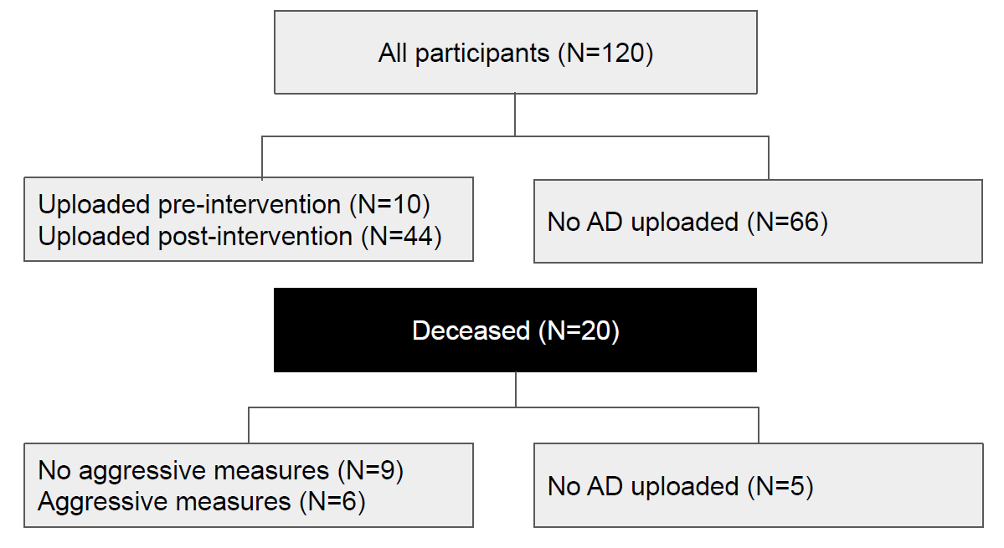
AD=advance directive

