Osteoporosis and fragility fractures in patients with cirrhosis evaluated for liver transplantation: Identification of high-risk patients based on computed tomography at evaluation
Authors: Clément Nachef (MD), Valérie Bousson (MD, PhD), Nadia Belmatoug (MD), Martine Cohen-Solal (MD, PhD), Valérie Vilgrain (MD, PhD), Olivier Roux (MD), Claire Francoz (MD, PhD), François Durand (MD, PhD) and Thomas Funck-Brentano (MD, PhD)

Supplementary Table S1: Univariate associations with vertebral fractures
 | Presence of VF n= 55 |  | Absence of VF n= 321
 | N or mean | % SD | N or mean | % SD
Age | 56.9 | ± 7.2 | 54.3 | ± 8.5 | 0.034
Sex (men) | 43 | 78.2% | 241 | 75.1% | 0.735
BMI (kg/m2) | 25.5 | ± 4.1 | 26.5 | ± 4.7 | 0.149
Alcohol | 39 | 70.9% | 142 | 44.2% | < 0.001
Hepatocellular carcinoma | 20 | 36.4% | 35 | 10.9% | 0.107
Refractory ascites | 24 | 43.6% | 70 | 21.8% | 0.001
Encephalopathy | 21 | 38.2% | 97 | 25.8% | 0.023
Child-Pugh grade |  |  |  |  | 0.018
A | 9 | 16.4% | 112 | 34.9%
B | 27 | 49.1% | 110 | 34.3%
C | 19 | 34.5% | 99 | 30.8%
GFR -MDRD6 (mL/min) | 82.6 | ± 29.1 | 90.6 | ± 28.4 | 0.054
Natremia (mmol/L) | 133.0 | ± 5.5 | 135.5 | 4.0 | < 0.001
SMI (mm2/m2) | 347.8 | ± 106 | 359.5 | ± 108.8 | 0.462
L1-CT attenuation (HU) | 86.3 | ± 30.3 | 137.6 | ± 40.2 | < 0.001
L1-CT attenuation > 130 HU | 4 | 7.3% | 179 | 55.8% | < 0.001
L1-CT attenuation ≤ 100 HU | 38 | 69.1% | 59 | 18.3% | < 0.001

BMI: Body Mass Index; N: number; SD: Standard Deviation; SMI: Skeletal Muscle Index; VF: Vertebral Fracture

Supplemental FigureS1: ROC Curves: ROC curves showing model performances to detect vertebral fractures. The blue curve represents the model includes age, sex and body mass index (AUC 0.62); the red curve further includes liver-specific variables alcohol, refractory ascites, encephalopathy and natremia (AUC 0.73); the green curve further includes L1-CT attenuation (AUC 0.86); the orange curve represents the model with L1-CT attenuation alone (AUC 0.86).
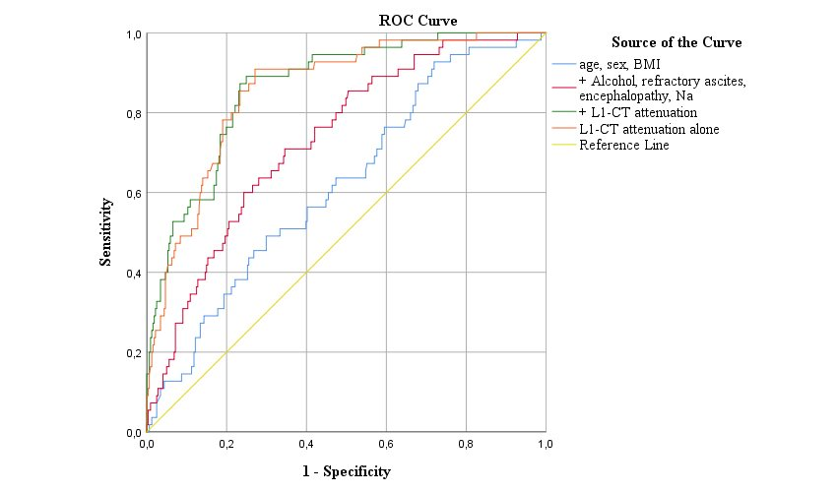

Supplementary Methods

Study population & design
We conducted a cross-sectional study in a single center cohort from an academic liver transplant center. We included all consecutive cirrhotic patients evaluated for LT between March 2004 and June 2018 and had thoraco-abdominal CT scans during evaluation. We excluded patients younger than 18, patient without cirrhosis, candidates for multiple organ transplantation and patients living with HIV. Hepatocellular carcinoma (HCC) was not an exclusion criterion. All patients had an alpha foeto-protein (AFP) score ≤ 2 according to the French selection criteria. A diagnosis of cirrhosis was based on concordant clinical, laboratory and imaging findings or biopsy. The study protocol conformed to the ethical guidelines of the 1975 declaration of Helsinki and was approved by the local ethics committee (IRB 2017-013).
According to our local protocol, all patients with cirrhosis evaluated for LT underwent thoraco-abdominal CT scan as a standard workup, except in patients with end stage kidney diseases who were considered for combined liver and kidney transplantation and, as a result, excluded. VF were identified by full spine evaluation on sagittal and coronal reconstructions of the thoraco-lumbar CT scans from T1 to L5 by one reader (CN, see Figure 1).

CT measurements
L1-CT attenuation (mean Hounsfield unit) was measured to assess bone density. Therefore, the lower is L1-CT, the lower is the bone density.
L1-CT was measured an elliptic region of interest, on an axial section of the L1 vertebral body, in the middle of the upper third of the vertebral body parallel to the upper vertebral plateau, in the anterior part, avoiding the cortical edges of the vertebra (see Figure 1).
In patients with a VF of L1, CT attenuation was measured on L2. We measured L1-CT attenuation on enhanced (portal phase) and unenhanced sequences for 344 patients. L1-CT attenuation on unenhanced sequences was used for the analyses. As L1-CT attenuation values for enhanced and unenhanced sequences were highly correlated (r²= 0.96), values for the 32 CT scans with missing unenhanced sequences were imputed from the values obtained in the enhanced sequences by applying a linear regression correction.
All CT measures were performed by one reader (CN), blinded of patient’s characteristics and outcomes.
To assess intra-examiner reproducibility, the same examiner (CN) reviewed 20 random cases for L1-CT attenuation measurement. This reproducibility was excellent with an intraclass correlations (ICC) at 0.99. To assess inter-examiner reproducibility, a separate examiner (TFB) reviewed 20 random cases for L1-CT attenuation measurement. This reproducibility was also excellent with an intraclass correlations (ICC) at 0.99.

Covariates
We used demographic variables obtained at the time of evaluation. Clinical variables included age, sex, anthropometric data, cause of cirrhosis, presence of hepatocellular carcinoma, Child-Pugh score, the MELD score and refractory ascites. Biological variables included natremia, serum creatinine (and eGFR according to MDRD-6), bilirubin, INR and factor V.

Statistical analysis
Our primary analyses aimed to identify the determinants of VF that were documented on CT reconstructions. We first performed univariate analyses to identify baseline differences between patients with and without VF using Student’s t test, or Mann-Whitney test for continuous variables, and Chi² test for categorical variables. Then, multivariate analyses by logistic regression were performed. The best model was identified by using a stepwise method including a selection of covariates obtained from univariate analyses. All entered continuous variables were normalized and odd ratios (OR) were expressed per standard deviation change of the parameter with 95% confidence intervals.
We next calculated the performance of the different models to identify VF with the AUC using ROC curves. As L1-CT attenuation appeared to be the main determinant of prevalent VF, we used the ROC curve to identify the best threshold to dichotomize this continuous parameter into low or high values. Finally, we aimed to identify the parameters associated with L1-CT attenuation using multivariate linear regression. A P value of less than .05 was considered significant. Statistical analyses were performed using SPSS version 24 and R version 4.0.4.

