METHODS
ICD-10 codes used to define the cohort is in Supplementary Table 2; the model followed the cohort from presentation to the ED through either inpatient stay to 28 days post-discharge, or 28 days after discharge from the ED. This timeframe was chosen because generally, post-discharge diagnostic evaluation and assessment with endoscopy, if necessary, is completed within 30 days of the patient encounter. Moreover, the patients modeled (very low risk), are not expected to have complications past this timeframe.

Model Inputs

Rates of hospital admission from the ED, in-patient mortality, discharge from the hospital, discharge from the ED, post-ED discharge mortality, post-ED readmission, and outpatient endoscopy under each triage strategy were derived from a prospective multicenter study.¹ The GBS triage strategy used GBS=0; the admission rates of 71% with use of GBS=0 and 96% with usual care are based on results from the multicenter prospective trial. The estimated proportion of admitted patients using the machine-learning model was 65% based on the absolute increase in specificity of the machine-learning model (14%) compared to GBS at the matched 100% sensitivity threshold in an external validation study. Since this value was not taken directly from a clinical study, the proportion of admitted patients was varied along a beta distribution with standard deviation of 5%. (Supplementary Table 1)
Additional analysis was performed to estimate the estimated savings at GBS 0-1, which is recommended by recent guidelines.²⁻⁴ Due to the absence of prospective studies applying the extended range threshold, the estimated proportion of admitted patients from the prospective multicenter study¹ was scaled by the absolute increase in specificity taken from the external validation study.⁵ Based on these estimates the performance of the GBS=1 from GBS=0 increases specificity by 15%, with calculated admission rate of 64%. For the machine-learning model at 99% sensitivity, the performance increases by 23%, with admission rate of 61%. Since the 99% sensitivity threshold accordingly may lead to increased false negatives, we adjusted the readmission rate of low-risk UGIB patients discharged from the emergency department by 1% (1.5% from baseline assumption 0.5%). Gamma distributions were applied to re-admission rates for discharged low risk patients and mortality rates for inpatient and discharged patients due to recent estimates that reflect decreasing case fatality since the original study was performed in 2009.⁶
Ninety-five percent uncertainty intervals were estimated using the proportion and number of patients in the study across the 10,000 simulations with applied normal, beta, or gamma distributions used for the model input. Proportions of 30-day readmissions were derived from a retrospective study using the Agency for Healthcare Research and Quality’s Healthcare Cost and Utilization Project 2014 Nationwide Readmission Database for hospitalized patients with non-variceal UGIB, with beta distribution and the proportion adjusted for the projected decrease in hospital admissions with the applied triage tool.⁷ The proportion of patients discharged from the hospital without endoscopic evaluation, and thus potentially needing outpatient endoscopic evaluation, was derived from the 2019 National Emergency Department Sample (NEDS). Of patients who require outpatient endoscopy, the proportion of patients who attend to an Ambulatory Surgery Center versus a Hospital Outpatient Surgery Center were derived from a report published by the Anthem Public Policy Institute in 2020. Specific details are in Supplementary Table 1.

We chose to use Medicare reimbursement cost because Medicare pays less than other insurers and is a conservative estimate of cost savings when applying either the GBS or the machine-learning model. For inpatients, we used a national weighted estimate of inpatient cost and provider fees based on Diagnosis Related Groups (DRGs) for gastrointestinal bleeding from the NEDS (additional details in Supplementary Table 3). For outpatients, we assumed patients discharged from the hospital would require one outpatient clinic visit and one laboratory draw comprising a complete blood count, complete metabolic panel, and prothrombin time. We assumed that patients discharged from the ED may require double the visit and laboratory testing, since discharge from the ED typically recommends follow-up with a primary care provider with outpatient laboratory testing. We made this estimate with our expert opinion anticipating that these patients may require both initial follow-up after ED discharge and then a repeat follow-up to assess the trend in hemoglobin levels. Costs for outpatient endoscopy with conscious sedation fee in ambulatory surgery centers (ASC) versus hospital outpatient surgery centers (HOSC) were estimated from Medicare reimbursement tables and rates assumed to be 30% diagnostic and 70% with biopsy (to assess for H. pylori or other histological findings).

Total initial validation and implementation costs were estimated on an annual basis based on a range from published studies of implementation studies for hospital-based computerized decision support systems. We used two systematic reviews that identified twenty-one implementation studies for clinical decision support systems that covered a wide range of clinical tasks, settings, personnel availability, expertise, and clinical tasks.^{8, 9} The breadth of these studies give us confidence that the estimated implementation cost of a clinical decision support can be robust enough to apply across different centers, geographic locations, and resource availability in the U.S. For our cost estimates, we selected studies that specifically evaluated the implementation of a clinical decision support system. The baseline per-patient cost was estimated as the median of the annual cost over a 5-year time horizon of implementation after stratifying studies into small (1 to 4 providers)^{10, 11}, medium (5 to 24 providers)^{12, 13} or large (greater than 25 providers)^{14, 15} centers and applying the annual per patient cost to the corresponding quartile. (Supplementary Table 8)

We divided U.S. hospital-based EDs into quartiles based on the number of encounters with UGIB using 2019 NEDS and determined implementation costs for each quartile to provide a range of costs across the smallest to the largest EDs (Supplementary Table 9). The uncertainty interval is calculated by running the Monte Carlo probabilistic sensitivity analysis (PSA) over 10,000 simulations, calculating the difference between the costs for each of the 10,000 simulations and taking the different percentiles (2.5%, 97.5%) of the 10,000 differences in costs. The differences are then multiplied by 5 to obtain the cost difference estimate over the first 5 years of implementation.

For one-way sensitivity analyses costs varied included inpatient cost, estimated post-hospital cost, cost of ED visit, cost of upper endoscopy at the ambulatory surgery center versus hospital-based outpatient surgery center, post-ED discharge cost, provider assessment cost, and annual per-patient cost of implementation across different quartiles. Utilization parameters that were varied include rate of inpatient stay without endoscopic evaluation, readmission rate after discharge, rate of admission with the GBS, and rate of admission with an ML model. Specific information about parameters for cost and utilization are presented in Supplementary Table 10.

Supplementary Table 1: Key Input Parameters for Base Model with References and Costs based on Medicare reimbursement cost
Parameter | Base Case Value | Source | Distribution
Admission Rate from ED
Usual Care | 0.96 | Stanley et al 2009 | Normal with standard deviation of 0.01
GBS=0 | 0.71 | Stanley et al 2009 | Beta with standard deviation 0.05
Machine Learning Model at 100% Sensitivity | 0.65 | Shung et al 2020 | Beta with standard deviation 0.05
GBS=1 | 0.64 | Shung et al 2020 | Beta with standard deviation 0.05
Machine Learning Model at 99% Sensitivity | 0.61 | Shung et al 2020 | Beta with standard deviation 0.05
Proportion of Admitted Patients who Die | 0.04 | Stanley et al 2009 | Gamma with standard deviation 0.03
Proportion of Discharged Patients who Die | 0.005 | Stanley et al 2009 | Gamma with standard deviation 0.002
Discharge Rate
Patients Discharged From Inpatient Stay Readmitted to the ED | 0.13 | Abougergi et al 2018 | Normal with standard deviation of 3%
Patients Discharged from Inpatient Stay Without Endoscopy Performed Inpatient | 0.31 | National Emergency Department Sample 2019 | Normal with standard deviation 0.05
Patients Discharged From Inpatient Stay Who Return for Outpatient Endoscopy | 0.4 | Stanley et al 2009 | Normal with standard deviation 0.05
Low-Risk Patients at 100% Sensitivity Discharged From Emergency Department Readmitted to the ED | 0.005 | Stanley et al 2009 | Gamma with standard deviation 0.002
Low-Risk Patients at 99% Sensitivity Discharged From Emergency Department Readmitted to the ED | 0.015 | Stanley et al 2009 | Gamma with standard deviation 0.002
Ambulatory Surgery Center | 0.52 | Anthem Public Policy Institute 2020 | Normal with standard deviation 0.05
Hospital Outpatient Surgery Center | 0.48 | Anthem Public Policy Institute 2020 | Normal with standard deviation 0.05
Implementation and Maintenance Per-Patient Cost (Annual Cost Over 5 Years)
Small Centers (1 to 4 providers) | $149 ($73- $225) | Cleveringa et al 2020, Zamora et al 2013
Medium Centers (5 to 24 providers) | $42.58 ($42.15 - $43.00) | Gilmer et al 2012, Swart et al 2020
Large Centers (>25 providers) | $30.74 ($0.48 - $61.00) | Sendak et al 2017, Munoz et al 2012

Supplementary Table 2: ICD-10 CM codes used to define Emergency Department Encounters with Primary Diagnosis of Upper Gastrointestinal Bleeding from the National Emergency Department Sample 2019
 | ICD-10-CM *
Upper GIB
Bleeding from Ulcer | K22.11,  K25.0, K25.2, K25.4, K25.6,  K26.0, K26.2, K26.4, K26.6,  K27.0, K27.2, K27.4, K27.6,  K28.0, K28.2, K28.4, K28.6
Variceal Bleed | I85.01, I85.11
Mallory-Weiss Tears | K22.6
Angiodysplasia | K31.811
Dieulafoy’s Lesion | K31.82
Gastritis/Duodenitis | K29.01, K29.21, K29.31, K29.41, K29.51, K29.61, K29.71, K29.81, K29.91
Unspecified Esophageal  Hemorrhage | K22.8
Hematemesis | K92.0
*Other ICD-10-CM codes for GIB have been added after 2019 (K21.01, K20.81, K20.91) and are not used to define UGIB

Supplementary Table 3: Proportion of Patients with each Diagnosis-Related Group for Gastrointestinal Bleeding
Diagnosis-Related Group | National Medicare Payment Amount | Proportion of UGIB patients | Length of Stay (95% CI)
379 | $4,056.92 | 6.6% | 2.23  (2.18-2.28)
378 | $6,421.23 | 47.6% | 3.37  (3.34-3.40)
377 with ICU stay | $12,326.26 | 15% | 5.72  (5.63-5.81)
377 without ICU stay | $12,326.26 | 10% | 5.72  (5.63-5.81)
Observation
No DRG, Discharged from ED |  | 4.4% | N/A
We used a weighted cost derived from Diagnosis Related Groups (DRG) for gastrointestinal bleeding: 377, 378, and 379 with proportions of patients with each DRG derived from the 2019 NEDS based on length of stay estimates for DRG 378 and 379 with Hospitalist and Gastroenterology services rendered, while for DRG 377 we assumed 60% required ICU care for half of their stay and 40% did not. From the 2019 NEDS 4.4% of patients with UGIB were under observation, and we assumed billing of 99235 (Observation Same Date), 99217 (Observation Care Discharge), and 99204 (GI consult while observation). We note that approximately 17% of all patients in the NEDS sample with a primary ICD Diagnosis code for UGIB did not have an associated DRG and chose to keep the actual proportion to maintain the relative spacing of the values. Additionally, we chose to maintain original proportions since this actually biases in the direction of decreased savings due to a systemic underestimate of inpatient cost.
Provider fees were calculated using national average Medicare Payment Amount from 2021 Medicare tables.

Supplementary Table 4: Medicare Costs for Inpatient Care
CPT | CPT Code Description | 2021 National Medicare Rate
Critical Care Services-Inpatient Only
99291 | Critical Care First Hour | $220.87
99292 | Critical Care Additional 30 Min | $110.96
Hospital Care, Inpatient
99221 | Initial Hospital Care | $101.19
99222 | Initial Hospital Care | $136.08
99223 | Initial Hospital Care | $200.29
Subsequent Hospital Care, Inpatient
99231 | Subsequent Hospital Care | $38.38
99232 | Subsequent Hospital Care | $71.88
99233 | Subsequent Hospital Care | $103.28
Hospital Discharge, Inpatient
99238 | Hospital Discharge Day | $72.23
99239 | Hospital Discharge Day | $106.42
Admission & Discharge on Same Day from Hospital Observation Care
99234 | Observation/Hospitalization Same Date | $131.55
99235 | Observation/Hospitalization Same Date | $167.14
99236 | Observation/Hospitalization Same Date | $214.59
99217 | Observation Care Discharge | $72.23
Outpatient GI Consult
99204 | Office New | $137.48

Supplementary Table 5: Projected Daily Provider Fee Breakdown By Diagnosis-Related Group
Diagnosis-Related Group | Day 1 | Day 2 | Day 3 | Day 4 | Day 5 | Day 6
379 | 99222 Hospitalist  99222  GI Consult | 99231 Hospitalist  99231  GI | 99238 Hospitalist
378 | 99222 Hospitalist  99222  GI Consult | 99232 Hospitalist  99232  GI | 99231 Hospitalist  99231  GI | 99238 Hospitalist  99231  GI
377 with ICU stay | 99291 Hospitalist or MICU  99223  GI Consult | 99291 MICU  99232  GI | 99291 MICU  99232  GI | 99232 Hospitalist  99232  GI | 99231 Hospitalist  99231  GI | 99239 Hospitalist
377 without ICU stay | 99223 Hospitalist  99223  GI consult | 99233 Hospitalist  99232  GI | 99233 Hospitalist  99232  GI | 99232 Hospitalist99232  GI | 99231 Hospitalist  99231  GI | 99239 Hospitalist
We note that the projected provider costs for each DRG reflects the median length of stay estimated from the 2019 NEDS database, listed in Supplementary Table 3.

Supplementary Table 6: Inpatient Upper Endoscopy Provider Fees from Medicare Reimbursement Tables With Estimated Proportion of UGIB Patients from the National Emergency Department Sample 2019
Inpatient Endoscopy Fee | Description | Provider Fee only | Proportion of UGIB Patients
45235 | EGD only | $124.57 | 19.8%
43239 | EGD with biopsy | $140.27 | 35.1%
43255 | EGD and hemostasis | $203.43 | 22.5%
43244 | EGD and ligation | $248.44 | 1.9%
Conscious Sedation Fee
99151 | Conscious Sedation | $25.47
We note that approximately 21% of all patients in the NEDS sample with a primary ICD Diagnosis code for UGIB did not have an associated CPT code for EGD and chose to keep the actual proportion to maintain the relative spacing of the values.

Supplementary Table 7: Outpatient Endoscopy Costs
CPT Code | ASC | HOSC
45235 | $533.00 | $933.00
43239 | $549.00 | $949.00

Supplemental Table 8: Per-Patient Implementation Cost from published studies evaluating clinical decision support systems in the electronic health record
Manuscript | Center Size | Adjusted Cost Per Patient
Cleveringa 2010 | Small | $73.00
Zamora 2013 | Small | $225.00
Gilmer 2012 | Medium | $43.00
Swart 2020 | Medium | $54.80*
Munoz 2012 | Large | $61.00
Sendak 2017 | Large | $0.48
*Conversion from GBP to USD 1.3
Median per patient cost estimates from small center studies are applied to the lowest quartile, medium center studies to the second quartile, and large center studies to the third and fourth quartiles. If per-patient annual cost was unavailable, we used the numerator as implementation cost at year 1 and maintenance cost every year thereafter divided by the denominator of number of centers and patients seen per center to calculate the 5-year annual cost. Depending on the volume of patients, we estimated large centers with greater than 1,000 patients seen, medium centers with 500 to 1,000 patients, and small if less than 500 patients were seen. We also perform sensitivity analysis to include the lowest and highest reported per-patient annual cost from published studies for each quartile, with the baseline model as the median cost in each quartile.

Supplementary Table 9: Quartiles of Emergency Departments with Number of Encounters with Upper Gastrointestinal Bleeding from the National Emergency Department Sample 2019
Quartile | Number of Encounters Median (Range) | Total Number of Encounters
1 | 15 (3-34) | 3,633
2 | 81 (34-166) | 19,793
3 | 288 (167-469) | 67,138
4 | 718 (469-2,490) | 186,182

Supplementary Table 10: Cost and Utilization Parameters Used for One-Way Sensitivity Analyses via Tornado Diagram.
Parameter | Low | Source | High |  | Source
Cost Parameters
Inpatient Cost | $4,785 | NEDS 2019 Median |  | $7,885 | Peery et al Median
Post-Hospital Cost | $143.97 | Medicare Tables |  | $485 | Campbell et al. (mean estimate, converted from GBP to USD)
Cost of ED visit | $838.09 | NEDS 2019 Median |  | $1386.78 | NEDS 2019 Mean
Cost ASC | $533 | Lowest CPT for Diagnostic EGD Medicare Tables |  | $1401 | Sidecar Health (Average Cash Price for EGD)
Cost HOSC | $933 | Lowest CPT for Diagnostic EGD Medicare Tables |  | $2016 | Sidecar Health (Average Cash Price for EGD)
Cost ED Discharge | $287.94 | Medicare tables, (estimated double of post-hospital cost) |  | $485 | Campbell et al. (mean estimate, converted from GBP to USD)
Cost of Provider Assessment | $639.86 | NEDS 2019, Lower Bound (95% CI) |  | $756.30 | NEDS 2019, Upper Bound (95% CI)
Per-Patient Annual Cost of Implementation |  |  |  |  | NEDS 2019; Cleveringa et al 2010, Zamora et al 2013, Gilmer et al 2012, Swart et al 2020, Sendak et al 2017, Munoz et al 2012
Quartile 1 | $73.00 | Quartile 1 |  | $225.00
Quartile 2 | $42.15 | Quartile 2 |  | $43.00
Quartile 3 | $0.48 | Quartile 3 |  | $61.00
Quartile 4 | $0.48 | Quartile 4 |  | $61.00
Utilization Parameters
Machine Learning Rate of Admission | 0.65 | Shung et al |  | 0.96 | Stanley et al
Inpatient discharge without endoscopy | 0.31 | NEDS 2019, subsetted to Urban Teaching and Non-Teaching Hospitals |  | 0.48 | NEDS 2019, subsetted to Rural Hospitals
Readmission after discharge | 0.13 | Abougergi et al |  | 0.176 | Peery et al
GBS Rate of Admission | 0.71 | Stanley et al |  | 0.96 | Stanley et al

Supplemental Figure 1: Tornado Diagrams with One-Way Sensitivity Analyses Across Cost and Utilization Rates in Year 1 of Implementation Across Quartiles.
Quartile 1 Annual UGIB Encounters: 15 (3-34) Median (Range)
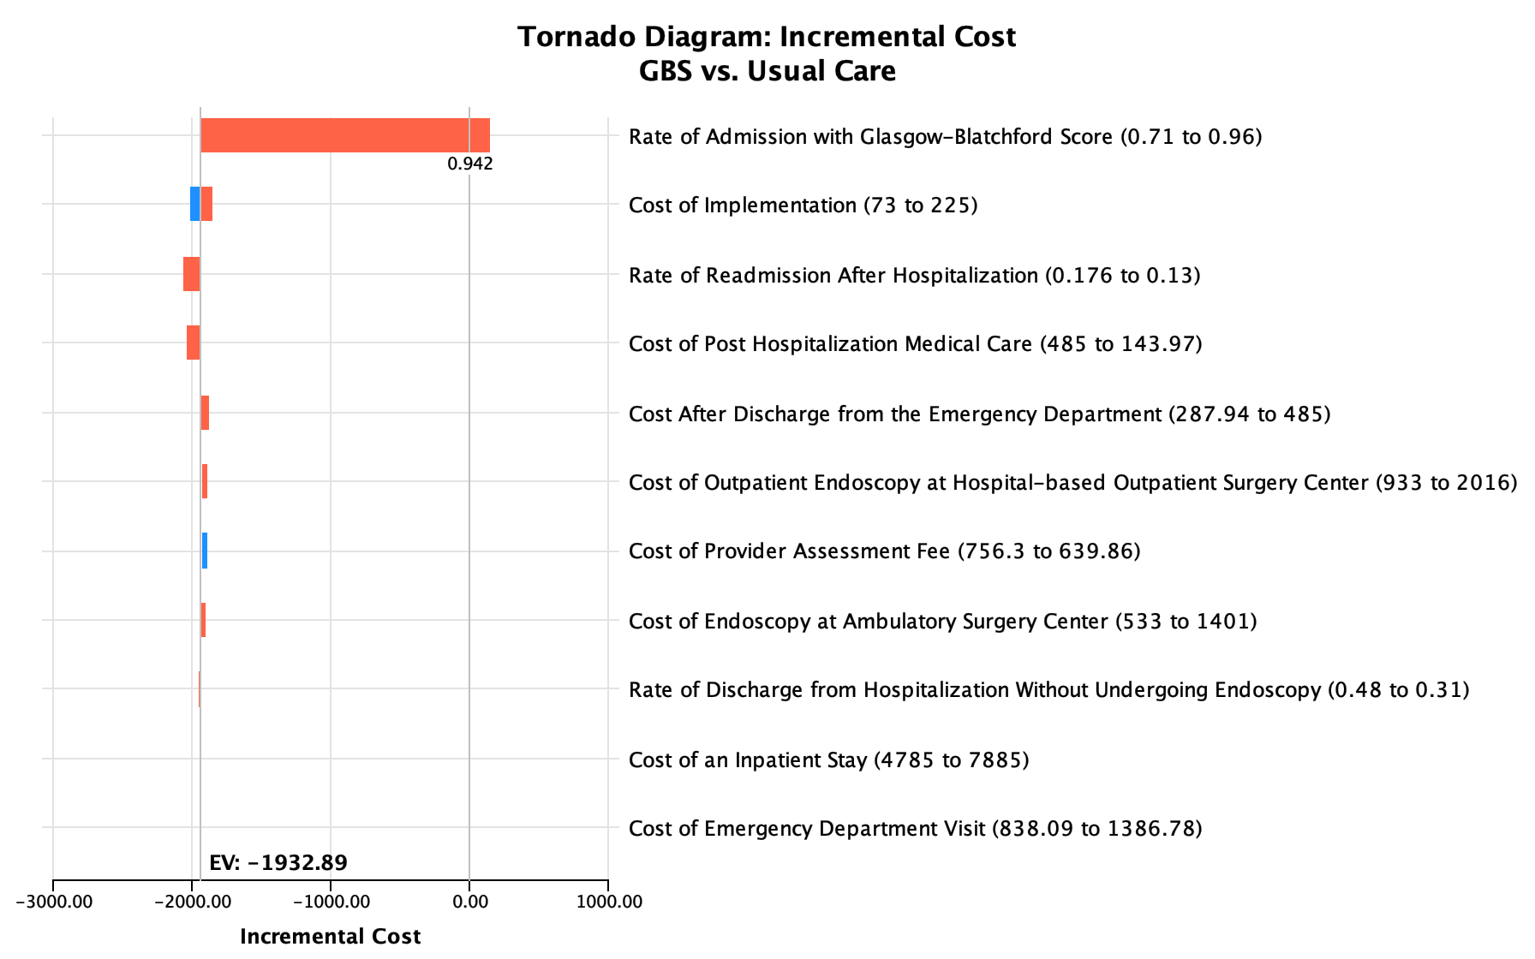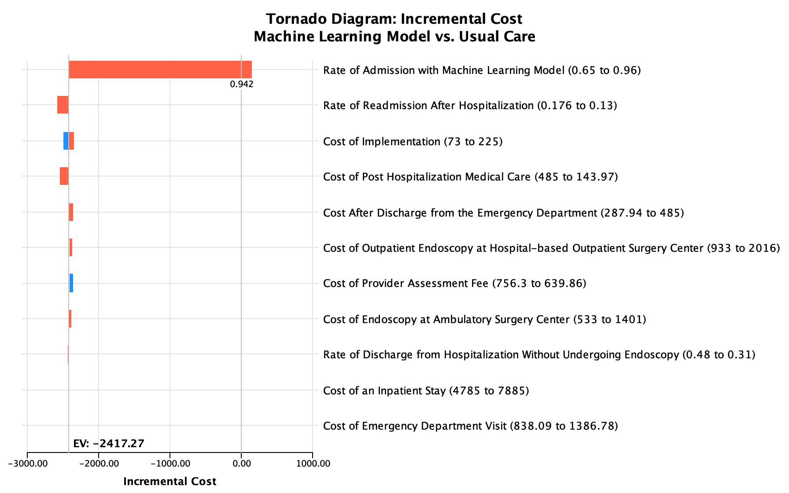
Quartile 2 Annual UGIB Encounters: 81 (34-166)
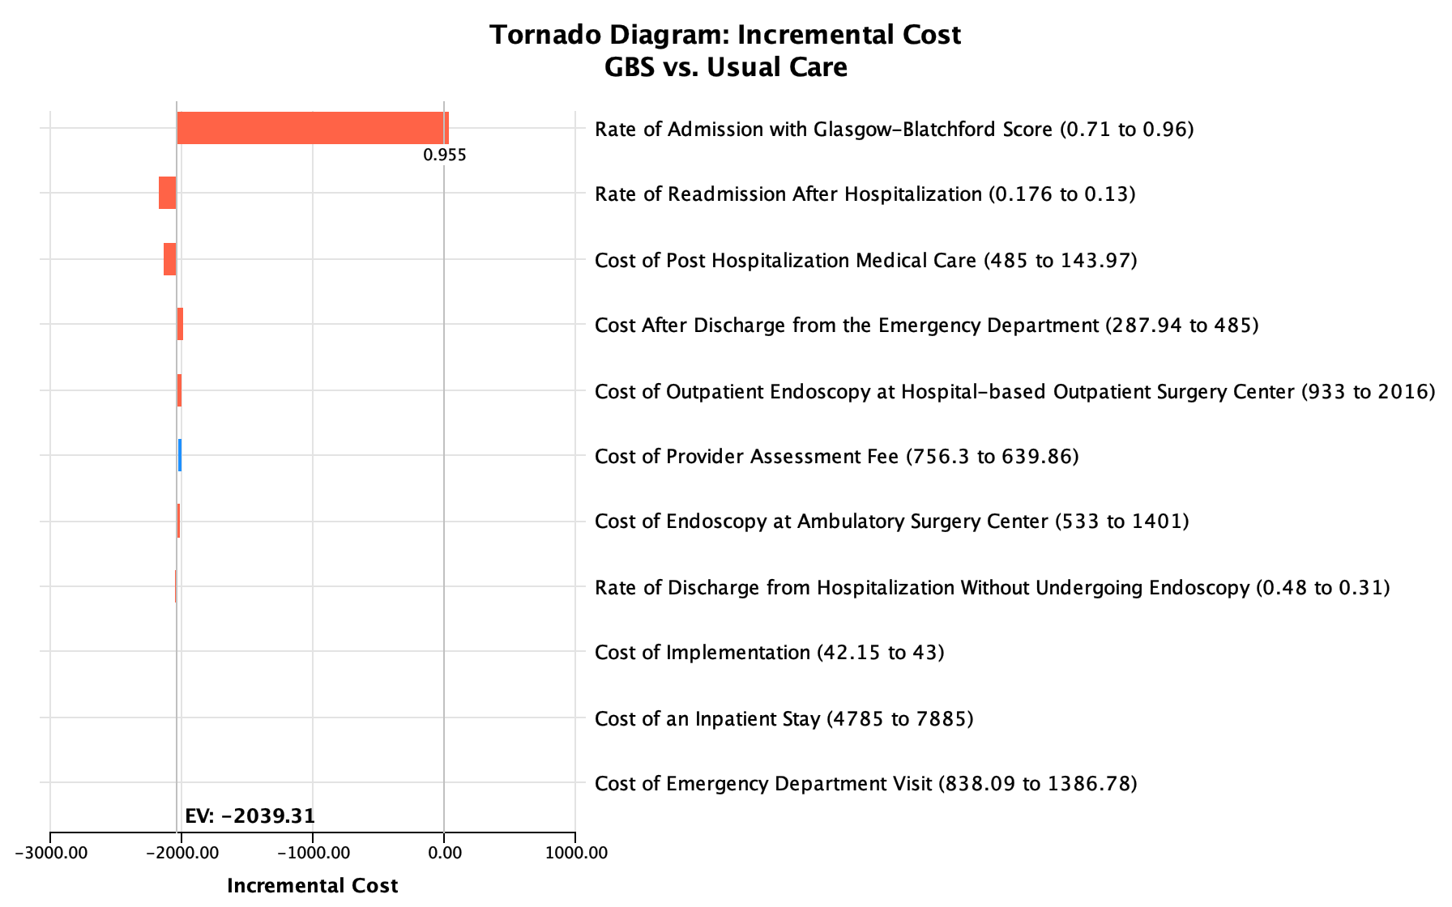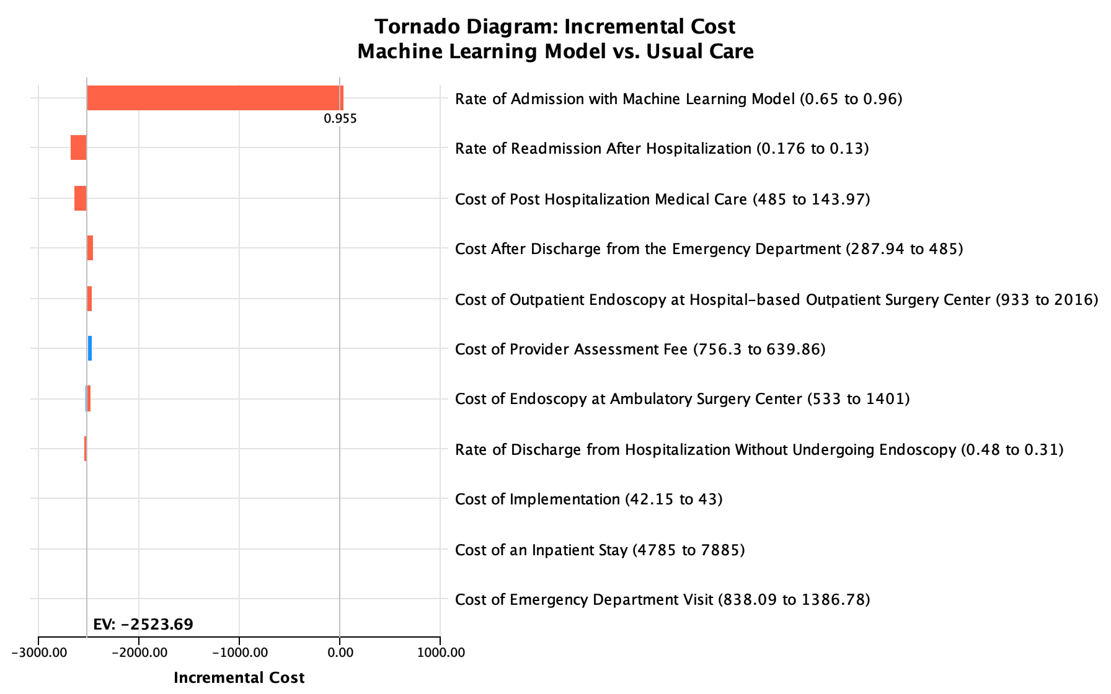
Quartile 3 Annual UGIB Encounters: 288 (167-469)
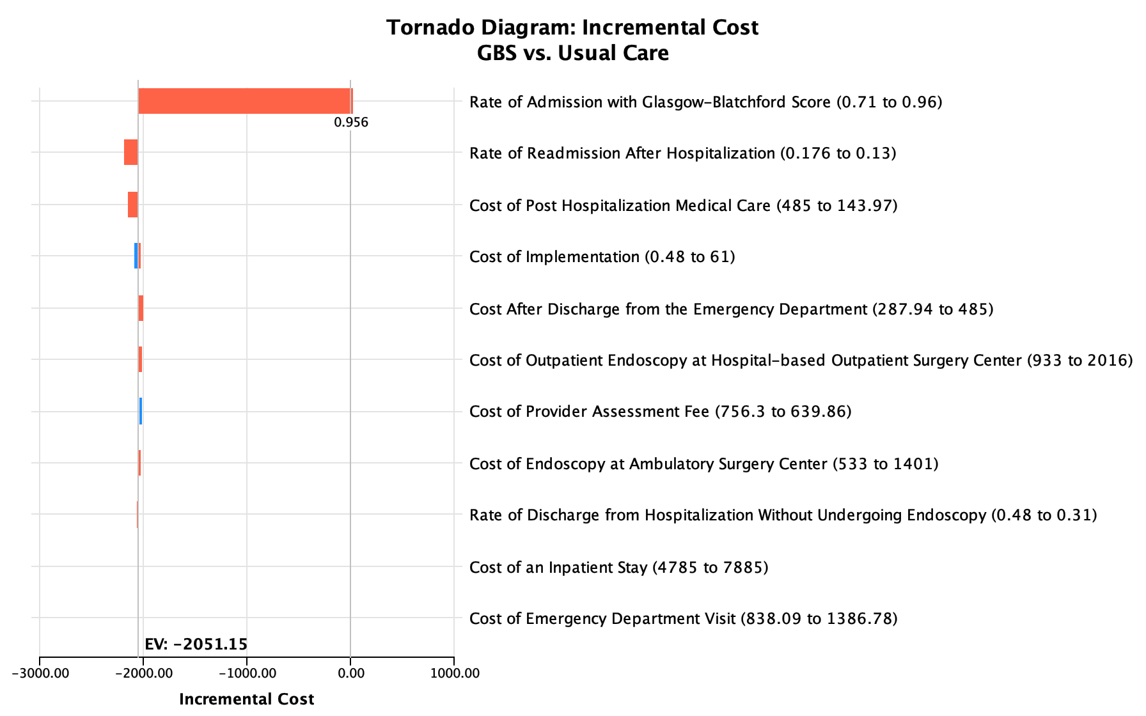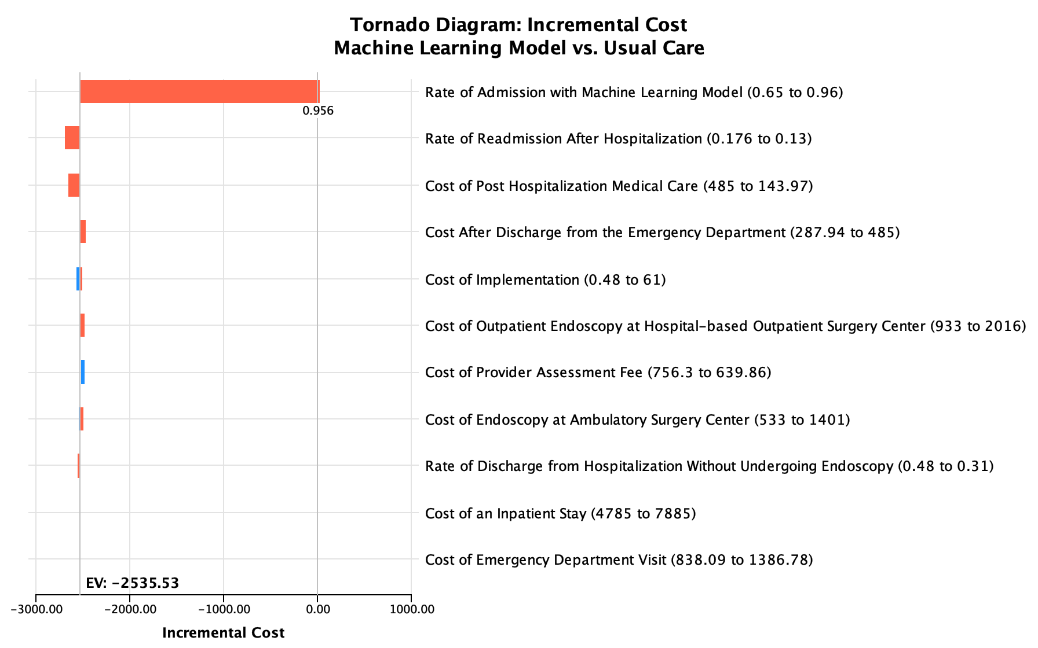
Quartile 4 Annual UGIB Encounters: 718 (469-2,490)

Supplementary Table 11: Estimated Per-Patient, Per-Center, and Nationwide Savings of Care with Implementation of the Glasgow-Blatchford Score 0-1 or Machine-Learning Risk Assessment Matched at 99% Sensitivity By Quartiles of Emergency Departments Based on Number of Annual Patient Encounters for Upper Gastrointestinal Bleeding.
ED Patient Encounters for UGIB;  Median (Range)  Total N | Usual Care Annual Per-Patient Cost of Usual Care  (95% UI) | Annual Per-Patient Cost of Care with Implementation of GBS or ML Model  (95% UI) | Annual Per-Patient Cost Difference with GBS or ML Model vs. Usual Care  (95% UI) | Total Projected Cost Difference for 5 Years Per Center Based on Median Encounters  (95% UI) | Total Nationwide Projected Cost Difference for 5 Years Based on Total Encounters  (95% UI)
Glasgow-Blatchford Score 0-1
Quartile 1  15  (3-34) N=3,633 | $7,948.20  ($7,520.63-$8,391.48) | $5,543.42  ($3,906.91-  $7,015.41) | $2,406.85  ($947.01-  $4,078.20) | $180,513.40  ($71,025.70-  $305,864.87) | $43,720,346.49  ($17,202,424.30-  $74,080,472.58)
Quartile 2  81  (34-166)  N=19,793 | $7,954.36  ($7,534.34-$8,392.82) | $5,439.02  ($3,780.38-  $6,900.75) | $2,512.92  ($1,085.26-$4,211.11) | $1,017,731.60  ($439,531.54-  $1,705,498.23) | $248,690,883.26  ($107,403,059.82-  $416,752,179.70)
Quartile 3  288  (167-469)  N=67,138 | $7,952.46  ($7,527.57-$8,402.23) | $5,420.50  ($3,782.26-  $6,901.71) | $2,521.81  ($1,049.07-$4,199.28) | $3,631,410.79  ($1,510,658.92-  $6,046,969.02) | $846,547,422.08  ($352,161,869.72-  $1,409,657,660.13)
Quartile 4  718  (469-2,490)  N=186,182 | $7,952.46  ($7,527.57-$8,402.23) | $5,439.74  ($3,780.72-  $6,902.28) | $2,521.81  ($1,049.07-$4,199.28) | $9,053,308.84  ($3,766,156.61-  $15,075,429.71) | $2,347,580,984.51  ($976,588,537.47-  $3,909,155,507.73)
All Quartiles  N=276,746 |  |  |  |  | $3,486,539,636.35  ($1,453,355,891.31-  $5,809,645,820.13)
Machine Learning Model at 99% Sensitivity
Quartile 1  15  (3-34) N=3,633 | $7,948.20  ($7,520.63-$8,391.48) | $5,299.93  ($3,690.75-  $6,789.62) | $2,645.44  ($1,176.52- $4,290.07) | $198,407.87  ($88,239.14-  $321,755.33) | $48,054,386.34  ($21,371,518.73-  $77,929,140.77)
Quartile 2  81  (34-166)  N=19,793 | $7,954.36  ($7,534.34-$8,392.82) | $5,195.35  ($3,569.39-  $6,704.76) | $2,758.71  ($1,266.83-$4,390.10) | $1,117,276.60  ($513,066.80-  $1,777,991.76) | $273,015,503.42  ($125,371,988.67-  $434,466,554.76)
Quartile 3  288  (167-469)  N=67,138 | $7,952.46  ($7,527.57-$8,402.23) | $5,175.09  ($3,566.84-  $6,690.21) | $2,770.36  ($1,285.53-$4,418.57) | $3,989,317.93  ($1,851,156.28-  $6,362,740.71) | $929,982,038.13  ($431,537,951.87-  $1,483,269,742.13)
Quartile 4  718  (469-2,490)  N=186,182 | $7,952.46  ($7,527.57-$8,402.23) | $5,175.09  ($3,566.84-  $6,690.21) | $2,770.36  ($1,285.53-$4,418.57) | $9,945,591.22  ($4,615,035.44-  $15,862,666.07) | $2,578,955,521.80  ($1,196,708,256.95-  $4,113,290,939.98)
All Quartiles  N=276,746 |  |  |  |  | $3,830,007,449.68  ($1,774,989,716.22-  $6,108,956,377.64)
ED: emergency department; GBS: Glasgow-Blatchford Score; ML: Machine Learning; UGIB: upper gastrointestinal bleeding; UI: uncertainty interval
*Note: UI calculated, details in supplement

Literature Cited

1. Stanley AJ, Ashley D, Dalton HR, et al. Outpatient management of patients with low-risk upper-gastrointestinal haemorrhage: multicentre validation and prospective evaluation. Lancet 2009;373:42-7.
2. Laine L, Barkun AN, Saltzman JR, et al. ACG Clinical Guideline: Upper Gastrointestinal and Ulcer Bleeding. Am J Gastroenterol 2021;116:899-917.
3. Barkun AN, Almadi M, Kuipers EJ, et al. Management of Nonvariceal Upper Gastrointestinal Bleeding: Guideline Recommendations From the International Consensus Group. Annals of internal medicine 2019:10.7326/M19-1795.
4. Gralnek IM, Stanley AJ, Morris AJ, et al. Endoscopic diagnosis and management of nonvariceal upper gastrointestinal hemorrhage (NVUGIH): European Society of Gastrointestinal Endoscopy (ESGE) Guideline - Update 2021. Endoscopy 2021;53:300-332.
5. Shung DL, Au B, Taylor RA, et al. Validation of a machine learning model that outperforms clinical risk scoring systems for upper gastrointestinal bleeding. Gastroenterology 2020;158:160-167.
6. Zheng NS, Tsay C, Laine L, et al. Trends in characteristics, management, and outcomes of patients presenting with gastrointestinal bleeding to emergency departments in the United States from 2006 to 2019. Aliment Pharmacol Ther 2022;56:1543-1555.
7. Abougergi MS, Peluso H, Saltzman JR. Thirty-Day Readmission Among Patients With Non-Variceal Upper Gastrointestinal Hemorrhage and Effects on Outcomes. Gastroenterology 2018;155:38-46.e1.
8. Donovan T, Abell B, Fernando M, et al. Implementation costs of hospital-based computerised decision support systems: a systematic review. Implementation Science 2023;18:7.
9. Jacob V, Thota AB, Chattopadhyay SK, et al. Cost and economic benefit of clinical decision support systems for cardiovascular disease prevention: a community guide systematic review. J Am Med Inform Assoc 2017;24:669-676.
10. Cleveringa FG, Welsing PM, van den Donk M, et al. Cost-effectiveness of the diabetes care protocol, a multifaceted computerized decision support diabetes management intervention that reduces cardiovascular risk. Diabetes Care 2010;33:258-63.
11. Zamora A, Fernández de Bobadilla F, Carrion C, et al. Pilot study to validate a computer-based clinical decision support system for dyslipidemia treatment (HTE-DLP). Atherosclerosis 2013;231:401-4.
12. Swart N, Morris S, Murphy MF. Economic value of clinical decision support allied to direct data feedback to clinicians: blood usage in haematology. Vox Sang 2020;115:293-302.
13. Gilmer TP, O'Connor PJ, Sperl-Hillen JM, et al. Cost-effectiveness of an electronic medical record based clinical decision support system. Health Serv Res 2012;47:2137-58.
14. Munoz M, Pronovost P, Dintzis J, et al. Implementing and evaluating a multicomponent inpatient diabetes management program: putting research into practice. Jt Comm J Qual Patient Saf 2012;38:195-206.
15. Sendak MP, Balu S, Schulman KA. Barriers to Achieving Economies of Scale in Analysis of EHR Data. A Cautionary Tale. Applied clinical informatics 2017;8:826-831.

