Supplementary Data

Supplementary Figure 1

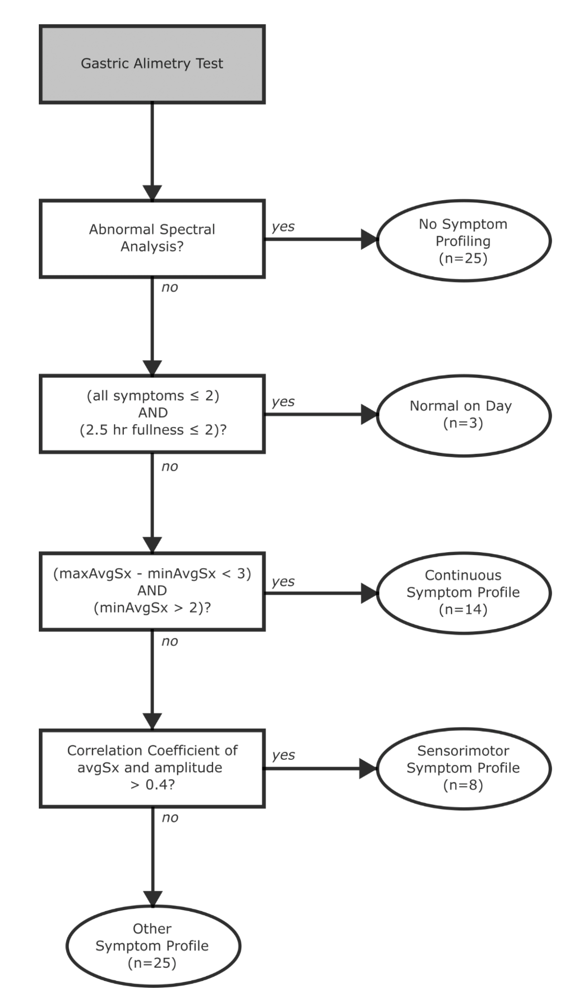

Supplementary Figure 1 Flow chart depicting rule-based symptom profiling. Symptoms were assessed on the same day of BSGM testing and only symptoms for patients with normal BSGM spectral analysis are profiled. Patients are determined to have normal symptoms on the day if excessive fullness is ≤2 at 2.5 hours and all other symptoms are ≤2 for the whole test. Continuous symptom profiles are determined by comparing the maximum and minimum of the average symptom curve, excluding excessive fullness (maxAvgSx and minAvgSx, respectively). Sensorimotor symptom profiles are determined using the correlation coefficient of the average symptom curve (avgSx) and the amplitude curve.

Supplementary Figure 2

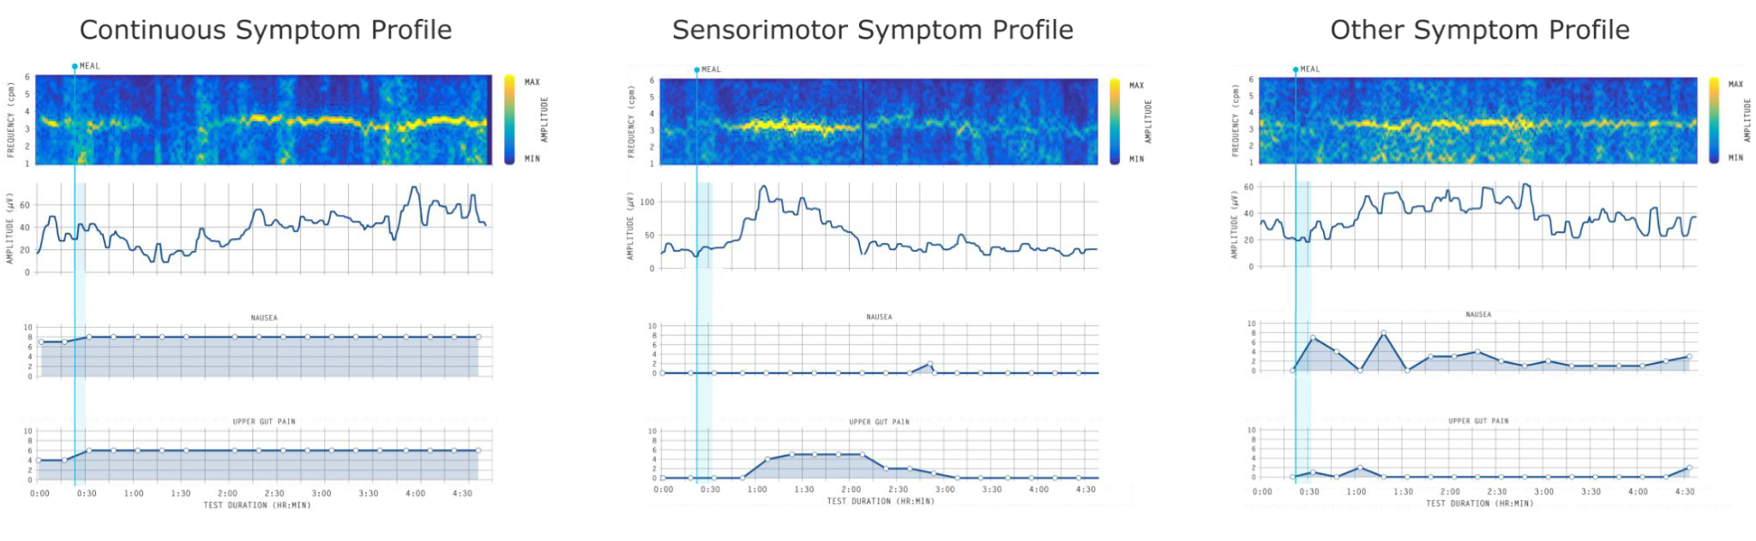

Supplementary Figure 2. Examples of symptom profiling outcomes generated from the scheme detailed in Supplementary Figure 1.

Supplementary Figure 3

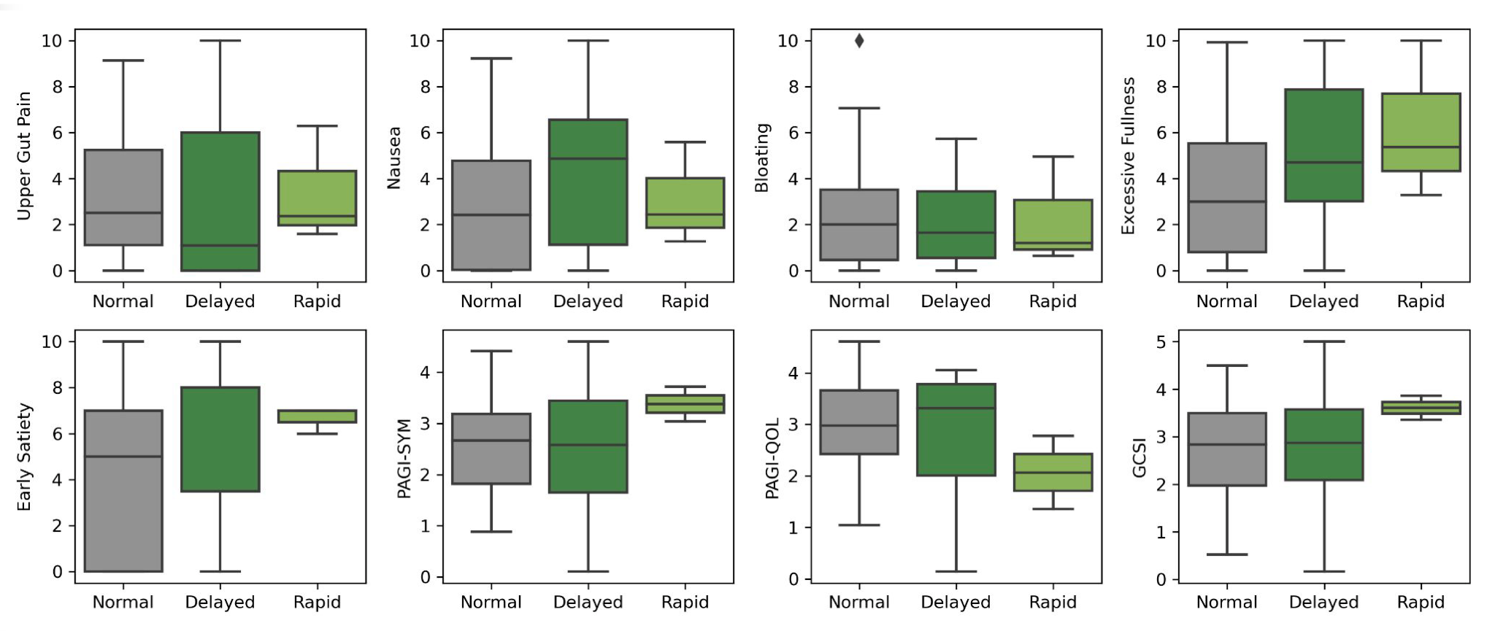

Supplementary Figure 3. Box plots showing relationships between GET results, and symptom burdens and quality of life. Symptom burden alone did not separate subgroups. All comparisons showed p>0.05. Outliers are 1.5 x IQR from Q1 or Q3.

Supplementary Figure 4

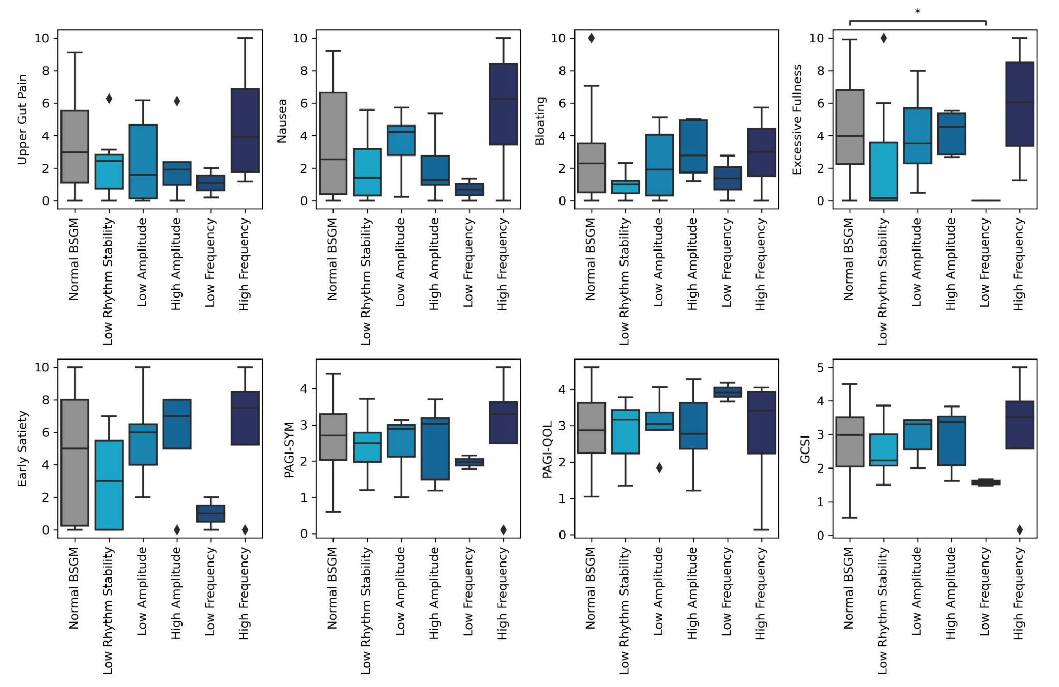

Supplementary Figure 4. Box plots showing relationship between Gastric Alimetry spectral data,and symptom burdens and quality of life. Only normal BSGM and low frequency groups showed slight differences in excessive fullness (p=0.048); all other comparisons showed p>0.05. Outliers are 1.5 x IQR from Q1 or Q3.

Supplementary Figure 5

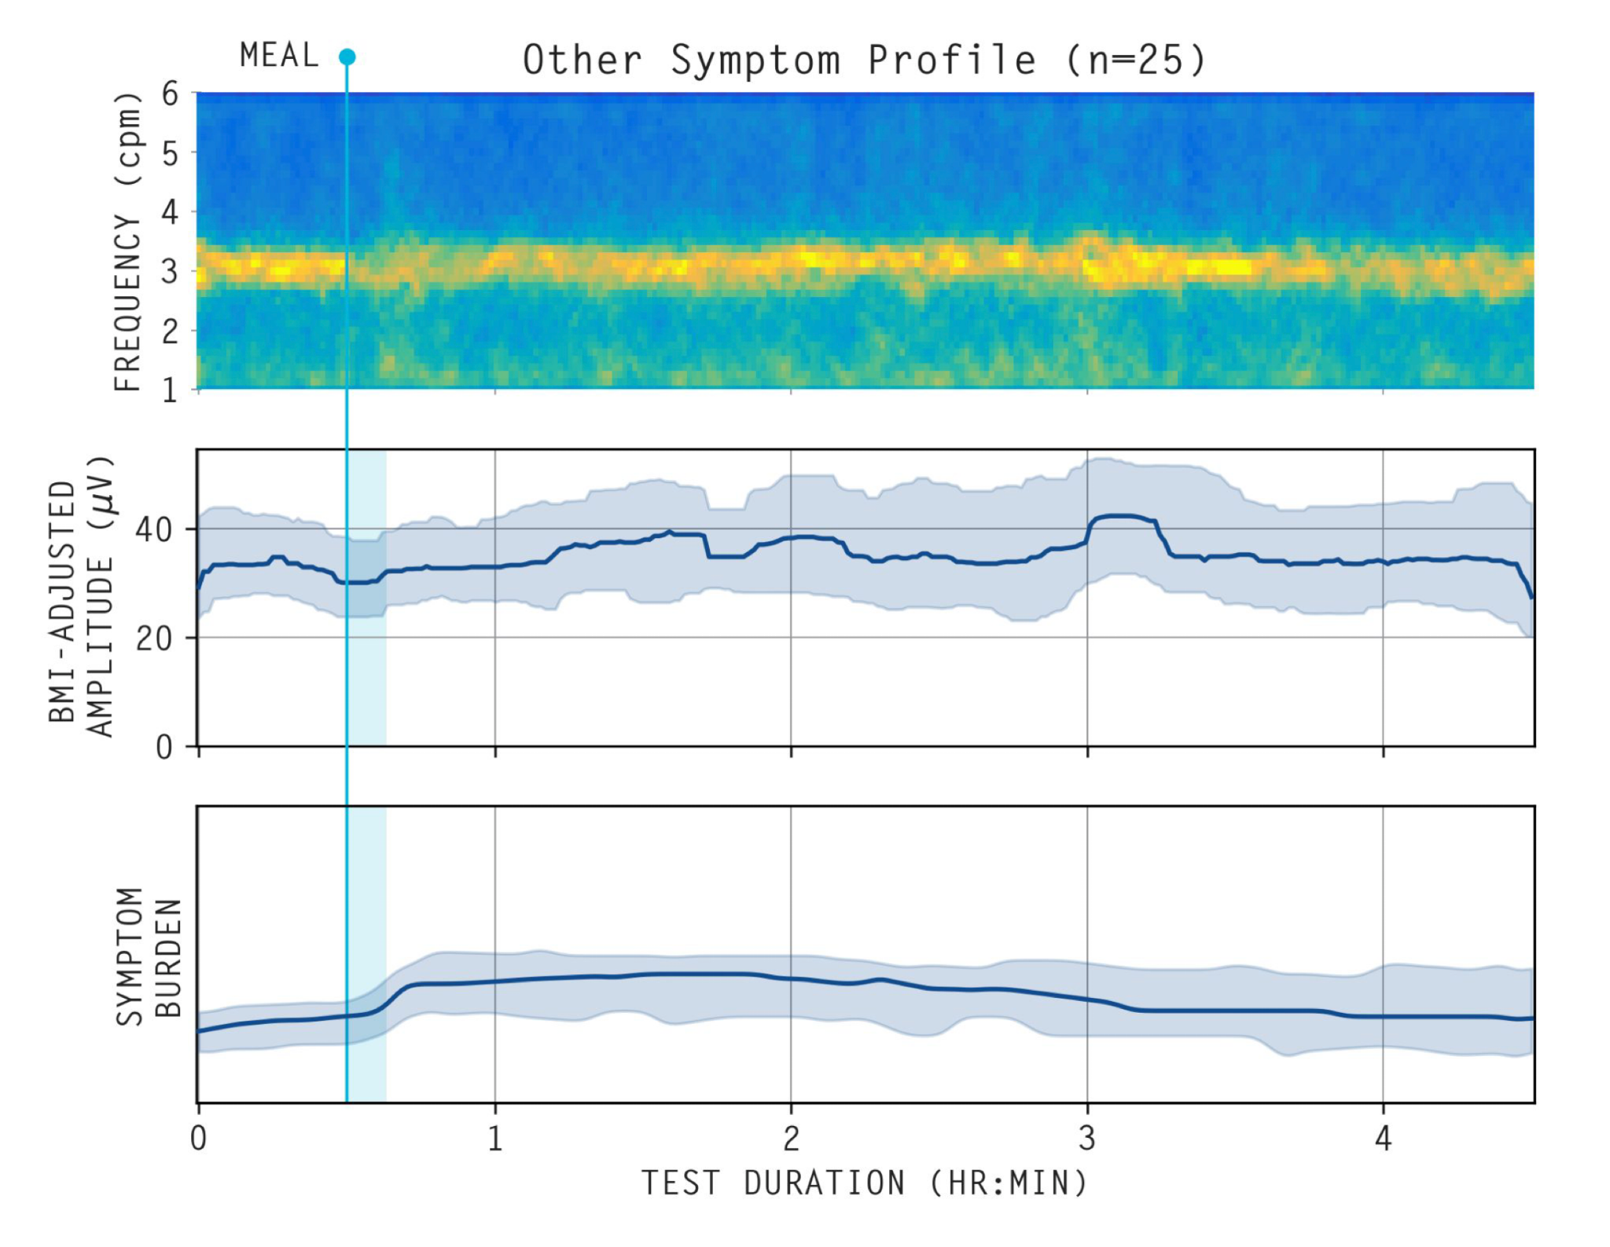
Supplementary Figure 5. Average spectrogram, median (IQR shaded) BMI-adjusted amplitude curves, and median (IQR shaded) symptom burdens for patients with ‘Other’ symptom profiles (n=25).

Supplementary Table 1: Univariate symptom and psychometric scores for patients, stratified by symptom profile.
 | Median (IQR) |  |  |  |  | p value
 | No abnormalities detected | BSGM Abnormal spectrogram | Normal BSGM; Continuous symptom profile | Normal BSGM; Sensorimotor symptom profile | Normal BSGM; Other symptom profile | Abnormal spectrogram / Continuous | Abnormal spectrogram/ Sensorimotor | Continuous / Sensorimotor | Sensorimotor / Other | Continuous / Other
PAGI-SYM | 1.44 (1.18 - 2.22) | 2.69 (1.80 to 3.16) | 3.46 (2.88 to 3.64) | 2.04 (1.55 to 2.46) | 2.67 (2.07 to 2.84) | 0.046 | 0.422 | 0.011 | 0.403 | 0.011
PAGI-QOL | 2.86 (2.84 - 3.49) | 3.16 (2.41 to 3.72) | 2.66 (1.89 to 3.17) | 3.63 (3.51 to 3.79) | 2.84 (2.10 to 3.58) | 0.293 | 0.394 | 0.012 | 0.175 | 0.6
GCSI* | 2.06 (1.94 - 2.44) | 2.83 (1.99 to 3.42) | 3.65 (3.22 to 3.76) | 2.18 (1.74 to 2.64) | 2.75 (1.90 to 3.22) | 0.026 | 0.698 | 0.026 | 0.805 | 0.016
PHQ2* | 1.00 (0.50 - 2.00) | 2.00 (1.00 to 2.00) | 3.00 (1.25 to 4.75) | 1.00 (0.50 to 1.50) | 2.00 (1.00 to 3.00) | 0.241 | 0.302 | 0.079 | 0.302 | 0.241
STAI State* | 11.00 (10.50 - 16.00) | 18.00 (16.00 to 21.00) | 23.50 (15.50 to 30.75) | 13.00 (10.25 to 15.00) | 17.00 (12.00 to 24.00) | 0.163 | 0.163 | 0.042 | 0.163 | 0.163
p values have been adjusted for multiple comparisons using Benjamini and Hochberg correction. *Pairwise post-hoc t tests were performed. All other comparisons are made using the pairwise Wilcoxon rank sum exact test.

Supplementary Table 2: Univariate symptom and psychometric scores for patients, stratified by gastric emptying status.
 | Median (IQR) |  |  |  | p value
 | Normal | Delayed | Rapid | Indeterminant | Normal / Delayed | Normal / Rapid | Delayed / Rapid
PAGI-SYM | 2.67 (1.87 to 3.12) | 2.58 (1.47 to 3.58) | 3.38 (3.21 to 3.55) | 2.89 (2.89 to 3.10) | 0.71 | 0.6 | 0.6
PAGI-QOL | 2.97 (2.38 to 3.66) | 3.23 (2.10 to 3.73) | 2.06 (1.71 to 2.42) | 2.94 (2.91 to 3.36) | 0.98 | 0.6 | 0.87
GCSI* | 2.82 (1.98 to 3.42) | 2.88 (2.06 to 3.79) | 3.61 (3.49 to 3.74) | 3.31 (3.24 to 3.35) | 0.72 | 0.61 | 0.61
PHQ2* | 2.00 (1.00 to 3.00) | 2.00 (1.00 to 6.00) | 3.00 (2.00 to 4.00) | 1.00 (0.50 to 1.50) | 0.32 | 0.49 | 0.91
STAI State* | 17.50 (12.75 to 23.25) | 16.50 (12.50 to 24.50) | 21.00 (21.00 to 21.00) | 15.00 (14.50 to 16.50) | 0.8 | 0.8 | 0.8
p values have been adjusted for multiple comparisons using Benjamini and Hochberg correction. *Pairwise post-hoc t tests were performed. All other comparisons are made using the pairwise Wilcoxon rank sum exact test.

