Supplemental Digital Content 1
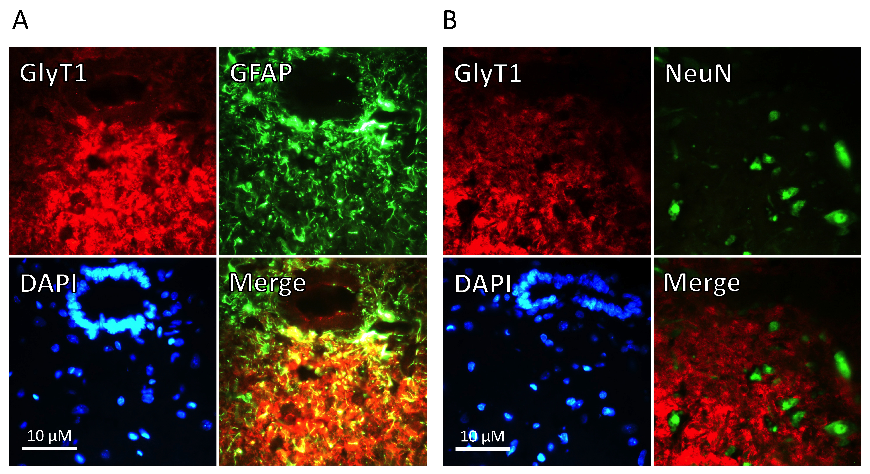
Supplemental Digital Content 1. Immunofluorescence microscopy of glycine transporter 1 (GlyT1) expression in rat spinal cord cryosections (central region including grey matter). GlyT1-related signals were found in cryosections of central regions (directly ventral from the central canal in the lamina X) of the spinal cord (Th12-L4), predominantly in cells that stained positive for GFAP, a specific marker for astroglial cells (A). Although numerous neurons were indentified, as they stained positive for neuron-specific nuclear protein (NeuN), no clear GlyT1-related fluorescence was seen in these cells (B). Note that digital overlays (Merge) demonstrate the colocalization of astrocytes with GlyT1.

