Supplemental Digital Content
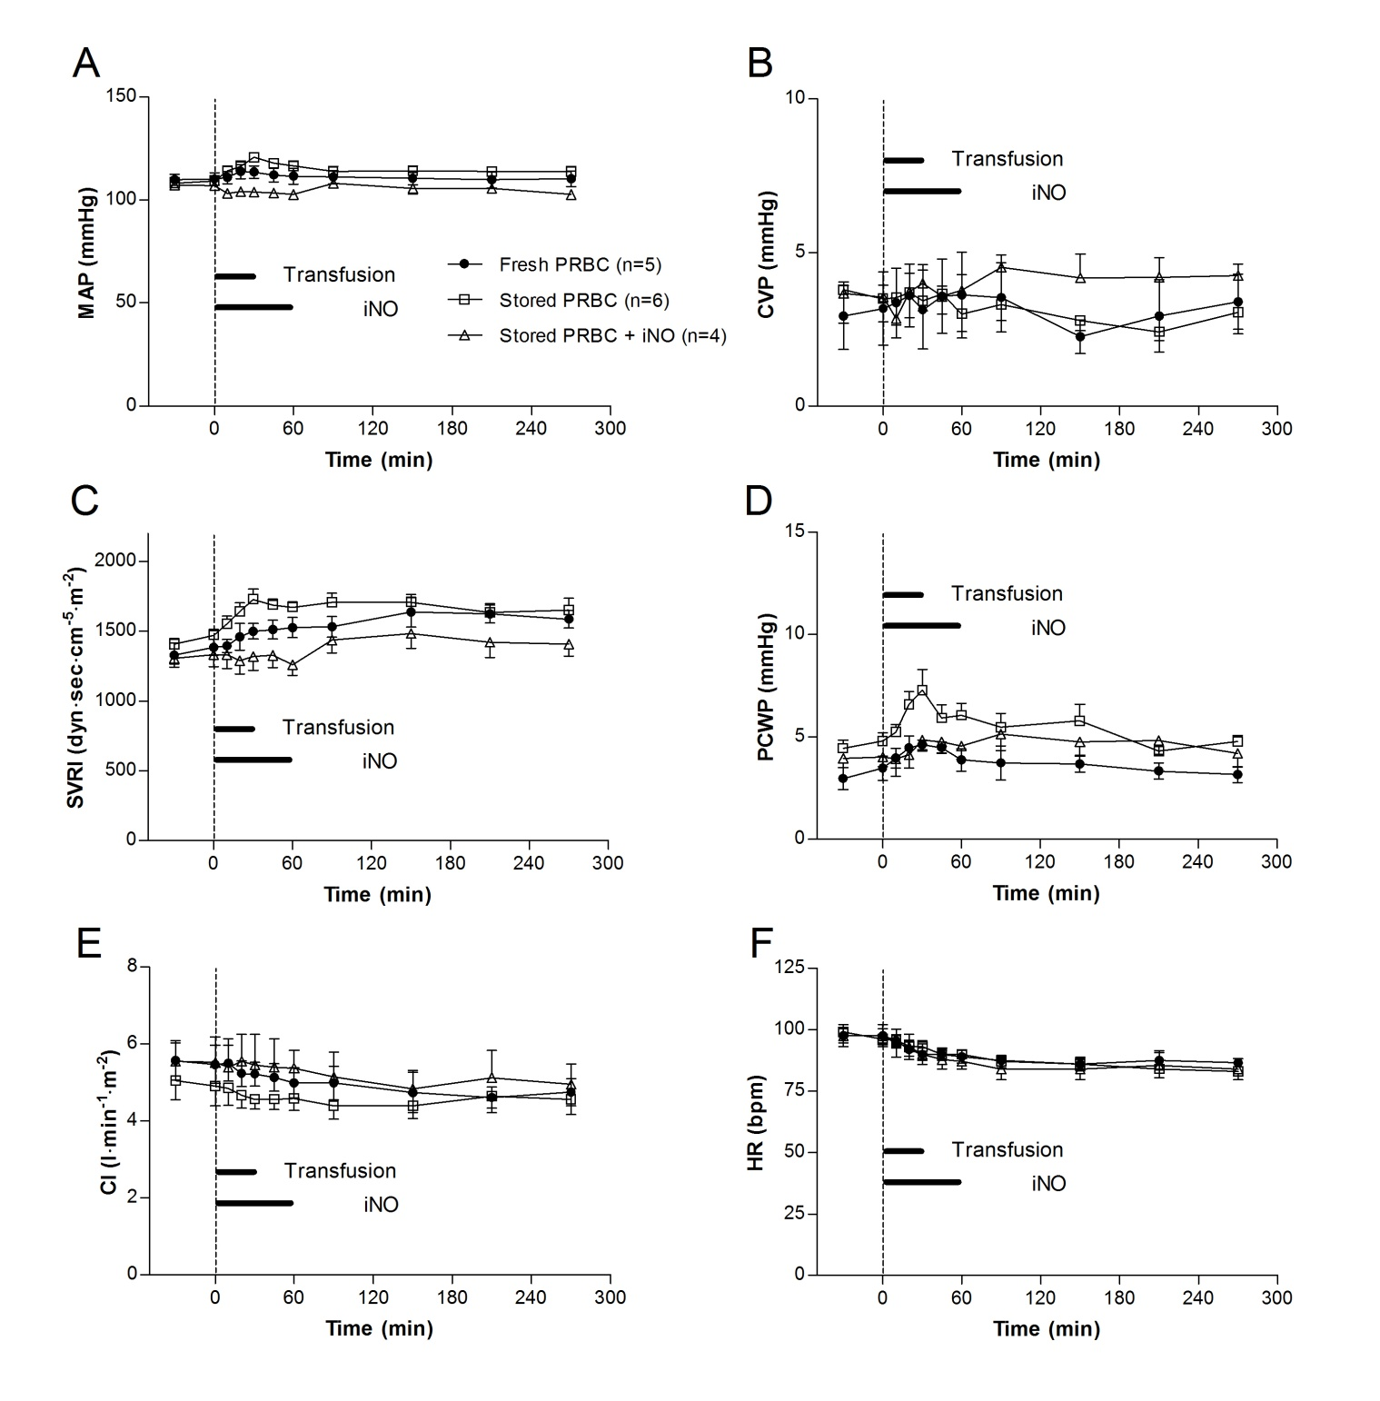

Figure 1. (A) Mean systemic arterial pressure, (B) central venous pressure, (C) systemic vascular resistance index, (D) pulmonary capillary wedge pressure, (E) cardiac index, and (F) heart rate measured during and after transfusion of fresh and stored PRBC with or without concurrent inhalation of nitric oxide in awake lambs. CI = cardiac index; CVP = central venous pressure; HR = heart rate; iNO = inhaled nitric oxide; MAP = mean systemic arterial pressure; PCWP = pulmonary capillary wedge pressure; PRBC = packed erythrocytes; SVRI = systemic vascular resistance index. All data mean ± SD.

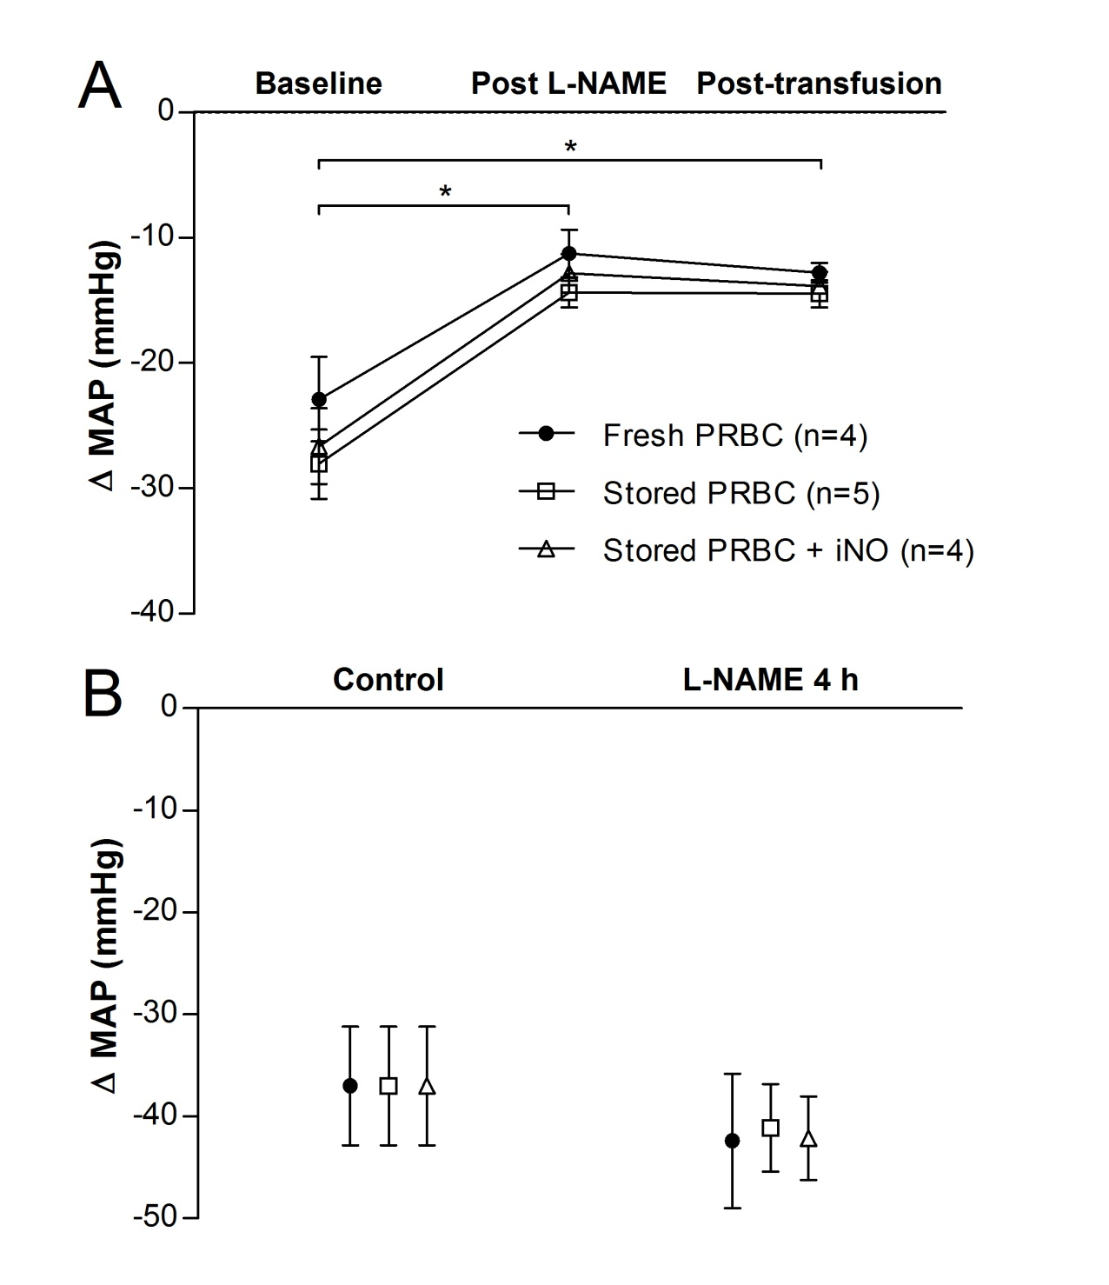
Figure 2. Systemic vasodilation in awake lambs after a bolus of (A) 10⁻⁵ M acetylcholine (10 ml) or (B) 10⁻⁴ M sodium nitroprusside (10 ml). *P<0.05, value differs vs. baseline. iNO = inhaled nitric oxide; L-NAME = N^{G}-nitro-L-arginine methyl-ester; MAP = mean systemic arterial pressure; PRBC = packed erythrocytes. All data mean ± SD.

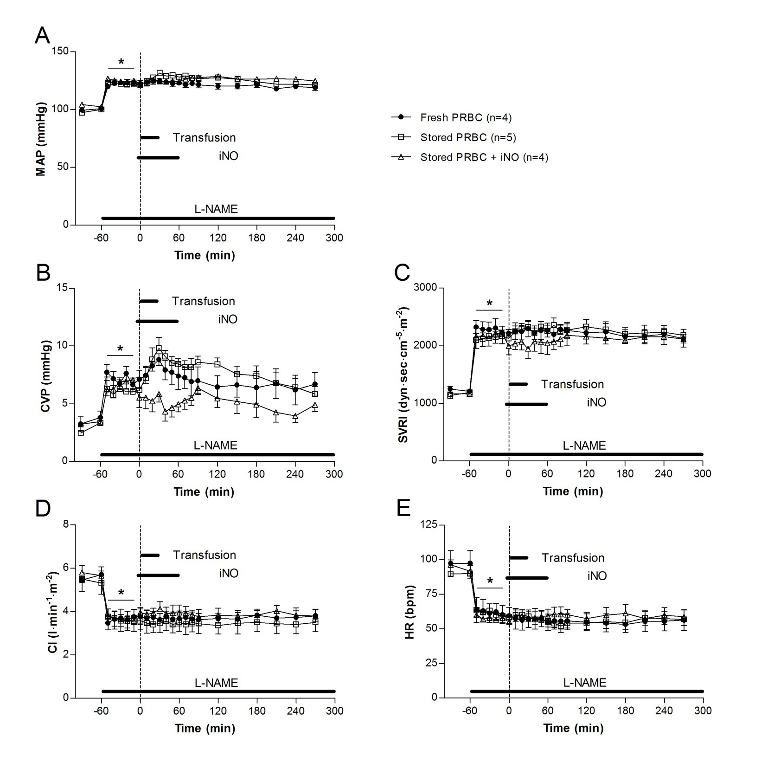
Figure 3. (A) Mean systemic arterial pressure, (B) central venous pressure, (C) systemic vascular resistance index, (D) cardiac index, and (E) heart rate measured during and after transfusion of fresh and stored PRBC. *P<0.05, measurements at -60 min (before L-NAME) differ from measurements between -50 min and -10 min in each group. L-NAME was administered in order to inhibit nitric oxide synthase as a model of endothelial dysfunction. CI = cardiac index; CVP = central venous pressure; HR = heart rate; iNO = inhaled nitric oxide; L-NAME = N^{G}-nitro-L-arginine methyl-ester; MAP = mean systemic arterial pressure; PRBC = packed erythrocytes; SVRI = systemic vascular resistance index. All data mean ± SD.

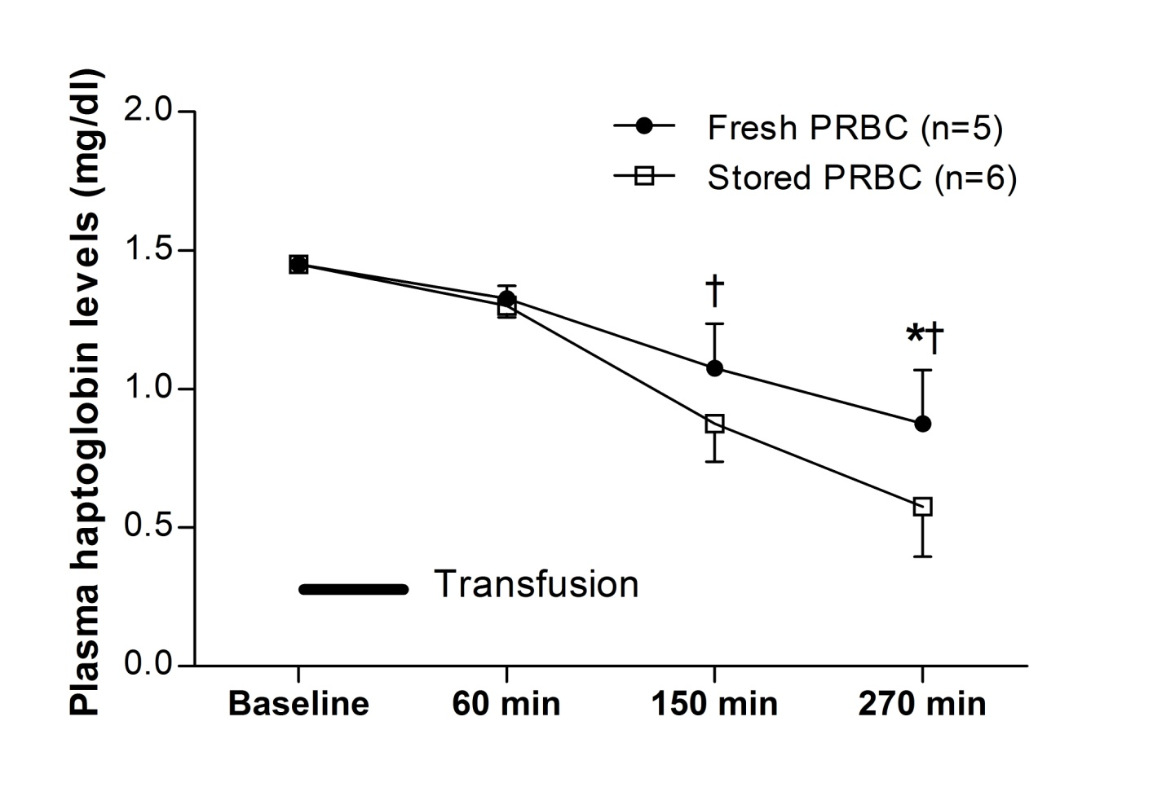
Figure 4. Plasma haptoglobin levels measured before and after transfusion of fresh and stored PRBC in healthy awake lambs. *P<0.05, fresh PRBC differ from stored PRBC; †P<0.05, fresh PRBC after transfusion differ from fresh PRBC before transfusion, and stored PRBC after transfusion differ from stored PRBC before transfusion. PRBC = packed erythrocytes. All data mean ± SD.

Figure 5. Messenger RNA levels of interleukin-6, tumor necrosis factor-α, and myeolperoxidase in lung and liver 4 h after transfusion of either fresh or stored PRBC. IL-6 = interleukin-6; MPO = myeloperoxidase; mRNA = messenger RNA; PRBC = packed erythrocytes; TNF-α = tumor necrosis factor-α. All data mean ± SD.

