Supplemental Digital Content 5 : likelihood profiles for the estimated PK parameters of ABP-700.
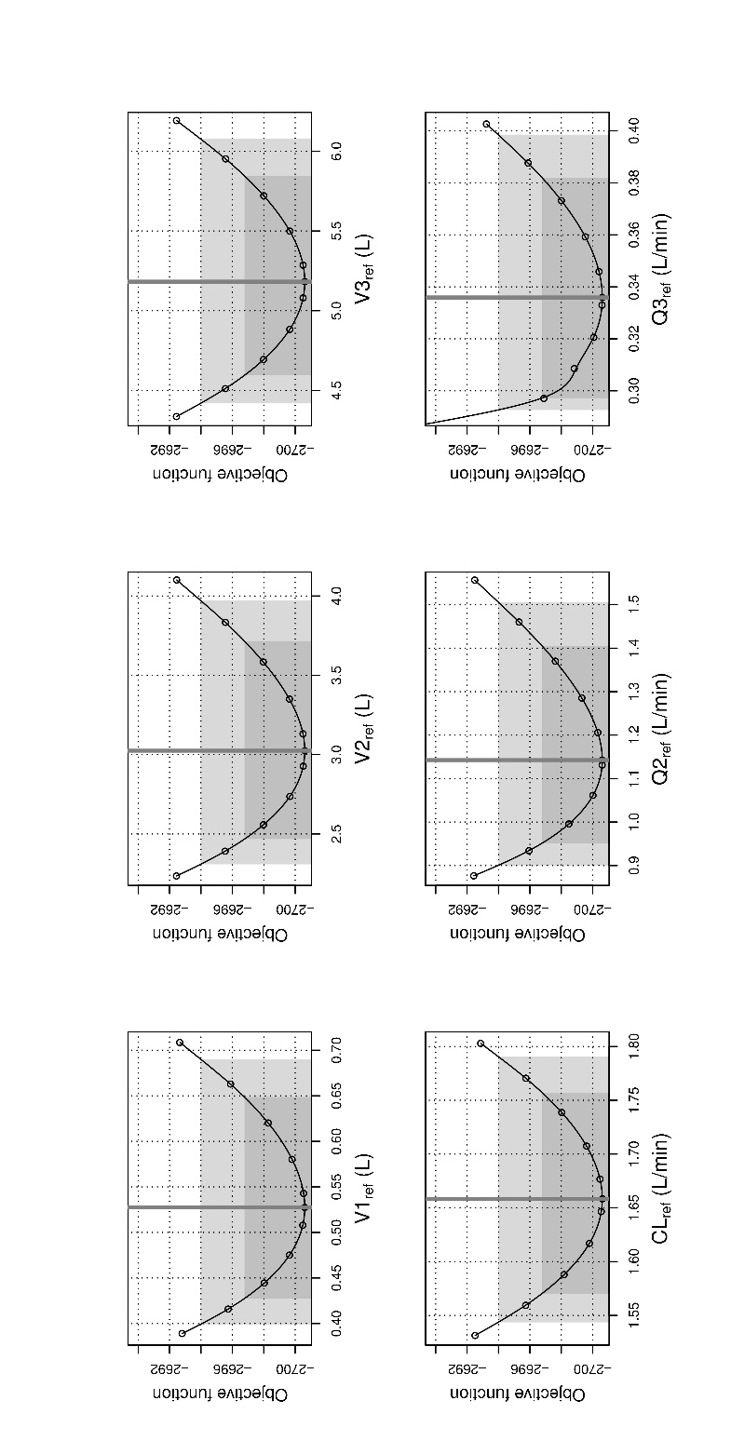
V1_{ref}, V2_{ref}, V3_{ref}, CL_{ref}, Q2_{ref}, Q3_{ref} are the estimated compartmental volumes and clearances for a 70 kg individual.

