Supplemental Digital Content 9 : ABP-700 likelihood profiles for the estimated Modified Observer’s Assessment of Alertness/Sedation (MOAA/S) score pharmacodynamic parameters.

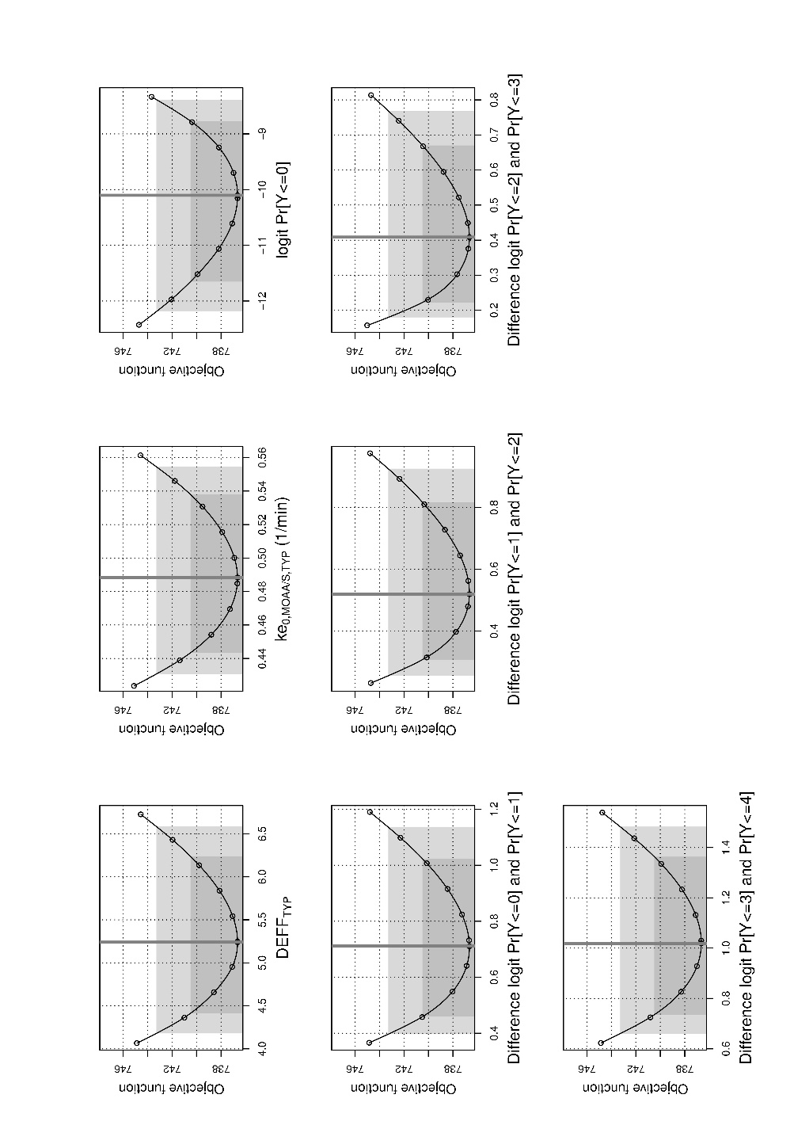
DEFF is a fixed effect parameter for the model.
ke_{0,MOAA/S},_{TYP} is the typical population model parameter for the first-order rate constant between plasma and effect-site using MOAA/S as effect parameter.
“logit Pr” stands for the logit probability of the various MOAA/S scores.

