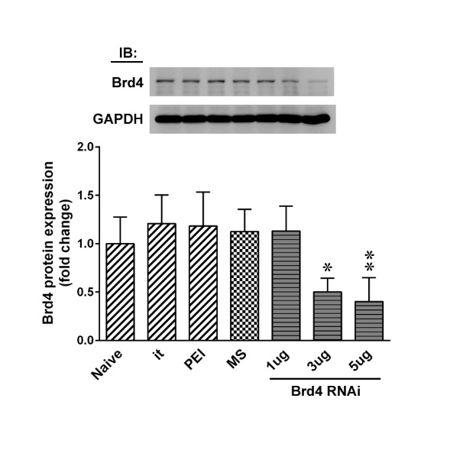
Supplemental Digital Content 1. Efficiently and specifically knocked-down Brd4 expression in DRG of naïve rats
Representative Western blot and statistical analysis (normalized to GAPDH) demonstrating that administration of Brd4-specific siRNA (Brd4 RNAi; 10 μL; 1, 3, and 5 μg; once daily for 4 days), but not missense siRNA (MS RNAi, 10 μL, 5 μg), polyethylenimine (PEI, a transfection reagent, 10 μL), or intrathecal puncture (it), led to a dose-dependent decrease in Brd4 levels in the DRG of naïve rats. IB, Immunoblotting. *P<0.05, **P<0.01 vs. Naïve. n=6.

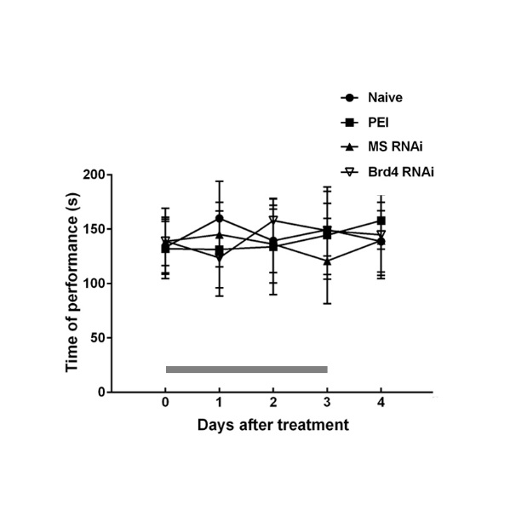
Supplemental Digital Content 2. Motor response in naïve rats after knocked-down Brd4 expression in DRG
Application of Brd4-specific siRNA (Brd4 RNAi, 10 μL 5 μg) resulted in no motor deficits in rats (rotarod test). The grey bar at the bottom indicates the duration of intrathecal administration. n=7.

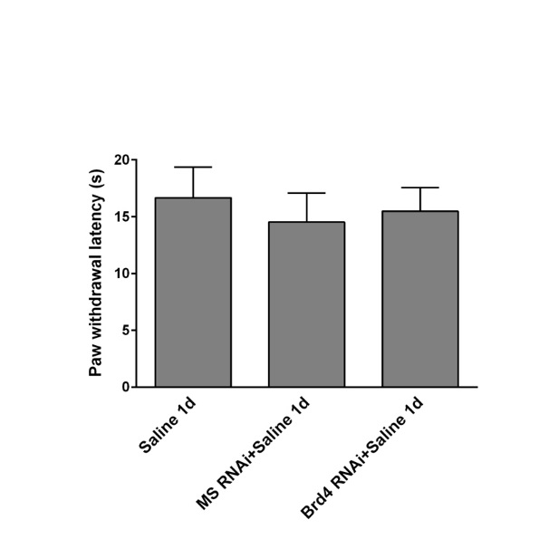
Supplemental Digital Content 3. Paw withdrawal latency of saline-treated rats after knocked-down Brd4 expression in DRG
Brd4-specific siRNA (Brd4 RNAi+CFA 1d, 10 μL, 5 μg) exhibited no effect on the paw withdrawal latency (PWL) in saline-treated rats (Brd4 RNAi+Saline 1d, 10 μL, 5 μg). n=7.

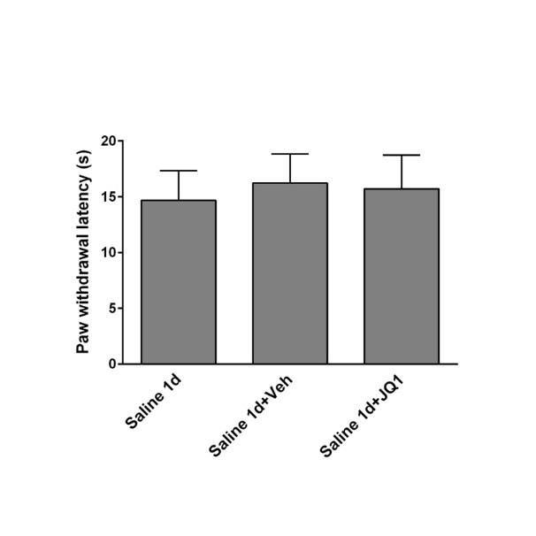
Supplemental Digital Content 4. Paw withdrawal latency of saline-treated rats after injection with JQ1
Injection with JQ1 (Saline 1d+JQ1; 10 μL; 100 μM) exhibited no effect on the paw withdrawal latency in saline-treated rats. n=7.

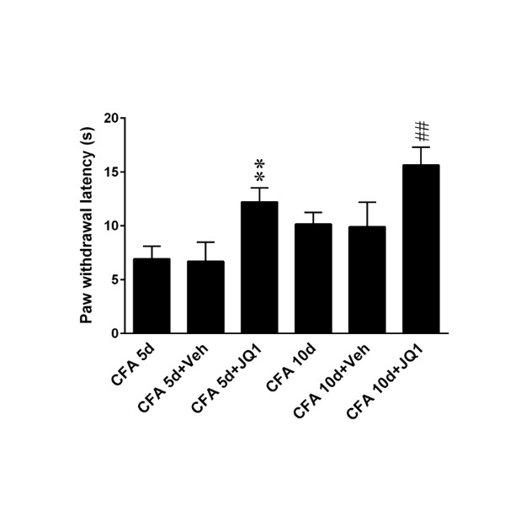
Supplemental Digital Content 5. Paw withdrawal latency of CFA-treated rats at day 5 and day 10 after injection with JQ1
Injection with JQ1 (10 μL; 100 μM) attenuated the behavioral hyperalgesia in CFA-treated rats at day 5 and day 10. **P <0.01 vs. CFA 5d. ##P<0.01 vs. CFA 10d. n=7.

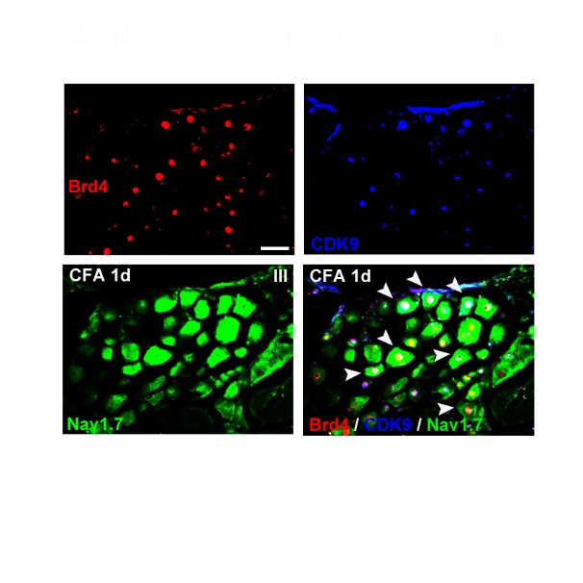
Supplemental Digital Content 6. Brd4, CDK9, and Nav1.7 immunoreactivity colocalized in DRG slices of CFA 1d rat
Image analysis showing colocalization of Brd4-, CDK9-, and Nav1.7-positive immunofluorescence in CFA rat DRG neurons (CFA 1d). Scale bar=50 μm. Thickness=16 μm. n=7

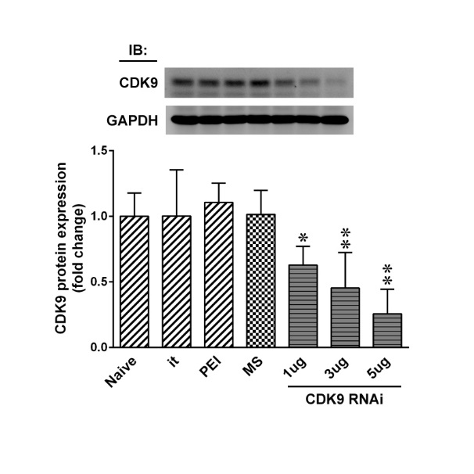
Supplemental Digital Content 7. Efficiently and specifically knocked-down CDK9 expression in DRG of naïve rats
Representative Western blot and statistical analysis (normalized to GAPDH) demonstrating that administration of CDK9-specific siRNA (CDK9 RNAi; 10 μL; 1, 3, and 5 μg; once daily for 4 days), but not missense siRNA (MS RNAi, 10 μL, 5 μg), polyethylenimine (PEI, a transfection reagent, 10 μL), or intrathecal puncture (it), led to a dose-dependent decrease in CDK9 levels in naïve rat DRG. IB, Immunoblotting. *P<0.05, **P<0.01 vs. Naïve. n=6.

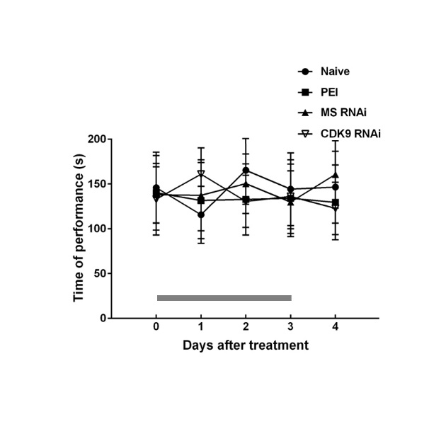
Supplemental Digital Content 8. Motor response in naïve rats after knocked-down CDK9 expression in DRG
Application of CDK9-specific siRNA (CDK9 RNAi; 10 μL, 5 μg, once daily for 4 days) results in no motor deficits in rats (rotarod test). The grey bar at the bottom indicates the duration of intrathecal administration. n=7

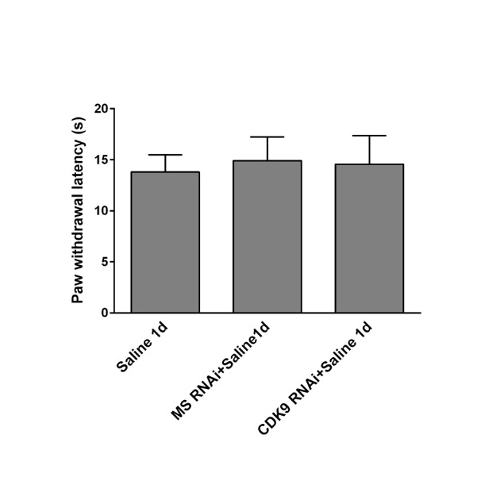
Supplemental Digital Content 9. Paw withdrawal latency of saline-treated rats after knocked-down CDK9 expression in DRG
CDK9-specific siRNA (CDK9 RNAi+Saline 1d, 10 μL, 5 μg) exhibited no effect on the paw withdrawal latency (PWL) in saline-treated rats. n=7.

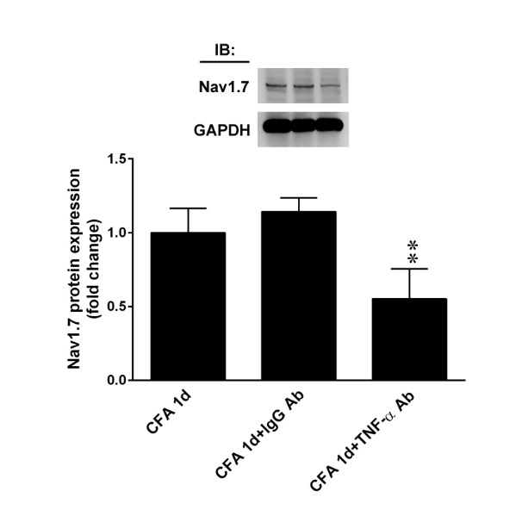
Supplemental Digital Content 10. TNF-α-neutralizing antibody decreased Nav1.7 protein expression in DRGs of CFA rats
Representative Western blot and statistical analysis (normalized to GAPDH) demonstrated that Nav1.7 expression in DRG of CFA rats was attenuated by a TNF-α-neutralizing antibody (CFA 1d+TNF-α Ab, 10 μL, 100 ng). **P<0.01 vs. CFA 1d. n=6.

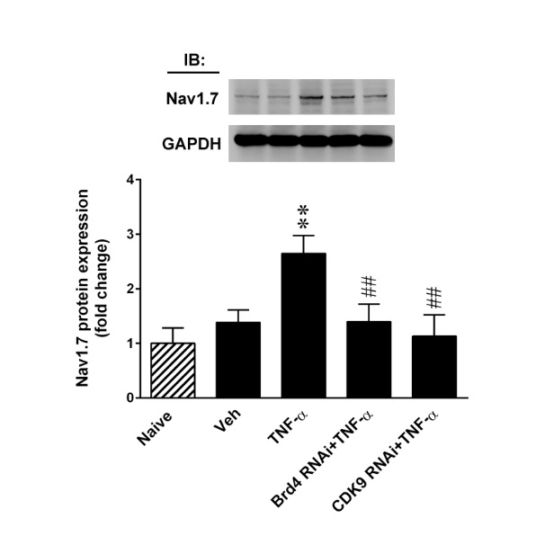
Supplemental Digital Content 11. TNF-α increased the abundances of Nav1.7 protein in DRG samples in naïve rats; that was reduced by Brd4- and CDK9-specific siRNA
Representative Western blot and statistical analysis (normalized to GAPDH) demonstrating that TNF-α-(10 μL, 1 pM, i.t.) enhanced Nav1.7 protein expression in DRG was attenuated by administration of Brd4-specific siRNA (Brd4 RNAi+TNF-α, 10 μL, 5 μg) and CDK9-specific siRNA (CDK9 RNAi+TNF-α, 10 μL, 5 μg). **P<0.01 vs. Naïve. ##P < 0.01 vs. TNF-α. n=6.

Supplemental Digital Content 12.
(A) The Brd4-Brd4, Brd4-RelA, and Brd4-RelA Ac co-precipitations in CFA rat DRG (CFA 1d). No detectable immunoreactivity was observed in the control IgG precipitation. In, input control. IP, immunoprecipitation. IB, Immunoblotting.
Brd4 (rabbit, 1:1000, Abcam, Cambridge, USA), RelA (rabbit, 1:1000, Santa Cruz Biotechnology, Santa Cruz, CA), and RelA Ac (rabbit, 1:1000, cell signaling, Danvers, USA). (B) Western blot analysis of DRG lysates of naïve rat. 1. Anti-Nav1.7 antibody (1:200, Alomone labs, Jerusalem, Israel). 2. Anti-Nav1.7 antibody, preincubated with the control peptide antigen. (C) RT-PCR’s RT activity.

