ASA Practice Advisory-Peripheral Neuropathies Literature Search Summary and PRISMA flow diagram.

Search terms (AND, OR, NOT) and truncation (wildcard characters like *) | Peripheral neuropathy(ies) (ies) AND an(a)esthesia, patient position* strategy(ies) AND an(a)esthesia, upper extremity position* AND an(a)esthesia, lower extremity position* AND an(a)esthesia, sciatic neuropathy(ies) AND an(a)esthesia, femoral neuropathy(ies) AND an(a)esthesia, radial neuropathy(ies) AND an(a)esthesia, ulnar neuropathy(ies) AND an(a)esthesia, brachial plexus injury AND an(a)esthesia, upper extremity pad* AND an(a)esthesia, lower extremity pad* AND an(a)esthesia
Databases searched | PubMed, Google Scholar, EMBASE
Part of journals searched | Keywords in abstract, title, and subject headings
Years of search | 2010-2017
Language | All languages. English abstract should be included
Types of studies to be included | All studies found in peer-reviewed journals
Inclusion criteria | Adult, sedated and/or anesthetized patients
Exclusion criteria | Grey literature, animal studies, children, neonates and infants, compartment syndrome, diabetic neuropathy(ies)

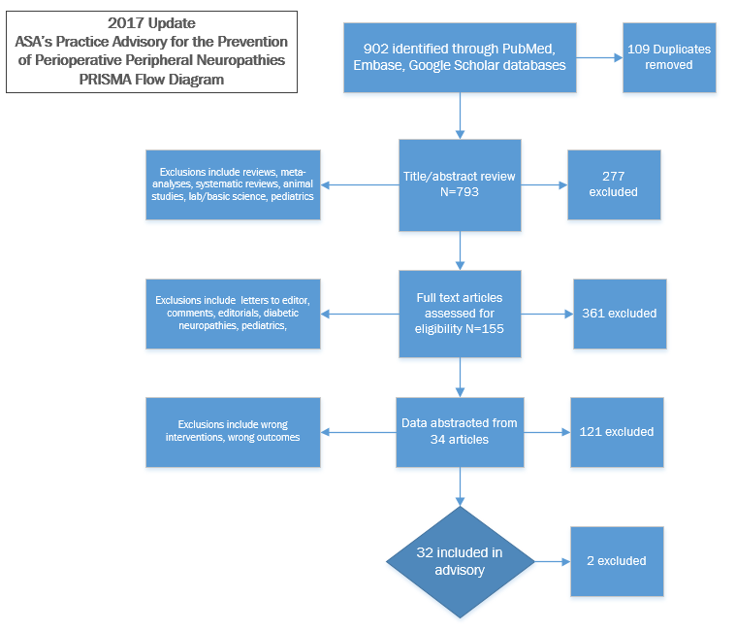

Preferred Reporting Items of Systematic reviews and Meta-Analyses

