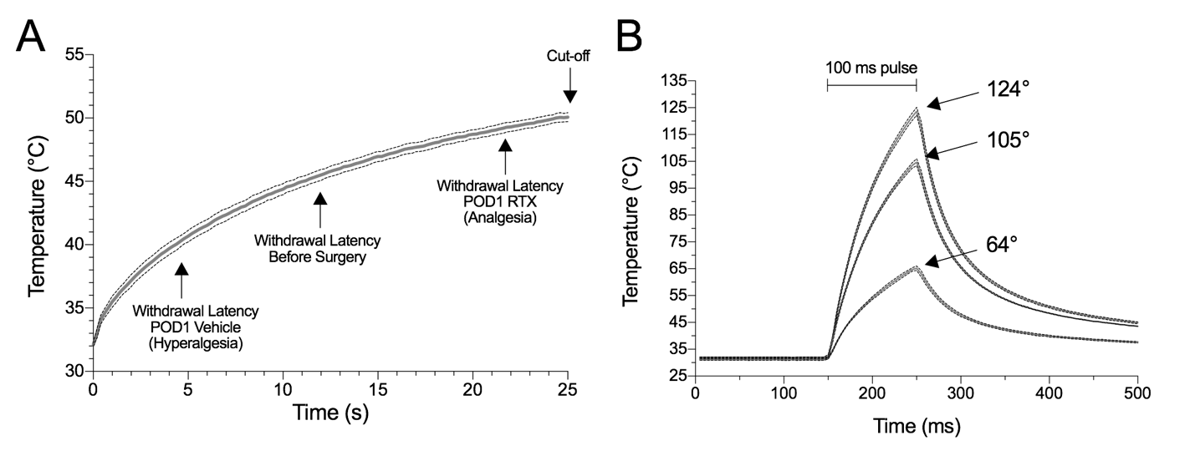Supplemental Digital Content 2. A) The relationship between continuous heating and paw surface temperature (C-fiber mediated withdrawal). An infrared diode laser (LASS-10 M; Lasmed, Mountain View, CA, USA) with an output wavelength of 980 nm was used to generate continuous thermal stimuli via a 5 mm diameter beam at 1000 mA. A thermistor (Omega, Stamford, CT) was inserted intradermally into the paw of an anesthetized rat, and temperature was recorded with the thermocouple DAQ instrument (Model DI-245, DATAQ Instruments, Akron, OH). Readings were taken four times from a single animal. Dotted lines show standard error. B) The relationship between low-, medium-, and high-intensity laser stimulus and temperature for 100 msec pulse (A-δ mediated withdrawal assay). Temperature was recorded as described in A), but with diode laser stimulation at 3500, 4500, or 5000 mA with a 1.6 mm diameter beam. As the laser amperage increases, the maximum temperature of the intradermal tissue increases. At the lowest amperage, 22% of animals withdrew at control baseline; at the middle amperage, 61% of animals withdrew at control baseline; at the highest amperage, 83% of animals withdrew at control baseline.

