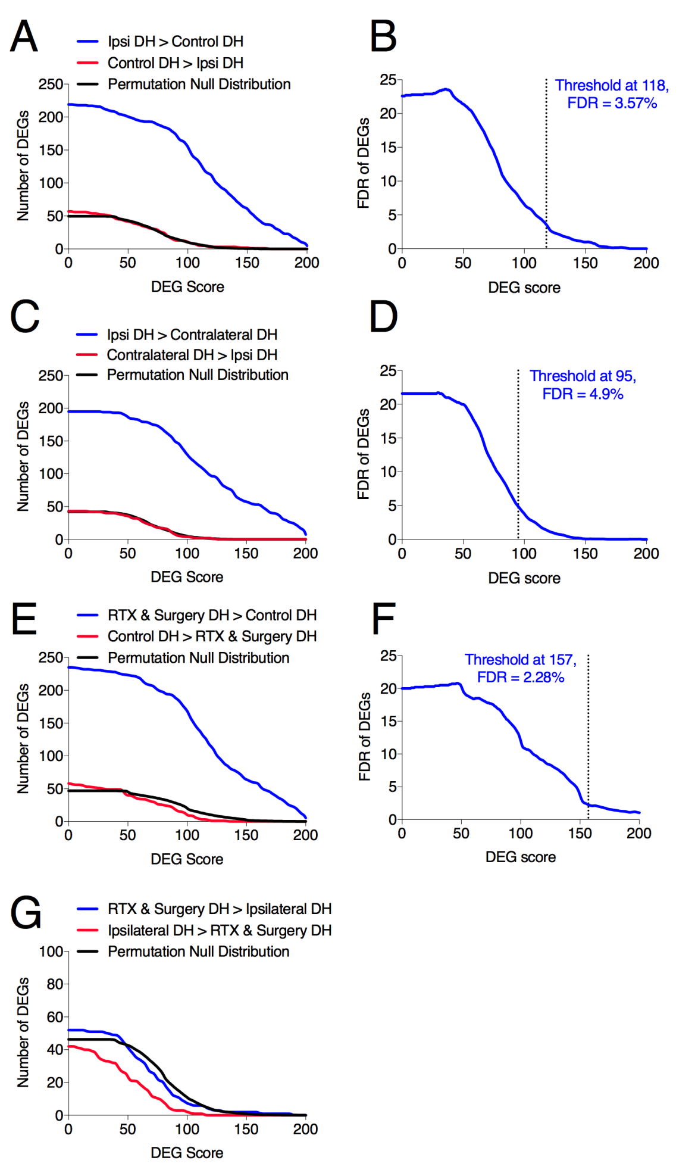
Supplemental Digital Content 3. Determination of threshold for significant differentially expressed genes. MAGIC assigns a differentially expressed gene (DEG) score to each gene for each pair-wise comparison. In order to determine an appropriate DEG score threshold to establish significance, the program performs a permutation test with 80 balanced resamplings. (A) The number of candidate DEGs for the comparison of dorsal horn tissue ipsilateral to surgical incision and control dorsal horn tissue is shown as a function of the DEG score. The average number of DEGs counted in the 80 random permutations (Permutation Null Distribution) is shown in black. These genes are differentially expressed in the experiment but in a way that does not correlate with the phenotype. For each gene, this random average DEG score is subtracted from the experimental DEG score. (B) For the same comparison, the false discovery rate (FDR) is shown as a function of the DEG score. The threshold (dotted line) is chosen to maintain the false discovery rate (FDR) below 5% without exceeding an incremental false discovery rate of 20% upon addition of more potential differentially expressed genes. This analysis was repeated for other experimental comparisons including (C,D) comparison of expression in dorsal horn ipsilateral to surgical incision with dorsal horn contralateral to surgical incision and (E,F) comparison of dorsal horn from control animals with dorsal horn from incised animals treated with resiniferatoxin. As there are no significant DEGs between dorsal horn tissue with and without pre-treatment with resiniferatoxin (G), no curve of the FDR was generated.

