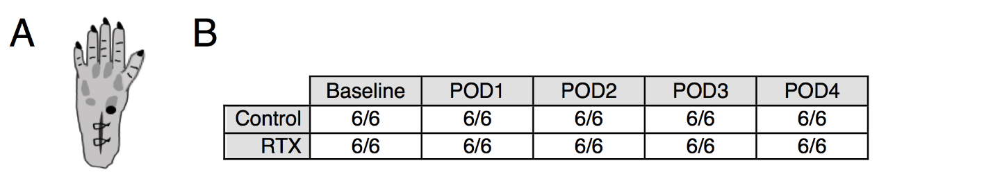

Supplemental Digital Content 5. Lack of effect of intraplantar resiniferatoxin on mechano-nociceptive pin prick. A) The pin was placed near the medial and distal edge of the wound (black dot) until skin was depressed but not pierced. The anatomical site for pinprick testing was approximately the same site used for thermal A-δ and Von Frey filament testing as well. B) Response was graded as binary (responders vs. non-responders), however all animals (6/6 in each case) withdrew from pinprick, irrespective of resiniferatoxin treatment.

