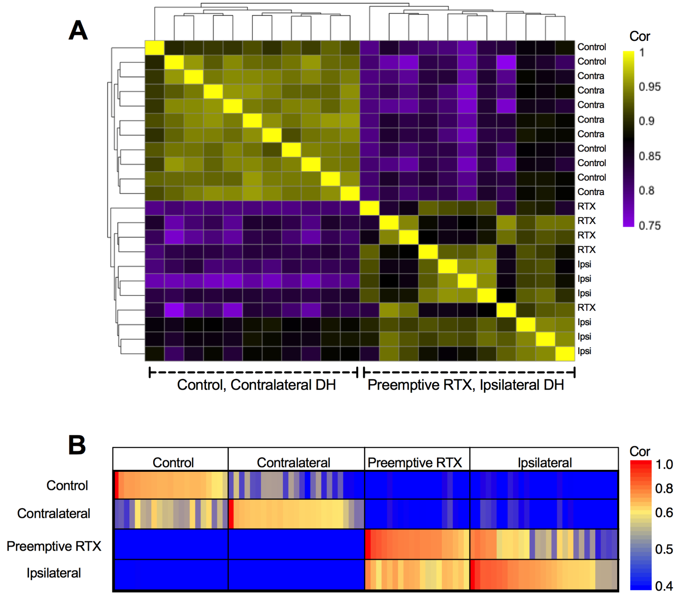

Supplemental Digital Content 6. A) Unbiased correlation analysis among the samples results in two main clusters: the control DH and contralateral DH cluster together, whereas the DH ipsilateral to surgery and the DH ipsilateral to surgery for resiniferatoxin treated animals cluster together. Heatmap generated with pheatmap package in R. B) Differential correlation analysis utilizes the known experimental group labels and demonstrates that the samples form discrete subclusters that correspond to the four experimental groups. Most genes that were induced by surgical incision were unaffected by preemptive resiniferatoxin, and this is reflected in the fact that the preemptive RTX and ipsilateral groups appear more closely related than the control and contralateral DH.

