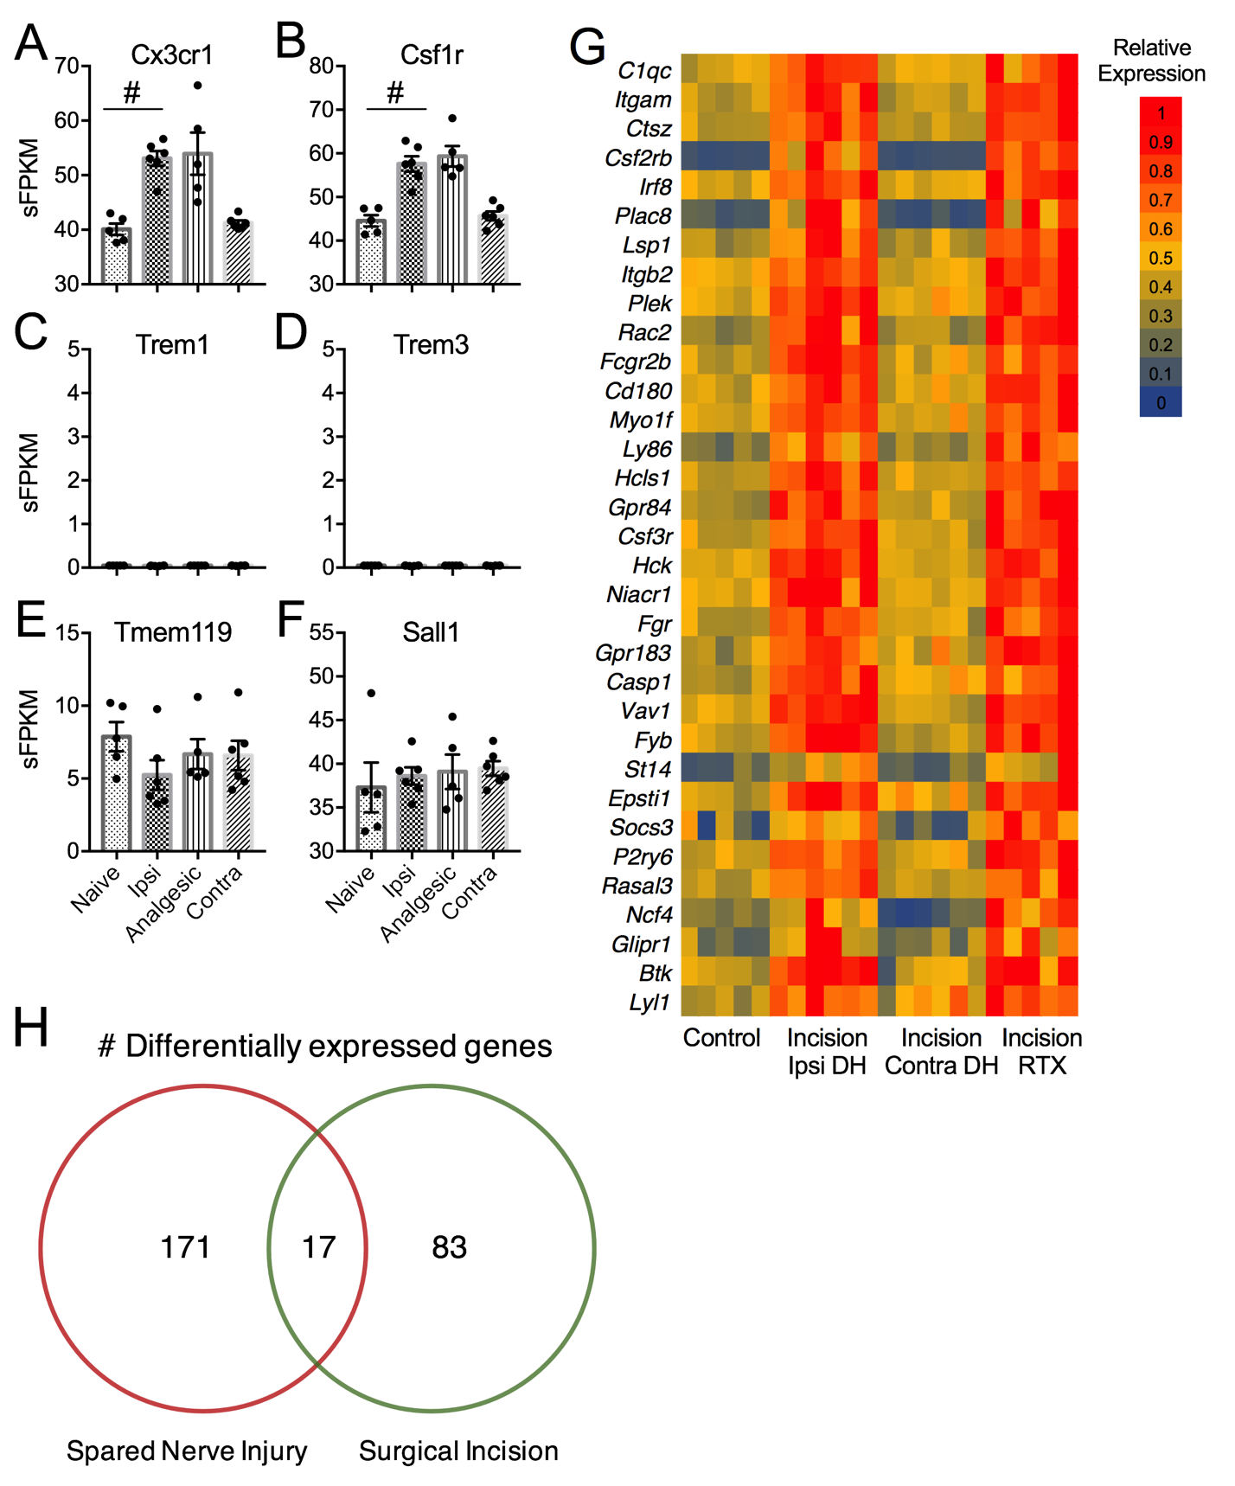

Supplemental Digital Content 11. A, B) Induction of genes Cx3cr1 and Csf1r that are expressed higher in microglia than monocytes³⁴ after surgical incision with or without resiniferatoxin. C, D) Genes Trem1 and Trem3 are more specific for monocytes than microglia³³ and have negligible expression in the dorsal horn after surgical incision. E, F) Microglial subtype markers Tmem119 and Sall1 are not significantly different after surgical manipulation. G) Signature of microglial-specific genes (from public database²⁷) across experimental groups. Only genes that were differentially expressed in the surgical incision with or without intraplantar resiniferatoxin compared to control are included. Gene expression (sFPKM) is normalized across each row. The pattern of microglial-specific genes is similar in the dorsal horn after surgical incision with or without resiniferatoxin treatment. H) Differentially expressed genes in common between the spared nerve injury model (microarray data from rats 7 days after spared nerve injury from public database⁶⁵) and the surgical incision model. Genes altered by surgical incision were considered those genes differentially expressed in the incision group with or without resiniferatoxin compared to the unmanipulated control group or the contralateral DH group (i.e., those genes listed in Supplemental Digital Content 13). Genes significantly affected by both conditions include Ctsz, Anxa3, Itgam, C1qc, Irf8, Plac8, Plek, Fcgr3a, Rac2, Rrm2, Tspo, Ly86, Atf3, Hck, Vav1, P2ry6, and P2ry14, and the majority of these genes are microglial-specific. These genes were significantly induced in the dorsal horn of animals after surgical incision or spared nerve injury.

