Supplemental Digital Content 8

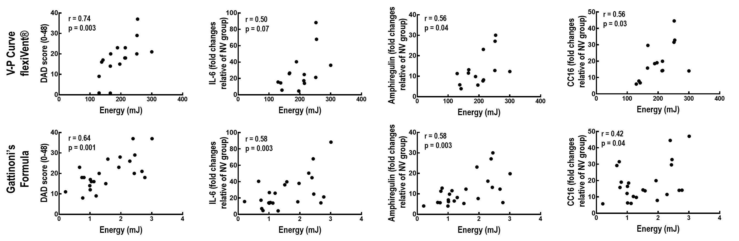

Supplemental Digital Content - figure 4. Spearman’s correlation analyses of diffuse alveolar damage (DAD) score and interleukin (IL)-6, amphiregulin, and club cell protein 16 (CC16) mRNA expressions with mechanical energy calculated based on a quasi-static volume-pressure curve (flexiVent®) and equation of motion (Gattinoni’s formula). r = correlation coefficient with the respective p-value.

