Supplemental Digital Content 13
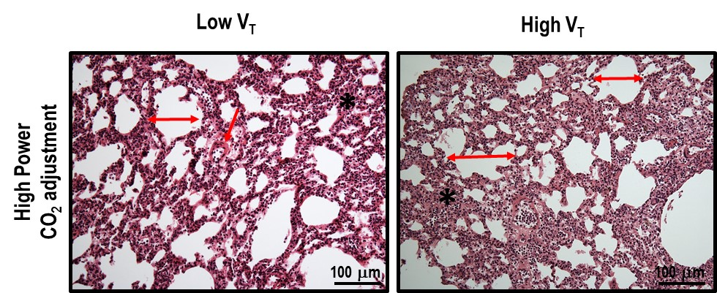

Supplemental Digital Content - figure 5. Representative photomicrographs (light microscopy) of lung parenchyma stained with hematoxylin and eosin in the High Power/Low tidal volume (V_{T}) (6 mL/kg) and High Power/High V_{T} (11 mL/kg), with respiratory rate (RR) set to obtain a power three times that obtained in the low-power groups. The PaCO₂ target was set according to the low-power groups. Asterisks show alveolar collapse. Double arrows indicate alveolar overdistension. Photomicrographs are representative of data obtained from lung sections of seven animals (original magnification, ×200). Bars = 100 µm.

