**Supplementary material**

Positive end-expiratory pressure and mechanical power

*Francesca Collino1, *Francesca Rapetti1, Francesco Vasques1, Giorgia Maiolo1, Tommaso Tonetti1, Federica Romitti1, Julia Niewenhuys1, Tim Behnemann1, Luigi Camporota2, Günther Hahn1, Verena Reupke3, Karin Holke4, Peter Herrmann1, Eleonora Duscio1, Francesco Cipulli1, Onnen Moerer1, John J. Marini5, Michael Quintel1, Luciano Gattinoni1

Authors’ affiliations:

1 Department of Anesthesiology, Emergency and Intensive Care Medicine, University of Göttingen, Germany.

2 Department of Adult Critical Care, Guy’s and St Thomas’ NHS Foundation Trust, King’s Health Partners, and Division of Asthma, Allergy and Lung Biology, King’s College London, London, UK.

3 Department of Experimental Animal Medicine, University of Göttingen, Germany.

4 Department of Pathology, University of Göttingen, Germany.

5 Regions Hospital and University of Minnesota, St. Paul, Minnesota, United States.

* These two authors contributed equally.

**ADDITIONAL METHODS**

Ethics

The local authorities (Niedersächsisches Landesamt für Verbraucherschutz und Lebensmittelsicherheit LAVES) approved the study.

Experimental protocol

*Anesthesia*

Anxiolytic premedication with 2 mg/kg azaperone (Janssen, Neuss, Germany), 10 mg/kg ketamine (Inresa, Freiburg, Germany) and 15 mg midazolam (Ratiopharm, Ulm, Germany) was administered in a stress-free environment by intra-muscular injection. Venous access was established in an ear vein with a 20G or 22G indwelling cannula.

After being placed in the prone position on the surgical table, anesthesia was induced with 1-3µg/Kg sufentanyl (Rotex medica, Trittau, Germany) and 2-2,5mg/Kg propofol. Adequate depth of anesthesia was ascertained before endotracheal tube positioning (6-7 mm). During preparation, pigs received volume-controlled ventilation with tidal volume 8-10 ml/kg, FiO2 0,4, I:E = 1:2 and respiratory rate titrated to etCO2 35-45 mmHg. Infusion of midazolam 1,5- 1,2 mg/kg/h, propofol 6-9 mg/kg/h and sufentanyl 2-3 µg/kg/h allowed adequate depth of anesthesia. Physiological body temperature was maintained during the experiment with a heating blanket.

*Instrumentation*

With animals lying supine, the following catheters were positioned under sonographic guidance: femoral artery, central venous line and Swan-Ganz sheath catheters in the external jugular veins. A urinary catheter and a gastric tube with esophageal balloon were also inserted. The animals were then pronated before starting the experimental protocol.

Data collection

Baseline weight, nose-to-tail length and chest circumference were measured.

*Measured respiratory mechanics variables*: tidal volume, slow pressure-volume curve, I:E ratio, respiratory rate, peak inspiratory pressure, plateau pressure, volume release at plateau pressure, volume release at PEEP, PEEP, mean airway pressure, esophageal pressure, esophageal plateau pressure, esophageal pressure at PEEP, esophageal pressure at ZEEP.

*Computed respiratory measures*:

respiratory system compliance = tidal volume / Pplat-PEEP

respiratory system elastance = 1 / respiratory system compliance

transpulmonary inspiratory pressure = (Pplat – Pplates) – (0 – ZEEPes)

transpulmonary expiratory pressure = (PEEP – 0) – (PEEPes - ZEEPes)

lung compliance = tidal volume / transpulmonary inspiratory pressure – transpulmonary expiratory pressure

lung elastance = 1 / lung compliance

transpulmonary driving pressure = (Pplat – Pplates)-(PEEP – PEEPes)

specific lung elastance = lung elastance * FRC

respiratory system driving pressure = Pplat – PEEP

airway resistances = (Ppeak – Pplat)/flow

stress relaxation of the respiratory system = P2- P1

tissue resistances = (P2-P1)/inspiratory flow

mechanical power (see text)

cumulative mechanical power = area under the curve of the mechanical power/time curve

stress = Pplat * (lung elastance/ total elastance)

strain = ( tidal volume + PEEP volume ) / FRC.

*Measured gas exchange variables:* pH, pO2, pCO2, etCO2, FiO2, hematocrit, hemoglobin, satO2%, blood lactate, Na+, Ca2+, K+.

*Derived gas exchange variables:* arterial, central venous, mixed venous contents of O2 and CO2, O2 consumption, CO2 production, physiological dead space, anatomical death space, venous admixture, minute ventilation, base excess, H2CO3-.

*Measured haemodynamic variables:* systemic and pulmonary arterial pressures, wedge and central venous pressures, heart rate.

*Derived haemodynamic variables:* cardiac output, pulmonary artery resistances, systemic resistances and PiCCO variables.

*Fluid-balance variables:* urinary output, maintenance fluidsandresuscitation fluids.

During autopsy, three samples of approximately 1 cm3 from each lung (upper, medium and lower) as well as from liver, kidney, small bowel and skeletal muscle were obtained for wet-to-dry analysis.

Histology

The lungs were fixed in 4% formalin for at least two days. Ten samples of lung tissue were obtained from each lung for histological examination according to the scheme displayed in figure S1. The samples were fixed, dehydrated in a graded alcohol series, cleared in xylene and embedded in paraffin. Two µm sections were cut with a microtome, mounted on slides, and stained with hematoxylin-eosin for histological analysis. The sections were viewed under a light microscope, and histology scoring was performed by an investigator (K.H.) blinded to the group allocation of the animals. A score from 0 (not present) to 100% (extensive) was attributed to each sample for each of the following parameters: alveolar edema, vascular congestion, perivascular edema, ruptures or septal dilatation, inflammation, alveolar collapse and atelectasis, intravascular thrombi, hyaline membrane, emphysema, intra-alveolar hemorrhage.



**Figure S1**.Schematic representation of lung sampling for histological analysis.

**SUPPLEMENTARY RESULTS**

PEEP levels׃

0

4

7

11

14

18

Lung power (J/min)

5

10

15

20

25

30

0

6

12

18

24

30

36

42

48

50

Time (h)

A

Time (h)

Respiratory System Power (J/min)

15

20

25

30

35

40

45

0

6

12

18

24

30

36

42

48

50

B

Time (h)

Cumulative Lung Energy (KJ)

0

10

20

30

40

50

60

70

0

6

12

18

24

30

36

42

48

50

C

**Figure S2**. Time course of mechanical power applied to the lung (linear mixed effects model: time p<0.001; PEEP p<0.001; PEEP:Time interaction p=0.713) (panel A), to the respiratory system (linear mixed effects model: time p<0.001; PEEP p<0.001; PEEP:Time interaction p=0.696) (panel B) and of the cumulative energy applied to the lung (linear mixed effects model: time, PEEP and PEEP:Time interaction p <0.001) (panel C) in the different PEEP groups.

0

10

20

30

40

50

0.0

0.2

0.4

0.6

0.8

1.0

Time (hours)

Survival (fraction)

PEEP 18 cmH2O

PEEP 14 cmH2O

PEEP 0, 4, 7, 11 cmH2O

**Figure S3**. Kaplan-Meier curve showing survival according to PEEP level (log-rank test p=0.012).

End-Expiratory Lung Volume (ml)

400

600

800

1000

1200

1400

0

6

12

18

24

30

36

42

48

50

A

B

Time (hours)

Plateau Airway Pressure (cmH2O)

10

20

30

40

6

12

18

24

30

36

42

48

50

0

C

Time (hours)

Driving Pressure (cmH2O)

10

20

30

40

50

0

6

12

18

24

30

36

42

48

50

Time (hours)

D

Time (hours)

Transpulmonary Driving Pressure (cmH2O)

10

20

30

40

0

6

12

18

24

30

36

42

48

50

**Figure S4**. Time course of end-expiratory lung volume (linear mixed effects model: time p=0.023; PEEP p<0.001; PEEP:Time interaction p=0.010) (A), airway plateau pressure (linear mixed effects model: time p<0.001; PEEP p<0.001; PEEP:Time interaction p=0.413) (B), driving pressure (linear mixed effects model: time p<0.001; PEEP p<0.001; PEEP:Time interaction p=0.334) (C) and transpulmonary driving pressure (linear mixed effects model: time p <0.001; PEEP p<0.001; PEEP:Time interaction p=0.427) (D) in the different PEEP groups.

Stress (cmH2O)

10

15

20

25

30

35

0

6

12

18

24

30

36

42

48

50

Time (h)

A

Time (h)

Total strain

1

2

3

4

5

0

6

12

18

24

30

36

42

48

50

B

Time (h)

Lung Specific Elastance (cmH2O)

5

10

15

20

25

30

0

6

12

18

24

30

36

42

48

50

C

PEEP levels׃

0

4

7

11

14

18

**Figure S5**. Time course of stress (linear mixed effects model: time p<0.001; PEEP p<0.001; PEEP:Time interaction p=0.667) (A), strain (linear mixed effects model: time p=0.379; PEEP p<0.001; PEEP:Time interaction p<0.001) (B) and specific lung elastance (linear mixed effects model: time p<0.001; PEEP p<0.001; PEEP:Time interaction p=0.032) (C) in the different PEEP groups. The apparent rise of strain observed in the 18 cmH2O PEEP group between 18 and 42 hours (3 pigs died within this timeframe).

Time (h)

Shunt fraction (%)

0.00

0.02

0.04

0.06

0.08

0

6

12

18

24

30

36

42

48

50

B

Time (h)

PaO2/FiO2 (mmHg)

450

500

550

600

650

0

6

12

18

24

30

36

42

48

50

A

PEEP levels׃

0

4

7

11

14

18

PaCO2 (mmHg)

15

20

25

30

35

0

6

12

18

24

30

36

42

48

50

Time (h)

C

Time (h)

Dead space (%)

0.2

0.3

0.4

0.5

0.6

0

6

12

18

24

30

36

42

48

50

D

**Figure S6**. Time course of PaO2/FiO2 (linear mixed effects model: time p<0.001; PEEP p=0.216; PEEP:Time interaction p=0.216) (A), shunt fraction (linear mixed effects model: time p<0.001; PEEP p=0.132; PEEP:Time interaction p=0.016) (B), PaCO2 (linear mixed effects model: time p<0.001; PEEP p=533; PEEP:Time interaction p=0.011) (C) and physiological dead space fraction (linear mixed effects model: time p<0.001; PEEP p<0.001; PEEP:Time interaction p=0.103) (D) in the different PEEP groups.

Time (h)

pH

7.50

7.55

7.60

7.65

7.70

7.75

0

6

12

18

24

30

36

42

48

50

B

A

Time (h)

Arterial BE (mmol/L)

-5

0

5

10

15

0

6

12

18

24

30

36

42

48

50

**Figure S7.** Time course of arterial base excess (linear mixed effects model: time p<0.001; PEEP p=0.899; PEEP:Time interaction p=0.006) (panel A) and pH (linear mixed effects model: time p<0.001; PEEP p=0.062; PEEP:Time interaction p=0.755) (panel B). Data are shown as mean values and standard error.

PEEP levels׃

0

4

7

11

14

18

Time (h)

Transmural Wedge (cmH2O)

5

10

15

20

25

0

6

12

18

24

30

36

42

48

50

A

Time (h)

Mean PAP (mmHg)

15

20

25

30

35

40

0

6

12

18

24

30

36

42

48

50

B

**Figure S8.** Time course of mean pulmonary artery pressure (PAP) (linear mixed effects model: time p<0.001; PEEP p<0.001; PEEP:Time interaction p=0.452) (Panel A) and transmural wedge pressure (incomplete data available for PEEP 18 cmH2O after 30 hours) (linear mixed effects model: time p=0.0251; PEEP p<0.001; PEEP:Time interaction 0.961) (Panel B). Data are displayed as means and standard error.

PEEP levels׃

0

4

7

11

14

18

Arterial Lactate (mmol/L)

Time (h)

1

2

3

4

0

6

12

18

24

30

36

42

48

50

PEEP

0

4

7

11

14

18

**Figure S9.** Time course of mean arterial lactate (linear mixed effects model: time p=0.002; PEEP p=0.362; PEEP:Time interaction p=0.037). Data are displayed as means and standard error.

Time (h)

Fluid balance (ml)

0

1000

2000

3000

0

6

12

18

24

30

36

42

48

50

PEEP

0

4

7

11

14

18

**Fig S10.** Time course of fluid balance (linear mixed effects model: time p<0.001; PEEP p<0.001; PEEP:Time interaction p<0.001). Data are displayed as means and standard error.

**Figure S12.** Macroscopic aspect of the lungs prior to dissection and histological analysis.

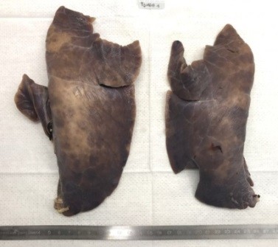

ZEEP (pig 14)

4 cmH2O (pig 29)

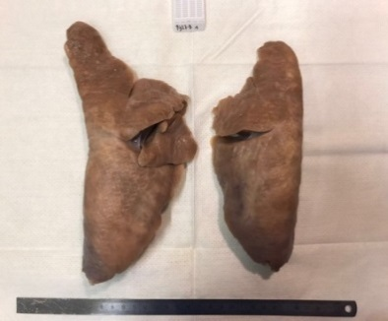

7 cmH2O (pig 27)

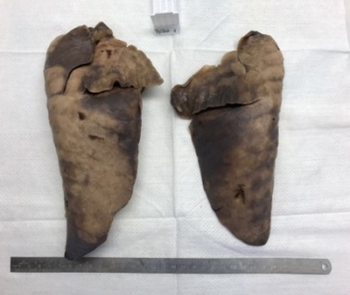

11 cmH2O (pig 22)

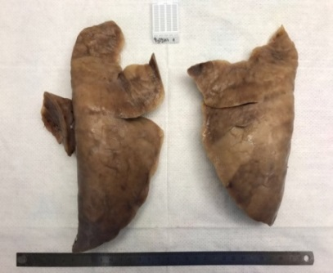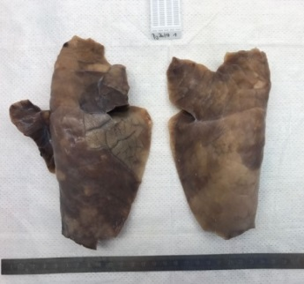

14 cmH2O (pig 36)

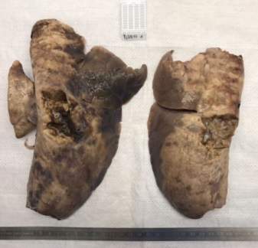

18 cmH2O (pig 34)

**Figure S11.** Wet-to-dry ratio index of lung, small bowel, kidney, liver and skeletal muscle. The wet-to-dry index is obtained dividing the wet-to-dry ratio by the time fraction of the 50 hours that each animal survived (e.g. if a pig died at 25h, this fraction would be 0.5).

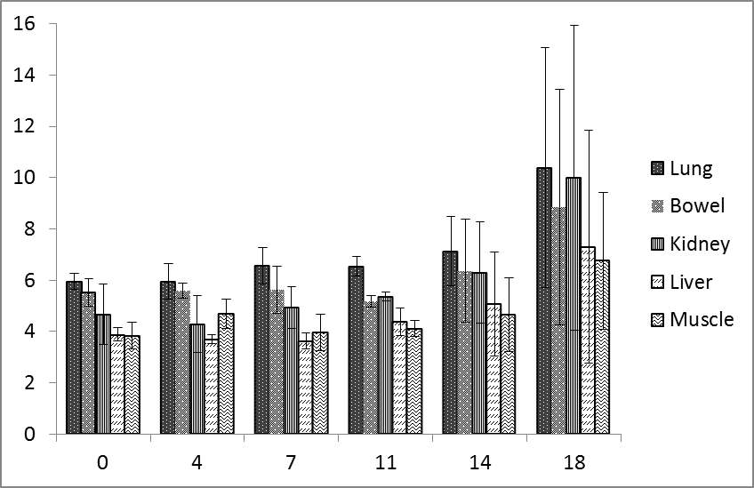

Wet to dry ration index

**Figure S12.** Macroscopic appearance pig’s lungs representative of each PEEP group.

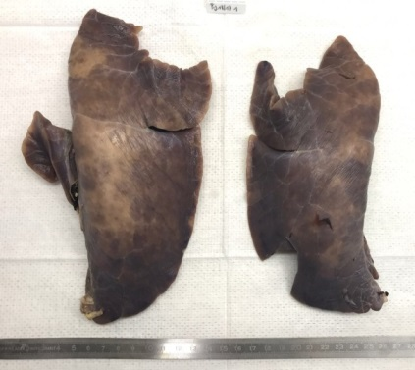

ZEEP (pig 14)

4 cmH2O (pig 29)

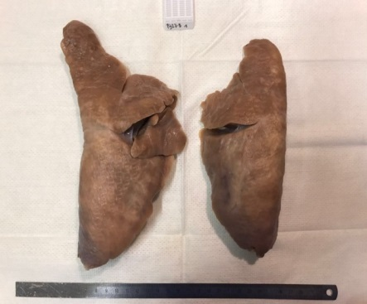

7 cmH2O (pig 27)

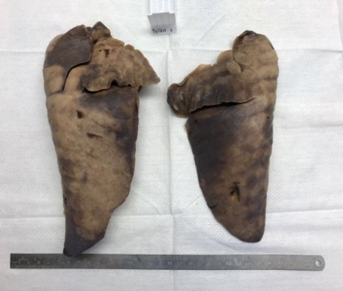

11 cmH2O (pig 22)

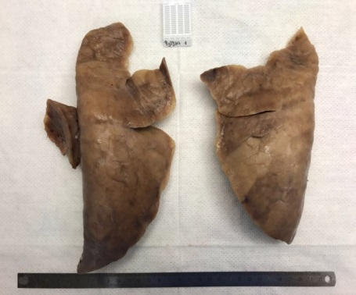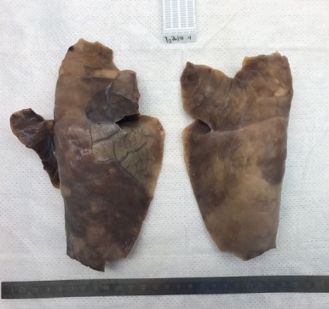

14 cmH2O (pig 36)

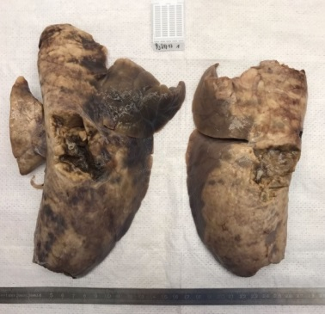

18 cmH2O (pig 34)

**Figure S11.** Wet-to-dry ratio index of lung, bowel, kidney, liver and skeletal muscle. We defined the wet-to-dry index: wet-to-dry∙50/H1, where H1 are the actual hours of experiment and 50 are the hours planned for the experiment. This ratio accounts for the shorter time available for edema formation in the animals which died before intended. The 50/H1 adjustment assumes that edema accumulates linearly with time.

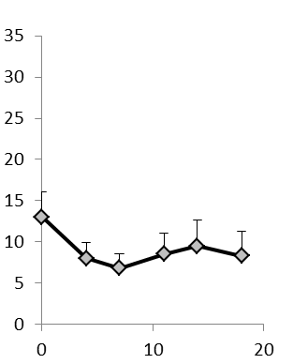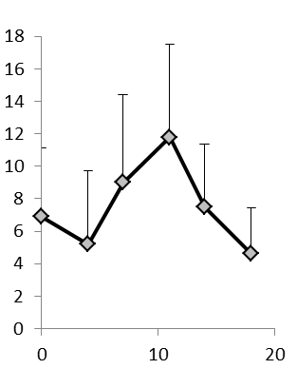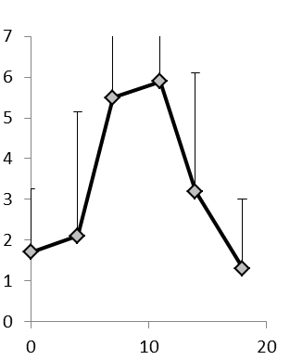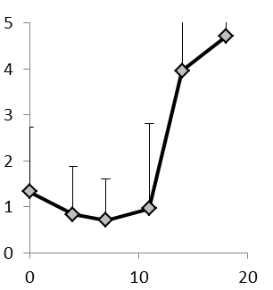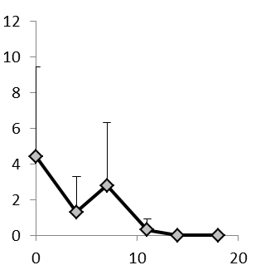

**Emphysema-like**

**Perivascular edema**

**Alveolar edema**

A

B

C

0 4 7 11 14 18

0 4 7 11 14 18

0 4 7 11 14 18

0 4 7 11 14 18

0 4 7 11 14 18

D

E

PEEP (cmH2O)

PEEP (cmH2O)

**Alveolar hemorrhage**

**Intravascular thrombi**

●

●

●

●

§

§

●

§

∆

○

§

○

∆

∆

∆

●

○

●

§

∆

§

∆

○

§

●

○

∆

●

○

●

●

○

§

∆

●

○

§

∆

○

§

∆

●

●

§

●

§

●

§

●

§

Optical field (%)

Optical field (%)

**Figure S13.** percentages of optical field with emphysema-like (A), inflammatory infiltrates (B), alveolar collapse/atelectasis (C), septal dilations/ruptures (D) and intravascular thrombi (E) as a function of experimental PEEP groups. Significant statistical differences are indicated by ● (ZEEP), ○ (4 cmH2O); § (7 cmH2O); ∆ (11 cmH2O).

|  |  |  |  |  |  |  |  |  |  |  |
| --- | --- | --- | --- | --- | --- | --- | --- | --- | --- | --- |
| **Set PEEP** | **0** | **4** | **7** | **11** | **14** | **18** | **P** | **Time** | **PEEP** | **Time:**  **PEEP**  **Interaction** |
| **Pig number** | 6 | 6 | 6 | 6 | 6* | 6** |
| **VT (ml)** | 375 ± 58 | 325 ± 45 | 310 ± 90 | 361 ± 36 | 372 ± 69 | 326 ± 60 | 0.336 | 0.656 | 0.330 | 0.346 |
| 373 ± 57 | 325 ± 40 | 312 ± 90 | 360 ± 36 | 374 ± 75 | 330 ± 57 | 0.378 |
| **FRC (ml)** | 369 ± 65 | 333 ± 68 | 305 ± 86 | 375 ± 60 | 370 ± 75 | 342 ± 47 | 0.451 | 0.997 | < 0.001 | < 0.001 |
| 305 ± 34 | 317 ± 59 | 302 ± 72 | 399 ± 38 | 356 ± 51 | 377 ± 96 | 0.050 |
| **Driving Pressure**  **(cmH2O)** | 15.33 ± 1 .03 | 12 .61 ± 1 .29 | 12 .04 ± 2 .64 | 16 .41 ± 2 .95 | 20 .01 ± 7 .79 | 24 .63 ± 7 .18 | <0.001 | <0.001 | <0.001 | 0.334 |
| 21.52 ± 5.77 | 16.39 ± 1.81 | 15.05 ± 4.02 | 18.00 ± 2.98 | 21.37 ± 5.35 | 23.72 ± 4.05 | 0.007 |
| **Driving Transpulmonary**  **(cmH2O)** | 8.34 ± 1.04 | 6.32 ±1.27 | 6 .22 ± 2.19 | 7 .54 ± 2.7 | 8.4 ± 3 | 12.96 ± 6.66 | 0.005 | <0.001 | <0.001 | 0.427 |
| 16.28 ± 6.33 | 9.40 ± 2.83 | 9.37 ± 3.60 | 8.76 ± 2.84 | 11.23 ± 2.22 | 15.11 ± 2.57 | 0.008 |
| **Airway Plateau Pressure**  **(cmH2O)** | 16.6 ± 1.41 | 17.78 ± 1.5 | 20.3 ± 3 | 29.34 ± 3.14 | 35.84 ± 8.46 | 43.75 ± 7.42 | <0.001 | <0.001 | <0.001 | 0.413 |
| 22.72 ± 5.78 | 21.54 ± 2.12 | 23.38 ± 4.04 | 31.04 ± 3.50 | 37.19 ± 6.01 | 43.49 ± 4.54 | <0.001 |
| **PEEP volume (ml)** | 0 | 80 ± 27 | 189 ± 36 | 453 ± 141 | 651 ± 200 | 878 ± 106 | <0.001 | 0.011 | < 0.001 | 0.478 |
| 0 | 71 ± 47 | 204 ± 73 | 512 ± 106 | 734 ± 143 | 851 ± 205 | <0.001 |
| **EELV (ml)** | 369 ± 65 | 412 ± 94 | 494 ± 105 | 828 ± 147 | 1021 ± 156 | 1219 ± 128 | <0.001 | 0.0226 | <0.001 | 0.010 |
| 304 ± 34 | 388 ±96 | 505 ± 137 | 910 ± 98 | 1090 ± 166 | 1228 ± 257 | <0.001 |
| **Stress (cmH2O)** | 9.1 ± 1.3 | 9.7 ± 2.3 | 12.9 ± 2.6 | 17.7 ± 3.9 | 19.5 ± 4.8 | 28.7 ± 8.2 | <0.001 | < 0.001 | < 0.001 | 0.667 |
| 17.3 ± 6.4 | 14.9 ± 4.3 | 15.1 ± 6 | 21.3 ± 4 | 25.6 ± 3.7 | 33 ± 5.6 | <0.001 |
| **Strain** | 1.0 ± 0.04 | 1.2 ± 0.1 | 1.7 ± 0.2 | 2.2 ± 0.5 | 2.8 ± 0.4 | 3.6 ± 0.4 | <0.001 | 0.379 | <0.001 | <0.001 |
| 1.2 ± 0.08 | 1.3 ± 0.27 | 1.7 ± 0.22 | 2.2 ± 0.41 | 3.17 ± 0.72 | 3.23 ± 0.8 | <0.001 |
| **Elastance (L) (cmH2O/l)** | 23.0 ± 4.8 | 20.9 ± 3.2 | 25.1 ± 4.8 | 27.3 ± 6.1 | 28.3 ± 6.0 | 49.2 ± 13.3 | <0.001 | < 0.001 | 0.002 | 0.499 |
| 46.0 ± 23.54 | 34.6 ± 7.12 | 34.1 ± 0.2 | 34.6 ± 9.5 | 39.6 ± 8.6 | 55.6 ± 13.3 | 0.113 |
| **Elastance (CW) (cmH2O/l)** | 18.1 ± 5.9 | 18.0 ± 3.8 | 14.5 ± 2.7 | 18.0 ± 8.3 | 23.8 ± 6.5 | 25.7 ± 4.3 | 0.026 | 0.005 | 0.103 | 0.125 |
| 13.9 ± 3.1 | 16.0 ±9.8 | 17.1 ± 3.9 | 15.5 ± 4.8 | 17.7 ± 3.9 | 17.3 ± 3.0 | 0.832 |
| **Elastance (RS) (cmH2O/l)** | 41.76 ± 6.69 | 38.95 ± 2.13 | 39.64 ± 5.55 | 45.29 ±5.44 | 52.11± 11.32 | 74.91± 11.67 | <0.001 | <0.001 | <0.001 | 0.445 |
| 59.94 ± 23.72 | 50.63 ± 5.23 | 51.14 ± 20.25 | 50.13 ± 8.04 | 57.25 ± 11.12 | 72.88 ± 12.30 | 0.991 |
| **Specific Elastance (L)**  **(cmH2O)** | 8.32 ± 1.41 | 6.98 ± 1.94 | 7.58 ± 2.09 | 10.12 ± 2.08 | 10.82± 4.46 | 17.05 ± 5.98 | <0.001 | <0.001 | <0.001 | 0.032 |
| 13.55 ± 5.67 | 10.94 ± 3.15 | 9.70 ± 4.66 | 13.88 ± 4.10 | 14.21 ± 4.34 | 21.46 ±8.75 | 0.013 |
| **Mechanical Power (L)**  **(J/min**) | 6.21 ± 1.9 | 6.94 ± 2.11 | 9.1 ± 3.69 | 15.29 ± 3.3 | 17.85 ± 6.94 | 21.38 ± 8.5 | <0.001 | <0.001 | <0.001 | 0.713 |
| 11.86 ± 4.12 | 11.29 ±3.88 | 10.88 ± 4.88 | 17.78 ± 3.17 | 22.58 ± 6.32 | 25.56± 6.59 | <0.001 |
| **Mechanical Power (RS)**  **(J/min**) | 20.31 ± 10.57 | 18.05 ±3.99 | 18.39 ± 7.28 | 31.3 ± 6.75 | 37.39 ±14.22 | 37 .56 11 .23 | <0.001 | <0.001 | <0.001 | 0.696 |
| 23.03 ± 7.33 | 20.29 ± 2.72 | 21.05 ± 8.06 | 32.87 ± 6.88 | 39.52 ± 13.97 | 39.91 ± 10.31 | <0.001 |

**Table S1**. **Lung mechanics.** For each variable, data are reported as mean values ± standard deviation at baseline (first row) and at the end of the experiment (second row). The grey column reports p-value of one way ANOVA at baseline (first row) and at the end of the experiment (second row). In the last three columns, we report the p values of linear mixed effects model for each variable tested for PEEP level and time. VT, Tidal volume; FRC, functional residual capacity; PEEP, positive end-expiratory pressure; EILV, end-inspiratory lung volume; EELV, end-expiratory lung volume; TLC, total lung capacity; L, lung; CW, chest wall. * two pigs at 14 of PEEP died at 30 and 42 h; ** three pigs at 18 of PEEP died at 18 h and one at 30 h.

|  |  |  |  |  |  |  |  |  |  |  |
| --- | --- | --- | --- | --- | --- | --- | --- | --- | --- | --- |
| **PEEP**  **(cmH2O)** | **0** | **4** | **7** | **11** | **14\*** | **18\*\*** | **P** | **Time** | **PEEP** | **Time:**  **PEEP**  **Interaction** |
| **PaO2/FiO2 (mmHg)** | 632 ±59 | 567 ±36 | 601 ±87 | 620 ±55 | 624 ±61 | 549 ±163 | 0.492 | <0.001 | 0.216 | 0.216 |
| 505 ±106 | 569 ±32 | 594 ±30 | 545 ±60 | 565 ±52 | 565 ±43 | 0.266 |
| **Shunt fraction (%)** | 0 ±0 | 2.5 ±2.5 | 2.0 ±2.4 | 1.1 ±2.0 | 0.7 ±2.4 | 2.1 ±3.7 | 0.570 | <0.001 | 0.132 | 0.016 |
| 6.8 ±3.1 | 2.8 ±1.1 | 3.4 ±1 | 4.3 ±2.5 | 4.3 ±2.8 | 3.4 ±1.7 | 0.050 |
| **SatO2 venous (%)** | 92.8 ±4.6 | 86.7 ±3.9 | 89.7 ±5.9 | 92.5 ±7.1 | 94.6 ±1.1 | 86.7 ±10.1 | 0.192 | <0.001 | 0.500 | 0.504 |
| 84.3 ±8.8 | 80 ±13.2 | 88.8 ±5.9 | 85.0 ±7.3 | 82.7 ±6.5 | 82.7 ±12.9 | 0.711 |
| **VE (L/min)** | 11.2 ±1.8 | 9.7 ±1.3 | 9.3 ±2.7 | 10.8 ±1.1 | 11.2 ±2.1 | 9.8 ±1.8 | 0.330 | 0.656 | 0.330 | 0.346 |
| 11.2 ±1.7 | 9.8 ±1.2 | 9.4 ±2.7 | 10.8 ±1.1 | 11.2 ±2.2 | 9.9 ±1.7 | 0.370 |
| **Dead space fraction (%)** | 0.27 ±0.13 | 0.28 ±0.09 | 0.32 ±0.20 | 0.41 ±0.08 | 0.44 ±0.08 | 0.40 ±0.14 | 0.096 | <0.001 | 0.019 | 0.103 |
| 0.35 ±0.03 | 0.41 ±0.06 | 0.36 ±0.06 | 0.43 ±0.11 | 0.45 ±0.03 | 0.55 ±0.08 | <0.001 |
| **PaCO2 (mmHg)** | 27 ±9 | 32 ±10 | 27 ±8 | 24 ±7 | 25 ±7 | 25 ±3 | 0.464 | <0.001 | 0.533 | 0.011 |
| 16 ±7 | 18 ±3 | 22 ±11 | 18 ±2 | 19 ±6 | 25 ±8 | 0.239 |
| **arterial pH** | 7.69 ±0.08 | 7.65 ±0.10 | 7.64 ±0.12 | 7.73 ±0.08 | 7.73 ±0.07 | 7.61 ±0.19 | 0.378 | <0.001 | 0.062 | 0.755 |
| 7.60 ±0.05 | 7.58 ±0.03 | 7.58 ±0.08 | 7.59 ±0.01 | 7.60 ±0.07 | 7.54 ±0.08 | 0.488 |
| **arterial BE**  **(mmol/L)** | 12.5 ±1.9 | 13.7 ±2.9 | 11.8 ±1.8 | 12.8 ±2.6 | 15.0 ±3.4 | 9.8 ±3.7 | 0.110 | <0.001 | 0.899 | 0.006 |
| -3.7 ±4.2 | -3.3 ±2.8 | -1.3 ±5.8 | -3.4 ±1.9 | -2.3 ±3.4 | -0.7 ±4.0 | 0.677 |

**Table S2. Gas exchange.** For each variable, data are reported as mean values ± standard deviation at baseline (first row) and at the end of the experiment (second row). The grey column reports p-value of one way ANOVA at baseline (first row) and at the end of the experiment (second row). In the last three columns, we report the p values of linear mixed effects model for each variable tested for PEEP level and time. PaO2, arterial oxygen partial pressure; SatO2, Oxygen hemoglobin saturation; VE, minute ventilation; PaCO2, arterial carbon dioxide partial pressure; BE, base excess. * Two pigs at 14 of PEEP died at 30 and 42 h; ** three pigs at 18 of PEEP died at 18 h and one at 30 h.

|  |  |  |  |  |  |  |  |  |  |  |
| --- | --- | --- | --- | --- | --- | --- | --- | --- | --- | --- |
| **PEEP** | **0** | **4** | **7** | **11** | **14** | **18** | **P** | **Time** | **PEEP** | **Time:**  **PEEP**  **Interaction** |
| **Pig number** | 6 | 6 | 6 | 6 | 6* | 6** |
| **MAP (mmHg)** | 65.8 ±8.7 | 74.7 ±9.8 | 84.2 ±13.9 | 84.2 ±14.3 | 87.3 ±11.3 | 84.8 ±16.3 | 0.045 | <0.001 | 0.543 | 0.011 |
| 74.7 ±10.1 | 66.2 ±10.4 | 63.2 ±7.8 | 71.8 ±13.7 | 75.2 ±10 | 66 ±23.75 | 0.54 |
| **HR (bpm)** | 102 ±17 | 90 ±8 | 110 ±33 | 122 ±22 | 137 ±18 | 117 ±28 | 0.024 | <0.001 | <0.001 | 0.399 |
| 79.2 ±14.8 | 80 ±17.5 | 97.8 ±19.3 | 89 ±26.7 | 102.5 ±32.5 | 117.7 ±43.8 | 0.164 |
| **CO (ml/min)** | 3.8 ±1.1 | 3.5 ±0.2 | 3.3 ±0.5 | 3.8 ±0.8 | 3.5 ±1.2 | 3.2 ±0.8 | 0.752 | <0.001 | 0.684 | 0.315 |
| 2.7 ±0.5 | 2.7 ±1.6 | 3.4 ±1.0 | 2.7 ±1.4 | 2.3 ±0.5 | 2.4 ±0.9 | 0.549 |
| **mean PAP (mmHg)** | 21.8 ±3.4 | 22.4 ±7.1 | 20.0 ±5.2 | 25.3 ±4.3 | 33.2 ±5.1 | 31.0 ±9.0 | 0.008 | <0.001 | <0.001 | 0.452 |
| 22.3 ±3.8 | 21.3 ±3.4 | 23.2 ±5.7 | 32.3 ±3.3 | 35.5 ±76.7 | 32.5 ±11.6 | 0.002 |
| **Wedge (mmHg)** | 12 ±5 | 14 ±5 | 11 ±4 | 20 ±7 | 23 ±7 | 26 ±11 | 0.005 | 0.014 | <0.001 | 0.936 |
| 10.2 ±3.3 | 12.2 ±7.4 | 12.8 ±2.3 | 18.7 ±1.5 | 16.7 ±6.3 | 32 ±5.7 | <0.001 |
| **Arterial lactate (mmol/L)** | 0.93 ±0.39 | 0.85 ±0.43 | 0.73 ±0.26 | 0.95 ±0.37 | 1.20 ±0.5 | 1.30 ±0.79 | 0.333 | 0.002 | 0.362 | 0.037 |
| 0.75 ±0.2 | 0.78 ±0.4 | 0.7 ±0.2 | 0.8 ±0.2 | 1.2 ±0.2 | 2.4 ±4 | 0.468 |
| **Noradrenaline (μg/kg/min)** | 0 ±0 | 0 ±0 | 0 ±0 | 0.08 ±0.1 | 0.16 ±0.21 | 0.04 ±0.09 | 0.100 | <0.001 | 0.001 | 0.003 |
| 0.10 ±0.17 | 0.10 ±0.23 | 0.12 ±0.14 | 0.19 ±0.16 | 0.41 ±0.24 | 0.48 ±0.29 | 0.025 |
| **Resuscitation Fluid (ml)** | 350.0 ±141.4 | 283.3 ±169.3 | 460.0 ±54.8 | 470.0 ±263.6 | 733.3 ±432.0 | 716.7 ±435.5 | 0.062 | <0.001 | <0.001 | <0.001 |
| 788 ±554 | 817 ±406 | 1050 ±486 | 1096. ±164 | 1733 ±662 | 2312 ±1112 | 0.007 |
| **Fluids cumulative (ml)** | 312 ±78 | 249 ±86 | 551 ±597 | 268 ±22 | 195 ±46 | 248 ±65 | 0.263 | <0.001 | 0.675 | 0.586 |
| 3213 ±190 | 2959 ±297 | 3394 ±651 | 3323 ±231 | 2858 ±656 | 2841 ±993 | 0.441 |
| **Urine output (ml/h)** | 104 ±76 | 122 ±82 | 235 ±151 | 310 ±270 | 191 ±203 | 218 ±85 | 0.267 | <0.001 | 0.224 | 0.866 |
| 54 ±10 | 65 ±17 | 48 ±8 | 45 ±21 | 51 ±13 | 47 ±17 | 0.258 |

**Table S3. Hemodynamics.** For each variable. data are reported as mean values ± standard deviation at baseline (first row) and at the end of the experiment (second row). The grey column reports p-value of one way ANOVA at baseline (first row) and at the end of the experiment (second row). In the last three columns, we report the p values of linear mixed effects model for each variable tested for PEEP level and time. MAP, mean arterial pressure; HR, heart rate; CO, cardiac output. * Two pigs at 14 of PEEP died at 30 and 42 h; ** three pigs at 18 of PEEP died at 18 h and one at 30 h.

|  |  |  |  |  |  |  |  |  |  |  |  |  |
| --- | --- | --- | --- | --- | --- | --- | --- | --- | --- | --- | --- | --- |
| **PEEP** | **0** | p | **4** | p | **7** | p | **11** | p | **14** | p | **18** | **ANOVA** |
| **Lung elastance (cmH2O/ml)** | 31.3 ± 13.5 | 0.134 | 26.1 ± 10.5 | 0.911 | 28.2 ±14.0 | 0.999 | 29.1 ± 8.8 | 0.641 | 32.4 ± 8.0 | **<0.001** | 45.9 ± 12.9 | <0.001 |
| **Lung specific elastance (cmH2O/ml)** | 10.3 ±3.6 | 0.280 | 8.6 ±3.9 | 1 | 8.6 ±3.7 | **0.001** | 11.6 ±4.3 | **0.001** | 12 ±3.7 | **<0.001** | 16.1 ± 6.3 | <0.001 |
| **Stress (cmH2O)** | 12.4 ± 4.6 | 0.998 | 12.0 ± 5.2 | 0.747 | 13.2 ± 4.4 | **<0.001** | 18.4 ± 4.2 | **0.007** | 21.6 ± 4.7 | **<0.001** | 28.2 ± 6.2 | <0.001 |
| **Strain** | 1.1 ± 0.1 | 0.606 | 1.2 ± 0.2 | **<0.001** | 1.6 ± 0.2 | **<0.001** | 2.3 ± 0.5 | **<0.001** | 3.0 ± 0.5 | **<0.001** | 3.9 ± 0.8 | <0.001 |
| **Dead space (%)** | 30.6 ± 9.7 | **<0.001** | 37.7 ± 7.9 | 0.086 | 42.3 ± 10.3 | 0.999 | 42.9 ± 7.1 | 0.835 | 40.8 ± 8.5 | 0.127 | 45.6 ± 12.0 | <0.001 |
| **Shunt (%)** | 4.2 ± 2.5 | 0.704 | 3.7 ± 1.8 | 0.967 | 3.4 ± 1.6 | 0.863 | 3.0 ± 1.7 | 1 | 3.0 ± 2.2 | 1 | 3.0 ± 1.6 | 0.003 |
| **PAP mean (mmHg)** | 19.7 ± 5.3 | 0.970 | 18.8 ± 5.7 | **<0.0001** | 20.9 ± 4.6 | **<0.001** | 26.0 ± 7.0 | **<0.0001** | 32.6 ± 5.3 | 0.999 | 32.2± 9.2 | <0.001 |
| **Fluid challenge (ml)** | 573± 403 | 0.989 | 513 ± 357 | **0.002** | 893± 377 | 0.993 | 835 ± 301 | **<0.001** | 1376±635 | **<0.001** | 2043 ± 930 | <0.001 |
| **Noradrenaline (µg/kg/min)** | 0.04 ± 0.09 | 1 | 0.04 ± 0.14 | 0.985 | 0.06 ± 0.13 | **0.036** | 0.17 ± 0.18 | 0.061 | 0.27 ± 0.21 | 0.437 | 0.34 ± 0.31 | <0.001 |
| **Wet-to-Dry Lung index** | 5.9 ± 0.3 | 0.934 | 6 ± 0.7 | 1 | 6.6 ± 0.7 | 1 | 6.5 ± 0.4 | 0.944 | 6.8 ± 0.9 | 0.973 | 10.4 ± 4.7 | 0.006 |
| **Atelectasis (%)** | 20.2± 17.3 | **<0.001** | 9.8±10 | 0.726 | 12.5 ± 10 | 0.287 | 14.1 ± 12.4 | 0.571 | 19.5 ± 19.5 | 0.743 | 21.6± 22 | 0.041 |
| **Lung weight (g)** | 326 ± 35 | 1 | 332 ± 126 | 0.996 | 364 ± 130 | 0.874 | 436 ± 132 | 0.994 | 381 ± 100 | 1 | 386 ± 85 | 0.524 |

**Table S4. Adjacent group comparison.** Data are reported as mean ± standard deviations. P values originate from Pairwise analysis performed by one-way ANOVA testing and Tukey’s test for adjacent groups analysis (0 vs 4; 4 vs 7; 7 vs 11; 11 vs 14; 14 vs 18 cmH2O PEEP).

.