Supplemental Digital Content 3
Blood pressure and end-tidal carbon dioxide ranges during aneurysm occlusion and neurological outcome after an aneurysmal subarachnoid hemorrhage

Annemarie Akkermans, MD¹
Judith A. van Waes, MD, PhD¹
Linda M. Peelen, PhD^{1,2}
Gabriel J. Rinkel, MD, FRCP(E)³
Wilton A. van Klei, MD, PhD¹

¹ Department of Anesthesiology, University Medical Center Utrecht, Utrecht University, The Netherlands
² Department of Epidemiology, Julius Center for Health Sciences and Primary Care, University Medical Center Utrecht, Utrecht University, The Netherlands
³ Department of Neurology and Neurosurgery, Brain Centre Rudolf Magnus, University Medical Center Utrecht, Utrecht University, The Netherlands

Correspondence to:

A. Akkermans, MD; Email: a.akkermans@umcutrecht.nl

Figure 1. Estimation of the area under the curve per threshold

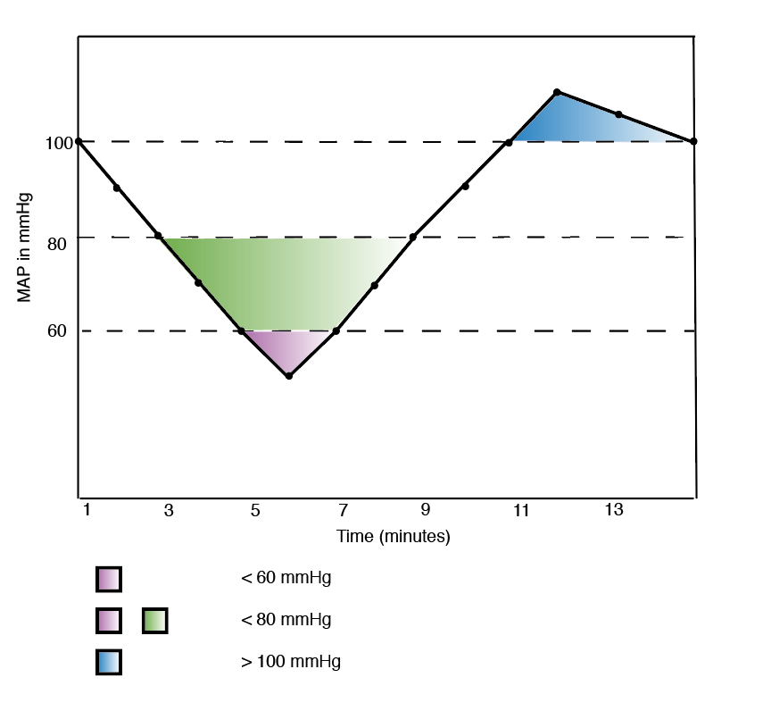

MAP: Mean arterial blood pressure.
This figure shows how the area under the curve was estimated for an absolute threshold of a MAP < 60 mmHg, MAP < 80 mmHg and MAP > 100 mmHg.

