Supplemental Digital Content 7
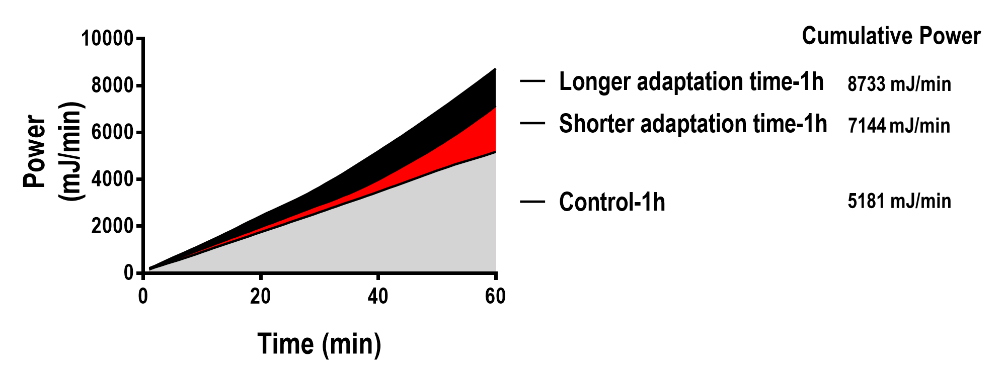

figure 3. Cumulative power over 1 h in the three groups: Low tidal volume (V_{T}) – mechanical ventilation with a protective strategy (V_{T}=6ml/kg) for 1 hour (Control); High V_{T} achieved after a short ‘run-up’ adaptation time – V_{T}=6mL/kg during the first 30 minutes followed by a slow V_{T} increase up to 22mL/kg for 30 minutes (Shorter adaptation time); and High V_{T} with a longer adaptation time – a slow V_{T} increase from 6 mL/kg to 22 mL/kg during 1 hour (Longer adaptation time).

