Supplemental Digital Content 9
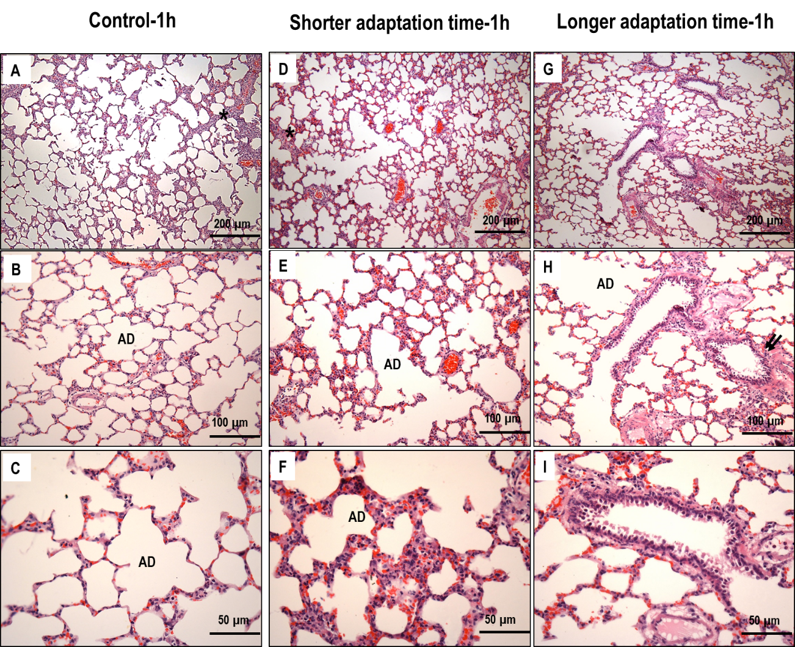
figure 5. Representative photomicrographs (light microscopy) of lung parenchyma stained with hematoxylin and eosin. Asterisks show areas of alveolar collapse. Two arrows indicate areas of alveolar/interstitial edema. AD: alveolar duct. Photomicrographs are representative of data obtained from lung sections of eight animals. Control-1h: low tidal volume (V_{T}) – mechanical ventilation with a protective strategy (V_{T}=6ml/kg) for 1 hour; shorter adaptation time-1h: high V_{T} achieved after a short ‘run-up’ adaptation time – V_{T}=6mL/kg during the first 30 minutes followed by a slow V_{T} increase up to 22mL/kg for 30 minutes; and longer adaptation time-1h: high V_{T} with a longer adaptation time – a slow V_{T} increase from 6 mL/kg to 22 mL/kg during 1 hour.

