Supplemental Digital Content 12
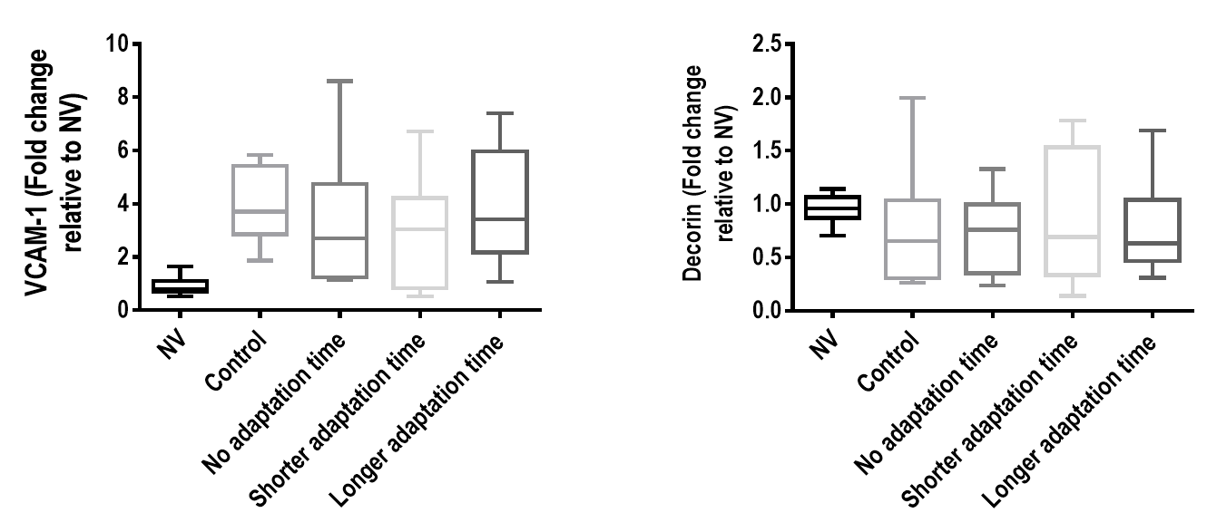
figure 7. Expression of biologic markers associated with endothelial cell damage [vascular cellular adhesion molecule (VCAM)-1] and fibrosis (decorin) in the following groups: : mechanical ventilation with a protective strategy (V_{T}=6ml/kg) for 2 hours (Control); V_{T}=6mL/kg during hour 1 followed by constant V_{T}=22mL/kg (V_{TH}) during hour 2 (no adaptation time); V_{T}=6mL/kg during the first 30 minutes followed by a gradual slow V_{T} increase up to 22mL/kg for 30 minutes, then constant V_{T}=22mL/kg during hour 2 (shorter adaptation time); and a more gradual V_{T} increase from 6mL/kg to 22mL/kg during hour 1 followed by constant V_{T}=22mL/kg during hour 2 (longer adaptation time). Relative gene expression was calculated as a ratio of the average gene expression levels compared with the reference gene (36B4) and expressed as fold change relative to non-ventilated animals (NV). Values are medians and interquartile ranges of 8 rats in each group.

