Supplemental Digital Content 13
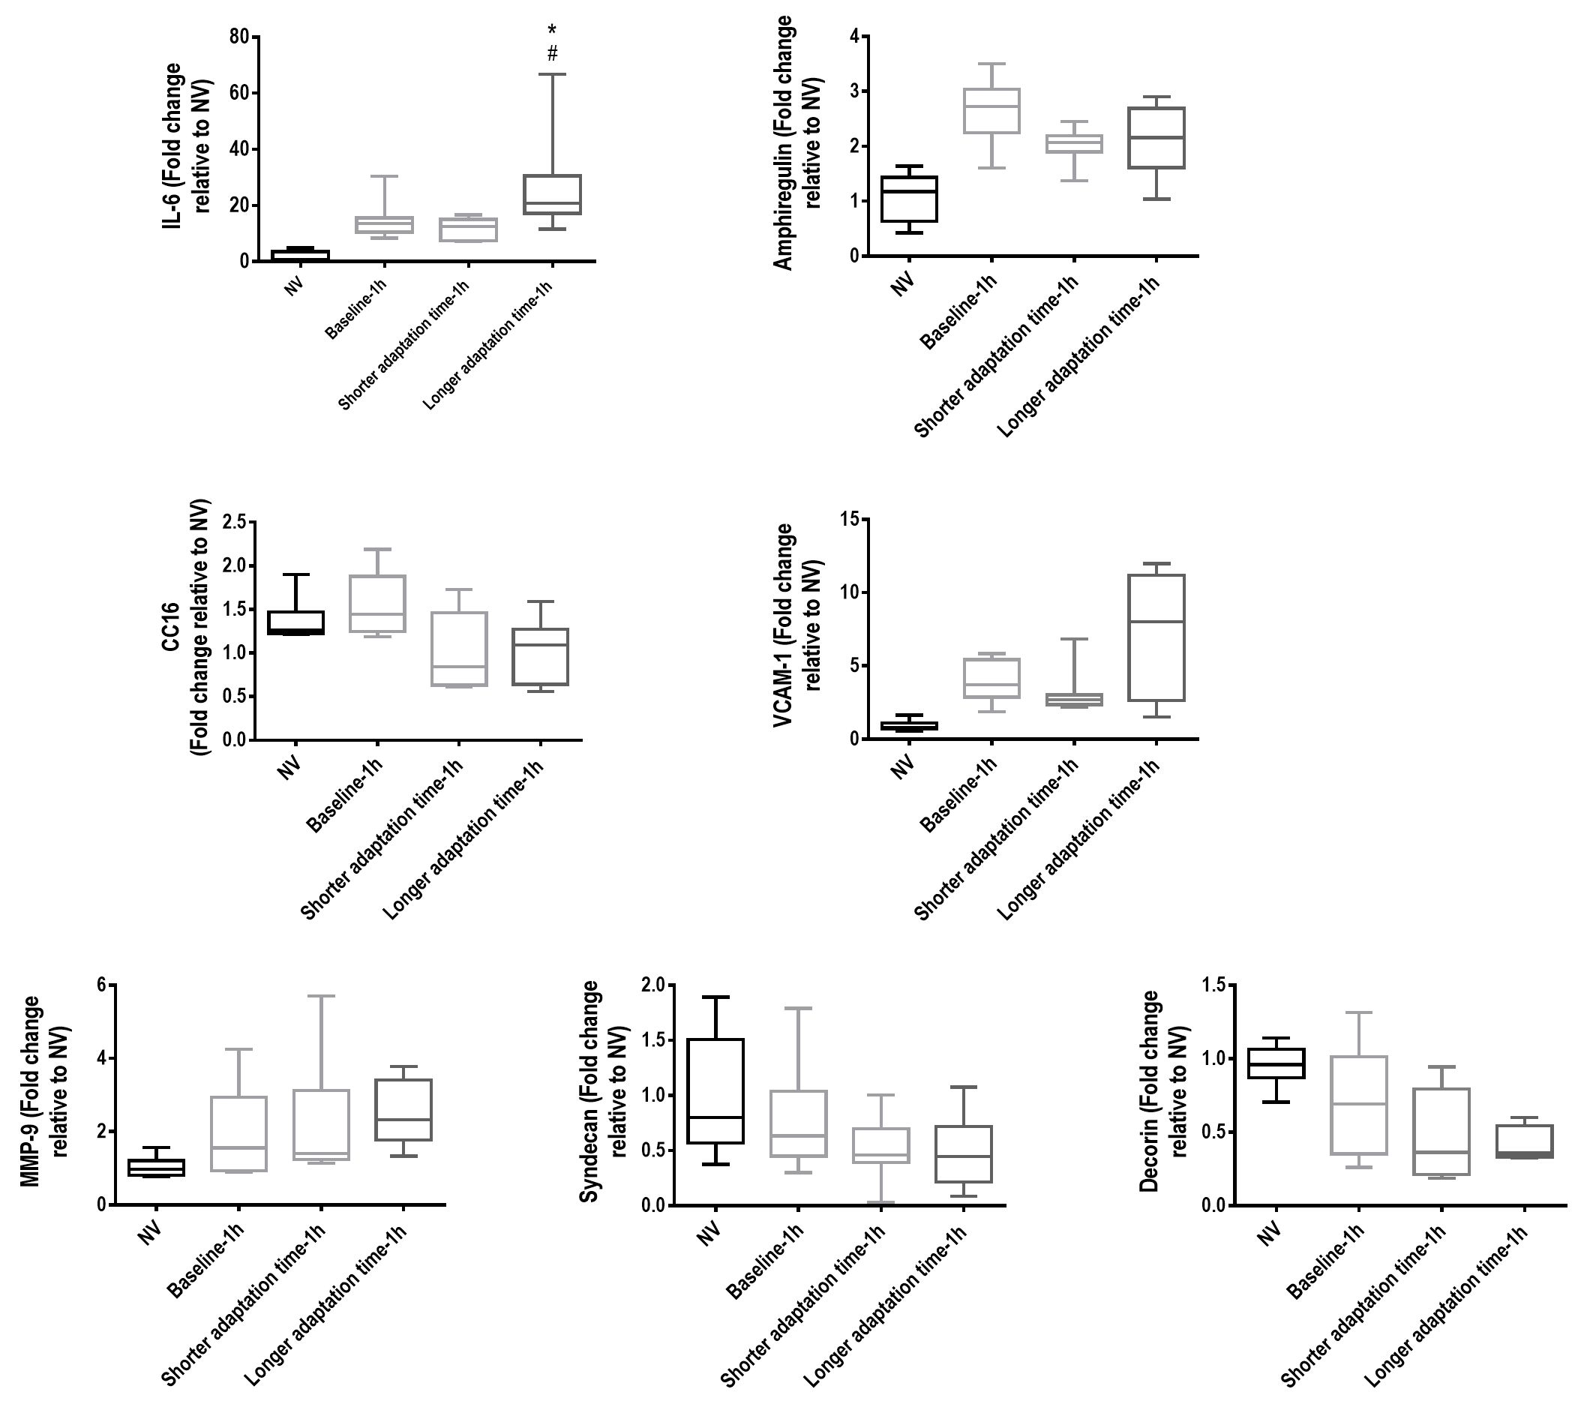
figure 8. Expression of biologic markers associated with inflammation [interleukin (IL)-6], alveolar pulmonary stretch (amphiregulin), epithelial cell damage [club cell protein 16 (CC16)], endothelial cell damage [vascular cellular adhesion molecule (VCAM)-1], and damage to extracellular matrix (metalloproteinase (MMP)-9), syndecan, and decorin) in the following groups: Low tidal volume (V_{T}) – mechanical ventilation with a protective strategy (V_{T}=6ml/kg) for 1 hour (Control-1h); High V_{T} achieved after a short ‘run-up’ adaptation time – V_{T}=6mL/kg during the first 30 minutes followed by a slow V_{T} increase up to 22 mL/kg for 30 minutes (Shorter adaptation time-1h); and High V_{T} with a longer adaptation time – a slow V_{T} increase from 6 mL/kg to 22 mL/kg during 1 hour (Longer adaptation time-1h). Relative gene expression was calculated as a ratio of the average gene expression levels compared with the reference gene (36B4) and expressed as fold change relative to non-ventilated animals (NV). Values are medians and interquartile ranges of 8 rats in each group. * versus Control; # versus Shorter Adaptation Time group.

