Supplemental Digital Content 1: Static connectivity analysis.
Spectral and spatial properties of static cortical connectivity
To characterize the spectral and spatial properties of cortical connectivity across altered conscious states during general anesthesia, we chose the following five epochs: 5-min during baseline (N=29), 5-min immediately after LOC (N=30), 5-min during maintenance (specifically, the non-burst suppression segment in the last hour of maintenance period, N=27), 5-min right before ROC (N=28), and 5-min during recovery (N=28). Given the pharmacokinetics of isoflurane, we assume the primary effect is from propofol for the LOC epoch and from isoflurane for the maintenance epoch. For each epoch, the averaged wPLI was estimated for each frequency point at 0-45 Hz between each pair of channels over all the 30-s windows.

The spectral properties were assessed by focusing on the connectivity between regions of interest. We compared the spectral profiles of wPLI between different studied epochs or different region pairs using the jackknife-based method in Chronux analysis toolbox.¹ Briefly, the wPLI values were Fisher z-transformed to approximate Gaussian distribution, and the test statistic was defined as²
$$Δy(f)=\frac{y_{a}(f)-y_{b}(f)}{\sqrt{{\left(N_{a}-1\right)}^{-1}+{\left(N_{b}-1\right)}^{-1}}}$$
where $y_{a}(f)$ and $y_{b}(f)$ were the frequency-resolved wPLI from two groups to be compared, and $N_{a}$and $N_{b}$were sample sizes of the two groups. The statistic Δy(f) can be assumed to be distributed as a Gaussian $Δy(f)\sim N\left(0, σ^{2}\left(f\right)\right)$, and the variance $σ^{2}\left(f\right)$ was estimated via the jackknifed method.² Since the test statistic is a function of frequency, the difference between two groups was considered to be statistically different if the FDR-adjusted P<0.05 over a contiguous frequency range whose width is larger than the bandwidth in wPLI analysis (2 Hz in this study).

Figure S1 (A) presents the frequency-resolved prefrontal-frontal, frontal-parietal and parietal-occipital wPLI across the studied epochs. The cortical connectivity during baseline was characterized by a predominance of frontal-parietal connectivity at alpha (8-13 Hz) band, which was suppressed during propofol-induced LOC, while a prominent prefrontal-frontal connectivity was evident at delta (0.5-3 Hz) and alpha (8-14 Hz) bands. Interestingly, isoflurane anesthesia was associated with increased frontal-parietal connectivity at 2-6 Hz and high frontal-parietal and prefrontal-frontal connectivity at 6-10 Hz. Before ROC, the alpha frontal-parietal connectivity returned to baseline level, but there was a mild connectivity at high-frequencies (15-35 Hz) in both frontal-parietal and prefrontal-frontal connectivity that lasted after recovery. The parietal-occipital wPLI behaved similarly, while demonstrating less statistically significant changes across the studied epochs as compared to frontal-parietal wPLI. These results demonstrate the complex spectral dynamics of cortical connectivity associated with the altered conscious states induced by general anesthesia.

Furthermore, we assessed the spatial properties of cortical connectivity at delta (0.5-3 Hz), theta (3-6 Hz), alpha (6-15 Hz) and high-frequency (15-35 Hz) bands, as determined by the spectral properties of cortical connectivity described above. The averaged wPLI values were calculated at each frequency band, and the matrix so obtained represented the connectivity for each pair of the 21 channels, as shown in Figure S1 (B). Moreover, the connectivity strength for each channel was calculated as the mean wPLI between the channel and all the other channels for each studied epoch and frequency band, with the group-level topographic map constructed using the topoplot function in EEGLAB toolbox³ and shown in Figure S1 (C). It is evident that the connectivity changes across the states were mainly concentrated on the prefrontal, frontal and parietal regions; this might be partly due to the coarse spatial discretization of scalp electroencephalographic recordings.

Taken together, static connectivity analysis demonstrated distinct connectivity patterns with different spectral and spatial (frontal-parietal and prefrontal-frontal) properties at the studied epochs. Although the time-averaged pattern may reflect the averaged activity, it could obscure the temporal variations of cortical connectivity in each epoch. Furthermore, it is unclear how the cortical connectivity evolves from a certain pattern into another pattern during the time between the discrete epochs studied. Therefore, we aimed to investigate the temporal progression of cortical connectivity, as assessed by the frequency-resolved frontal-parietal and prefrontal-frontal wPLI, during the anesthesia-induced alterations of consciousness.

Group-level frontal-parietal and prefrontal-frontal connectograms across participants
One of the frequently used method to investigate the temporal changes is to quantify the time-varying changes at a group level by averaging across all participants.⁴⁻⁶ Figure S2 shows the averaged frontal-parietal and prefrontal-frontal wPLI connectogram across all available participants. As compared to static connectivity analysis presented above, it provided useful information about the evolution of cortical connectivity during alterations of consciousness induced by anesthesia. Although averaging across participants may reflect the averaged connectivity changes at a group level, it could obscure the fluctuations and transitions of connectivity patterns at individual level since they occur at different times across the participants.⁷ Moreover, it is unclear if a certain pattern was contributed by all or only a subgroup of participants. For example, the isoflurane anesthesia was associated with (1) 2-6 Hz frontal-parietal connectivity, (2) 6-10 Hz frontal-parietal connectivity, and (3) 6-10 Hz prefrontal-frontal connectivity at a group level, but it is unknown if these patterns were contributed by all participants, or each pattern was separately contributed by a subgroup of participants. To resolve these issues, we employed cluster analysis to investigate the temporal dynamics of cortical connectivity that occurred in individual participants in the main study.

References
1. Mitra P, Bokil H: Observed brain dynamics, Oxford University Press, 2007
2. Bokil H, Purpura K, Schoffelen J-M, Thomson D, Mitra P: Comparing spectra and coherences for groups of unequal size. J Neurosci Methods 2007(2); 159: 337-45
3. Delorme A, Makeig S: EEGLAB: an open source toolbox for analysis of single-trial EEG dynamics including independent component analysis. J Neurosci Methods 2004; 134(1): 9-21
4. Lee U, Ku S, Noh G, Baek S, Choi B, Mashour GA: Disruption of frontal–parietal communication by ketamine, propofol, and sevoflurane. Anesthesiology 2013; 118(6): 1264-75
5. Vlisides PE, Bel-Bahar T, Lee U, Li D, Kim H, Janke E, Tarnal V, Pichurko AB, McKinney AM, Kunkler BS, Picton P, Mashour GA: Neurophysiologic correlates of ketamine sedation and anesthesiaa high-density electroencephalography study in healthy volunteers. Anesthesiology 2017; 127(1): 58-69
6. Blain-Moraes S, Lee U, Ku S, Noh G, Mashour GA: Electroencephalographic effects of ketamine on power, cross-frequency coupling, and connectivity in the alpha bandwidth. Front Syst Neurosci 2014; 8:114
7. Hudson AE: Metastability of neuronal dynamics during general anesthesia: time for a change in our assumptions? Front Neural Circuits 2017; 11: 58

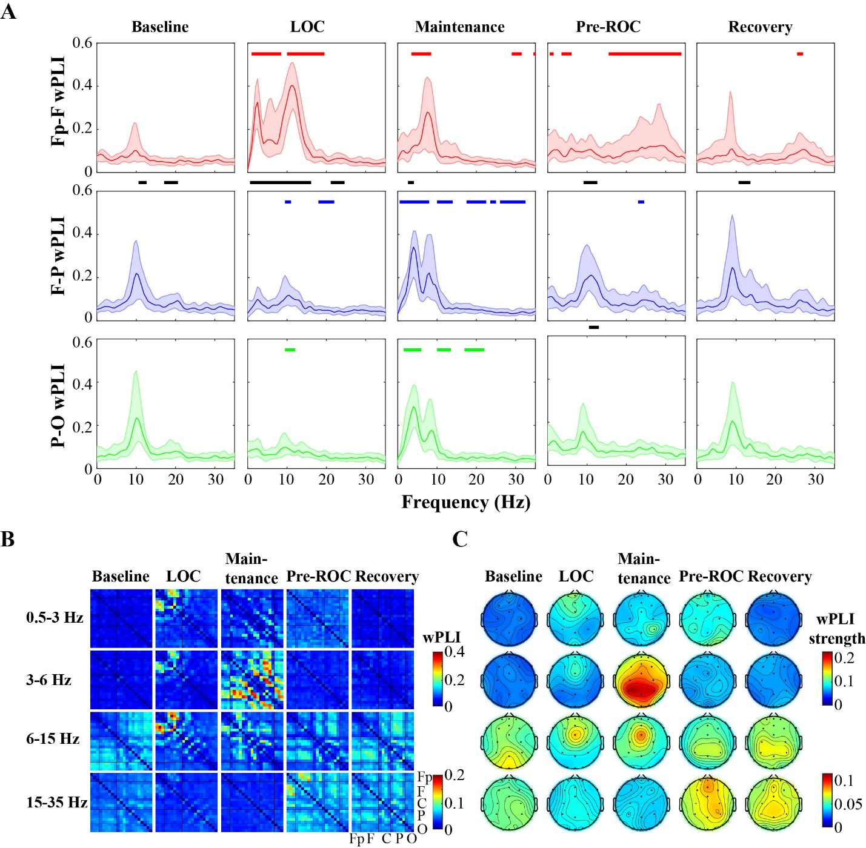
Figure S1. The spectral and spatial properties of static cortical connectivity as assessed by weighted phase lag index (wPLI). (A) Frequency distribution of the prefrontal-frontal, frontal-parietal and parietal-occipital wPLI at the five studied epochs. The colored lines and shadows represent the median and the interquartile range (IQR) of the wPLI values across all available participants. For each epoch, the horizontal colored bars indicate the frequency ranges that showed statistically significant changes relative to baseline, while the black bars indicate the frequency ranges that showed significant difference between prefrontal-frontal and frontal-parietal (or between frontal-parietal and parietal-occipital) wPLI (FDR adjusted P<0.05, Fisher z-transformed wPLI). (B) Group-level (median across all participants) connectivity matrices at the studied epochs and frequency bands. The electroencephalographic channels were re-ordered from anterior to posterior regions (Fp: Fp1/z/2; F: F7, F3, Fz, FCz, F4, F8; C: T3, C3, C4, T4; P: T5, P3/z/4, T6; O: O1/z/2). (C) Group-level scalp topography of the connectivity strength (mean wPLI in each channel with all other channels) at the studied epochs and frequency bands.

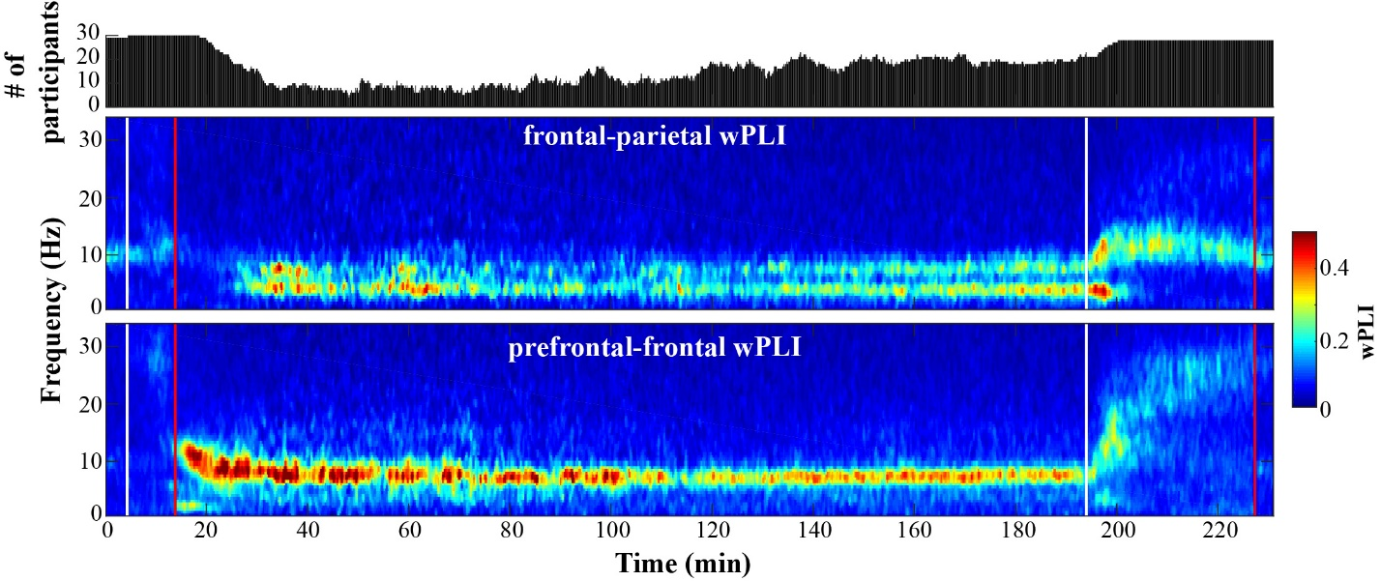Figure S2. Group-level (median across all participants) connectograms of the mean wPLI between frontal (F3, F4, Fz) and parietal (P3, P4, Pz) channels, and between prefrontal (Fp1, Fp2, Fpz) and frontal channels. The left-most vertical line in white indicates the start of the propofol infusion that separates the baseline and induction periods; the following red line indicates the time where LOC occurred; the second white line indicates the discontinuation of isoflurane; the right-most red line indicates ROC that separates emergence and recovery periods. The time spans during baseline, induction, maintenance, emergence, and recovery were rescaled before the calculation. The time windows with suppression ratio>20% were excluded, and the number of participants to be averaged for each time window was indicated on the top panel.

