Supplemental Digital Content 2: Dynamic connectivity analysis.
Parameter selection
In this study, the implementation of the dynamic connectivity and cluster analysis method involved the selection of the number of retained principal components (PCs) (M) and the number of clusters (N_{c}), which was determined by (1) the stability index that quantifies the reproducibility of clustering solutions for the studied dataset,^{1,2} (2) the amount of explained variance by the retained PCs, and (3) the interpretability of the clustering results.

Following the study,¹ we varied the number of retained PCs from 3 to 10, and the number of clusters from 5 to 10. For each pair of parameters, the following steps were repeated 100 times: (1) the participants were iteratively split into two disjointed halves, resulting in two independent datasets ($S_{template}$ and $S_{test}$); (2) the dataset $S_{template}$ was used to train a classifier, and the data from $S_{test}$ was classified using this classifier to obtain the clustering result $C_{template}$; (3) the data from $S_{test}$ itself was used to train another classifier, thus resulting in another clustering result $C_{test}$ of this same dataset; (4) if we assume the two sub-datasets are realizations of the same process, the clustering results derived from two classifiers should be similar. To quantify the dissimilarity between $C_{template}$ and $C_{test}$, the normalized minimum Hamming distance was calculated as an estimate of the stability measure,¹ which quantifies the fraction of differently labeled patterns between the two solutions, with a smaller value suggesting a higher agreement level.

Over 100 realizations, the stability index achieved local minimum values with two clustering solutions: 6 clusters with 4 retained PCs, and 8 clusters with 7 retained PCs (fig. S3A). The first 4 PCs and 7 PCs contained 50.7% and 62.3% of the total variance of the original connectivity patterns (fig. S3B). The solution with 7 retained PCs and 8 clusters was employed because of the improved interpretability of the clustering results. In this study, the connectivity states (clusters) are assumed to be associated with altered conscious states induced by general anesthesia. However, under the solution with 4 retained PCs and 6 clusters, there were no characterized patterns associated with wakeful baseline (alpha frontal-parietal connectivity) and that right after loss of consciousness (a predominance of delta connectivity), i.e. Cluster 1 and Cluster 3 as in the employed solution (fig. S3C).

Cluster separation
The employment of cluster analysis in this study was based on the assumption of separability of multiple clusters (connectivity states), which was inspired by the observation of the temporal changes in the frontal-parietal and prefrontal-frontal wPLI connectograms (e.g. fig. 2A). The k-means clustering algorithms is, by definition, bound to produce a discrete set of patterns. This kind of analysis may have the disadvantage of ignoring the non-discrete properties of the system that lie along a continuum, but it has the unique advantage of providing a statistical analysis tool to classify samples into groups to help unravel complex underlying patterns in the data.

To measure the extent to which the clusters are separated from each other with the employed clustering solution, Figure S4(A) shows the Squared Euclidean distance between the data points in each cluster to the centroid of all clusters. Overall, for the data points in a certain cluster, the distance is shorter to its cluster centroid as compared to other cluster centroids. However, this is not the case for all the data points, especially those in Cluster 5-8. To further examine how well these four clusters are separated, Figure S4(B) shows the data points in each pair of clusters in the space spanned by three selected principal components (PCs). Despite the constraints on 3-dimensional visualization, at least 90% of data can be well-separated for any two clusters. From the distribution of the data points, it is evident that some clusters are discrete from each other, e.g., Cluster 5 and Cluster 7. However, some clusters might be separated from a connected continuum, e.g., Cluster 5 and 6.

To test whether the closely connected clusters can be potentially classified into one cluster, we re-ran the k-means clustering algorithm as performed in the main study but classified the dataset into 6 or 7 clusters instead of 8. Figure S5 shows the representative connectivity patterns of the resultant clustering solution in each case. For the 7-cluster solution, Cluster 6 and 7 were mixed into one cluster, and further Cluster 1 and 2 were combined in the 6-cluster solution. Among the three solutions, the 6-cluster one was not a good option because of the absence of the cluster (connectivity state) associated with resting-state baseline (characterized by alpha frontal-parietal connectivity). The 8-cluster solution was adopted instead of the 7-cluster one because of high reproducibility (fig. S3A). With 7 clusters, the stability index was 0.31±0.07, or equivalently the 1-minimum Hamming distance was 0.73±0.06 across 100 realizations, which was significantly lower relative to that with the 8-cluster solution (0.80±0.06) (t(198)=8.82, P<0.001, two-samples t-test).

Taken together, given the constraints on 3-dimensional visualization, it remains an open question as to whether some of the clusters (e.g., Cluster 5 and 6) are discrete or separated from a continuum; however, the classification into separate clusters yielded higher reproducibility than alternative solutions.

References
1. Lange T, Roth V, Braun ML, Buhmann JM: Stability-based validation of clustering solutions. Neural Computation 2004; 16(6): 1299-323
2. Hudson AE, Calderon DP, Pfaff DW, Proekt A: Recovery of consciousness is mediated by a network of discrete metastable activity states. Proc Natl Acad Sci U S A 2014; 111(25): 9283-88

Figure S3. Parameter selection in the dynamic connectivity analysis. (A) The stability index as a function of the number of retained PCs and the number of clusters, with the mean (left) and SD (right) values across 100 realizations. (B) The cumulative sum of explained variance plots as a function of the number of retained principal components (PCs). (C) The representative connectivity patterns, i.e., the mean and its 95% confidence intervals (blue: frontal-parietal wPLI, red: prefrontal-frontal wPLI), for the clustering solution with 4 retained PCs and 6 clusters (top) and the employed one with 7 retained PCs and 8 clusters (bottom, equivalent to fig. 4A).

Figure S4. (A) The distance between the points in each cluster and the centroid of all clusters. Each panel shows the distribution of the Squared Euclidean distances for the points in each cluster. The histograms are normalized so that the relative areas covered in gray reflect the relative total number of data points, while the horizontal lines in red indicate the median and the interquartile range of the data points. (B) The data points in the space spanned by three PCs that best distinguish the two clusters by manual inspection. The approximate location of each cluster is shown by an ellipsoid centered at the cluster centroid. The radius of the ellipsoid along each dimension is the 90th percentile of the distance of all points in the cluster to the centroid along that dimension.

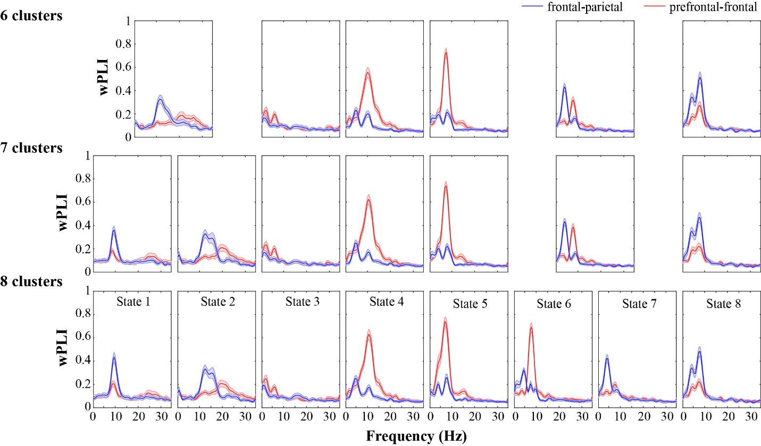
Figure S5. The representative connectivity patterns, i.e., the mean and its 95% confidence intervals (blue: frontal-parietal wPLI, red: prefrontal-frontal wPLI), for the clustering solutions with 6 and 7 clusters. The patterns associated with the 8-cluster solution were also presented at the bottom for comparison (equivalent to fig. 4A).

