Supplemental Digital Content 4: Isoflurane concentration and hemodynamic factors.
Effect of variations in isoflurane concentration on dynamic cortical connectivity
Figure S9 (A) shows the end-tidal concentration of isoflurane at 1-min interval for the assumed steady-state period for a subset of participants across the sites. It is not unexpected that some cases showed a considerable extent of fluctuations. To examine the effect of the variations of isoflurane concentration, we used coefficients of variation (CV), defined as the ratio of the standard deviation to the mean, to quantify the extent of variations for each case. Based on the CV values, we divided the participants into two groups: cases of high variations with CV>4% and those of low variations with CV<4%, and found there were no significant difference in terms of occurrence rate for any of the connectivity states between the two groups (all the P-values>0.1, Wilcoxon rank sum test) (fig. S9B). Furthermore, we tested the relationship of the CV value and the probability of state switches across the participants. Variations of isoflurane concentration had no significant correlation with the likelihood of switching to a different state (Spearman’s correlation r=-0.06, P=0.82). Taken together, the variations of isoflurane concentration do not account for the observed dynamic connectivity changes in this study.

Effect of hemodynamic factors on dynamic cortical connectivity
During the three hours of exposure to isoflurane, blood pressure was kept within 20% of baseline pre-induction values using phenylephrine infusion (23 participants) or intermittent boluses of ephedrine (3 participants). As shown in Figure S10 (A), there was a considerable amount of variability in systolic blood pressure (SBP), diastolic blood pressure (DBP) and heart rate (HR) across the participants. We assessed whether these hemodynamic factors had an impact on the main findings of the study. Panel B shows the relationship of individual hemodynamics and the occurrence rate of the five connectivity states that dominate during the isoflurane maintenance period as well as the probability of state switches. Although State 8 occurs less for lower SBP values (Spearman’s correlation r=0.38, p=0.04), there were no significant relationship observed in other cases (P>0.05). These results suggest that the variability of hemodynamic characteristics across participants cannot entirely account for the presence of multiple electroencephalographic connectivity states and the likelihood of switching to a different state.
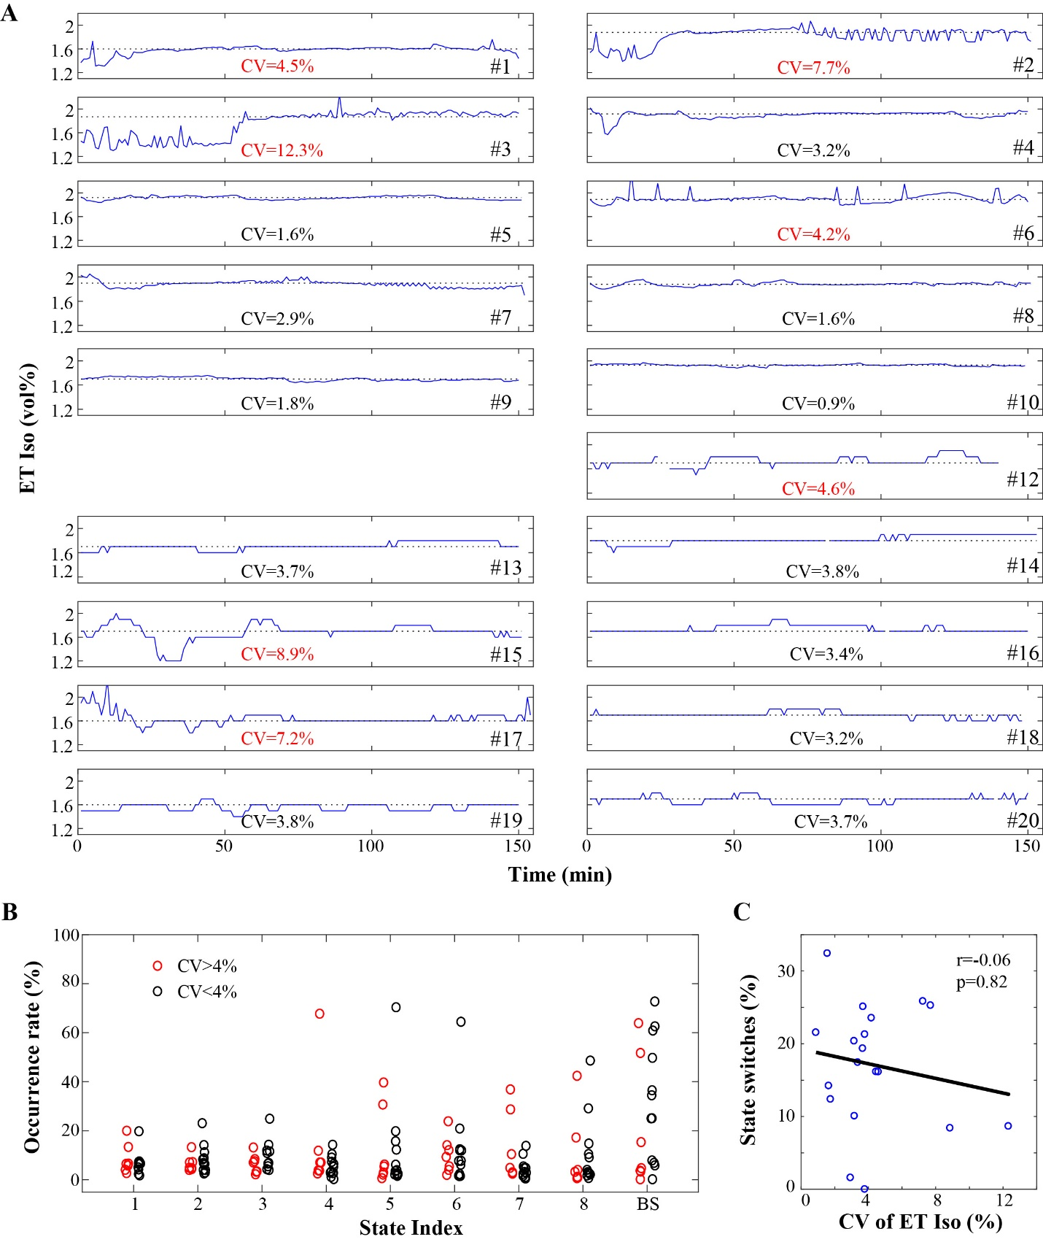
Figure S9. Effect of variations in isoflurane concentration on dynamic cortical connectivity. (A) End-tidal concentration of isoflurane at 1-min intervals from 30 min after administration to the discontinuation of isoflurane for 19 subjects. In the figure, the black dotted line indicates the median concentration. The coefficients of variation (CV) was used to quantify the extent of variations for each case. (B) Individual values of state occurrence rate for the cases with CV>4% and CV<4%, respectively. (C) the scatter plots and Spearman’s correlation coefficients (r) of CV value and the probability of state switches across the participants. In B and C, each circle indicates each participant.

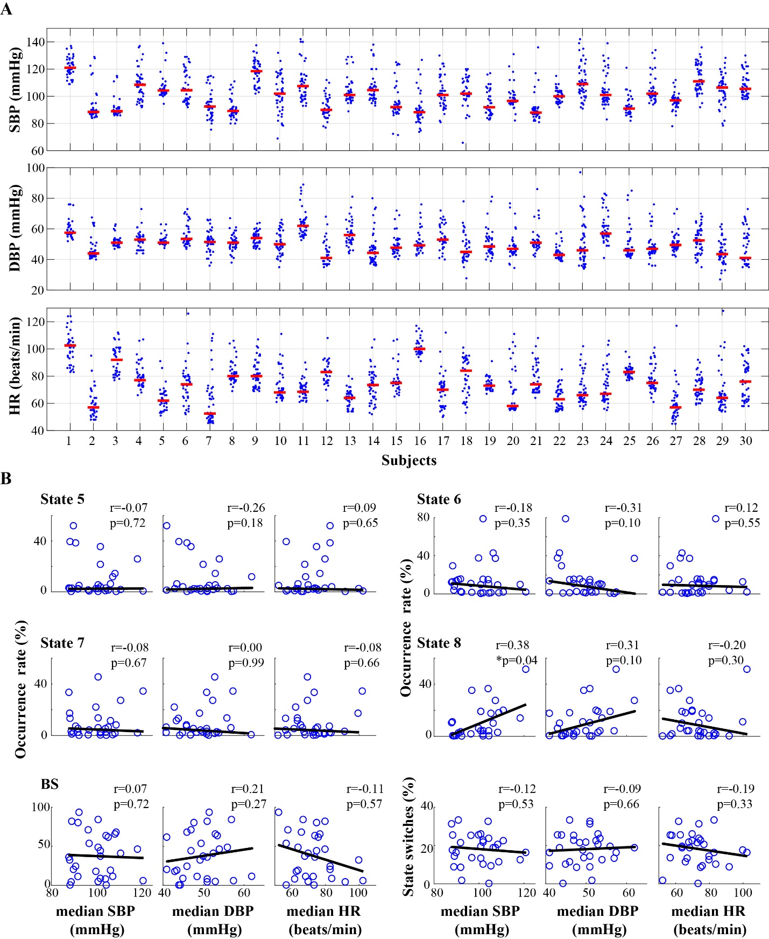

Figure S10. Effect of hemodynamic factors on dynamic cortical connectivity. (A) Individual systolic blood pressure (SBP), diastolic blood pressure (DBP) and heart rate (HR) values for every 5-min interval from loss of consciousness to recovery of consciousness for each subject (in blue dots), while the median values as indicated using red bars. (B) The scatter plots and Spearman’s correlation coefficients (r) of each hemodynamics and the occurrence rate of the five connectivity states that dominate the isoflurane maintenance period (State 5-8 and ‘BS’) as well as the probability of state switches across participants. Each circle indicates each participant.

