Supplemental Digital Content 3: Minimum Alveolar Concentration and Anesthetic Maintenance Data
Figure 1
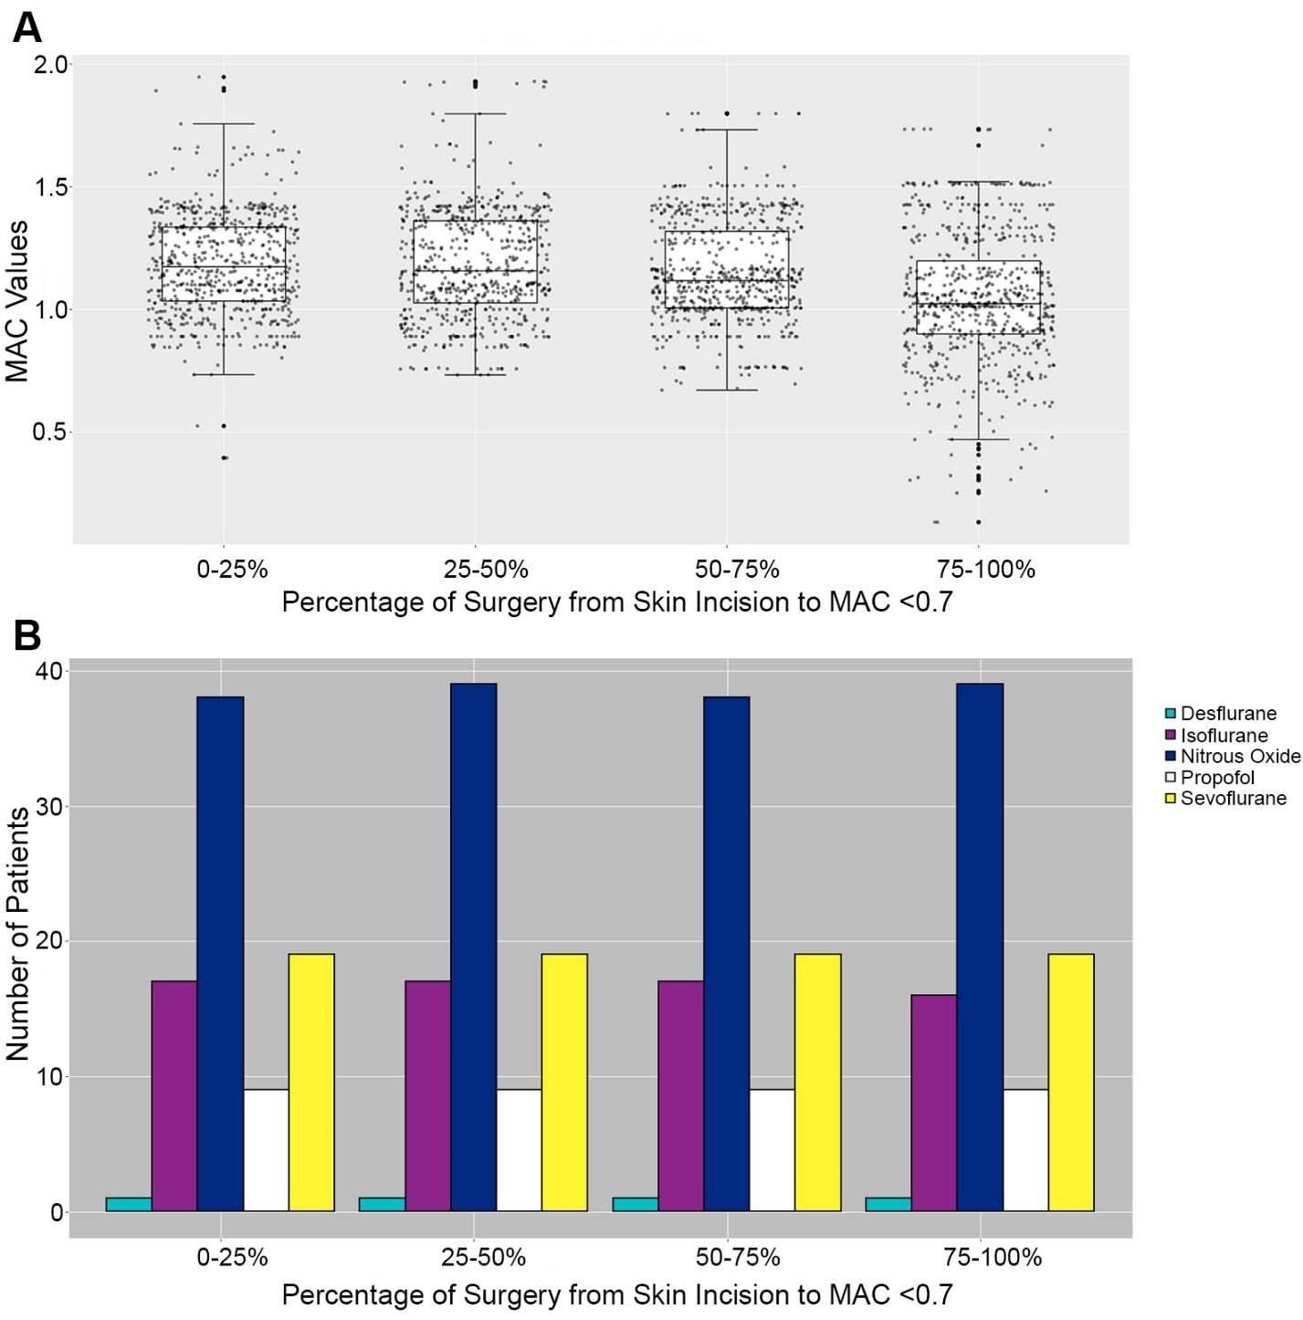

Figure A displays individual minimum alveolar concentration (MAC) values during anesthetic maintenance across all cases. Median values are automatically calculated as 1-minute medians by the intraoperative electronic information management system at our institution (Centricity; General Electric Healthcare, Waukesha, WI). The system uses previously described methods to calculate the estimated age-adjusted MAC in the setting of multiple anesthetic maintenance agents (Mashour GA et al., J Clin Monit Comput. 2009 Oct;23(5):273-7). The median MAC (and interquartile range) values for each quarter of the anesthetic maintenance phase were the following: 0-25% 1.17 (1.03–1.34), 25-50% 1.16 (1.03–1.36), 50-75% 1.12 (1.01–1.32), and 75-100% 1.03 (0.90–1.20). Figure B illustrates the anesthetic maintenance regimens for all included cases. Most patients received a combination of nitrous oxide and either isoflurane or sevoflurane during anesthetic maintenance.

Figure 2
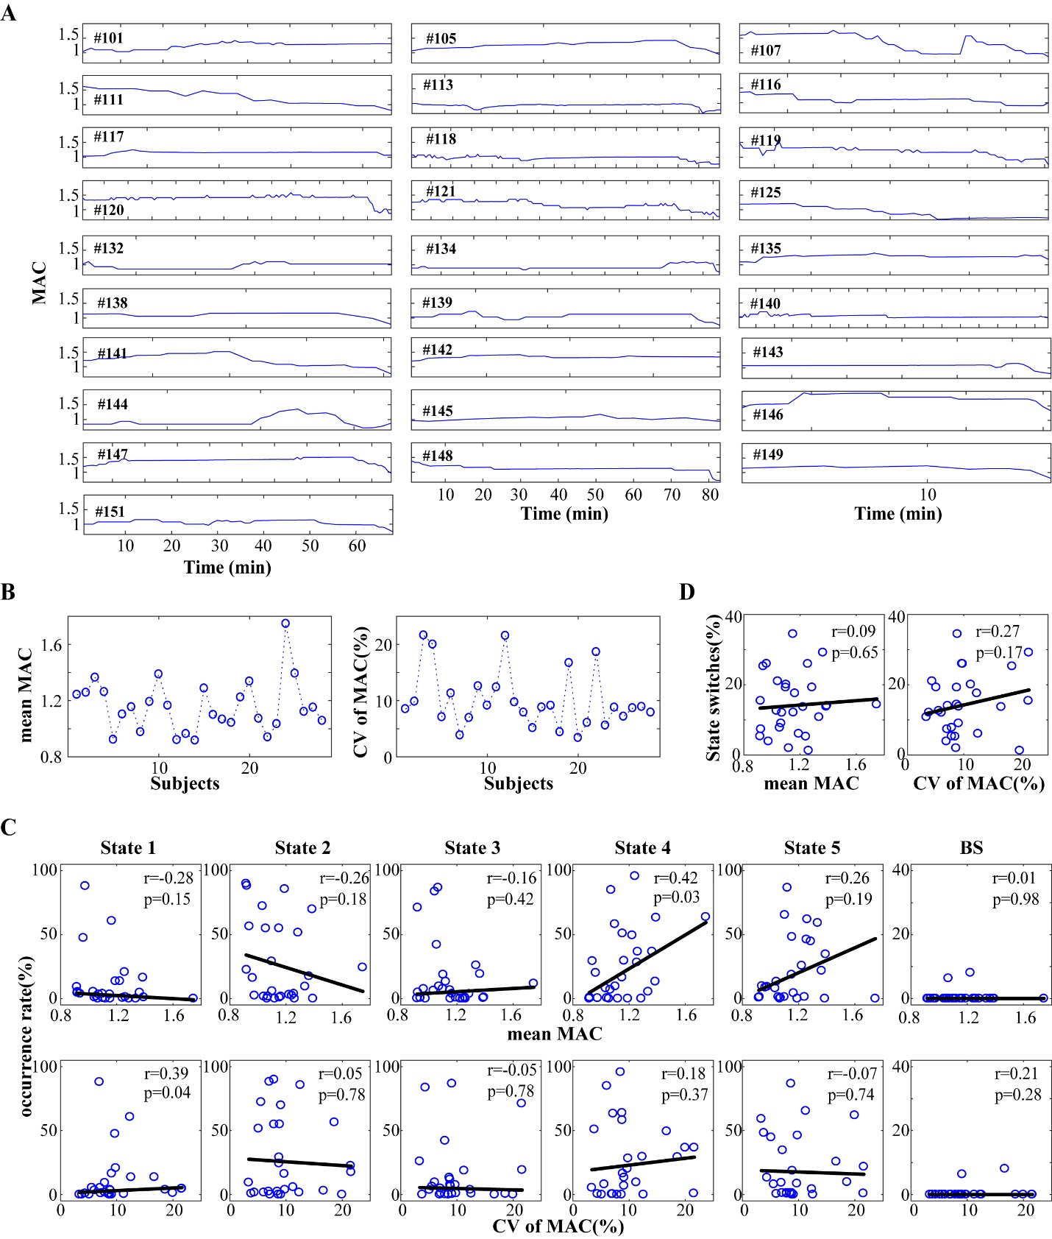
(A) Age-adjusted MAC values at 1-min intervals from the start of surgery to the last MAC value of 0.7 towards the end of surgery for 28 patients. The rest of the subjects (N=17) were excluded because the start of surgery was not recorded, the surgery duration was shorter than 15 min, or propofol was used for maintenance (and our goal was to present accurate, volatile anesthetic-based MAC depth). (B) There was considerable intra- and inter-variability of MAC values for each participant, as reflected by both mean MAC values and coefficients of variation (CV), defined as the standard deviation divided by the mean MAC values for each participant. To assess whether varying MAC values have impact on connectivity state dynamics, we tested the relationship between the mean or CV of MAC values and the occurrence rate of each connectivity state (C) as well as the probability of state switches across subjects (panel D) (uncorrected p-values presented). Aside from State 4 possibly occurring less in subjects with lighter anesthetic depth (smaller mean MAC values) (Spearman’s correlation r=0.42, uncorrected P=0.03) and State 1 occurring less in subjects with smaller variation (r=0.39, uncorrected P=0.04), there was no significant relationship observed in other cases (P>0.1). These results suggest that the variations of anesthetic concentration do not entirely account for the presence of multiple connectivity states and the likelihood of switching to a different connectivity state.

Figure 3

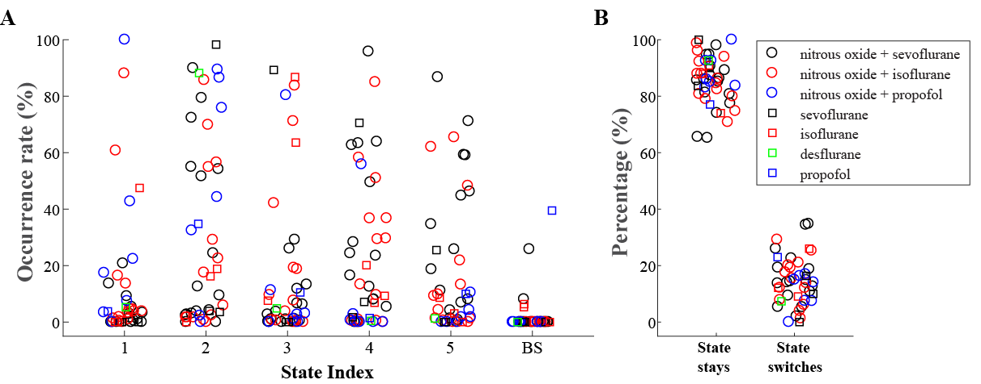
To examine whether different anesthetic regimens affected state dynamics, we examined state occurrence rate across each regimen (A) as well as the cortical connectivity state persistence (vs. switching) (B). There was no difference observed among the different groups with different anesthetic regimens.

